CONTROL FLOW ACTIVITY :
- Getting Metadata :
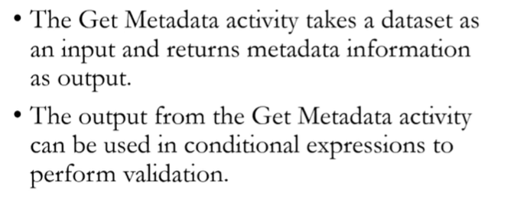
Steps to create and use Metadata Pipeline:
- Create a pipeline and under the “General” section -> Get Metadata
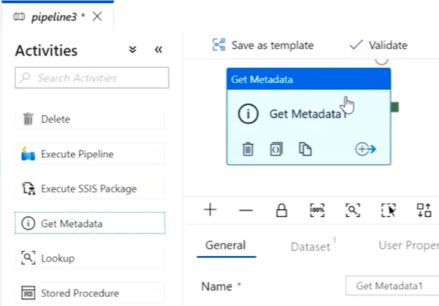

- Click on the “Dataset” -> New,
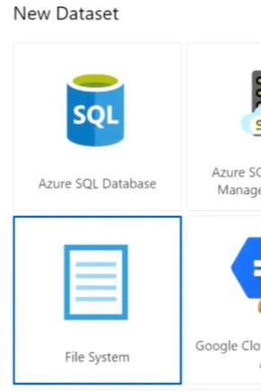

Then,
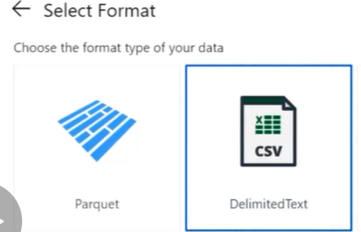

Create a New linked service having an Integrated Runtime for On Premise setup,
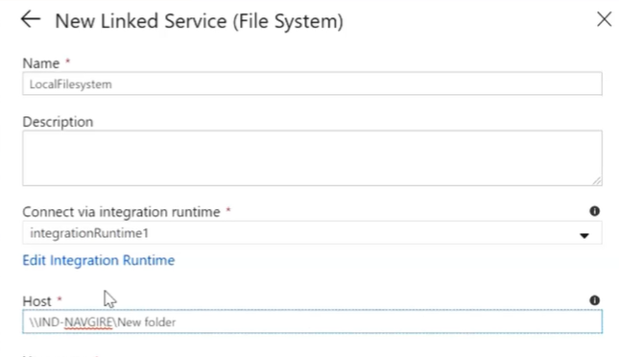
In this case, we will scan thru all the files within a directory,
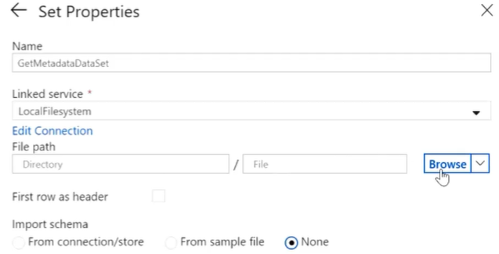
Empty

- In the dataset properties, configure the “Field List”
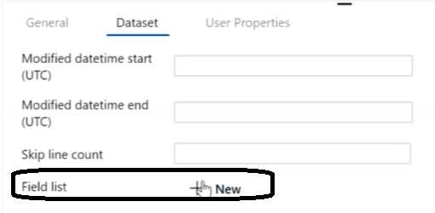
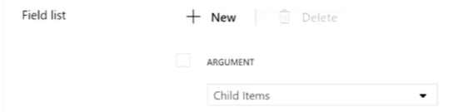

This option will scan thru the datasets and return the child items.

- Once done “Publish all” -> Add Trigger
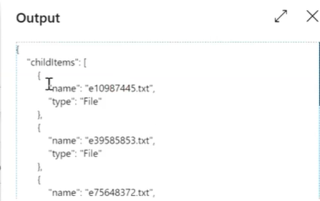

So all the files within the directory have been returned.

- Filter Metadata,
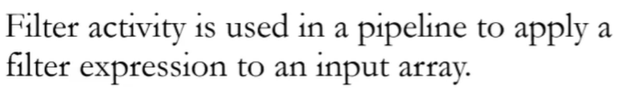

Setup and Use “Filter Activity:
- Within Dataflow, use “Iteration & Conditionals” -> “Filter”.
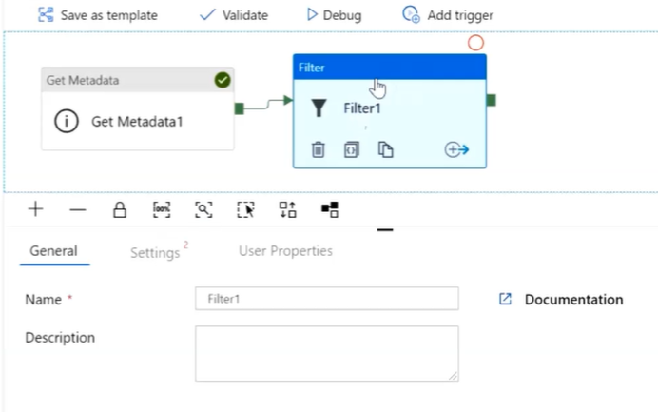

Filter out all the files which Start with “e”.

- In Settings -> “Items” refer to the i/p dataset.
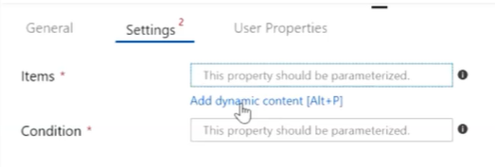

Click on “Add Dynamic content” ,
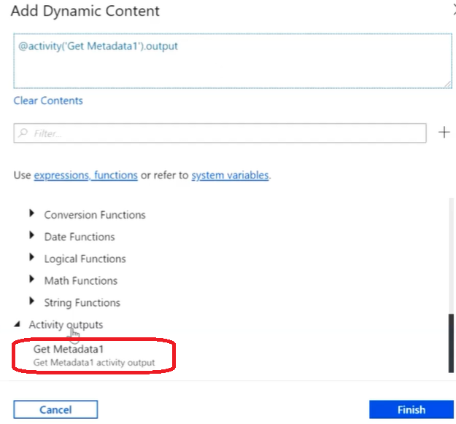
We have to add “childItems” as an item so that the filter logic refers to all the child items,
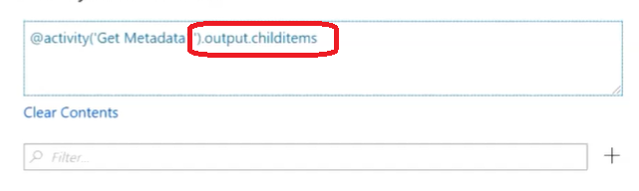

Next, choose the condition (i.e. filtering criteria),
Go to String functions,
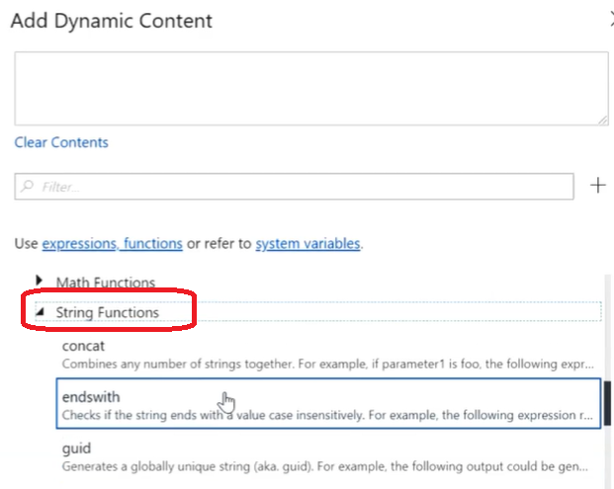

Choose the option for filtering criteria,
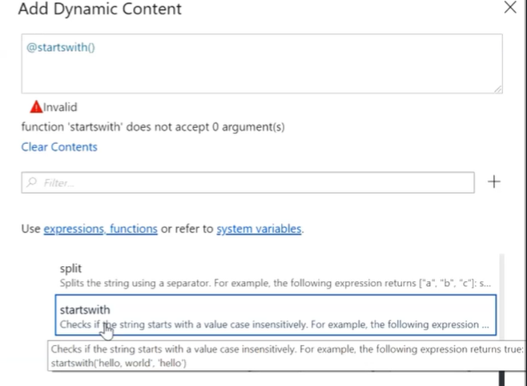
Modify startswith to fulfil the criteria i.e.
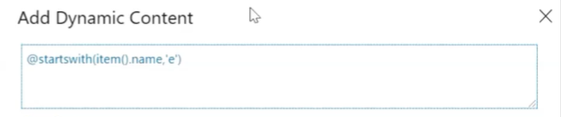

Click “finish”,
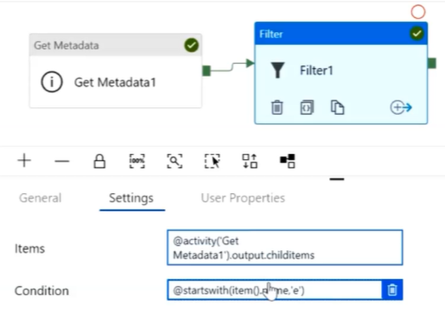

Publish and Trigger.

- Output is,
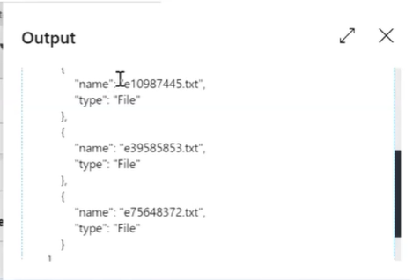

i.e. only files that start with “e”.

- If (else) Condition Activity,
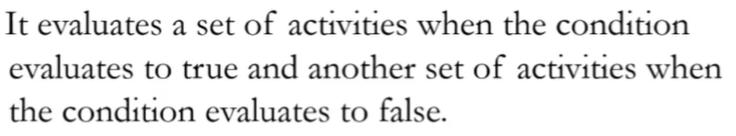

Setup and Use If condition activity:
- Set up a pipeline for If condition
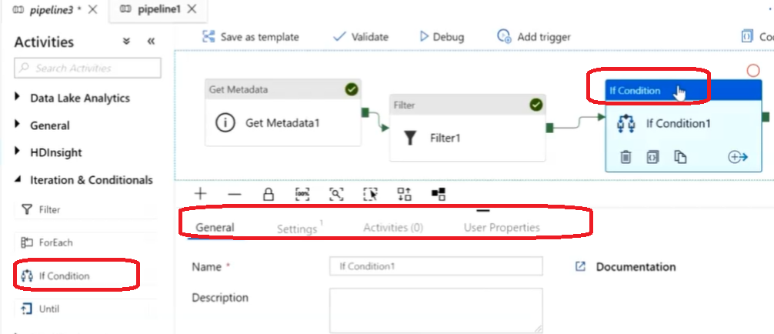

- Within “Settings” tab, go to “Add Dynamic Content”
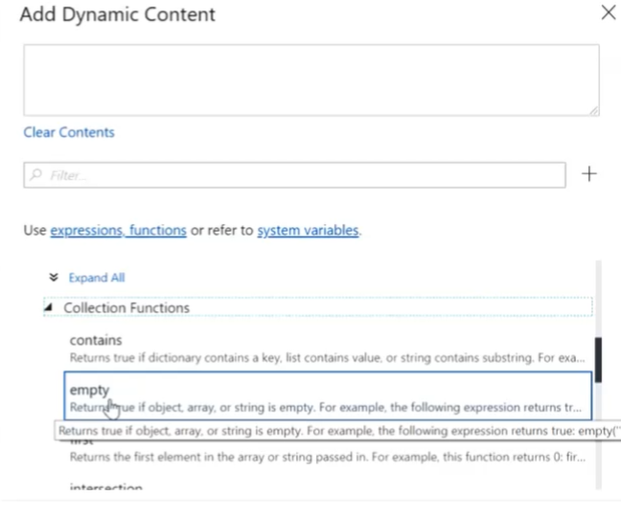
Input to this condition is o/p of filter activity, so
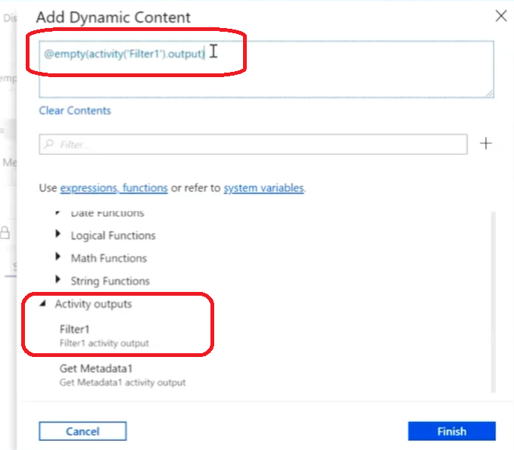

- In Activities tab, set “TRUE” and “FALSE activity. So if the condition added in “Settings” tab is true or false, the following activity (setup) is triggered.
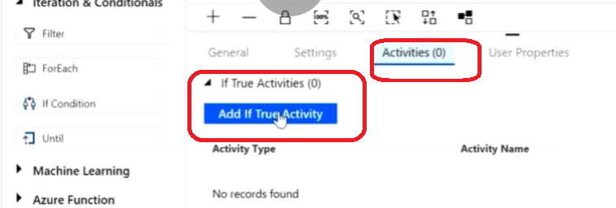

For “false”
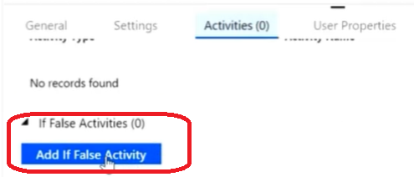

- Append Variable Activity,
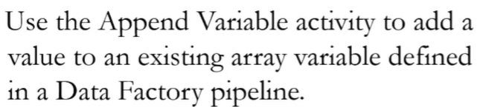

Create an “Append” Variable:
- Click on the Pipeline Canvas and add a variable as mentioned,
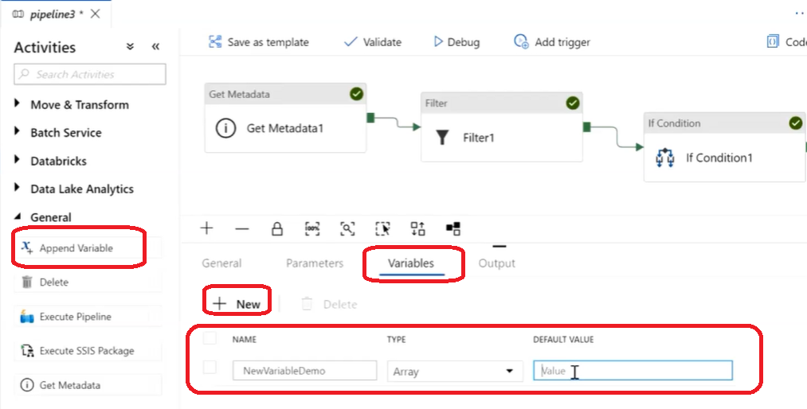

- For a scenario, append a variable against If Condition, if the condition is False,
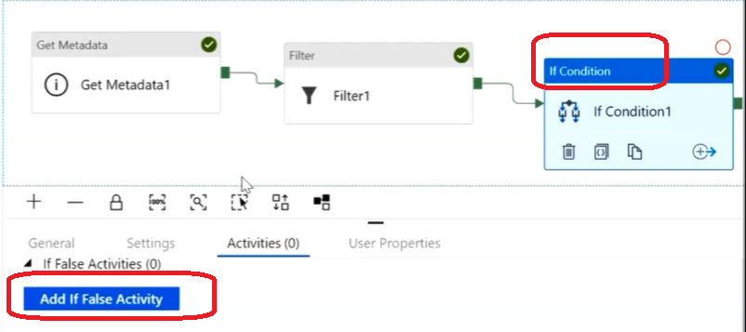

Click on “Add If False Activity”,
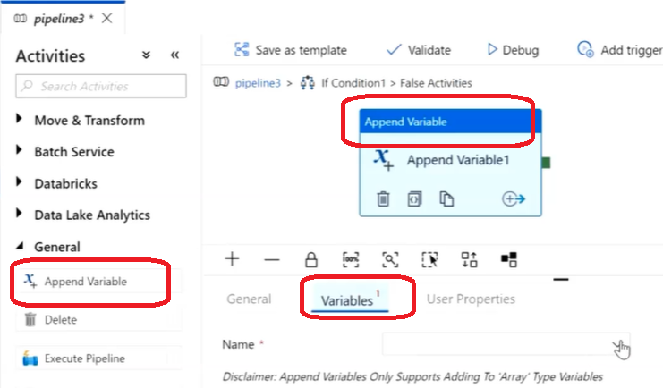

Set the Variable Value as,
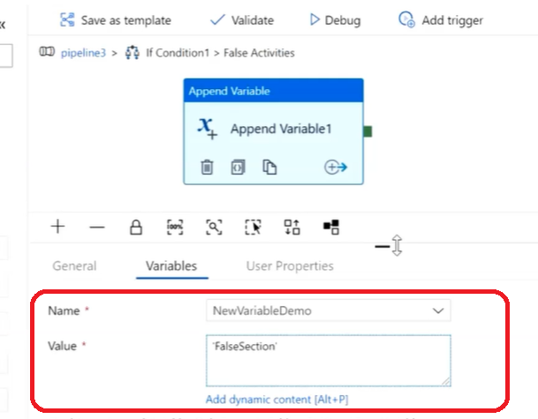

This variable can be further used in pipeline to do further calculations/conditions.

- Wait Activity :
