Cross Region Replication in AWS:
Cross region replication requires bucket versioning. We should enable versioning on the bucket before enabling cross region replication.
When doing cross region replication, we can,
- Copy the bucket to a different user account.
- Change the storage class of the replicated object.
- Change object ownership to destination bucket owner.

Example-1: cross region replication for buckets without versions (replication will not happen),
S3 console -> management -> Replication
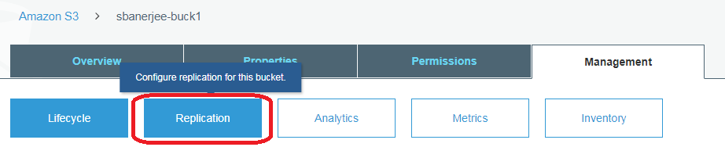
When hitting “Get Started”,
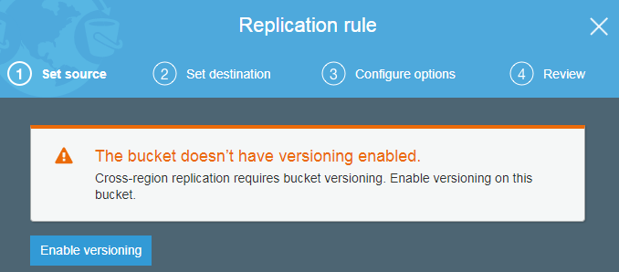
We can enable versioning using the “Enable Versioning”.
Example-2: cross region replication for buckets with versioning enabled.
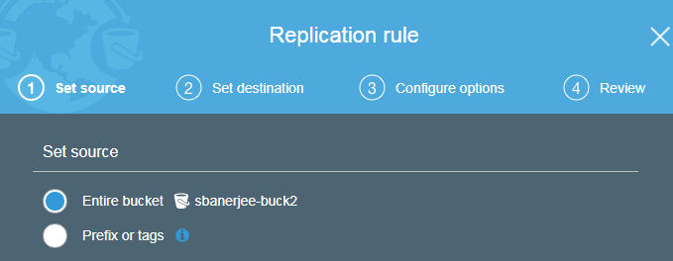
Click on “Create new bucket”,
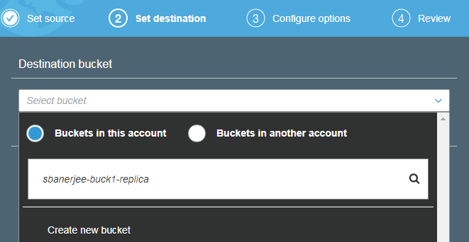
If you mention the same name as the source bucket, AWS will error as,
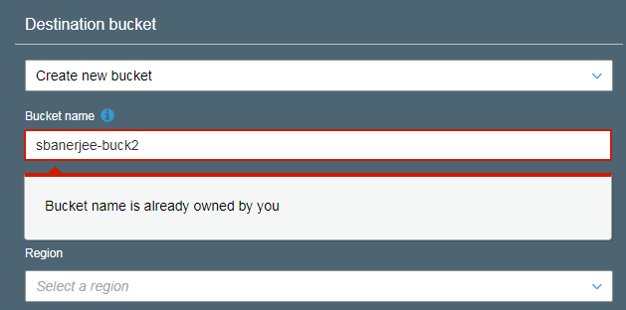
After mentioning a unique name and region,
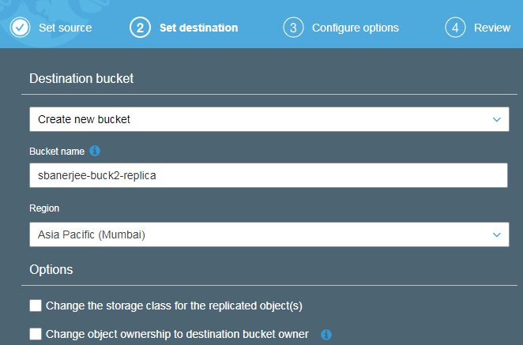
NOTE: AWS will not allow replication in the same region as source bucket.
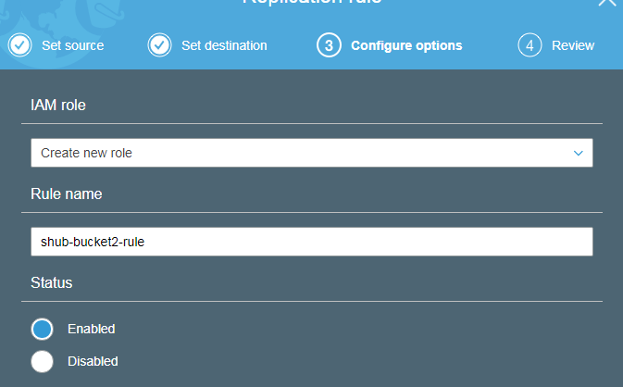
Next, review and hit “Save”
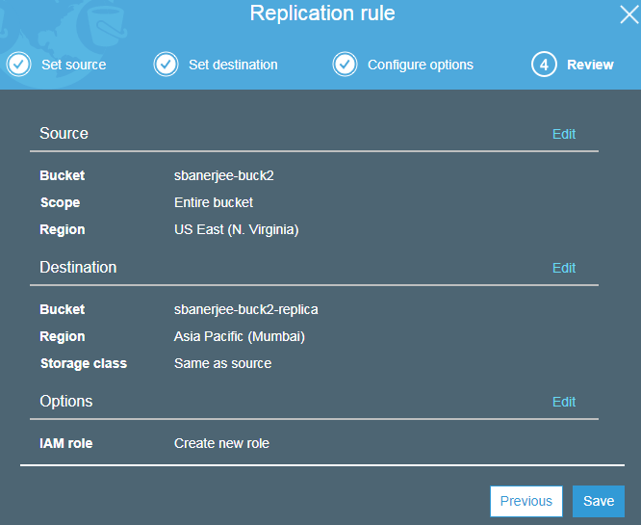
O/p:
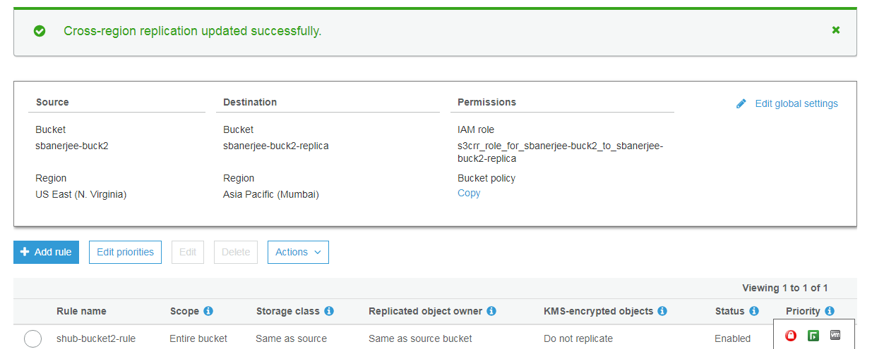

In S3 Console,
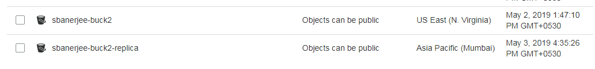
NOTE: Both source and destination buckets will have the same permissions.
But the replica (i.e. destination bucket) will not have the components within source bucket, as,
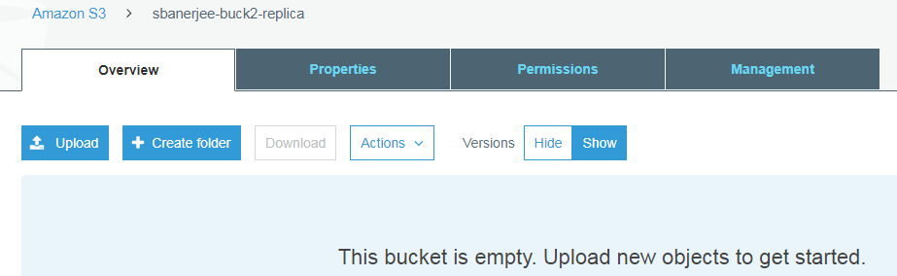
We will have to manually copy the objects between source and destination,
However, once cross region replication has been enabled on a bucket, all the new components will be automatically replicated between source and destination buckets.
In case of a delete operation on source bucket, the delete marker is not replicated in the destination bucket. This is true for both delete markers and when we delete a particular version.
Summary,
