Elastic BeanStalk

Elastic beanstalk is used by users who have no idea about AWS and want to create a word press site or provision a website. Such users do not have to go to cloudformation

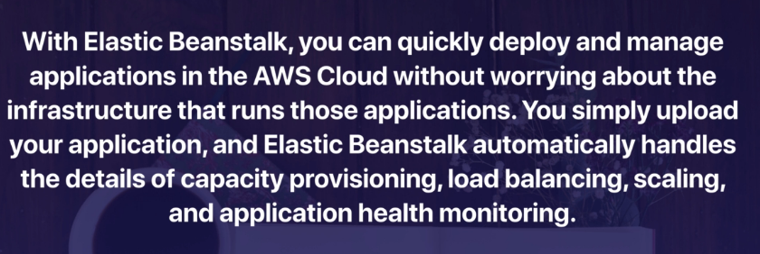

Elastic Beanstalk can be found under,
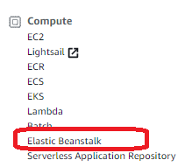

When clicked on Elastic Beanstalk, we get,
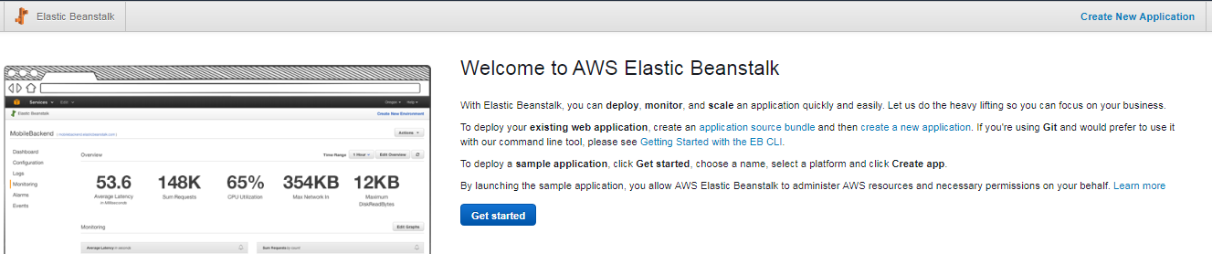

When we click “Get Started”, we can see,
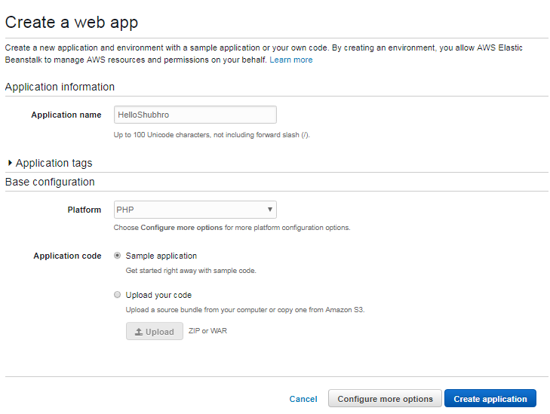
We can choose from Platforms,
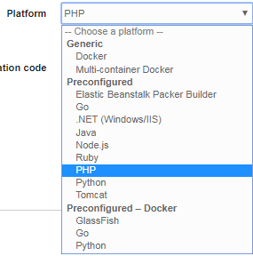

We chose PHP. Once done, click on “Create Application”.

We can see the env being created as,
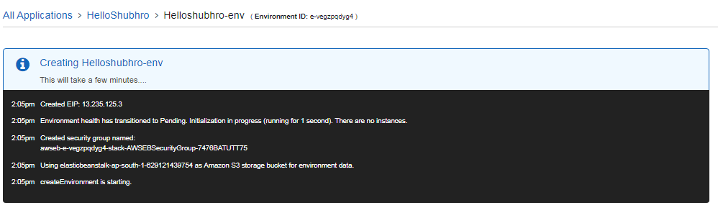
i.e. Elastic Beanstalk will provision AWS resources automatically. We just have to upload our code.

Once created,
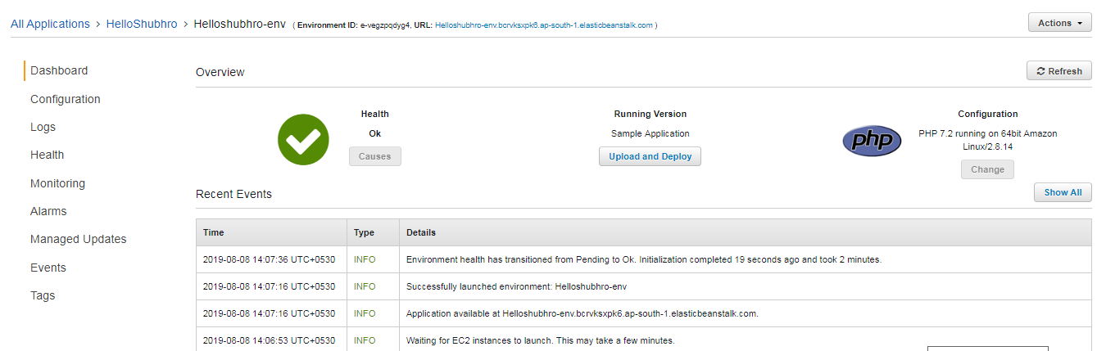

We can change the configuration on our env using the configuration tab,
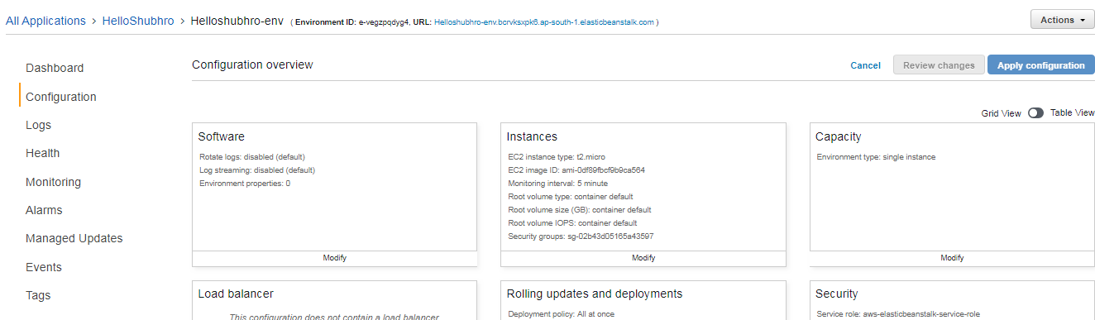

We can also view our env using the URL in the page,
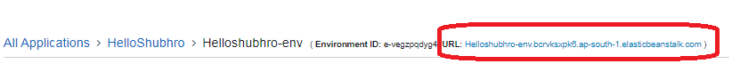
When we click on the URL,
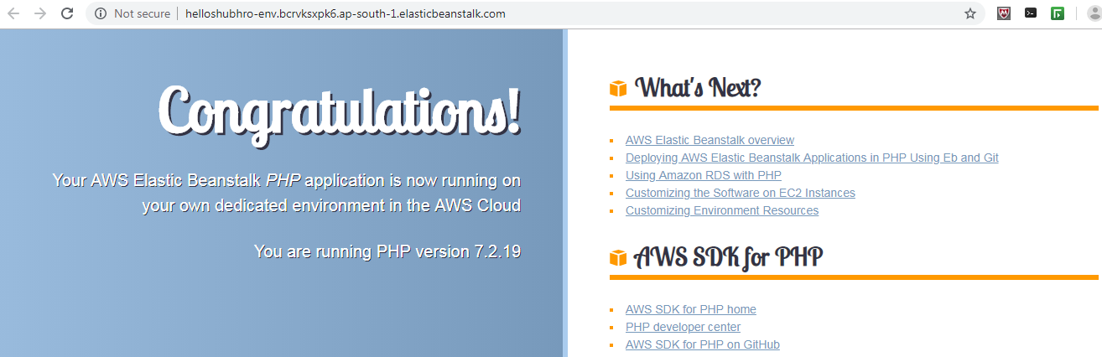

This is all we need to know for Elastic Beanstalk for the sake of exam.

To delete an Elastic Bean stalk environment, go to Actions -> Delete application,
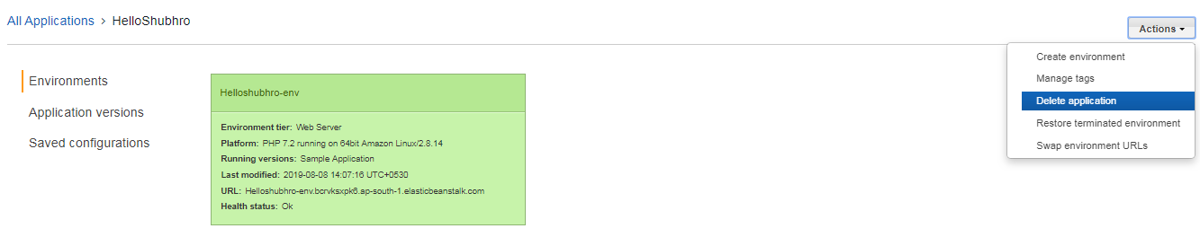

Once deleted,
