spring favors interface/class separation. Spring will provide the classes and coder can writr code with interfaces to implement the classes provided.
This concept is called wiring.

Tools required for Spring Application development:
Eclipse IDE
STS (Spring Tool Suite)
JAVA JDK > 6.0 version
JAVASE 8u45 JDK if using JAVA JDK 8.x version

Spring Framework Website: https://projects.spring.io/spring-framework/
STS: https://spring.io/tools/

SPRING can be run from ECLIPSE. STS IDE is a better tool to create SPRING applications.
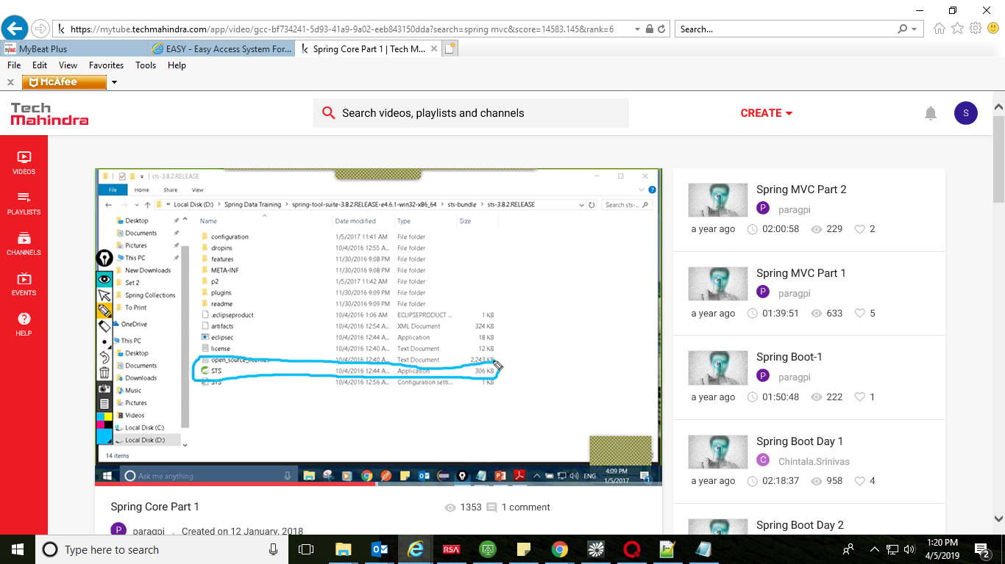

SPRING FRAMWWORK Release:
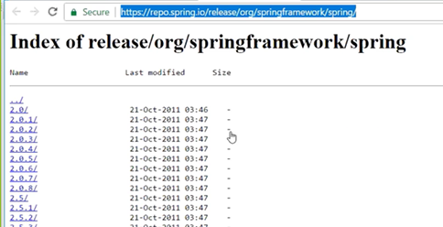

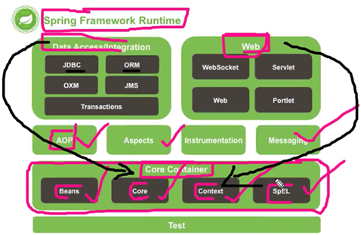

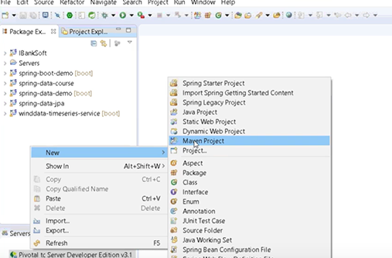

For SPRING BOOT project, use following:
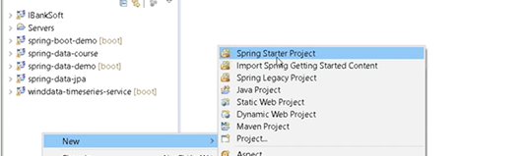

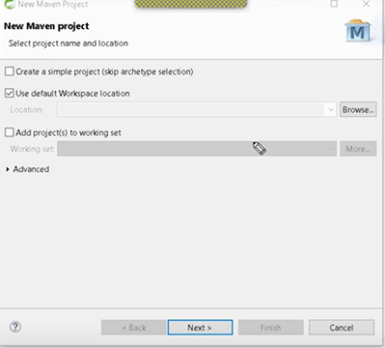
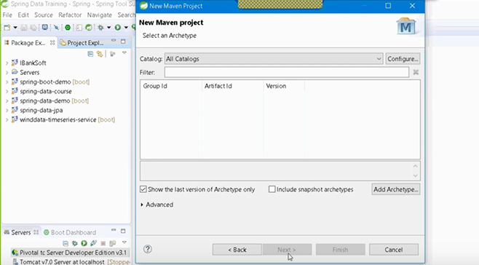
To create a core java maven template:
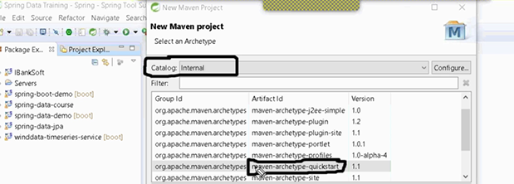

Group ID: package name (example : com.<>)
Artifact id : application name (example : bankapp)
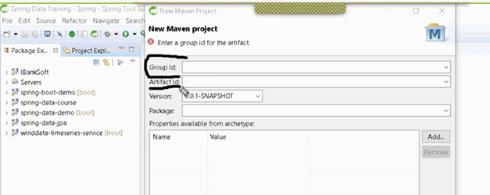
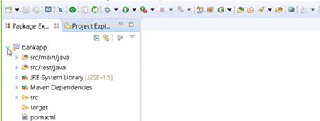
Here bankapp is a core java project (not spring)

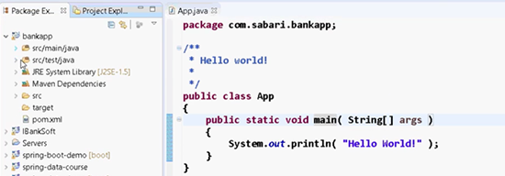
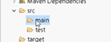
Within main we can create a resources directory which will contain property files and xml files.

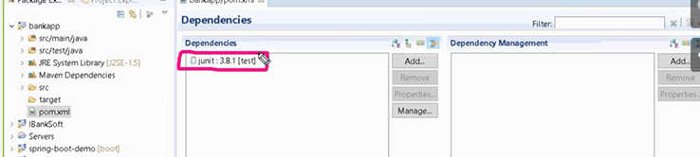
To include spring dependencies:
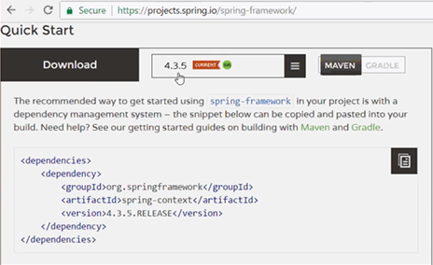
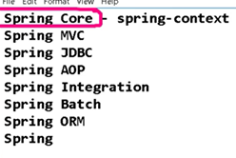
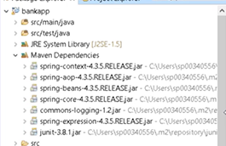
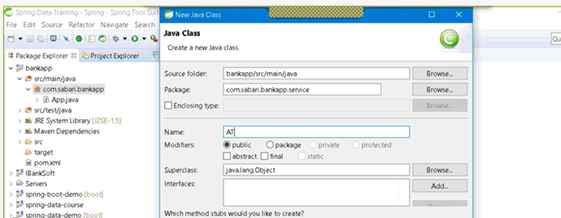
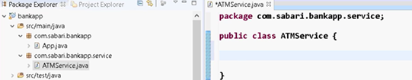

Program without Spring:
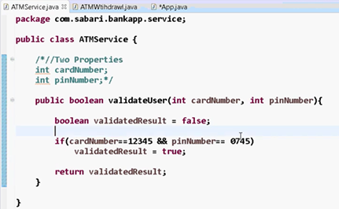
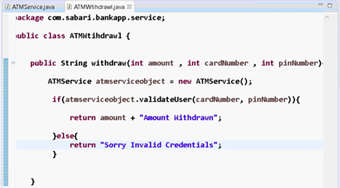
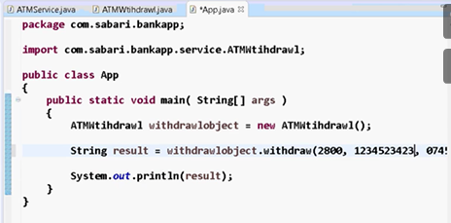
O/p:
