Simple Storage Service (S3):
S3 provides secure, durable, highly-scalable object storage (i.e. flat files like word document, pictures, movies etc). S3 provides a simple web service interface to store and retrieve any amount of data from anywhere on the web.
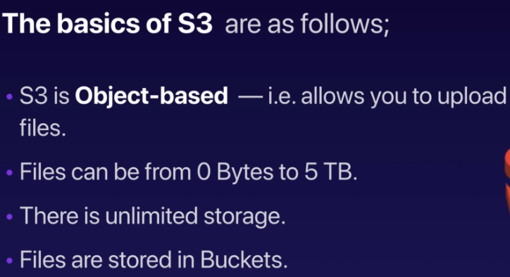
Buckets are folders that can be used to store files. Bucket names shoul;d be universally unique, because buckets are provided a web address i.e. https link. Example, https://s3-eu-west-1.amazonaws.com/acloudguru (where acloudguru is bucketname)
S3 is also not suitable to install OS on as it is object based storage. For OS, a block based storage is required. S3 is suitable for storing files.
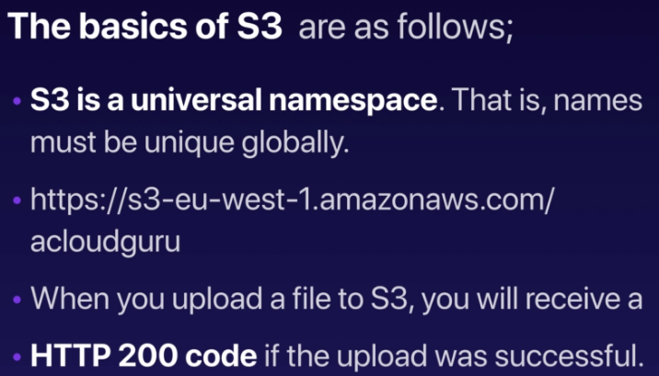
You can turn on MFA delete to protect objects for accidental deletion.
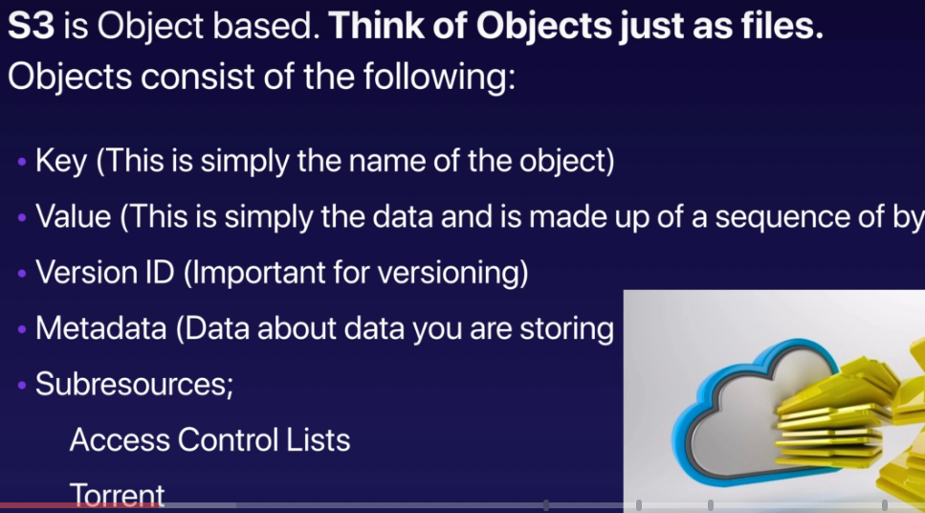
Permissions on the object. Can be at object level or bucket level.
S3 allows users to maintain multiple versions for the same filename which can be used.

Data consistency model for S3 i.e. how does data consistency work in S3:
- Read after Write consistency for PUTS of new objects i.e. if u upload a file to S3, you will be able to read it immediately
- Eventual consistency for overwrite PUTS and DELETES (can take some time to propagate) i.e. if S3 has a ver-1 of a file and ver-2 of the file is uploaded and if we immediately try to read the file, either V1 or V2 will be shown, but if we wait for some time (seconds), the latest version will come up. This happens only when we are overwriting or deleting a file, that eventual consistency is visible.

Amazon Guarantees following benefits for S3 storage,
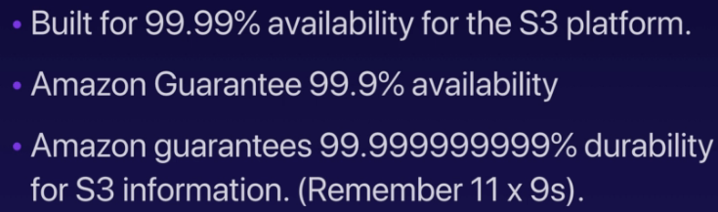

S3 Features,
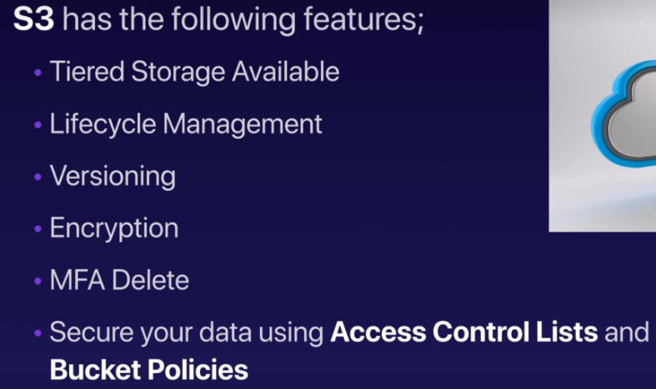
User needs proper permissions to delete a file.
If a file is 30 days old, we can move the file from one tier to another tier.

S3 Storage classes:
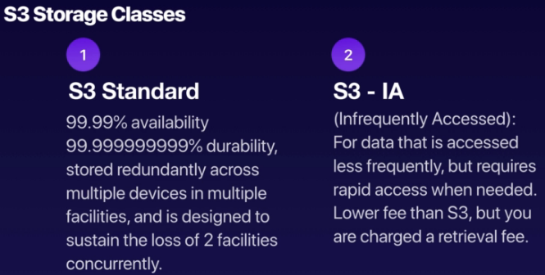
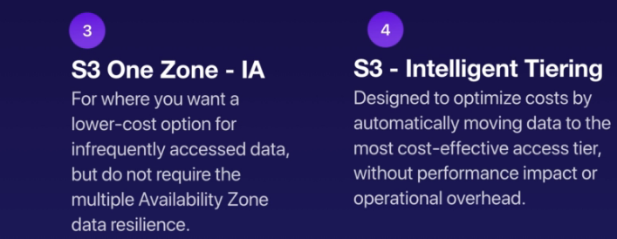
Also known as reduced redundancy storage (RRS)
Glacier has 2 flavors: glacier and deep archive. The difference is in cost and retrieval time.
The objects will be moved to different tiers depending on usage and will be coordinated by Amazon ML feature itself.
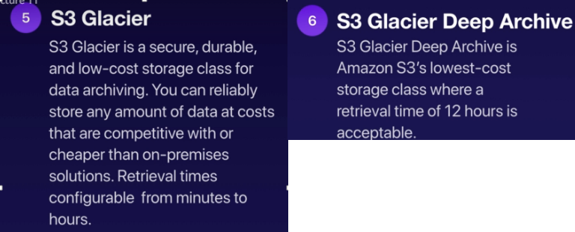
Storage class comparision,
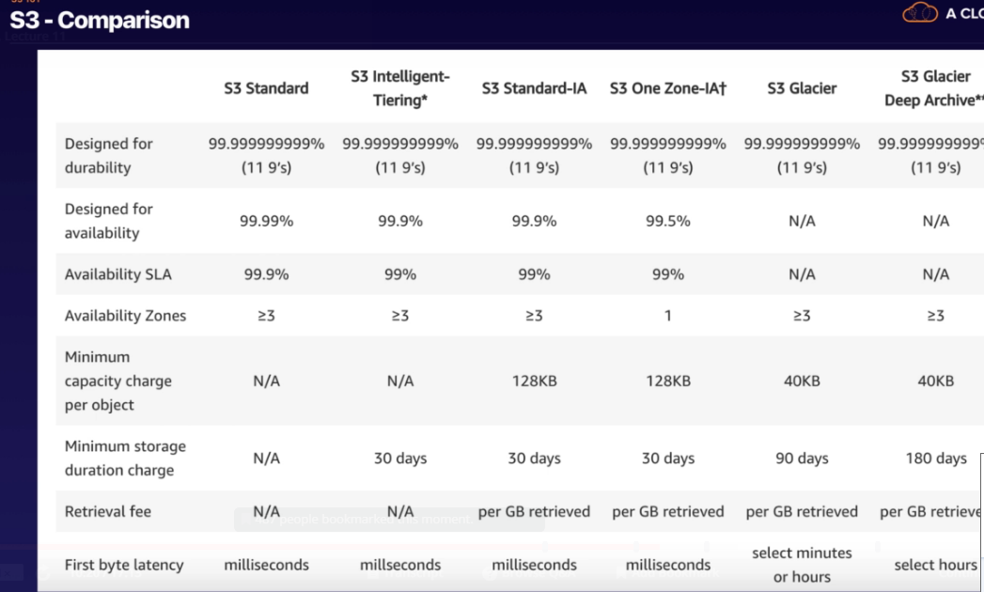

Ways you are charged in S3:
- Storage
- Requests
- Storage management pricing
- Data transfer pricing
- Transfer acceleration enables fast, easy and secure file transfers over long distance between end users and S3 buckets. TA uses Amazon’s cloudfront’s globally distributed edge locations . As the data arrives in an edge location, it is automatically routed to Amazon S3 over an optimized network path. i.e.
S3 bucket location
Edge location

User upload data to edge locations
- Cross Region replication pricing i.e. if this feature is enabled, then the data objects will be automatically replicated between different data centers for high availability and data recovery.

Creating a S3 Bucket:
- AWS Console -> Storage -> S3
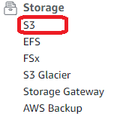
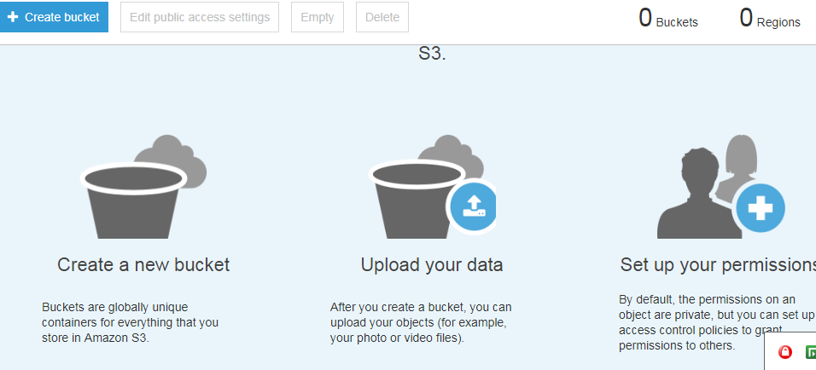

- To create a new bucket, click “create bucket” button,

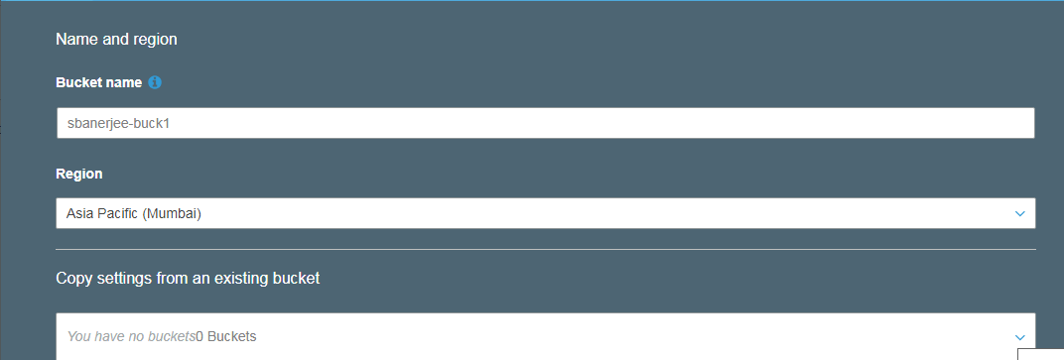

Next (Configure Options),
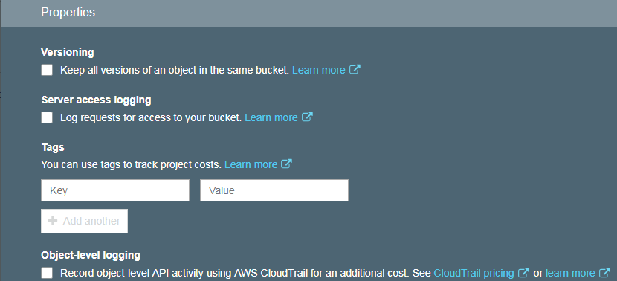

Next (Set Permissions),
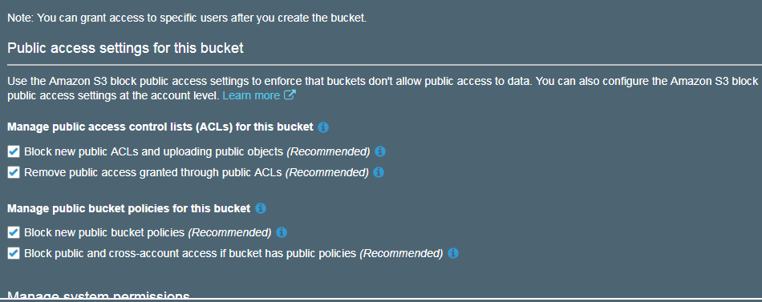
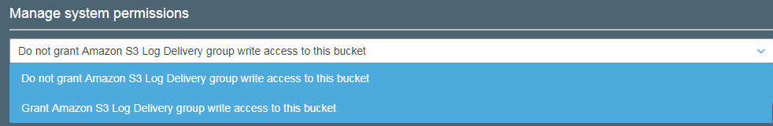

Next (Review),
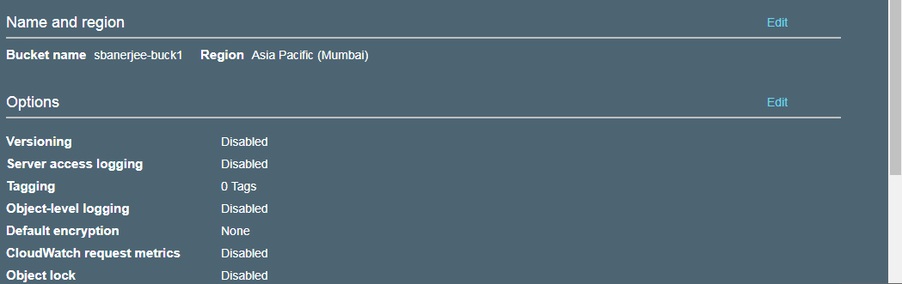

Create Bucket,
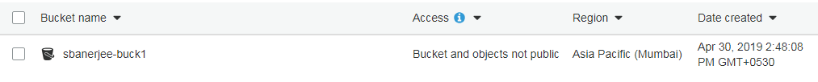

Upload files to the bucket created,
- On Amazon S3 console, click “Upload” button,
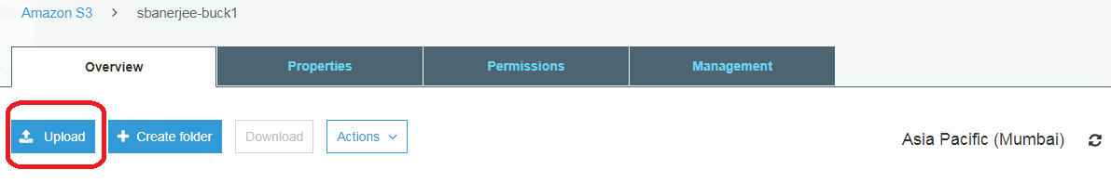

- Upload the files,
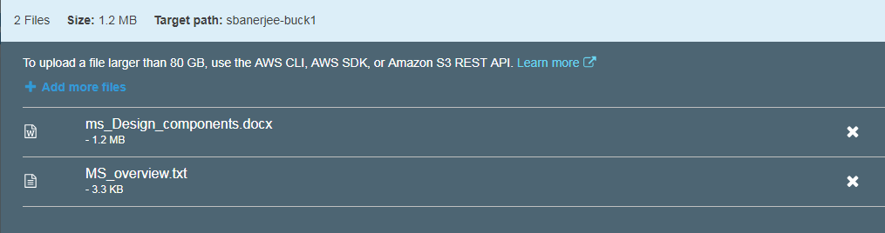

Press “Upload Button”,
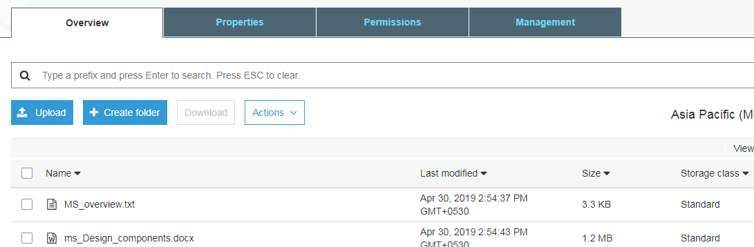

Access the files uploaded,
- Click on the checkbox against the object,
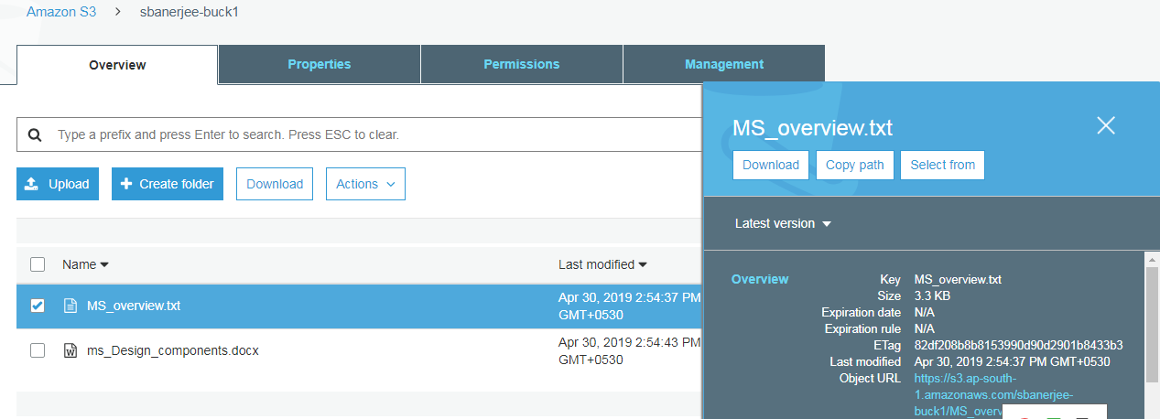
- Click on the “Object URL”,
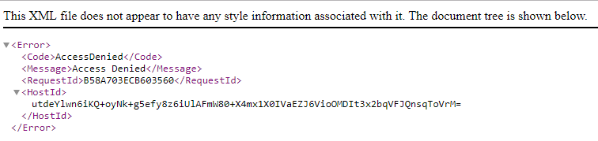

i.e. we get the error “Access Denied” as we have not made the Object as Public.

If we make the file (i.e. object) as Public,
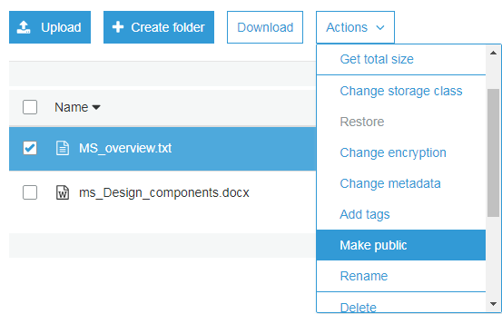

This operation fails,
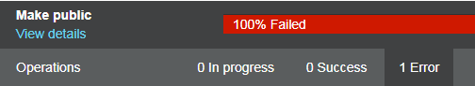

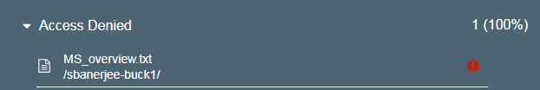

This is because the permissions at bucket level is not set.

To activate bucket level permissions, go to S3 console,
- Click on the checkbox against the bucket name,
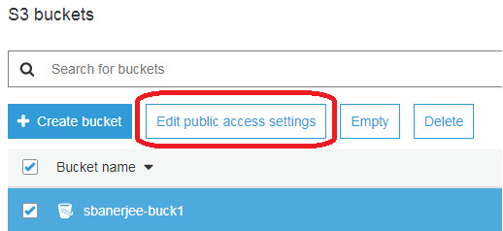

- Click “Edit public access settings”. By Default, “Manage public ACL’s for selected buckets” and “manage public bucket policies for selected buckets” sections are already UNCHECKED. Click “SAVE” button,
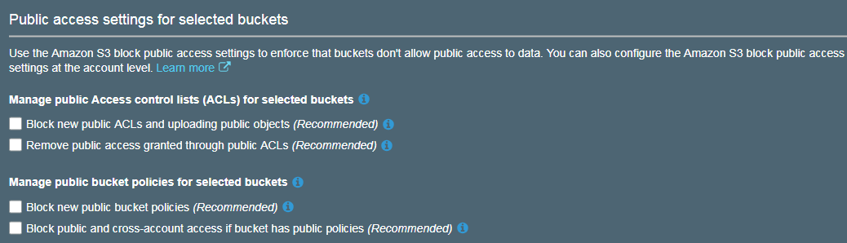

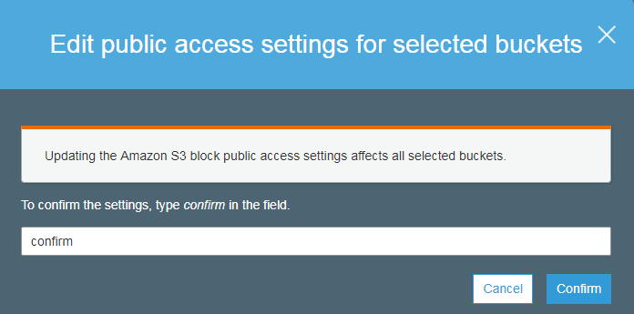

Press “Confirm” button.
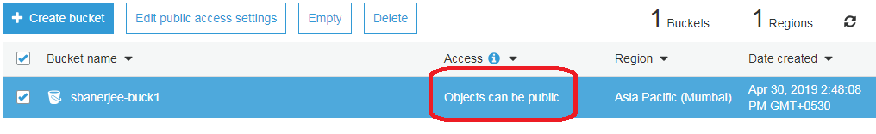

Not, if we again try to provide object level access,
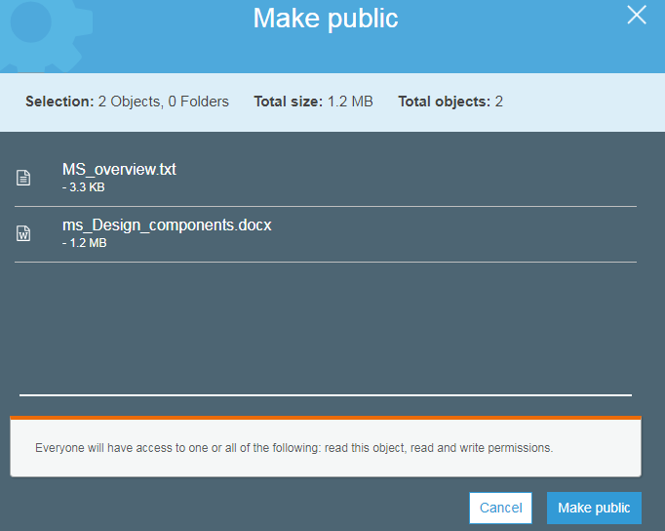

O/p:


Other Properties can be changed as,
- Changing storage class, click on Storage_class
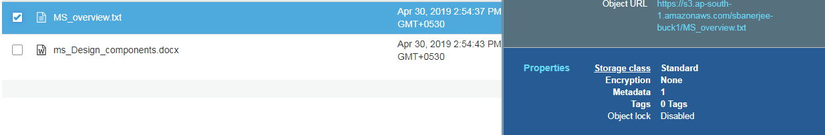

- We can select the storage class,
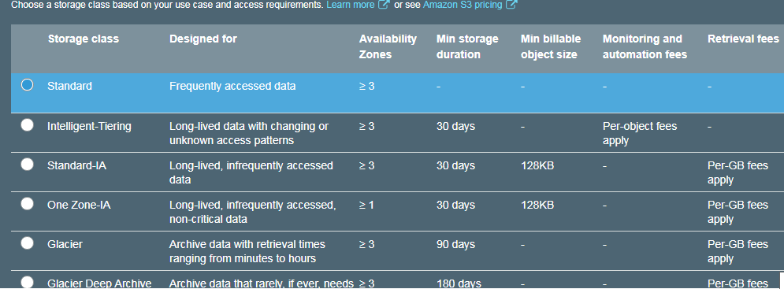

- This can also be done at bucket level. In Bucket level we have the following properties which can be used,
Within Permissions,
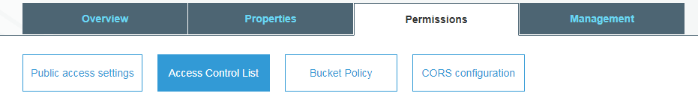
Implemented at bucket level, so the property will be implemented on all objects in the bucket.
Implemented at object level where we can provide access to one object but restrict access to other object.

Management,
