S3 Security and Encryption:
By Default, all the newly created buckets are PRIVATE. To set up access control on buckts, there are 2 ways,
- Bucket Policies, which apply on buckets.
- Access Control Lists which apply to objects within buckets.
S3 buckets can be configured to create access logs which log all the requests made to S3 Buckets. These logs can be sent to a different bucket residing within the same account or a different AWS account.
Encryption can be applied to 2 different kinds of data,
- Encryption in transit. For instance, if we are using a HTTPS:// URL, then the traffic is encrypted when transiting between user and server. Encryption in transit is always achieved by SSL (or TLS)
- Encryption at Rest i.e. encrypting the data that is being stored. For instance, if a word document is stored in harddisk and the harddisk is stolen, so is the data.

In Amazon, all the keys are managed by either,
- “S3 MANAGED KEYS” also known as SSE-S3 i.e. Server Side Encryption S3.
- AWS also provides AWS Key Management Service where the user and Amazon both manage the keys together. This is called MANAGED KEYS – SSE-KMS
- Server Side Encryption with Customer Provided keys. This will where the user provides the Amazon his own keys which the user manage. This is also called – SSE-C.
The other option is client side encryption where we encrypt the data before storing it in Amazon S3.
To Set Up Encryption On S3:
- Go To S3 Console -> Enter the bucket -> select the file
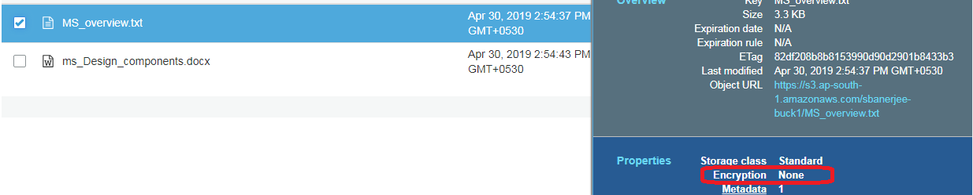

- Click on Encryption,
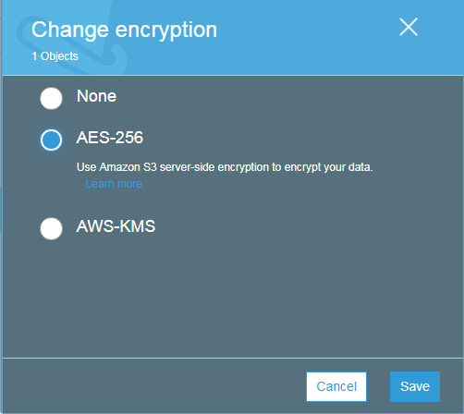

NOTE: AWS-KMS is out of scope for Solutions Architect. We will select AES-256 encryption on the file.

- Once Done, the file will show as encrypted,
