CONNECT THRU SSH From Chrome extension
STEP-1: Install google ssh extension,
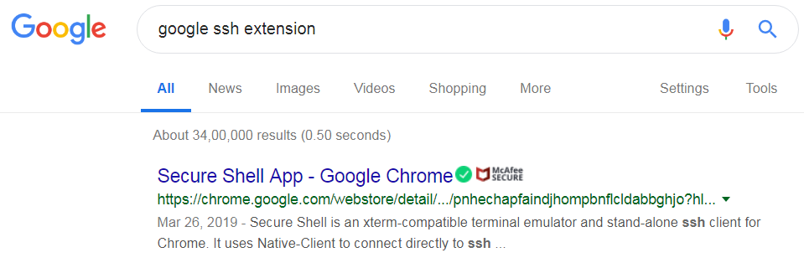
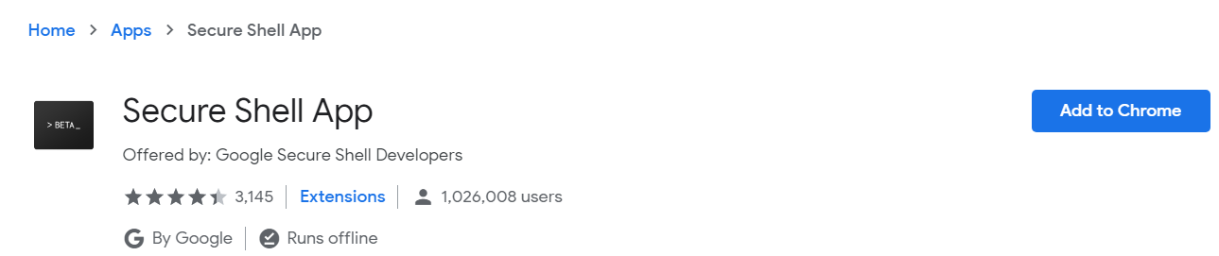
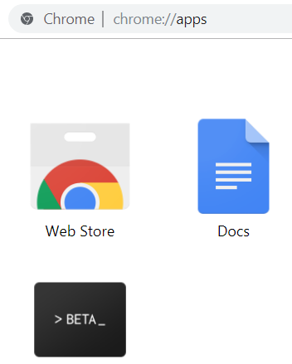

STEP-2: before opening the extension, we need to create the private (.pem) and public (.pub) key files
go to command prompt:
ssh-keygen -y -f shub-ec2-webservice1-key.pem > shub-ec2-webservice1-key.pub
this will create the public key
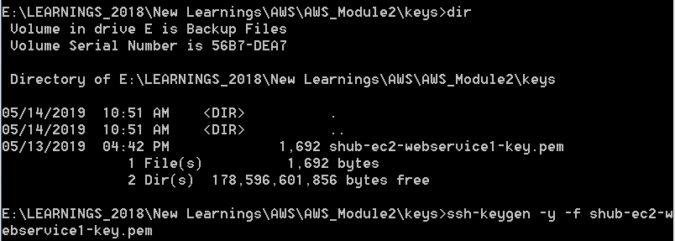
if you get this error, implies GIT is not properly configured
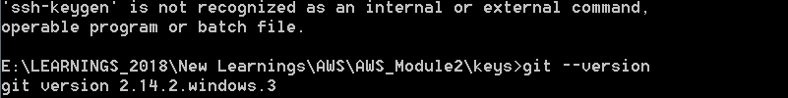
install git and use git bash to generate the public key (.pub file), as,
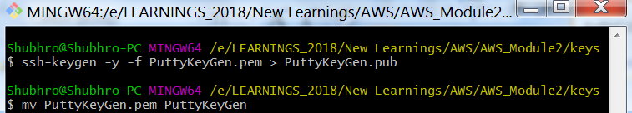
here,
1) generate public key
2) rename .pem file by removing the extension. example, rename PuttyKeyGen.pem to PuttyKeyGen

STEP-3 : Create the SSH Connection,
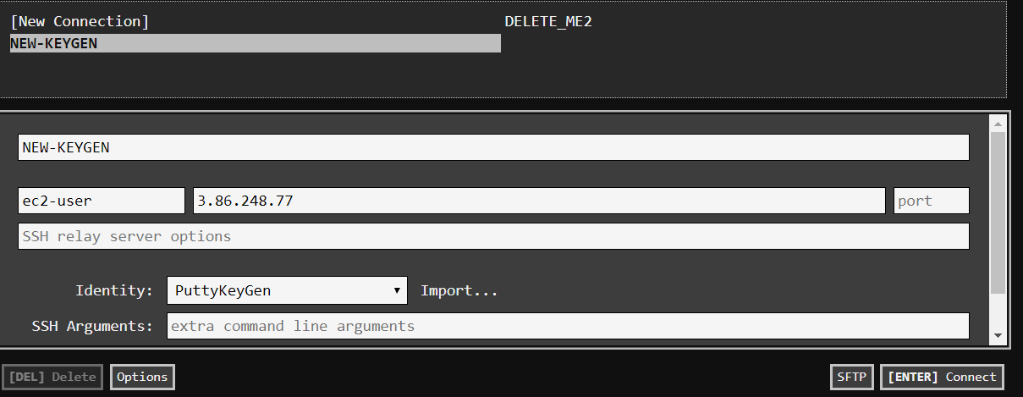
import both the file (after removing .pem extn) and the .pub file
provide a unique name. Override the default name i.e. ec2-user@3.86.248.77

Press the "Connect" button.

for error,
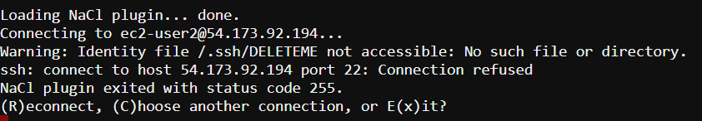
this is because PORT 22 is not open for all. So we go to AWS EC2 console -> Network & Security -> Security Groups,

then open 22 port for entire world i.e. 0.0.0.0/0
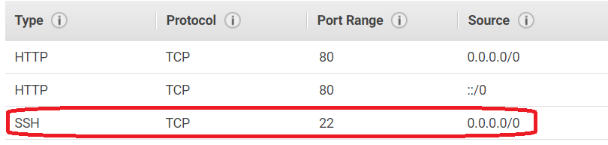
Then we can connect as,
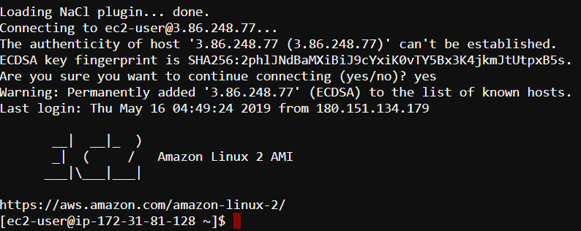

CONNECT THRU SSH From Chrome extension
For Putty, we have to install the putty.exe and puttygen.exe (https://www.putty.org/)
putty does not recognize .pem file, so we have to convert the pem file to a .ppx file.
Using Puttygen, create the private Key (.ppk file)
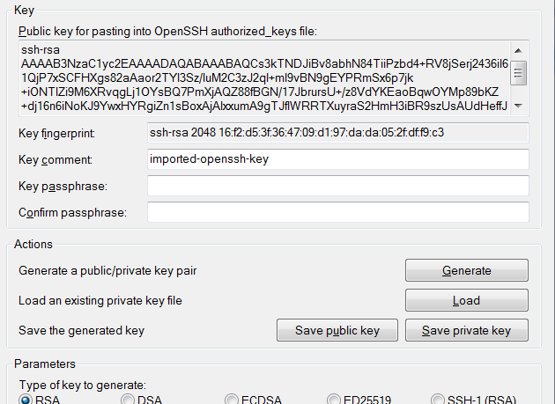
creates a SSH2-RSA type of key
creates the .ppk file
load the .pem file

Using the .ppk file, we will create a session in Putty.exe, as,
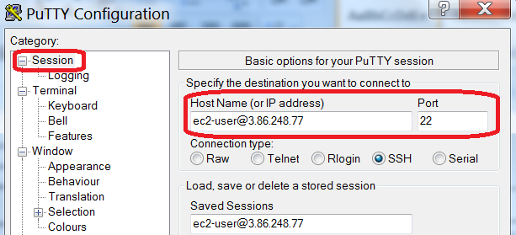

In Connection -> SSH -> auth
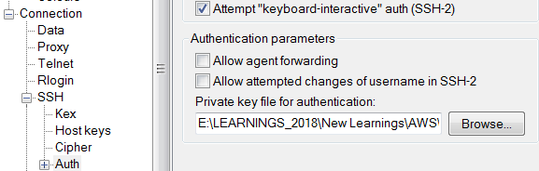
location of the ppk file

