**/ – The root directory**

Everything, all the files and directories, in Linux are located under ‘root’ represented by ‘/’. If you look at the directory structure, you’ll realize that it is similar to a plant’s root.

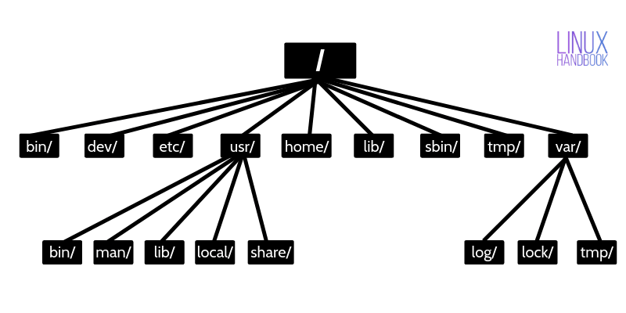Linux Directory Structure

Since all other directories or files are descended from root, the absolute path of any file is traversed through root. For example, if you have a file in /home/user/documents, you can guess that the directory structure goes from root->home->user->documents.