2. Product Backlog (Initial)
Epic | User Story | Priority | Notes
 | As a user, I would like to set up a profile for my clients so that I can add their nutritional data. | High
 | As a user, I would like to log food intake, so that I can track it. | High
Goal Summary | As a user, I want to set my daily energy goal | High | Users can define their daily energy target in either kilojoules (kJ) or calories (Cal).
Food Search Bar | As a user, I want to search for food items | High | Users can search for food items by name or category for quick selection.
Log Foods Component | As a user, I want to log what I eat each day | High | Users can select food items from the database and enter the quantity consumed to track daily intake
Daily Energy Summary | As a user, I want to view a summary of my daily energy intake | High | The app provides a daily summary of total kJ/Cal consumed based on logged food items.
Add Custom Food section | As a user, I want to add custom food items | High | Users can manually add new food items not found in the existing database for accurate tracking.
Intake vs RDI | As a user, I want to compare my intake to the recommended guidelines | Medium | Users can view how their intake compares to Recommended Dietary Intakes (RDI).
Save Daily Summary | As a user, I want to save my daily summary | Medium | Allows users to save their daily nutrition summary for future reference or progress tracking.

Daily Log | As a user, I want to log what I eat each day | High | Users can select food items from the database and enter the quantity consumed to track daily intake.
Register Account | As a user, I want to register an account | High | Users can register their account and add their initial profile details
Personal Profile | As a user, I want to create a personal nutrition profile | High | Users can enter personal information such as age, gender, weight, height, and any existing medical conditions (e.g., pregnancy) to personalize their nutrition experience.
Sign Out User | As a user, I want to be able sign out of my account | High | Users can use the sign out button from anywhere within the application while signed in to log them out and redirect them to the login screen
Nurse Management | As a nurse, I want to be able to manage my patients' diet and their profile. | High | Nurses can manage their patients diet and profile

User Stories:

- As a user, I want to register an account, so that I can save my information and track my nutrition over time.
- As a user, I want to create a personal nutrition profile, so that my intake recommendations are tailored to me.
- As a user, I want to set my daily energy goal, so that I can track my intake against a clear target.
- As a user, I want to search for food items, so that I can quickly find and log what I have eaten.
- As a user, I want to log what I eat each day, so that I can monitor my daily energy intake.
- As a user, I want to view a summary of my daily energy intake, so that I can see how much I've consumed throughout the day.
- As a user, I want to compare my intake to the recommended guidelines, so that I can see if I'm meeting my nutritional needs.
- As a user, I want to add custom food items, so that I can track foods not listed in the database.
- As a user, I want to save my daily summary, so that I can review my progress and habits over time.
- As a user, I want to be able to sign out of my account, so that I can keep my information secure when using a shared device.
- As a nurse, I want to be able to manage my patients’ diet and their profile, so that they can have a healthier lifestyle.

3. Project Outline
- Objective: Helping end users to manage their dietary goals and track their daily calorie intake. Also provide them summaries from their tracked progress.
- Scope (Inclusions/Exclusions): User information, food selection, calorie and nutrition summary, add custom food.
- Key Deliverables: Paper prototype, Figma board, Functional prototype, Final presentation.
- Constraints and Assumptions: Can’t be accessed offline, user knows personal BMI and relevant information, user has access to a mobile phone,
- Milestones / Timeline:
Zero Sprint (Pre-development)
Dates: By March 16, 2025

- Finalize Sprint Template
- Paper Prototype
- Figma Board
- Repository and branching strategy setup
- Architecture and tech stack agreed upon
- Local dev setup instructions written
- CI/CD outline

4. Architecture & Design
- Technology Stack: Firestore, Flutter, Firebase

- High-Level Architecture Diagram:

- Design Decisions: Minimalist UI. Color scheme and fonts. Calorie summary graph/visualisation.
- Integration Points: Importing Google's Firebase, FIrestore, and Auth libraries, using API calls to get, post, update and delete data. Push notifications are done by using Firebase Cloud Messaging.

5. Definitions
- Definition of Ready: The UI is built and matches the Figma design and is ready to begin development. (feature is ready but not tested)
- Definition of Done: The application is able to efficiently meet all the deliverables and success criteria.
- Acceptance Criteria Format: Against the outlined marking rubric blow, the feature and/or function must complete their designated task effectively.

Registering an Account

- Account is created with a valid email and password.
- User is notified if the email is already in use.

Creating a Personal Nutrition Profile

- Users can input and save age, sex, weight, height, and activity level.
- Saved profile data is pre-filled on return.

Set Daily Energy Goal

- Users can input and save a daily energy goal.
- Saved goal is displayed on the dashboard and used in summaries.

Search Food Items

- Users can search for food items by name.
- Search results display matching food items.
- Selected items can be added to the food log.

Log Daily Food Intake

- User can add a food item with quantity to today's log.
- Daily log shows all added items and aggregated energy total.

View Daily Summary

- Summary displays total energy intake vs daily goal.
- Visual indicators (e.g., progress bar) reflect consumption status.

Compare Intake to Guidelines

- Intake is compared to recommended daily intake
- Visual cues or tips are shown when values are under/over guidelines.

Add Custom Food Items

- Users can manually add a food with name, serving size, and nutrition.
- Custom food items are saved and reusable.

Save Daily Summary

- Daily summary can be saved to history.
- Users can view summaries from previous days.

Sign Out of Account

- Users can sign out and the session is cleared.
- Reopening the app requires login again.

6. Development Environment Setup
- Repositories Created: One.
- Branching Strategy: feature branch workflow
- Code Style Guidelines: Consistent naming conventions and commenting, descriptive naming, single responsibility, non repetitive functions and avoiding deep nesting. More context as follows in Medium - Mastering Flutter
- Local Developer Setup Instructions:
Clone the repo from the github link provided in the tools & infrastructure table below.
- git clone https://github.com/antoniomunro/iNutrition.git
- cd iNutrition
Install the dependencies required for the project.
- flutter pub get
Firebase Setup
- firebase login
- firebase init
Run the App
- flutter run
- (for web if supported)
  - flutter build apk –debug
Run Tests
- flutter test
Build APK (Optional for local testing)
- flutter build apk –debug

7. CI/CD Pipeline Setup
- CI Tool Chosen (e.g., GitHub Actions): GitHub Actions
- Build Scripts:
flutter pub get
flutter clean
flutter build apk --debug
- Deploy Targets: Android (Play Store), iOS (App Store), Firebase hosting.
- Status: In Progress

8. Test Strategy
- Unit Testing Framework:
flutter_test
- Used for testing individual Dart classes and widgets in isolation.
- Focus areas: input validation, state management, service logic.
- Integration Testing Tools:
Integration_test
- Simulates real user interactions and verifies complete app workflows.
- Will be used to test login, food logging, profile creation, and energy summary flows.
- Test Coverage Goals:
  - Target 80%+ coverage on core modules (e.g., food logging, daily summary, authentication).
  - Use flutter test --coverage to generate reports.
  - Visualize using tools like lcov or CI integration.
- Automation Plans:
  - Integrate unit and widget tests into the GitHub Actions pipeline for automated runs on every pull request.
  - Setup basic smoke tests on release builds.
  - Add Firebase Test Lab (optional) for device farm testing (especially if iOS is added later).

9. Tools & Infrastructure
Tool | Purpose | Access Info / URL
GitHub | Issue tracking | https://github.com/antoniomunro/iNutrition/issues
GitHub | Code repository | https://github.com/antoniomunro/iNutrition
Messenger | Communication | By invitation

10. 🗓 Sprint Planning Setup
- Sprint Length: 2 weeks
- Sprint Start Date: 2/03/2025
- Sprint Schedule / Ceremonies: Once every fortnight.
- Roles (Scrum Master, Product Owner, etc.):
Scrum Master - Antonio
Product Owner - Jesse
Lead Developer - Shubham

11. Other Artifacts
- Wireframes for UI Mockups
- ER Diagrams / Data Model Drafts
- Release Plan / Roadmap
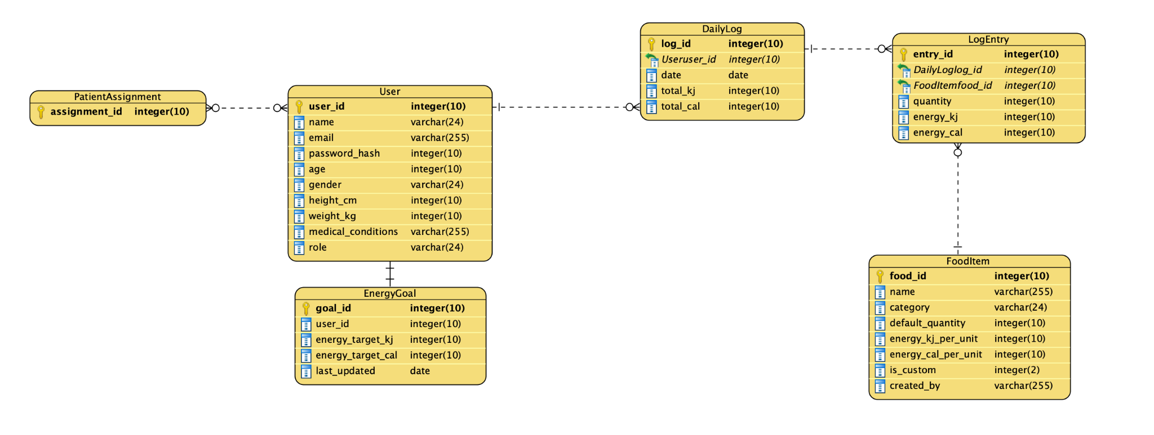
- Risk register
Risk Register

Risk Description | Likelihood | Impact | Severity | Mitigation Strategy | Owner | Status
Delays in account registration due to third-party service (Firebase) downtime | Medium | High | High | Implement retries and fallback mechanisms. Keep users informed about downtime. | Shubham | Open
Low user adoption or engagement after launch | Medium | High | High | Conduct a marketing campaign, utilize app store optimization, and gather user feedback to improve the app. | Antonio | Open
Bugs in logging food items or setting daily energy goals could lead to inaccurate tracking | Medium | High | High | Perform extensive testing (unit, integration, and manual) to ensure functionality works properly. | Shubham | Open
Data privacy issues, especially with sensitive user information (age, weight, etc.) | Low | High | High | Ensure compliance with GDPR or relevant privacy laws, implement data encryption. | Jesse | Open
Firebase authentication and authorization issues | Medium | High | High | Implement error handling and support for user recovery. Test thoroughly for edge cases. | Shubham | Open
User data loss during sign-out or system errors | Low | High | High | Implement proper session management, data backup before sign-out. | Shubham | Open

