THE INERNSHIP REPORT ON

“Keventer and Parle Agro ltd”

At

**Keventer Agro Ltd.**

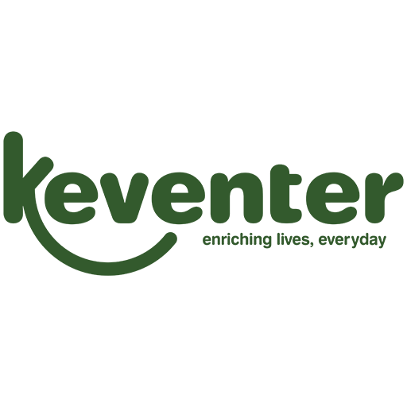

Shubrajyoti Deb

(20111347)

Under the Valuable Guidance of

Dr. Rohit Kumar Sharma

**Conducted By**

**School of Business and Management**

CHRIST (DEEMED TO BE UNIVERSITY)

Pune,Lavasa

2022-23

# **CERTIFICATE**

This is to certify that the project report, titled “Keventer and Parle Agro ”submitted to Christ (Deemed to be University), in partial fulfillment of the requirements for the award of the Degree of Bachelor of Business Administration, is a record of original research work done by Shubrajyoti Deb (20111347), during the period 2022 – 2023of his study in the School of Business and Management at Christ (Deemed to be University),Pune, Lavasa, under my supervision and guidance and the project report has not formed the basis for the award of any Degree/ Diploma/ Associate ship/ Fellowship or other similar title of recognition to any candidate of any University.

Prof. Rohit Kumar Sharma

Date:

Place: Pune, Lavas a

# 

# **Declaration**

I hereby declare that this project report titled “Keventer and Parle Agro” has been submitted by me for the monsoon internship programmed in BBA (Business Analytics as a partial fulfillment of this course.

This the result of the original work carried out be me. This report has not been submitted anywhere else for the award of any degree /diploma.

Name of the Student

Shubrajyoti Deb

Roll no: 20111347

Signature:

**Acknowledgement**

'’Knowledge is our expression of experience gained in life. It is the choiciest possessions that should be happily shared with others.”

I am grateful to Mr. P. Naha [ Sr Gm Hr./ Ire & Admin] who gave mee the opportunity to plan and this project on welfare facilities adopted in Keventer Argo Ltd.

I like to thank Mrs. Amrita Seal Mam on being my training guide and to helped me on my project. I’m very grateful to everyone who helped me during my training and provided me all the necessary information &under her guidance.1am able to complete my project on and about the company.

I shall remain grateful to Dr Rohit Kumar Sharma for his amble guidance and encouraging to give my best onto my report and giving me an opportunity to showcase on my internship work done so far.

# **Executive Summary**

Keventer Agro Limited is one of the major foods producing company of India. Trendsetters in food processing and packaged food industries with three decades of experience in numerous ventures, the Keventer Group has grown from strength to strength to emerge as one of the most respected corporate enterprises in India today. The Group today has a pan-India presence across three verticals - Food Processing, Steel, and Real Estate, spanning and building capabilities in each segment. Keventer currently employs around 1,100 people across services and facilities.

While the profound vision of Edward Keventer helped plant the seed more than 125 years back, it has been nurtured and carried forward by Mr. Mahendra Kumar Jalan, a visionary himself, and his team. Mr. Jalan was already a successful entrepreneur, trading in steel and structural, when the MKJ group took over Keventer in 1984, with the objective of providing good quality of life to the people.

Welfare helps in keeping the morale and motivation of the employees high so as to retain the employees for longer duration. The welfare facilities need not be in monetary terms only but in any kind/forms. Employee welfare includes monitoring of working conditions, creation of industrial harmony through infrastructure for health, industrial relations and insurance against disease, accident and unemployment for the workers and their families.

In this project I made data analysis and interpretation of parle product and gap analysis of B-Fizz which is another part of Parle product.

**Table of Content**

Chapter 1 – Introduction

1.1 Industry Profile

1.2 Company Profile

1.3 Vision, Mission, Goals, and Objectives of the Company

1.4 Products / Services offered by the Company

1.5 Major Competitors of the Company

Chapter 2 – SWOT / SWOC ANALYSIS

Chapter 3- leaning Experience

3.1 Literature Review

3.2 About Parle Agro Ltd

3.3 Data Analysis and Interpretation

3.4 Gap Analysis of B-Fizz

Chapter 4- SUGGESTIONS and CONCLUSION

4.1 Suggestion

4.2 Findings

4.3 Conclusion

CHAPTER 1

# **INTRODUCTION**

I had a brilliant preparation experience at the KEVENTER AGRO LIMITED refreshment fabricating plant. We stretch out our true appreciation to Mr. P. Naha, The Vice President-assembling, and Mr. G. Sahoo for permitting me to seek after preparing inside the organization. Specialist, Quality Manager, and all the other things for their important exhortation. Also, I would love to thank Mrs. Amrita Seal for helping us getting together with the report and day to day work

I likewise need to offer my genuine thanks to Mr. Sakanta Adhikari, the Quality Control Lab supervisor, and Mrs. Antrita Singha for giving their time and consideration regarding making the expected courses of action for our preparation. Our greatest wellspring of inspiration during our preparation period has been , who has taken colossal measures to assist us with getting past our challenges. I value the steady help from every one of the individuals throughout our preparation.

I'm likewise appreciative to Dr.Rohit kumar Sharma our coach at Christ University in Lavasa, Pune, who provided me the guidance I expected to get done with our course effectively. At last, I need to offer my thanks to my folks for their savvy direction during the preparation.

## **1.1 Industry Profile**

Most of the food ate by the total populace is given through a tremendous, global organization of different firms known as the food business. "Food ventures" alludes to various modern cycles that are utilized to create, disseminate, process, convert, get ready, safeguard, transport, ensure, and bundle food items. The assembling of food today is exceptionally different, going from minuscule, customary, family-run organizations that require a ton of work to gigantic, capital-serious, and vigorously motorized modern tasks. Various food organizations are generally reliant upon local horticulture or produce.

Tracking down a far-reaching way to deal with address each feature of food creation and dissemination is troublesome. Most of food created for the food business is produced using product crops using customary cultivating strategies. People produce 83% of the food they eat through earthbound farming.

One of the greatest reasons for a dangerous atmospheric devotion, overall horticultural result represents somewhere in the range of 14 and 28 percent of all ozone harming substance emanations. This is to a great extent due to conventional rural strategies including the utilization of nitrogen manures and deficient land the board.

The cycles and systems expected to transform natural substances into food planned for human utilization are alluded to as food handling. Creating attractive food things requires the usage of clean, gathered, butchered, or butchered parts.

## **1.2Company Profile**

**Name of the company:** Keventer Agro Ltd

**Number of Staff:** Around 500

**Year of Establishment:**1986

**Export Market:** Fruit BEVERAGES, Fruit Pulp, bakery ingredients

**OEM Provided:** No

**Membership:** EII, ICC

**Product Range:** Germany, Poland, Czech Republic, Greece, USA, Middle Eastern, Many South Eastern Countries

**Keventer Agro Limited Overview**

Keventer Agro Limited ( KAL), the flagship company of the Keventer Group, is engaged in fast moving consumer goods and Agri-related businesses. The company was established in 1989 as a franchisee for Parle Agro Pvt. Ltd. (PAPL), and is involved in the manufacturing and marketing of PAPL’s beverage (Frooti, Appy, Appy Fizz, Grappo Fizz, LMN and Bailey) and snack (Hippo) brands in Eastern India from its factory in Barasat, West Bengal. During the period 1990-2005, KAL was also packaging and distributing Dhara mustard oil on behalf of National Dairy Development Board (NDDB) in Eastern India. This business was subsequently discontinued and in 2006, KAL launched its own edible mustard oil under the brand name “Keventer’s Utsav “. In 2010-2011, KAL tied up with Apeejay Tea Limited to distribute and market Apeejay Tea’s brand, Typhoo Tea , in Eastern India . In 2011-2012, the company also tied up with ITC Limited for contract manufacturing of ITC’s Yippee Instant Noodles. Moreover, the company also diversified into commodity trading. kevenler Group finds its firm foundation in good quality products, indepth understanding of consumer needs and transparent business practices. It is synonymous with purity, quality and care leading to better life for more and more people. With extensive experience in food rind beverage industry company has brands like Metro Dairy, Frooti, Bailey mineral writer, and novel drinks like Appy and Njoi.

**1.3**

**Vision**

➢ We exist because our customers exist.

➢ To take pride in bringing value to their lives. This reflects our passion for

attaining excellence in our products and services.

➢ To create an environment where every Keventerian feels happy and committed to delivering their best.

➢ To be among the most preferred organisation to work for and deal with in the

country.

**Mission**

➢ Be a part of people's daily living by manufacturing and marketing food, beverages, agro-products, real estates and steel.

➢ Have significant presence in the chosen markets by becoming a leader in 5 years from now, in terms of brand image and market position.

➢Ensure that our market share in select product lines would be either No.1 or No2

➢Adopt state-of-the-art technology and environment- friendly practices in manufacturing and distribution of our products.

➢Be chosen by customers for high quality of our products, their availability and pricing.

➢Be one of the most trusted business houses for our associates where they shall enjoy their business relationship with us and share mutual growth.

➢ Ensure that our employees at all levels are constantly challenged to give their best and they shall find that working with Keventer is the most enriching experience. Their continuous training and development shall be outmost importance to the organisation.

# **Goal**

Within the next two to three years, Keventer Agro plans to launch enterprises selling frozen goods and milk in tetra packs around the country.

The Kolkata-based company plans to grow its sales by 10% to Rs 1,100 crore in the current fiscal year 2021–2022, up from Rs 1,000 crore in the previous fiscal year. A large portion of the revenue is anticipated to come from the frozen food and tetra pack milk industries. The management believes that they can build these two companies in India within the next two to three years: tetra pack milk and frozen goods.

# **Objective**

The business promotes the philosophy of gradually moving quickly while positioning oneself for success when it comes to entrepreneurship. The only entrepreneurs who are successful are those who play the long game. Having said that, contemporary Indian businesses are now integrating a dedication to expansion into their corporate cultures by encouraging a company-wide understanding of customer demands, making sufficient R&D investments, and dismantling rigid organizational structures. Consumers and businesses in India are becoming more and more empowered as access to and volume of information increases and they are better equipped to use it to make decisions. In order to serve these clients and generate profits, businesses are beginning to reevaluate their business models and competitive strategies.

# **1.4 Products of the Company**

Juice & Mineral Water:

Keventer group entered into a franchisee agreement with the food and beverage giant PARLE to manufacture, package, distribute and markets its well-known brands namely Frooti, Appy and Appy Fizz- mango and apple drinks and Bailley —the packaged drinking water.

Mango Pulp:

Alphonso with a warm sweet taste is sometimes pleasantly tart. This testiest fruit of India has a rich aromatic flavor an excellent source of vitamin A and C.

Guava Pulp:

Used mainly in beverage , Ice-cream and confectionary industries.

Fruit Jam, Jelly & Karonda:

Mixed fruit, mango, pineapple and flavored apricot.

Tutti Frutti:

Keventer Agro is the largest exporter of Glanced Papaya-Tutti Frutti from India.

Spices:

Black pepper, Indian green cardamom, nutmegs, red chilies, cumin seeds, fennel seeds, coriander seeds, peel dried Ginger.

**1.5 Major Competitors in the Market**

Keventer despite of its long-lasting suitability in the market and dominating most of the East India’s FMCG sector, its still poses a load of threat when it comes to competition with the other FMCG brand in India. Some of them are:

**Amul**

Amul is one such company who can give a good head-to-head toe with keventer. As Keventer has its own dairy farm comparatively known as ”*Metro*”. Even though, Metro is quite famous in states like West Bengal but not everywhere in India and on the other hand Amul is famous in entire India and has a huge market everywhere. Also, Amul market share has huge impact on ice-cream and sweet market which Metro do has but cannot be able to compete with Amul because of its low scalability.

**Any Frozen Food Beverage company(McVities or Goodej Foods)**

It is a no new significance that Keventer do have their own frozen food beverage which is quite famous in their regional sector ,but worldwide India they still lack the demand of the frozen taste as they cannot compete with the other competitors because of its low scalability and endurance towards the market.

**Staying under the regime of Parle Agro**

It must be a subtle ideology on why Parle who give their manufacturing hub to Keventer to produce their goods would be their main enemy. Well, it is been seen that Keventer are quite dependable on parle for the sale of their products mostly their drinks beverages products. As maximum of their revenue comes from Parle, their remains a threat that what if the partnership does come to an end and would end their most profitable business. So, their dependencies on Parle might also fall on a category of a huge burden to their business.

Chapter 2

**Swot Analysis of Keventer Agro Ltd.**

**Strengths**

* **Promoter with a long track record**

A promoter with extensive experience and a track record of success. Shri Mahendra Kumar Jalan (around 70 years old), the group's promoter and former Chairman, had diverse interests in steel, food processing, dairy, horticulture, real estate, and port sectors. However, he resigned from the board in January 2019, and his son has taken over as Chairman of the group. Shri M. K. Jalan (son of Shri M. K. Jalan), KAL's MD, is a graduate of the London School of Economics and has been spearheading the company's expansion plans since 2004. KAL has been in business for over three decades and is a well-known brand in Eastern India.

* **Diverse revenue profile**

KAL is diverse in several areas, including beverages, milk and milk products sales, fruit pulp and banana trading, rental revenue, and income from employment activities. The dairy and beverage segments account for roughly 40% and 35% of overall income, respectively.

* **Established market network**

In Eastern India, KAL has a strong distribution and marketing system. It has a network of over 35 super distributors, 700 distributors, and 110,000 stores that covers practically the whole region. This extensive network has been affiliated with the organization for several years, has been steadily developing, and is one of its fundamental strengths. Pasteurized milk and curd are distributed mostly through distributors and retailers in Kolkata and its surrounding areas, including North 24 Pargana, South 24 Pargana, Howrah, Hooghly, Midnapore, Bardhhaman, and Birbhum. The ice cream is distributed by distributors throughout West Bengal and in other states like Sikkim, Bihar, Odisha, Jharkhand, and Bhutan.

* **Exceptional performance in recent years**

KAL's operating income, albeit lowered to around Rs 833 crores in FY21 from Rs 949 crores in FY20 due to pandemic-related issues, remains on a reasonable scale. The aggregate PBILDT margin remained at 6.4 percent in FY21.

Furthermore, the company recorded TOI and PBILDT of Rs 519.94 cr and Rs 38.32 cr in H1FY22, respectively. Year on year, performance in H1FY22 has improved. In the PBILDT margin, KAL has also increased the MRP of its products over the period to reflect the increase in raw material prices. to make it available to customers. However, SMP prices have fallen from their highs in the current year.

**Weakness**

* **Reduced capacity utilization**

Due to underutilization of additional capacity in FY20, fruit juice capacity utilization (CU) decreased from 81 percent in FY19 to 72 percent in FY20. However, the volume of fruit juice produced rose year over year. In comparison to FY19, CU for milk and ice cream remained constant in FY20. The CU of all products was impacted in H1FY21 due to decreasing demand caused by the COVID-19 epidemic.

* **Dependence on Parle**

Around 35% of KAL's TOI is earned by the bottling of fruit juice and water for the brands Frooti, Appy, Appy Fizz, and Bailey (franchisee of PAPL). PAPL consistently introduces innovative products, differentiators, and refreshers and expands its reach and distribution to maintain market share and profitability as the focus on health and the growing popularity of fruit juice grows.

As a result of these items, several established FMCG businesses have launched products with comparable positioning to the current market players. As a result of increased competition, PAPL must increase its advertising and marketing spending while also innovating in terms of packaging and introducing new products to maintain its brand and market position.

* **Instability of profit margins due to volatile input prices**

KAL's profitability is vulnerable to changes in input costs, and it has limited ability to pass on such increases to buyers in both the fruit juice and packaged drinking water segments. PAPL determines the MRP of these products in order to sustain and retain growth by avoiding frequent price adjustments. However, in the event of a considerable increase in raw material prices, PAPL, in consultation with its franchisees, raises prices appropriately, which it passes on to the client.

In the dairy industry, raw material prices for skimmed milk powder (SMP) have been extremely unpredictable in recent years.

In FY20, there was particularly strong growth. This resulted in a large increase in raw material prices, resulting in deterioration.

**Opportunities**

* **New products**

Keventers is eyeing to enter into restaurant and qsr sector. Also, Keventers is looking to enter the real estate sector.

* **Smoodh Production**

Smoodh and other Parle products will increase revenue for Keventers Agro. Keventers Agro gets the job work of new products, which in turn means higher revenues for the company.

**Challenges**

* **Competiton**

Increasing competition from other companies reduces the demand and thus the production targets for Keventers Agro. This reduces revenue.

* **New entry of competitors**

The entry of companies like Amul and Mother Diary into the milk sector increases the competition for the Metro brand of Keventers Agro. The market share of Metro will be affected by this.

* **Procurement of raw materials**

Procurement of raw materials from different suppliers and sources will always be a challenge for Keventers Agro. As they operate in the manufacturing of food products, the raw materials are extremely volatile and their price depends a lot on the amount of rain received in the particular area. This makes the procurement of raw materials a tedious job.

**Chapter 3**

**LEARNING EXPERIENCE**

Through the Journey we got to know a brief idea about the company and its function and how the company works accordingly. Now its time to get understand the ,main component of the part of the company where they are getting most of their profit accumulated through selling drink beverages of Parle.

### **3.1 Literature Review**

Research on the study of "Keventer and Parle Agro and its impact on their products sales with special reference to Keventer Agro Ltd", Barasat. The main objective of the research is to study and examining the target, production and despatch of their products in the market. Data collected through observation, interviews with Hr manager and getting to know the whole procedure from MIS department. Concluded that safety training programme and provisions of safety equipment’s keep the work moving.

Excellent leave facilities to workers are provided to meet their requirements. Provision of provident fund, gratuity, and pension schemes allows the workers to spend their retirement in much better way. Welfare services are helpful in maintaining workers moral and health good. Company is provided medical facilities for families. Most of workers are unable to fulfil their habit of reading because of inadequate time that's why company provide rest room and keep some books for them. Accident insurance scheme is beneficial to workers. Payment for days in which workers remained absent due to accident are being paid by the company. Through credit society financial problems with the regards of purchasing essential commodities are to be solved. Company is providing interest free loan to workers.

From this Report we are going deep analysis of how many of parle products get into the market with proper consideration and how many does get involve towards its vitality and also, we are going to see the Gap analysis of B-fizz a subsidised product of Parle and its impact on the market along with some information about Parle and the company and its strategy in the future market.

### **3.2 About Parle Agro Ltd**

Parle Agro, a pioneer in the Indian beverage industry, has been creating innovative products and iconic brands since 1985

Headquartered in Mumbai, with over 4000 employees, Parle Agro is the largest Indian beverage company.

The strength lies in establishing new categories, building brands and capturing market share within those categories. Our bevy of brands include Frooti, Appy, Appy Fizz, BFizz, SMOODH, Bailley, Bailley Soda, Dhishoom and Frio.

They have always been passionate about building our own brands. We like to create, and we like to nurture what we create. Fueled by innovation that is engrained in the business DNA, our focus and vision is making Parle Agro, the No.1 beverage company in India.

### **3.2.1History of the company**

Parle Agro is an offshoot of Parle Products, which was founded in 1929 in British India. It was owned by the Chauhan family of Vile Parle, Mumbai. The original Parle company was split into three separate companies owned by the different factions of the original Chauhan family:

* Parle Products, led by Vijay, Sharad and Raj Chauhan (owner of the brands Parle-G, Melody, Mango Bite, Poppins, Kismi Toffee Bar, Monaco and Krack Jack)
* Parle Agro, led by Prakash Chauhan and his daughters (owner of the brands such as [Frooti](https://en.wikipedia.org/wiki/Frooti) and Appy)
* Parle [Bisleri](https://en.wikipedia.org/wiki/Bisleri), led by Ramesh Chauhan

All three companies continue to use the family trademark name "Parle".

Parle Agro commenced operations in 1984. It started with beverages, and later diversified into bottled water (1993), plastic packaging (1996) and confectionery (2007). [Frooti](https://en.wikipedia.org/wiki/Frooti), the first product rolled out of Parle Agro in 1985, became the largest selling mango drink in India.

The original Parle group was amicably segregated into three non-competing businesses. But a dispute over the use of "Parle" brand arose, when Parle Agro diversified into the confectionery business, thus becoming a competitor to Parle Products. In February 2008, Parle Products sued Parle Agro for using the brand Parle for competing confectionery products. Later, Parle Agro launched its confectionery products under a new design which did not include the Parle brand name. In 2009, the Bombay High Court ruled that Parle Agro can sell its confectionery brands under the brand name *Parle* or *Parle Confi* on condition that it clearly specifies that its products belong to a separate company, which has no relationship with Parle Products.

## 3.2.2Parle Agro brands

Parle Agro Pvt. Ltd operates under three major business verticals:

**Beverages** – fruit drinks, nectars, juice, sparkling drinks

**Water** – packaged drinking water

**Foods** – confectionery, snacks

Parle Agro also diversified into production of PET preforms (semi-finished bottles) in 1996. Its customers include companies in the beverages, edible oil, confectionery and pharmaceutical segments.

**Beverages**

**Frooti**

Launched in 1985, Frooti was India's only beverage sold in a Tetra Pak packaging at the time. It went on to become the largest selling Mango drink in the country. Frooti's website has some Frooti mocktail recipes on their website.

**Appy**

Appy Classic was launched in 1986 as an apple nectar and originally available in a white Tetra Pak packaging with an apple and leaf graphic. As of 2011, it comes in black Tetra Pak packaging. It was the first apple nectar to be launched in India.

**Appy Fizz**

Launched in 2005, Appy Fizz is India's first sparkling apple drink available in a champagne shaped PET bottle.

**Saint Juice**

Launched in 2008, Saint Juice is available in three variants – Orange, Mixed fruit, Grape and Apple. At the time of its launch, its USP was "100% juice with no added color, sugar or preservatives".

**LMN**

LMN was launched in March 2009, as non-carbonated lemon drink (nimbu paani or lemonade).

**Grappo Fizz**

Launched in 2008, Grappo Fizz is a sparkling grape juice drink. Grappo Fizz is along the lines of Parle Agro's existing product Appy Fizz.

**Dhishoom**

In 2012, Parle Agro launched India's first Jeera Masala Soda, Dhishoom.

**Frio**

Frio is a range of flavoured carbonated drinks. It is currently available in 3 flavours – Lemon, Orange, and Cola.

**Cafe Cuba**

Launched on 19 May 2013, Cafe Cuba is a carbonated Cuban coffee, more of a bottled Espresso.

Flavour: Strong Coffee with little sugar.

**Bailley Soda**

Launched in 2010, Bailley Soda has its packaging theme inspired by military colours and also the bottles are shaped like a grenade.

**Frooti Fizz**

Launched in March 2017, Frooti Fizz is a sparkling mango juice drink. Bollywood actress Alia Bhatt signed a deal with Parle Agro to endorse the product. Frooti Fizz is available in 250ml PET bottle, 500ml PET bottle and 250ml can.

**Water**

Parle Agro have launched Bailley packaged drinking water.

It has also introduced pouches of drinking water.

Food

Confectionary

**Mintrox mints** (launched in 2008), hard mint sweets available in 2 flavours.

**Buttercup sweets** (launched in 2008), hard boiled sweets.

**Buttercup Softease,** a toffee available in 4 flavours.

**Softease Mithai,** a toffee available in 3 flavours.

**Kaccha Aam**, a toffee.

**Snacks**

**Hippo** (launched in 2008), baked snack available in six flavours.

Hippo Namkeens is an assortment of traditional snacks from various parts of India. Hippo Namkeens is available in a range of seven traditional Indian snacks: Aloo Bhujia, Chana Dal, Moong Dal, Sev Bhujia, Masala Peanuts, Khatta Meetha, and Navratan Mixture.

*(Among all those products displayed Appy, B-Fizz, Frooti, Smoodh and Café Cuba were the products that are produced in Keventer Agro Ltd.)*

**3.2.3Parle Financial Overview**

Parle Agro Private Limited is an unlisted private company incorporated on 26 December, 1985. It is classified as a private limited company and is located in Mumbai, Maharashtra. Its authorized share capital is INR 15.00 cr and the total paid-up capital is INR 8.20 cr.

Parle Agro Private Limited's **operating revenues range is Over INR 500 cr** for the financial year ending on 31 March, 2021. It's **EBITDA has decreased by -3.35 %** over the previous year. At the same time, it's book net worth has increased by 20.88 %.

**3.3Data Analysis and Interpretation**

Question 1

What is the total Pet Bottle target, production and Despatch in the year 2021?

Graph 1

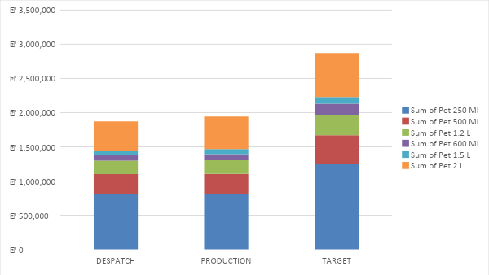

***(Total pet bottle sales of APPY, FROOTI and B-FIZZ in 2021)***

**Interpretation**

This data shows the number of pet bottle sold among the parle agro products. We can see that 250 ml of pet bottle has the highest sale and 600 Ml bottle has the lowest sale of Parle agro products. What’s really surprising is that 1.2 litres of bottle and litres of bottle has best sales better sales than 600 ml bottle.

Question 2.

What is the Target, Production and Despatch of Appy Fizz Tpk?

Graph 2.

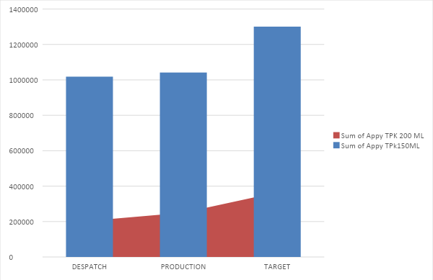

***(This data shows the total despatch, production and Target for Appy Tpk in the year 2021)***

**Interpretation**

This data shows the TPK sales of Appy fizz. Over here we can clarify that 150 ml of TPK of Appy has more stronghold in the market than 200 Ml of TPK of Appy. Which proves that people preference is more on the 150 ml TPK than on 200 Ml TPK.

Question 3

What is the Target, Production and Despatch of Frooti Tpk?

Graph 3

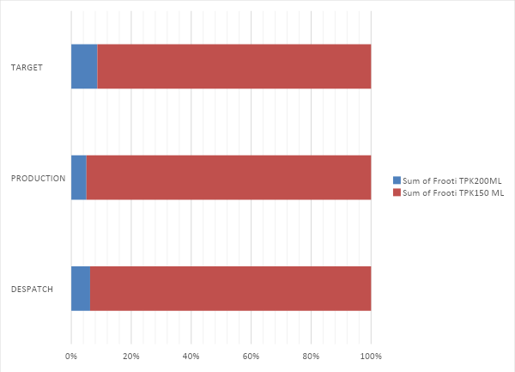

***(This data shows the total despatch, production and Target for Frooti Tpk in the year 2021)***

**Interpretation**

This data shows the TPK sales of Frooti . Over here we can clarify that 150 ml of TPK of Frooti has more stronghold in the market than 200 Ml of TPK of Frooti. Which proves that people preference is more on the 150 ml TPK than on 200 Ml TPK.

Question 4.

Monthly sales in the year 2021

Graph 4.

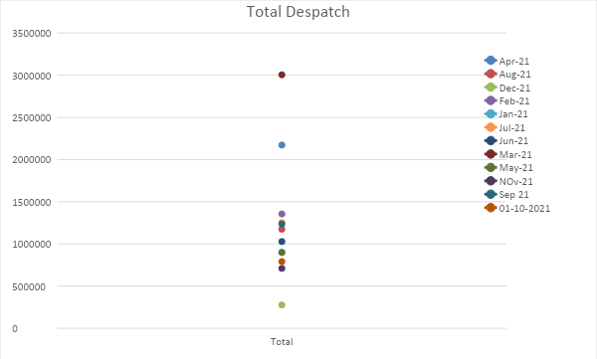

***(This box and whisker plots define which month has the exquisite sales of Parle products)***

**Interpretation**

This data shows the total despatch in various month of the year 2021.Over here we get to see that the month of April made the highest sales coming April as the 2nd, while December made the least sale along with January. This graph shows that in the Summers the sales are quite high and low in the time of winter.

Question 5.

Analysis of TCA (Tetra Classis Aseptic)

Graph 5

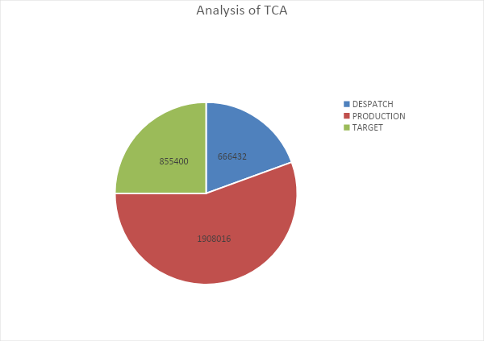

***(This data shows the total production, target and despatch of TCA)***

**Interpretation**

This data shows the total analysis of TCA production that took place in the year 2021. This data is for the total sales they made by selling TCA for Parle Agro products. This graph assumes that the target that they set was low compared to the production they made but at the end the despatch was low.

Flowchart for Aseptic Package Production

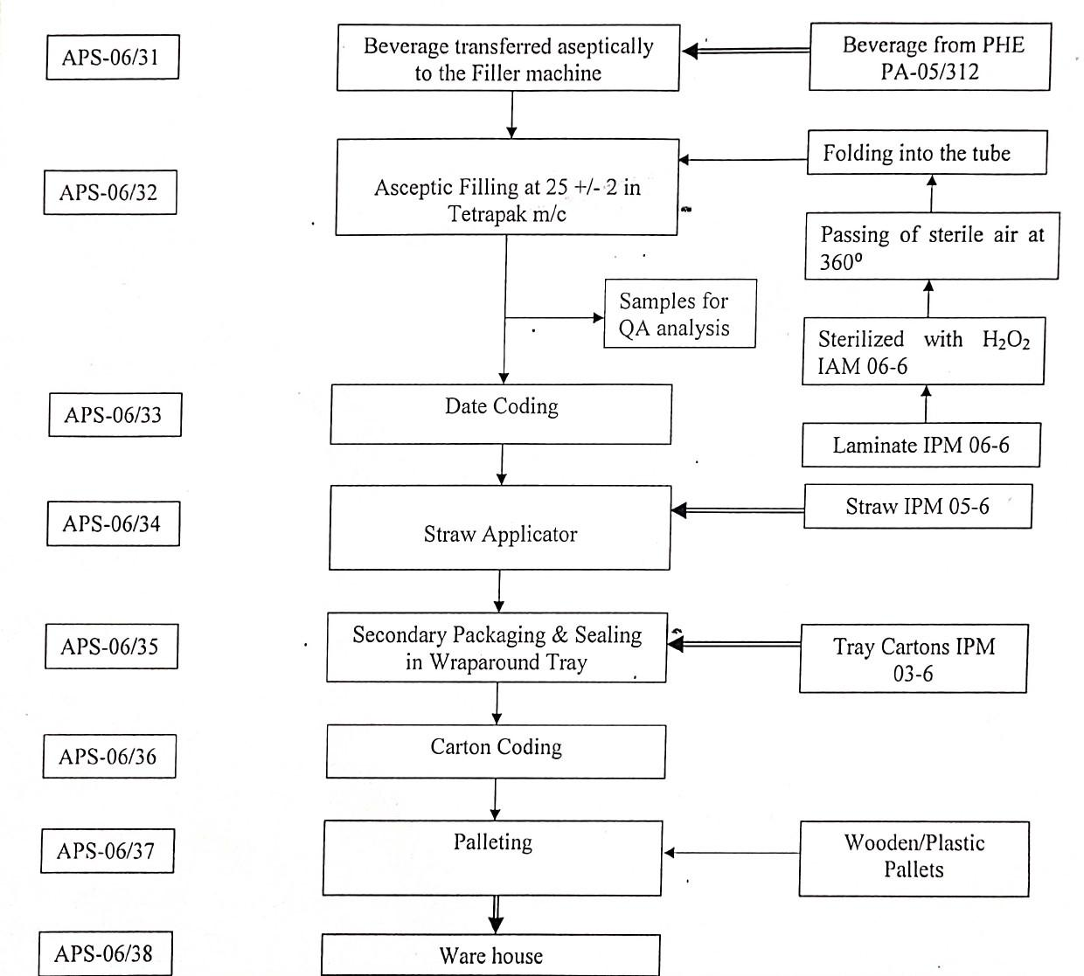

Question 6.

Brix Analysis of Frooti and Appy- fizz

Graph 6

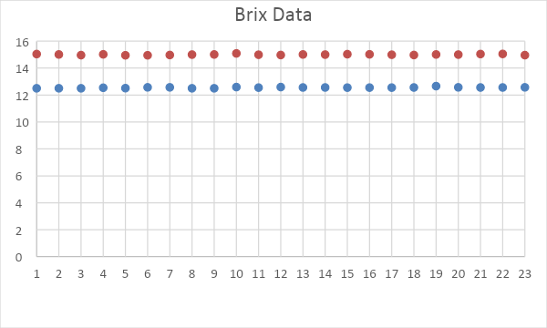

(This data shows the Brix analysis of both Frooti and Appy Fizz. Series 1 indicates Frooti and Series 2 indicates Appy fizz)

**Interpretation**

Degrees Brix (symbol °Bx) is the sugar content of a watery arrangement. One degree Brix is 1 gram of sucrose in 100 grams of arrangement and addresses the strength of the arrangement as rate by mass. In the event that the arrangement contains broke up solids other than unadulterated sucrose, the °Bx just approximates the disintegrated strong substance. For instance, when one adds equivalent measures of salt and sugar to approach measures of water, the levels of refraction (BRIX) of the salt arrangement rises quicker than the sugar solution[citation needed]. The °Bx is generally utilized in the wine, sugar, carbonated refreshment, natural product juice, new produce, maple syrup and honey businesses. In this data the content of both the drinks are more likely to be similar with one another despite of its taste difference.

**3.4 Gap Analysis of B-Fizz**

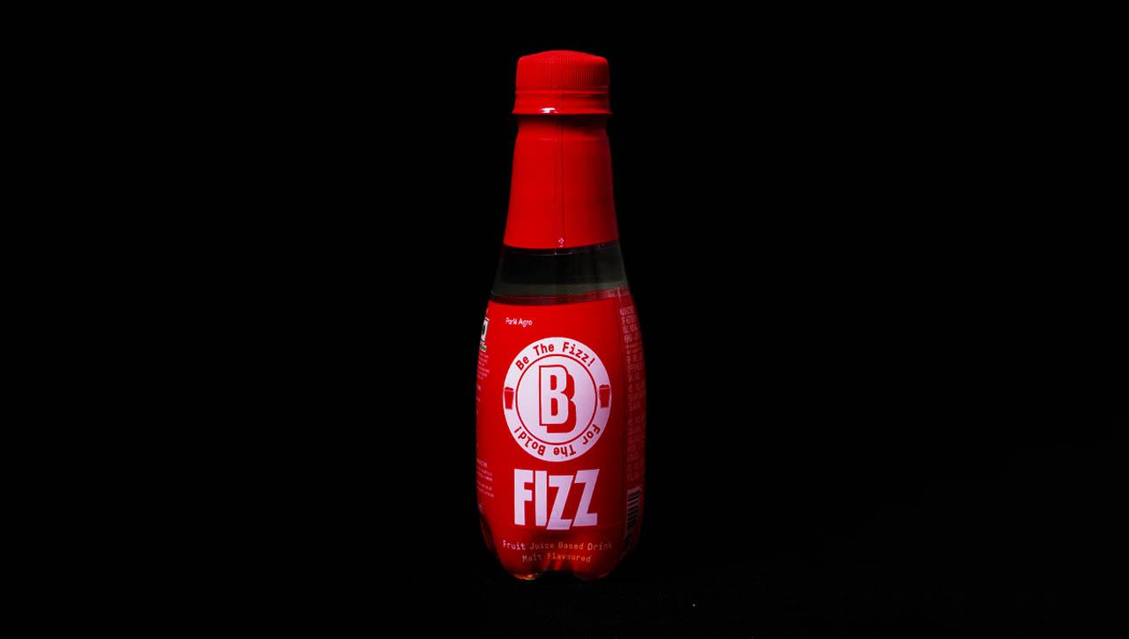

What is B-Fizz

We as a whole know Appy Fizz which is an insane carbonated squeezed apple drink. B Fizz drink is a reviving expansion to the realized Appy bubble drink (both are various brands however), where the B Fizz comes loaded with a Bold Beer flavor with tingly apple taste.

Flavor of B-Fizz?

The malt flavors are the flavors produced from the malted grains, where the grains are subjected to a process called malting. This can be seen in beer production.

Why its Beer Flavor?

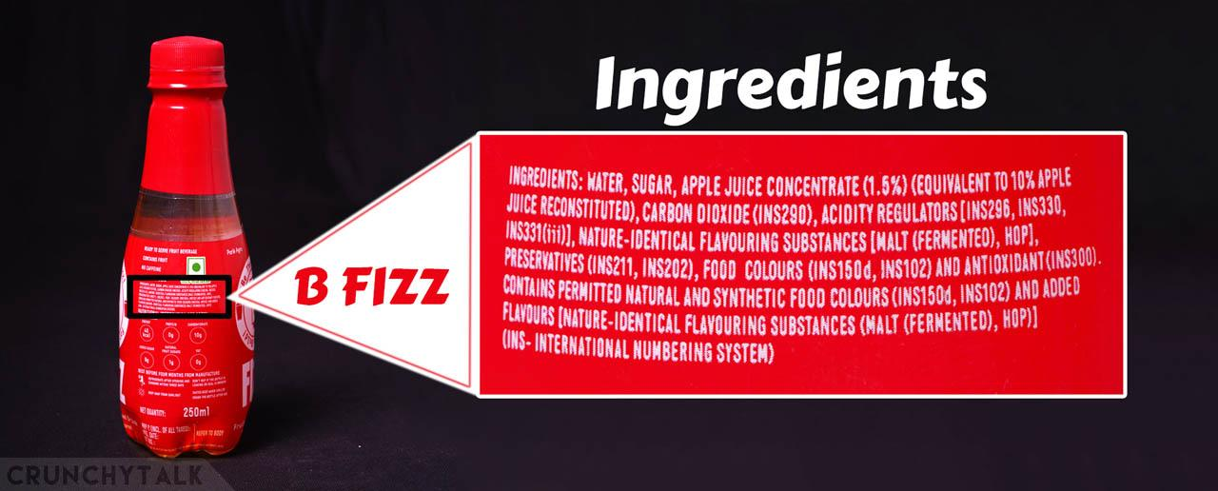

Beer is a fermented alcoholic beverage made from barley malt or other malted grains, sometimes with added things like wheat, maize, corn, rice or other cereal crops, and with hops or hop extracts to impart a bitter taste and flavour.

On the other hand, B Fizz contains no malted grains added as an ingredient. Only Flavouring substances are added which are just chemical compounds to mimic the Fermented beer flavour along with Hops for the bitter taste of the beer. From this we can conclude that B Fizz is not a beer.

**AF V/s B-Fizz(160 ml Head-to-Head Comparison)**

There is no major change in the ingredients list of both Appy fizz and B fizz. The changes between Appy fizz and B fizz are very few which I have listed below:

* Appy fizz contains more Apple juice concentrate of about 1.9%, B fizz contains about 1.5 % of concentrated Apple juice

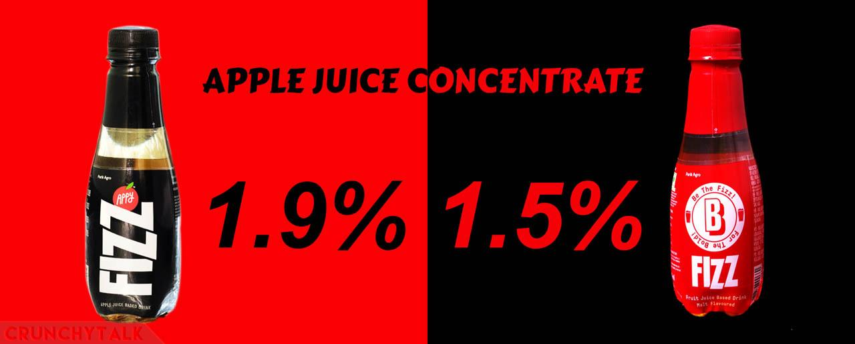

* Appy fizz contains three preservatives (INS 211, INS 224 and INS 202) whereas B Fizz contains only two preservatives (INS211, INS 202).

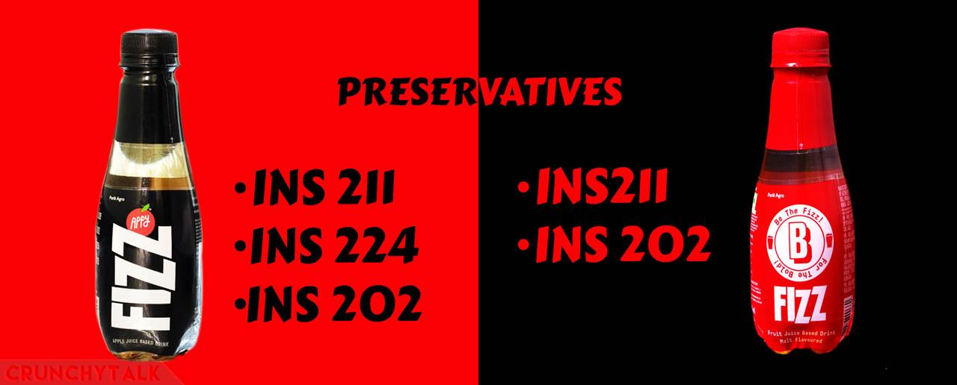

* B Fizz contains three acidity regulators (INS 296, INS 330 and INS 331 (iii)) whereas Appy fizz contains only two (INS 296, INS 330).

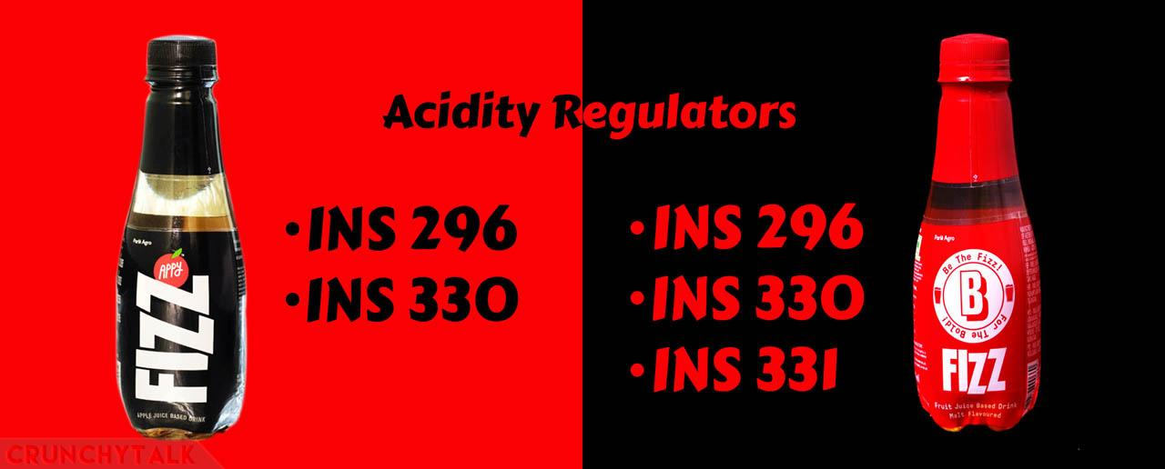

* B fizz contains two coloring agents (INS 150 d & INS 102) in them, whereas the Appy Fizz contains only one (INS 150 d).

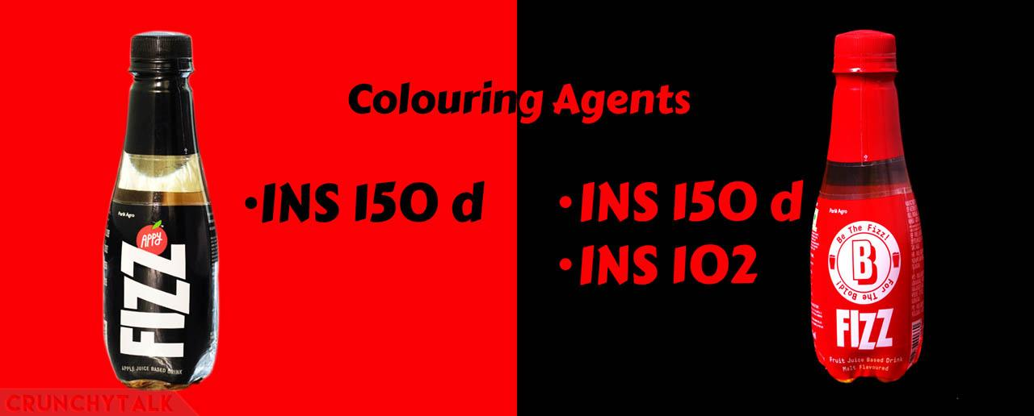**Price For 160 ml Bottle**

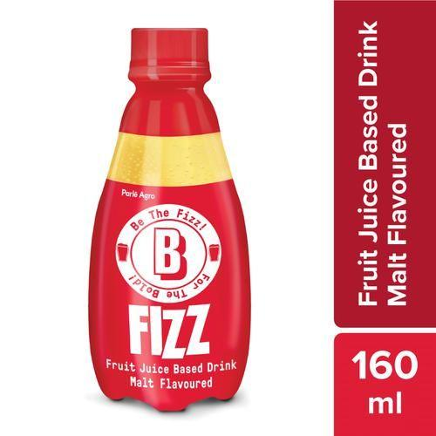 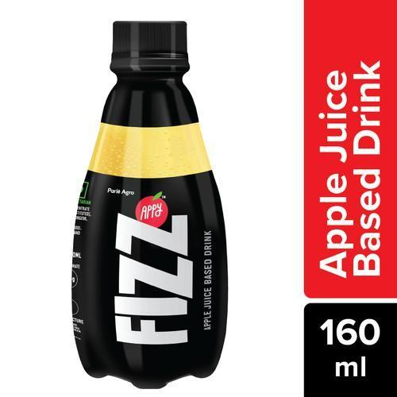

**Price for B-Fizz(160ml)-12**

**Price for Appy Fizz(160ml)-14**

3.4.1 Cold Fill Production (B- Fizz)

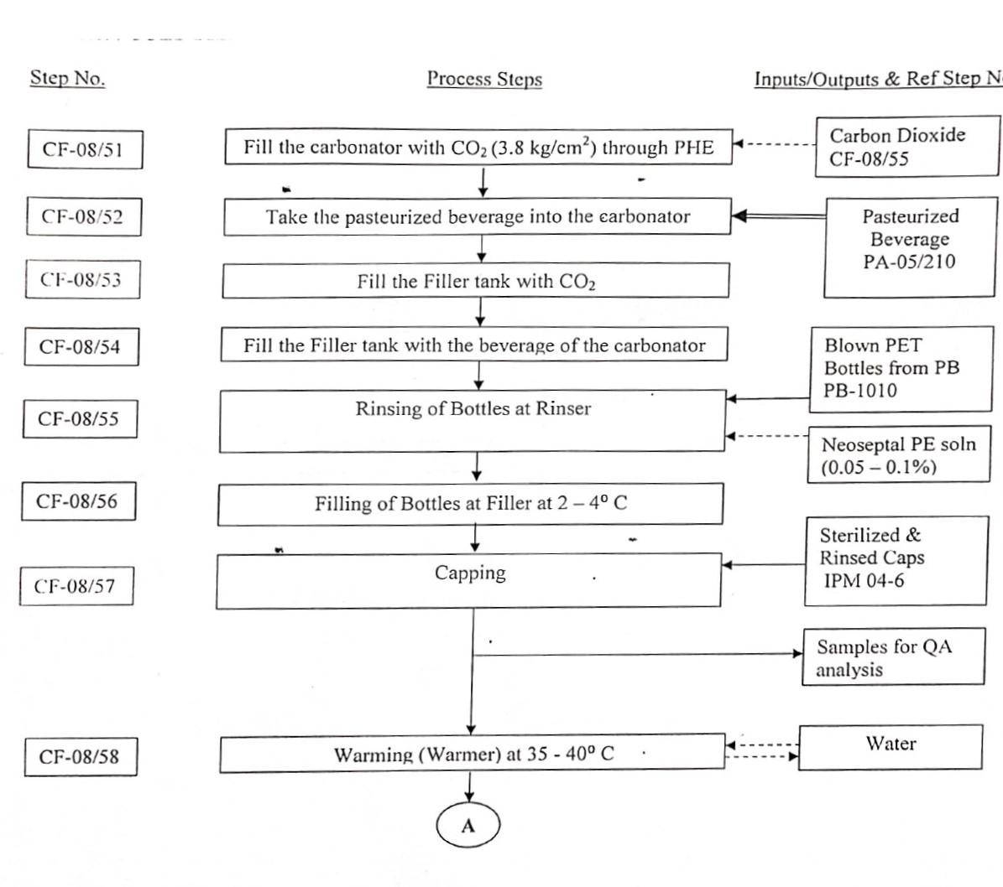

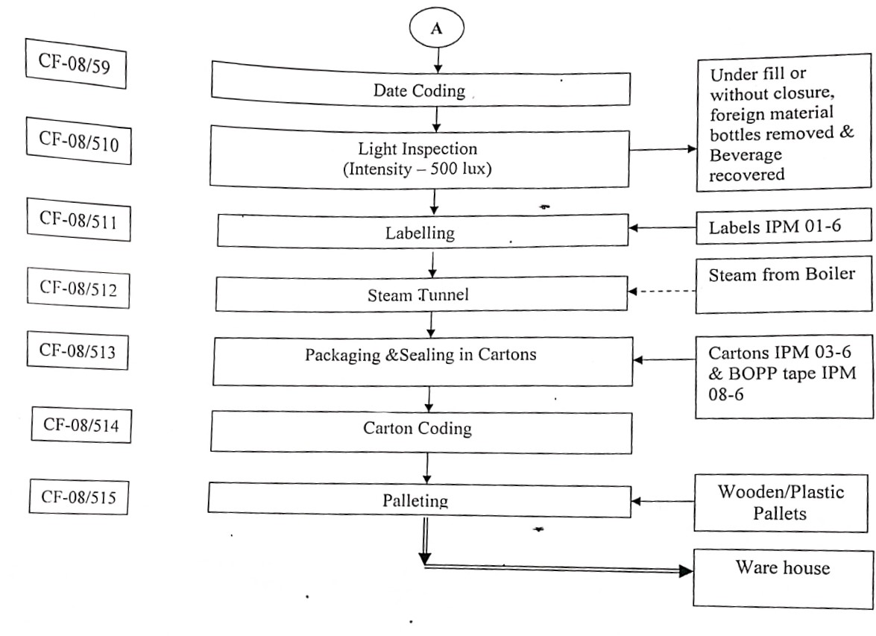

**3.4.2 B-Fizz lack of sales analysis**

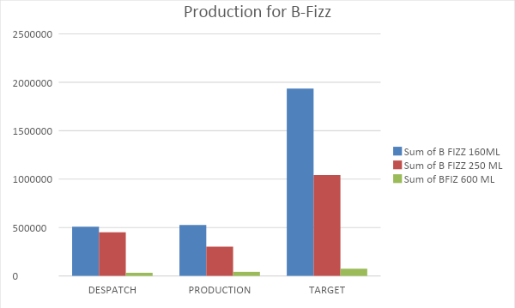\

(***This data shows the quantity of B-Fizz sold in the market along with different size of the bottle***.)

In this graph we can safely assume that the target for B-fizz isn’t met with the production that underwent. So, there might be certain issues that need to be undertaken while doing the whole analysis of this production of B-Fizz and how the target can be ascertain. Also, a huge difference among the 160 ml and 600 ml is a big whooping thing to worry about the whole procedure. Even though the price is low comparatively with Appy it’s still facing difficulties to withstand the outgoing situation.

**How to boost sales of B-Fizz**

* Marketing
* Advertising
* Giving free sample of the product in different mart
* Making aware to people about the new trend in the market with a (#) on twitter

**Chapter 4**

**4.1 Suggestion**

Well working in the company for the past 1 month I got to know the brief experience of working in an FMCG company and how the company basically overhauls its employees in working smooth and ease conduct of doing the work and continuing its production. Unlike most corporate , we haven’t enthusiast a lot of cubicle vibes as the company main function was to direct factory production but got an enhanced learning experience on how the company function and how it’s been directed. I want to thank Mr. Naha for giving me this glorious opportunity to give a brief insight about the industry and how the industry runs as a whole. Also like to thank Amrita Mam to help us in finding out project during the course of our journey.

**4.2 Findings**

The welfare facilities, which are organized by the management, are well- known to the workers and all about the respondents are satisfied with the majority welfare facility. The places we visited was really amazing and also the workers getting freedom of choices of expressing themselves towards the higher authority and getting to know about the company.

**4.3 Conclusion**

Business Analytics plays a key role in any organization. As per the data collected about Parle and their production hub on how their beverages is being produced , one thing is definitely sure that it’s a quite a lengthy and a complicated process to dilute every aspect of the stuff in one together.

Based on the indept study of Keventer and its partnership with Parle , it is clear that the company is very much keen in providing the best for the parle and their subdue products as they are very much happy to be sustained in their brand attire.

Finally, the study concludes that the work production being held is going on a day-to-day basis and with the present working life culture employees are really happy to make themselves more viable towards the way the production going and withstanding to keep the pace.

*References*

* [PARLE AGRO | Home page](https://www.parleagro.com/)
* [Keventer - Largest FMCG Company in Eastern India](https://www.keventer.com/)