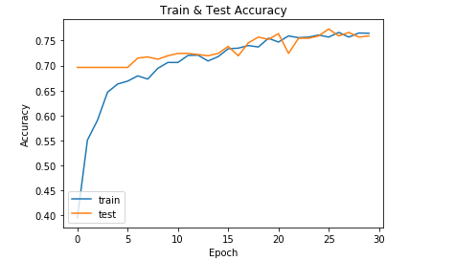

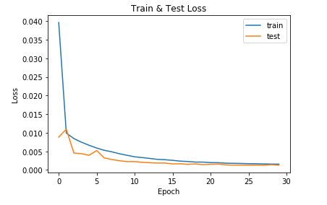

Epoch 30/30

1704/1712 [============================>.] - ETA: 0s - loss: 0.0016 - acc: 0.7641 Epoch 00029: val_loss did not improve

1712/1712 [==============================] - 190s - loss: 0.0016 - acc: 0.7646 - val_loss: 0.0013 - val_acc: 0.7593