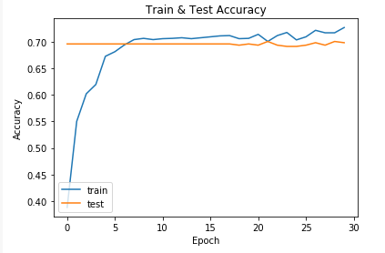

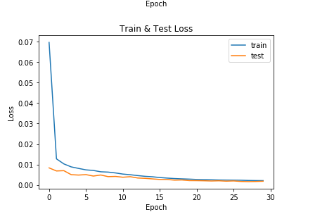

Epoch 30/30

1704/1712 [============================>.] - ETA: 1s - loss: 0.0021 - acc: 0.7265 Epoch 00029: val_loss did not improve

1712/1712 [==============================] - 305s - loss: 0.0021 - acc: 0.7272 - val_loss: 0.0018 - val_acc: 0.6986