localhost:8000/block/height/0

{

    "hash": "37353d62c6e7e1462407c44e528f859b60124b0a48619986f7e53e59a252a370",

    "height": 0,

    "body": "7b2264617461223a2247656e6573697320426c6f636b227d",

    "time": "1686795038",

    "previousBlockHash": **null**

}

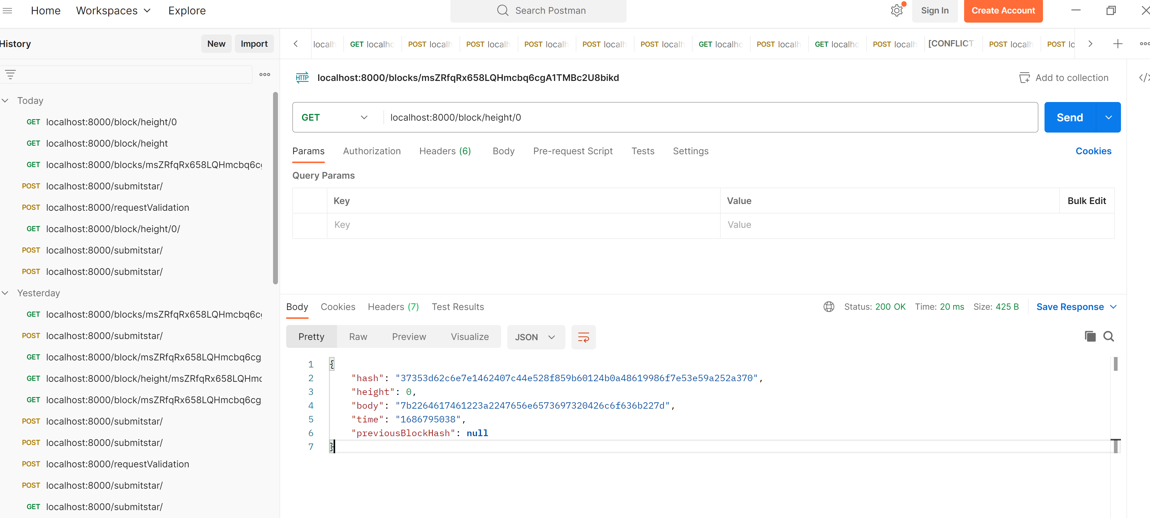

localhost:8000/requestValidation

{"address":"msZRfqRx658LQHmcbq6cgA1TMBc2U8bikd"}

"msZRfqRx658LQHmcbq6cgA1TMBc2U8bikd:1686795516:starRegistry"

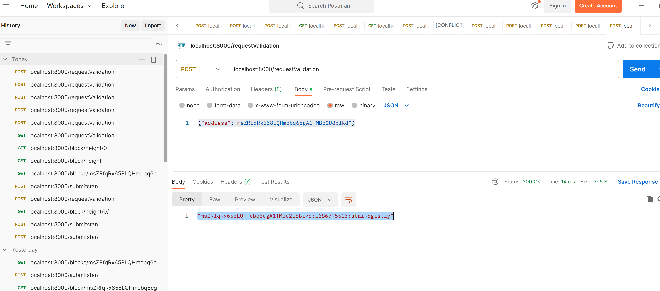

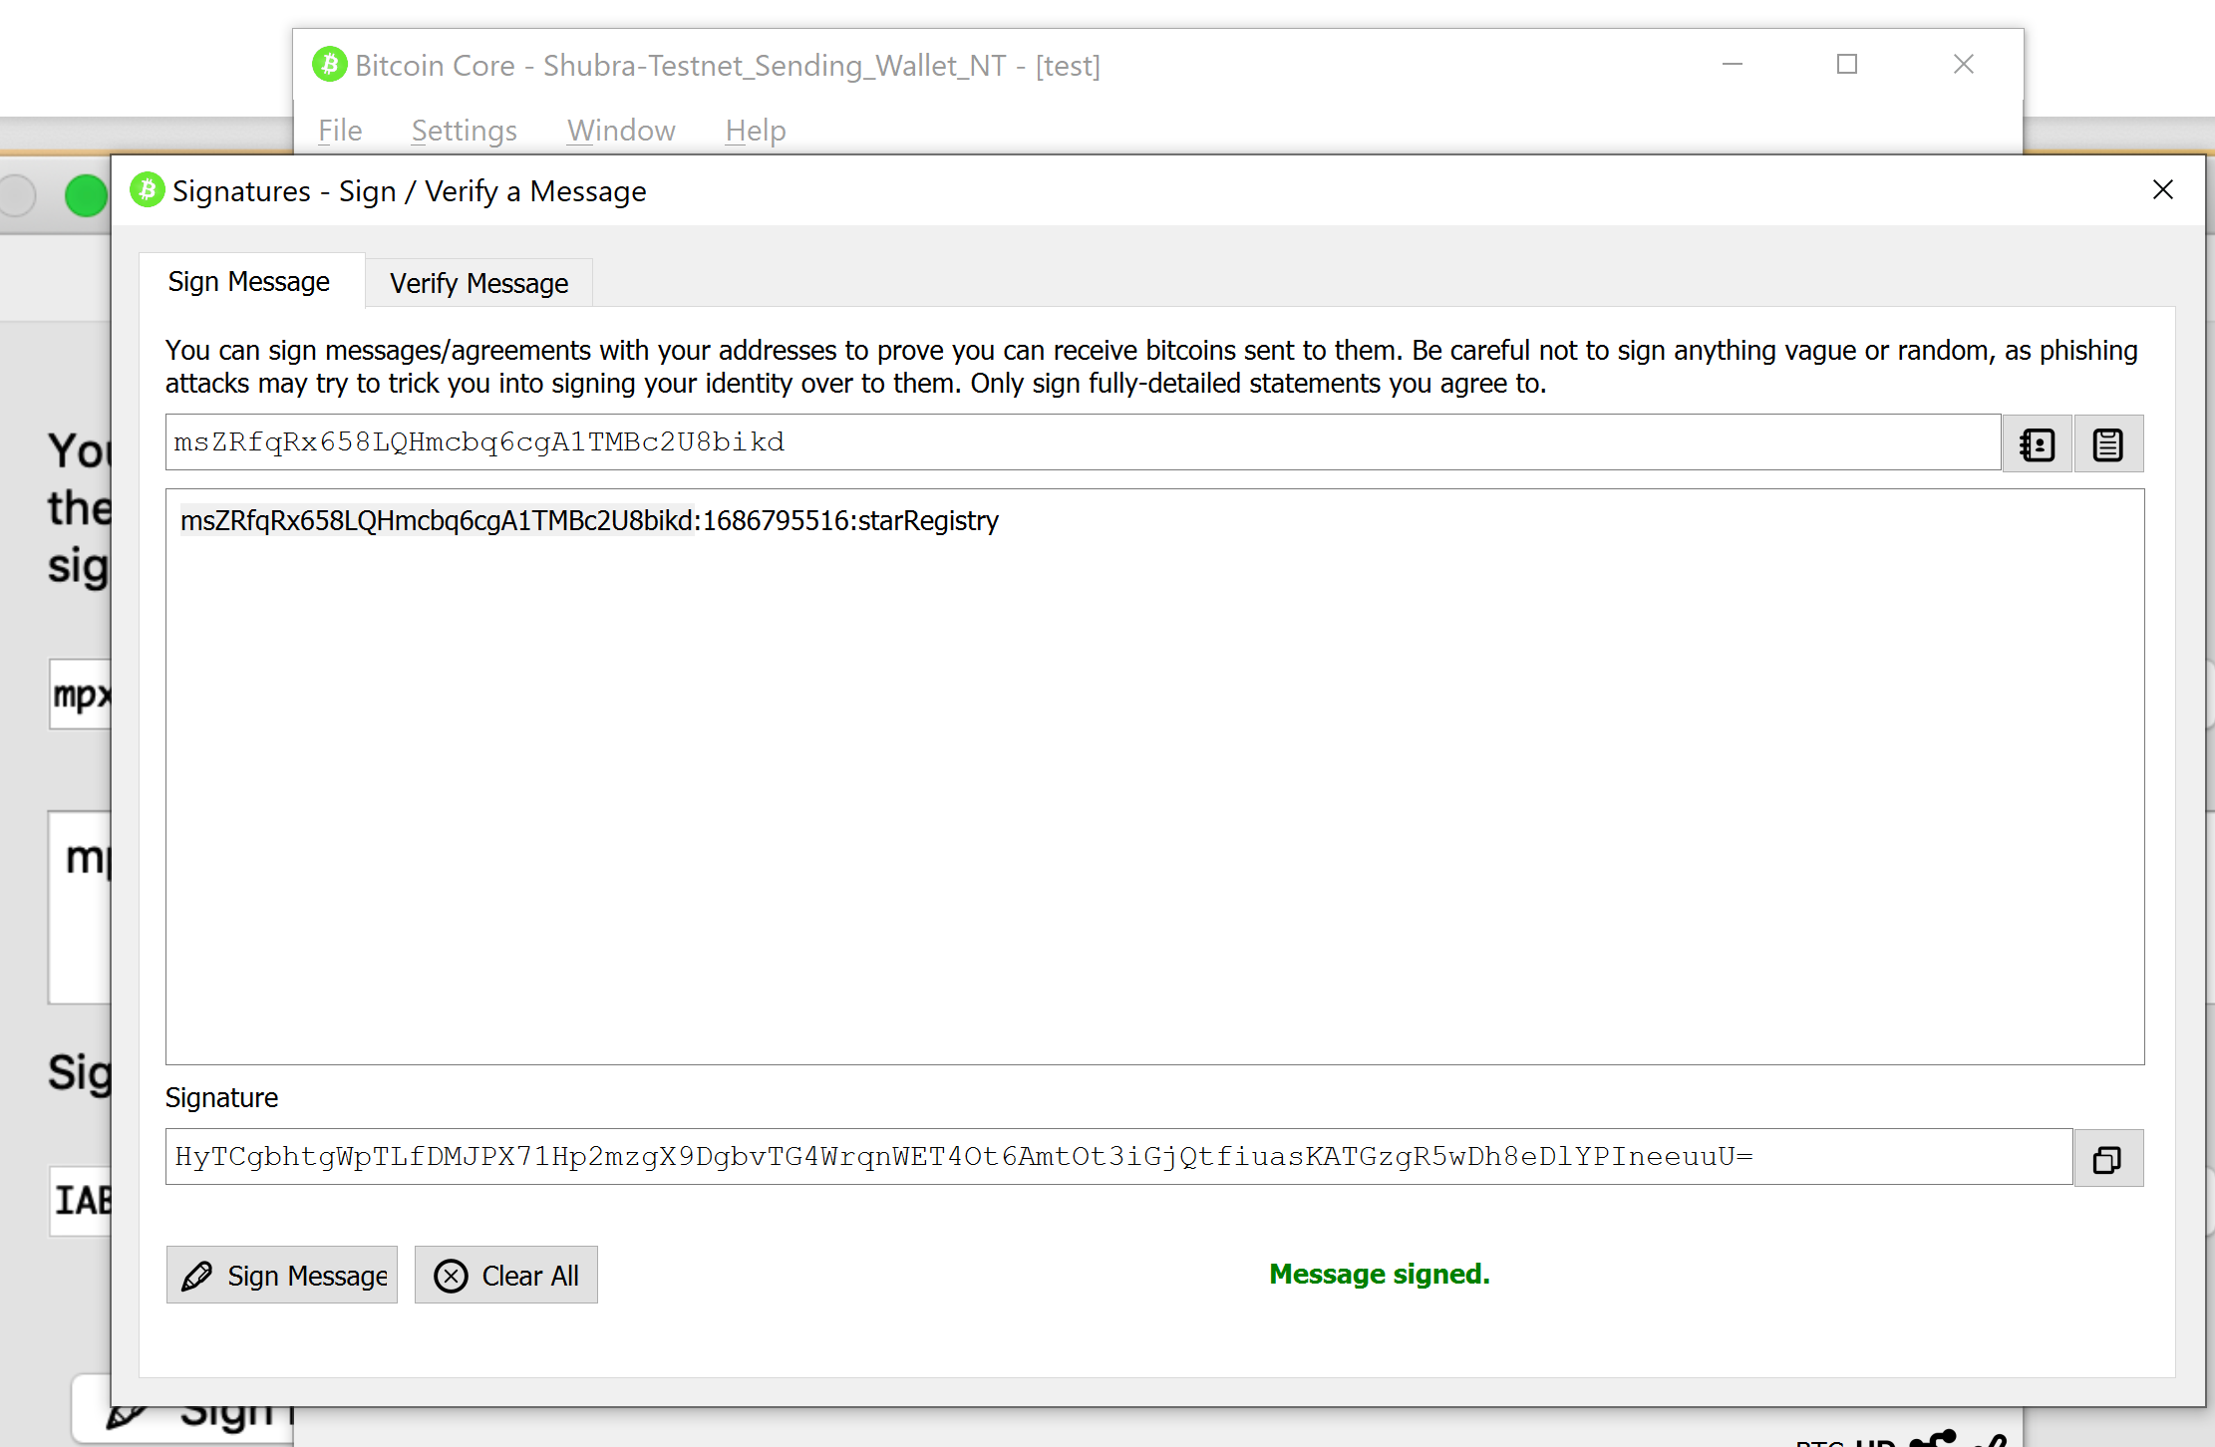

HyTCgbhtgWpTLfDMJPX71Hp2mzgX9DgbvTG4WrqnWET4Ot6AmtOt3iGjQtfiuasKATGzgR5wDh8eDlYPIneeuuU=

localhost:8000/submitstar/

{

"address":"msZRfqRx658LQHmcbq6cgA1TMBc2U8bikd",

"signature":"HyTCgbhtgWpTLfDMJPX71Hp2mzgX9DgbvTG4WrqnWET4Ot6AmtOt3iGjQtfiuasKATGzgR5wDh8eDlYPIneeuuU=",

"message":"msZRfqRx658LQHmcbq6cgA1TMBc2U8bikd:1686795516:starRegistry",

"star": {

        "dec": "68° 52' 56.9",

        "ra": "16h 29m 1.0s",

        "story": "Testing the story 4"

    }

}

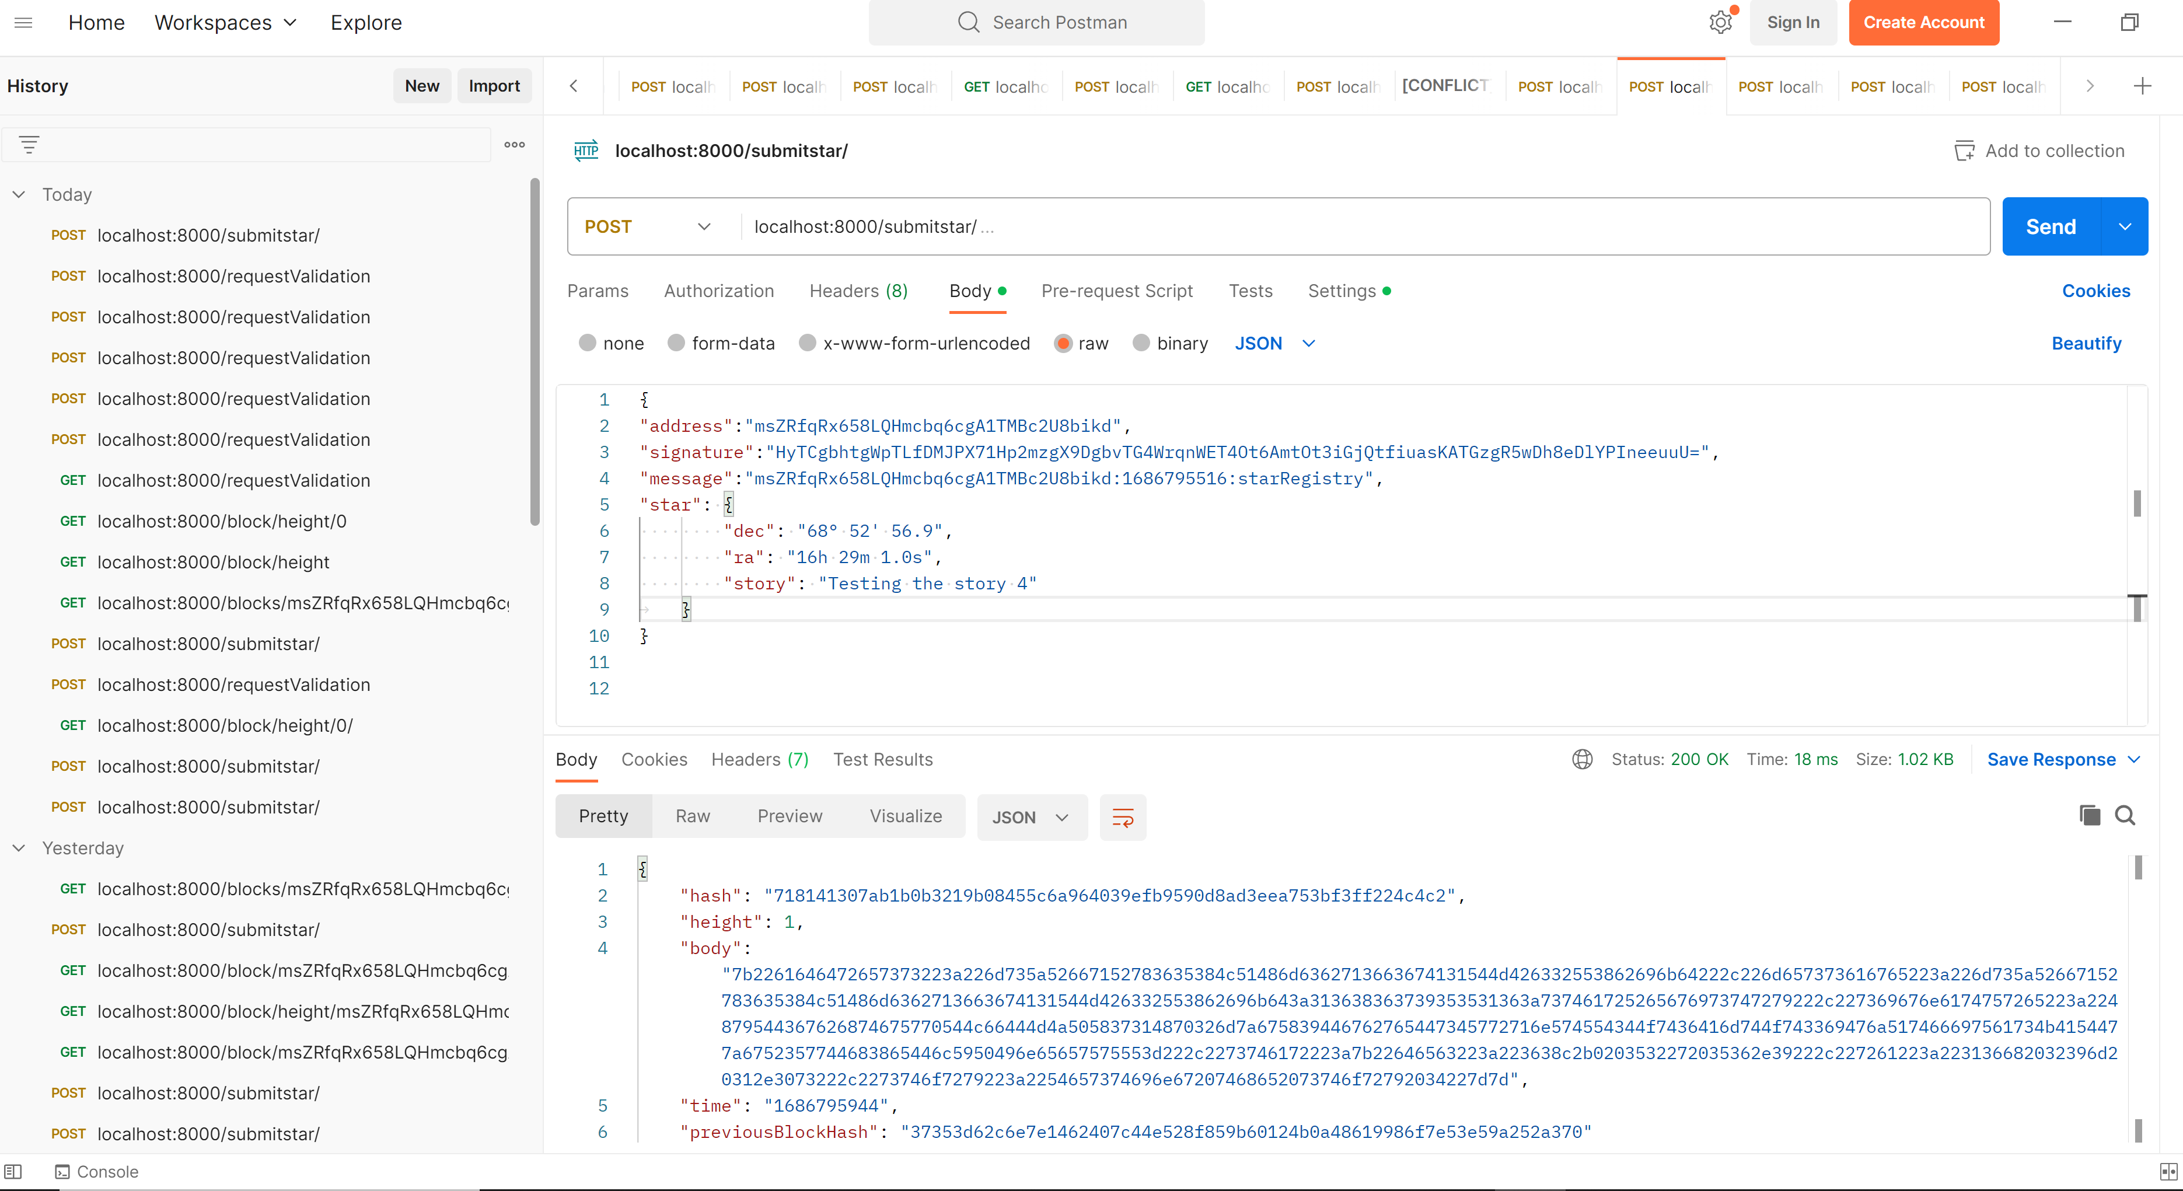

{

    "hash": "718141307ab1b0b3219b08455c6a964039efb9590d8ad3eea753bf3ff224c4c2",

    "height": 1,

    "body": "",

    "time": "1686795944",

    "previousBlockHash": "37353d62c6e7e1462407c44e528f859b60124b0a48619986f7e53e59a252a370"

}

Again on rerun to check the previous block hash is correct or not

{

    "hash": "72697d9388b8a9fe5da42539438af5698589f73d4faba02aa8550902fce621fe",

    "height": 2,

    "body": "",

    "time": "1686796062",

    "previousBlockHash": "718141307ab1b0b3219b08455c6a964039efb9590d8ad3eea753bf3ff224c4c2"

}

