EE443 - Embedded Systems
Experiment 1 Laboratory Report
Code Compilation and Simulation

Name: Burak YÖRÜK
Number: 210206041
Date: 31 - 10 - 2018

Objective

The purpose of the experiment is to run the software development environment using Atmel ATMega328p processor, to ensure the simulation and to understand the use of embedded systems.

Experimental Work

In the CodeBlocks environment, the AVR project file is created and the code is compiled on the IDE. ATmega328P was used as a microcontroller in the course. It’s specifications are 8-bit 20Mhz, 32 general purpose register, 23 I / O pins, 32k flash memory, 6 PWM channels and 6 channels 10 bit ADC [1].After the necessary setups were made in the Proteus environment, the experiment was run in advance, the analog graphic was extracted via the timer circuit, and then a simple led application in the Atmega processor was shown in the simulation environment.

In the procedure, as before, firstly 1 second led blink was applied, then blinking between Led0..3 and Led1 was repeated with changing on the Port-B. The pins are set to output by typing 0xFF into the DDRB (Data Direction Register B). In the while, the 7th pin of the PORTB is activated to ensure that it is ON. The Delay function is implemented in 500 ms. The PORTB = 0x0F equalization causes the first four pins hence leds light up. Then the delay function is used again.

In the last code, the delay part was commented and simulated again. The Digital Graph was observed in the Proteus. Also, the lss file is used to see the instruction set on the assembly process.

// Complete main program for EE443 laboratory experiment 1.

#include <avr/io.h>
#include <util/delay.h>

int main(void)
{
DDRB |= 0xFF; // all Port-B pins are set as an output
while(1) // the infinite loop
{
PORTB = 0x80; // Set the most significant one Port-B pin high
_delay_ms(500); // 500ms delay
PORTB = 0x0F; // Set the least four Port-B pins are high
_delay_ms(500); // 500ms delay
};
return 0;
}

Results and Conclusion

Open the lss file obtained because of the assembly done by deleting the Delay functions and the assembly codes were examined. In this review, a number of statements were found and datasheet Instruction Set Summary was examined to understand them. Such as load immediate, jumping, output.

00000080 <main>:
80: 84 b1 in r24, 0x04 ; 4
82: 8f ef ldi r24, 0xFF ; 255
84: 84 b9 out 0x04, r24 ; 4
86: 9f e0 ldi r25, 0x0F ; 15
88: 80 e8 ldi r24, 0x80 ; 128
8a: 95 b9 out 0x05, r25 ; 5
8c: 85 b9 out 0x05, r24 ; 5
8e: fd cf rjmp .-6 ; 0x8a <main+0xa>

In the main block first a register is defining input and then load the immediate address to this register. This register is updated as output after then and loads pin addresses. In 8a column while loop becomes. Pins are defining output and last column send us again 8a column.
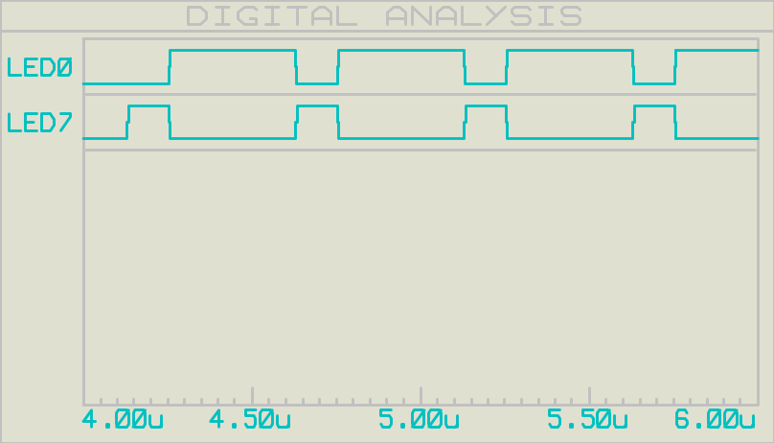

Figure 1: Digital Graph for Measurement of the Clock Cycles

We observe that one loop cycle takes 0.5us in the above digital analysis graph. So the clock frequency:

1 / T_{cyc} = f_{clk} = 2Mhz

Answers to the Questions

A1: The lss file and datasheet give us a necessary information. On the lss file, while loop start in 8a and end to 8e which contains out and rjmp instructions. Datasheet says that out needs one clock cycle and rjmp needs two cycles. So 4 clock cycle is needed to complete one cycle of the while loop.
The processor clock frequency is 8Mhz so 1 cycle instruction takes 0125us(125ns). As we see in the LED7 ON time. And 3 cycle ON Time of LED0 is 0.375us. Addition of two On time gives us execution time 0.5us same as graph.

A2: Addition of delays or dummy instructions change the program so that the ON-time of LEDs will be equal to the OFF-time. For example, if we repeat the PORTB write operation, we have the same ON-OFF timing of the LEDs.

PORTB = 0x80; // Set the most significant one Port-B pin high
PORTB = 0x80; // Set the most significant one Port-B pin high
PORTB = 0x80; // Set the most significant one Port-B pin high
PORTB = 0x0F; // Set the least four Port-B pins are high

Two dummies out command on the processor above and 0.1us delay function below.

while(1)
{
PORTB = 0x80;
_delay_us(0.1);
PORTB = 0x0F;
};
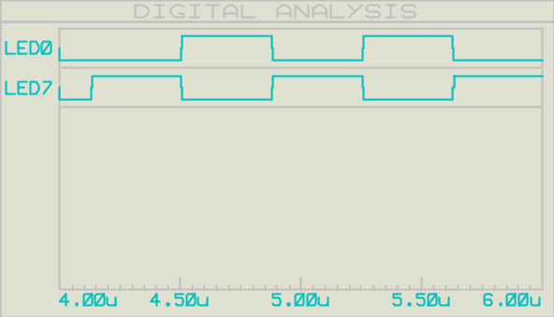
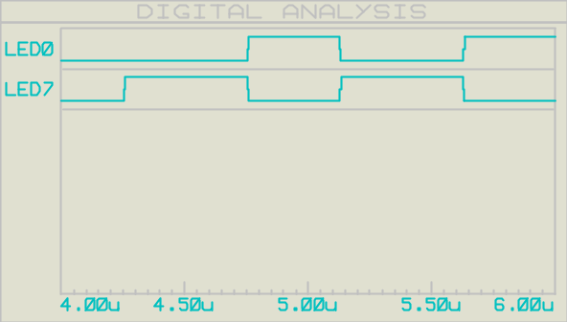
Figure 2: Digital Graph of Clock Cycles for dummy inst. Figure 3: Digital Graph of Clock Cycles for delay.

A3: If we write 2 out as a single out operation, we write 1 cycle faster.

References
[1] Atmel ATmega328/P Datasheet Complete 11/2016

