1. Plot 1: This is a Critic Ratings Vs Audience Rating plot where the different colors represent the Genres of the movies and size of the dot represents the Budget (in millions).

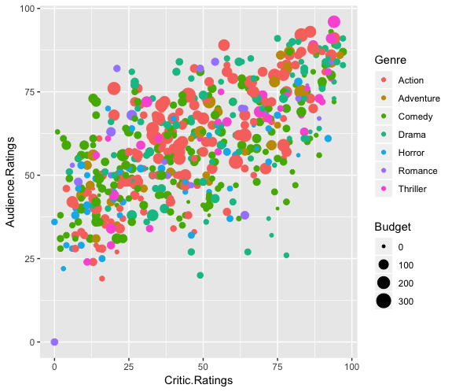

1. Plot 2: This is a Critic Ratings Vs Audience Rating plot where we have shown the overriding of aesthetics by changing the color to Genre here.

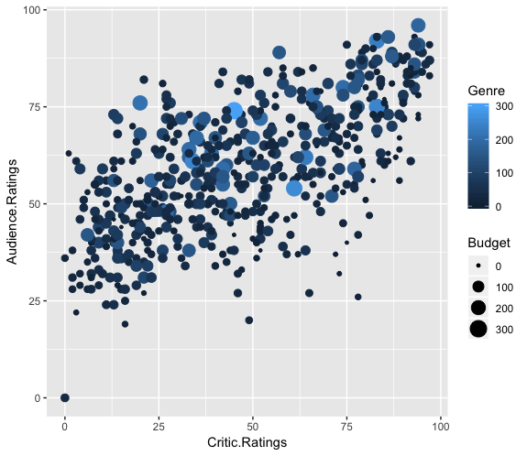

1. Plot 3: This is a histogram plot where we have Budget on x – axis and we have broken down the histogram based on different Genres. Giving the viewer a visual ratio of movies of different genres and we observe that comedy and action movies take the highest chunk of the money.

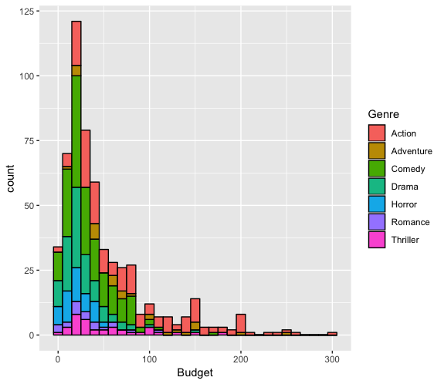

1. Plot 4: This is a box plot which shows where the median lies for various Genres of the movies. As we observe, the box of thrillers is smallest with high Audience rating. And we also observe the horror movies is the riskiest genre to put our money into.

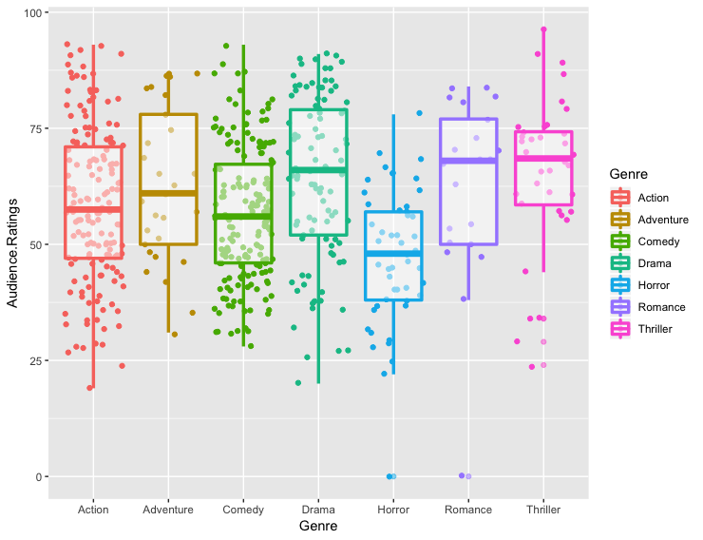

1. Plot 5: This is a scatter plot of Critic Ratings Vs Audience Rating broken down visually into years and Genres of the movie. This gives a beautiful breakdown on which genres movies released in which year.

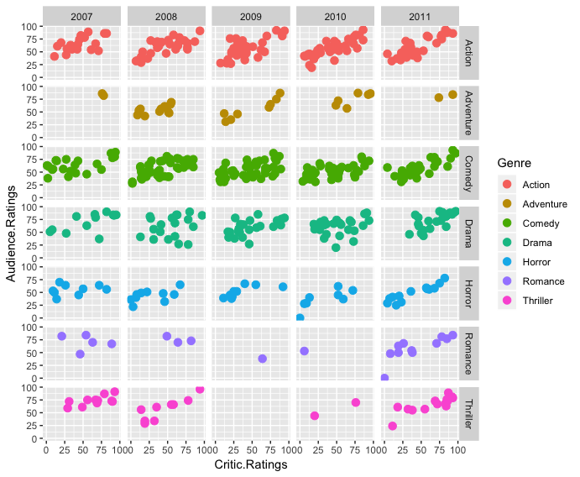

6. Plot 6: This is the same as plot 3, but we have applied various formatting techniques to make it more readable for the viewer. We have formatted the legend (Genre), the X-axis and Y-axis titles, and the title of the whole plot.

