**Shudhanshu Shrotriya**

**500086221**

**Batch-4**

**Experiment-2**

**Computer Graphics Lab**

**First Basic OpenGL program and**

**Features of Graphics program in C**

**Header files:**

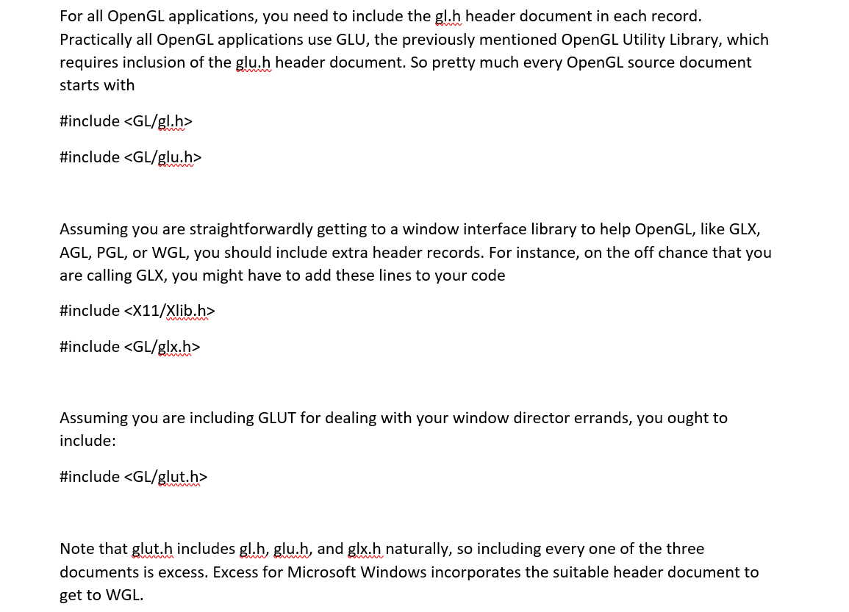

GLUT, the OpenGL Utility Toolkit

OpenGL contains delivering orders yet is intended to be autonomous of any window framework or working framework. Therefore, it contains no orders for opening windows or perusing occasions from the console or mouse. Tragically, it's difficult to compose a total designs program without at minimum opening a window, and most fascinating projects require a digit of client input or different administrations from the working framework or window framework. Generally speaking, complete projects make the most intriguing models, so this book utilizes GLUT to work on opening windows, identifying input, etc. Assuming you have an execution of OpenGL and GLUT on your framework, the models in this book should run without change when connected with them.

Now let’s create our main() function:

**int** main(){

Now we will begin by initializing GLFW:

glewExperimental **=** true; *// Needed for core profile*

**if**( **!**glfwInit() )

{

fprintf( stderr, "Failed to initialize GLFW\n" );

**return** **-**1;

}

Now Let’s create our first OpenGL window:

glfwWindowHint(GLFW_SAMPLES, 4); *// 4x antialiasing*

glfwWindowHint(GLFW_CONTEXT_VERSION_MAJOR, 3); *// We want OpenGL 3.3*

glfwWindowHint(GLFW_CONTEXT_VERSION_MINOR, 3);

glfwWindowHint(GLFW_OPENGL_FORWARD_COMPAT, GL_TRUE); *// To make MacOS happy; should not be needed*

glfwWindowHint(GLFW_OPENGL_PROFILE, GLFW_OPENGL_CORE_PROFILE); *// We don't want the old OpenGL*

*// Open a window and create its OpenGL context*

GLFWwindow**\*** window; *// (In the accompanying source code, this variable is global for simplicity)*

window **=** glfwCreateWindow( 1030, 780, "Prog_1", NULL, NULL);

**if**( window **==** NULL ){

fprintf( stderr, "Failed to open GLFW window. If you have an Intel GPU, they are not 3.3 compatible. Try the 2.1 version of the tutorials.\n" );

glfwTerminate();

**return** **-**1;

}

glfwMakeContextCurrent(window); *// Initialize GLEW*

glewExperimental**=**true; *// Needed in core profile*

**if** (glewInit() **!=** GLEW_OK) {

fprintf(stderr, "Failed to initialize GLEW\n");

**return** **-**1;

}

Now when we build and run this, we observe that a new window appears and then is closed right away. The User will have to press the Esc key:

glfwSetInputMode(window, GLFW_STICKY_KEYS, GL_TRUE);

**do**{

*// Clear the screen. It's not mentioned before Tutorial 02, but it can cause flickering, so it's there nonetheless.*

glClear( GL_COLOR_BUFFER_BIT );

*// Draw nothing, see you in tutorial 2 !*

*// Swap buffers*

glfwSwapBuffers(window);

glfwPollEvents();

} *// Check if the ESC key was pressed or the window was closed*

**while**( glfwGetKey(window, GLFW_KEY_ESCAPE ) **!=** GLFW_PRESS **&&**

glfwWindowShouldClose(window) **==** 0 );

**So, this was how you can create your very first OpenGL program and output a window. This window will be the where our output pf the program will be displayed.**