

UNIVERSITY OF PETROLEUM & ENERGY STUDIES

School of Computer Science

Dehradun

LAB FILE

Programme : B.Tech (CSE+AIML)

Course : Machine Learning Lab

Subject Code : CSAI2101

No. of credits : 1

Semester : IV

Session : Jan 2022 – July 2022

Batch : 2020-2024

Submitted By:

|  |  |  |  |
| --- | --- | --- | --- |
| Name | SAP-ID | Roll No. | Batch |
| Shudhanshu Shrotriya | 500086221 | R2142201891 | B4(Honors) |

Submitted To:

Dr Gopal Phartiyal

Associate Professor -SoCS



**INDEX**

|  |  |  |  |
| --- | --- | --- | --- |
| **S.No.** | **Experiments** | **Program Exercise** | **Signature** |
| 1. | Experiment 1 | Simple linear regression with one-dimensional input and output. |  |
| 2. | Experiment 2 | Linear regression with X and Y as vectors |  |
| 3. | Experiment 3 | Linear regression ( & Basis Function) with R2 vs Noise plots |  |
| 4. | Experiment 4 | Linear, Ridge, Lasso, and Elastic Net regression with R2 vs Noise plots |  |
| 5. | Experiment 5 | Logistic regression |  |
| 6. | Experiment 6 | Classification for 2 classes |  |
| 7. | Experiment 7 | Classification for Multi Classes |  |
| 8. | Experiment 8 | Decision tree |  |
| 9. | Experiment 9 | Random forest, Adaboost classification and Adaboost regression |  |
| 10. | Experiment 10 | Neural Network |  |
| 11. | Experiment 11 | SVM classification |  |
| 12. | Experiment 12 | K-Means Clustering |  |

**Experiment-1**

**Objective:** To perform the simple linear regression with one-dimensional input and output.

**Code:**

# -*- coding: utf-8 -*-

"""

@author: shudh

"""

#%%

import numpy as np

from sklearn.datasets import make_regression

import matplotlib.pyplot as plt

#%%

X , t = make_regression (100, 1, shuffle = True , bias = 0.0 ,noise = 20, random_state= 7)

#%%

plt.scatter(X,t)

#%%

mean_x = np.mean(np.squeeze(X))

mean_t = np.mean(t)

std_x = np.std(X)

std_t = np.std(t)

#%%

d_x= X - mean_x

d_t= t - mean_t

num = np.sum(np.squeeze(d_x) * d_t)

deno = np.sum(np.squeeze(d_x) * np.squeeze(d_x))

B1= num / deno

B0= mean_t - (B1 * mean_x)

#%%

print(B1)

print(B0)

#%%

y= B0 + B1 * X

print(y)

print(t)

#%%

#plotting line

plt.scatter(X, t, color='#000ff0')

plt.plot(X, y, color='#00ff00', label='Linear Regression Line')#plot the data point

**Output:**

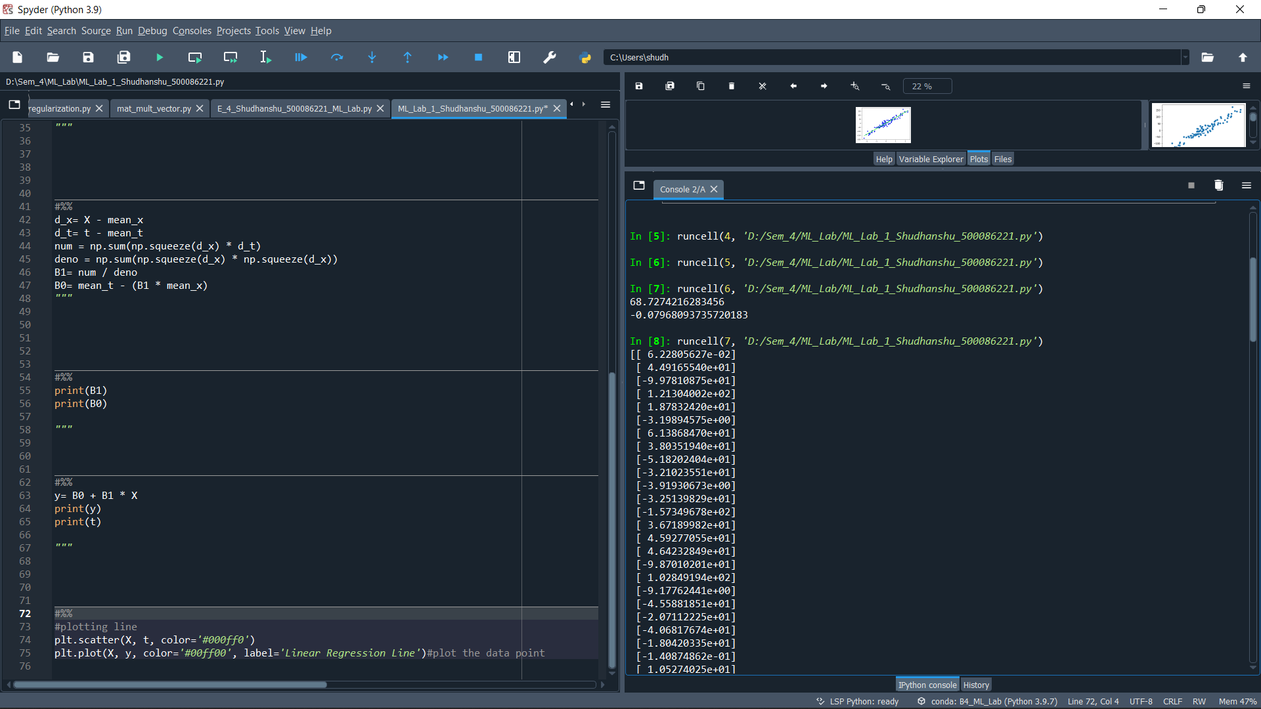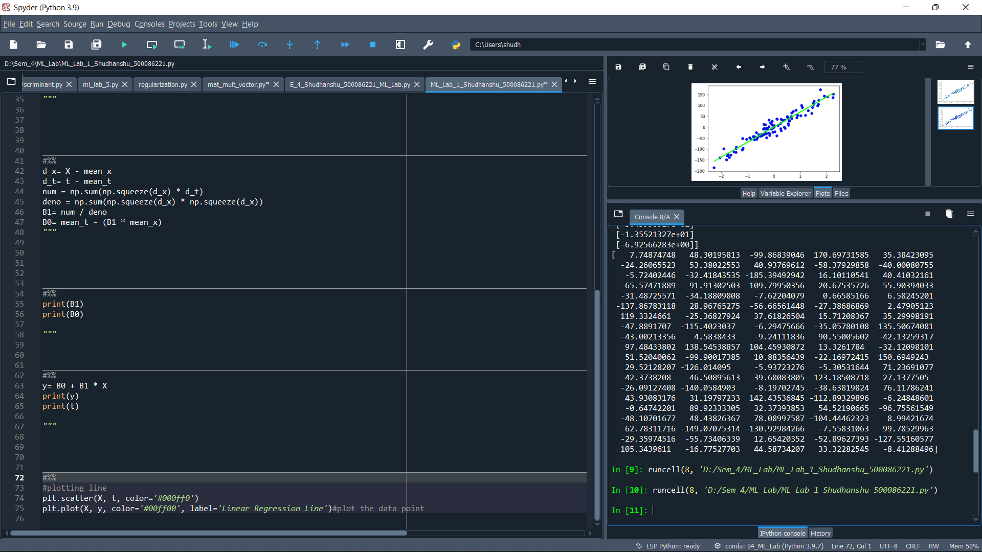

**Plots:**

**Original Dataset:**

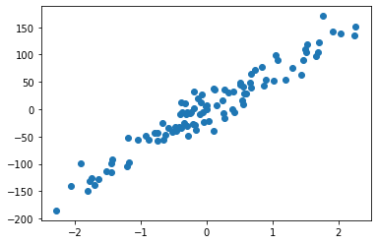

**Linear_Regression:**

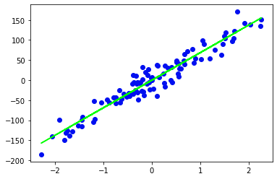

**Experiment-2**

**Objective:** To perform the linear regression with X and Y as the vectors.

**Code:**

# -*- coding: utf-8 -*-

"""

@author: shudh

"""

import numpy as np

from sklearn.datasets import make_regression

#%%

X , t = make_regression (100,5, shuffle = True , bias = 0.0 , n_targets=3 ,noise = 10, random_state= 4) ;

#%%

x0=np.ones((100,1), dtype=int);

new_x = np.concatenate((x0,X), axis = 1);

tr=new_x.transpose();

m3 = np. dot(tr,new_x);

#%%

i = np.linalg.inv(m3);

m4 = np. dot(i,tr);

m5=np.dot(m4,t);

transp=m5.transpose();

#%%

print("the value of W is:-");

print(m5);

#%%

from sklearn.linear_model import LinearRegression

model = LinearRegression()

w = model.fit(new_x,t)

#%%

print("Comparing the Value of w using sklearn function:")

print(model.intercept_)

print(model.coef_)

#%%

**Output:**

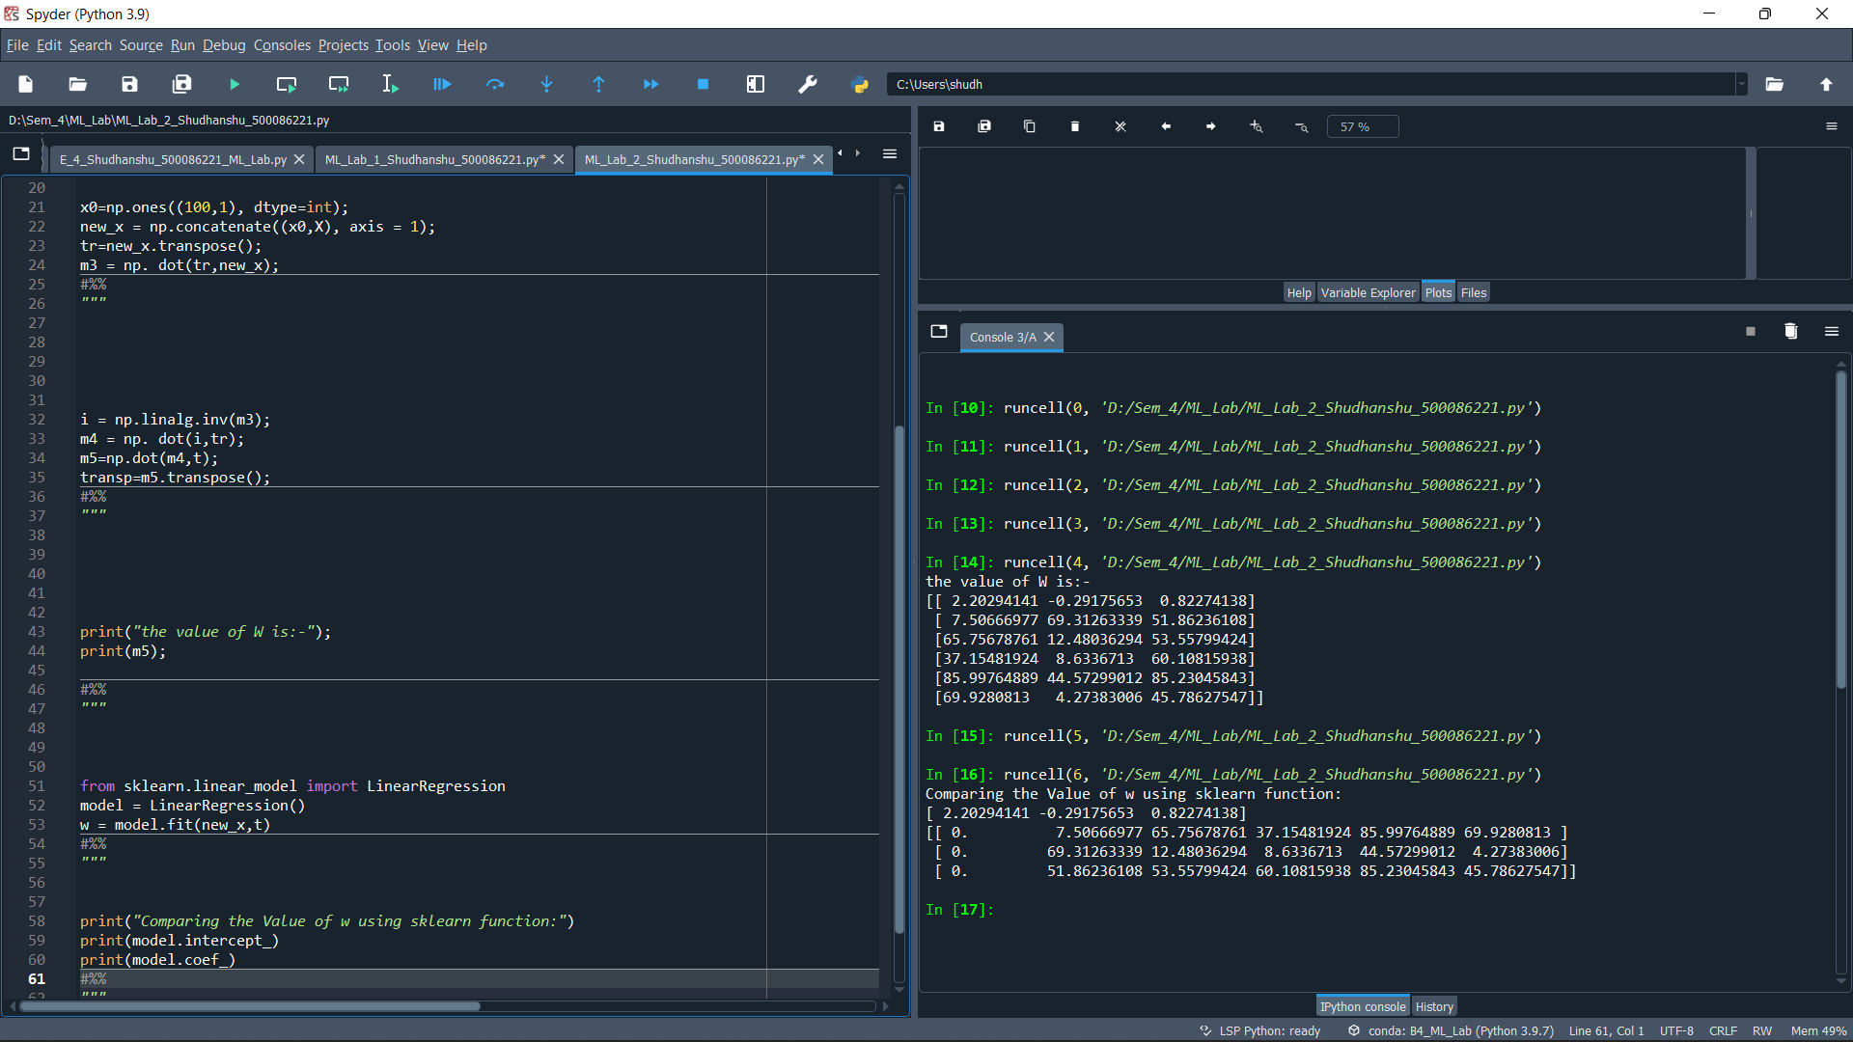

**Experiment-3**

**Objective:** To perform the linear regression with Basis Function and plot the R2 score vs Noise plots for training and test data.

**Code:**

from sklearn.datasets import make_regression

X,t = make_regression(100, 5, shuffle = True, bias = 0, noise = 77, random_state = 9)

X_mean = X.mean()

t_mean = t.mean()

X_std = X.std()

t_std = t.std()

print(X)

print(t)

import numpy as np

x0 = np.ones((100,1))

new_X = np.concatenate((x0, X), axis =1)

new_X.shape

X_t = np.transpose(new_X)

W_inv = np.dot(X_t,new_X)

W_1 = np.linalg.inv(W_inv)

W_2 = np.dot(X_t,t)

W = np.dot(W_1, W_2)

print(W)

from sklearn.linear_model import LinearRegression

model = LinearRegression()

w = model.fit(X,t)

model.coef_

#%%

X_vec,t_vec = make_regression(100, 3, shuffle = True, bias = 0, noise = 40, random_state = 9, n_targets = 3)

print(X_vec)

print(t_vec)

x0 = np.ones((100,1))

new_X = np.concatenate((x0, X_vec), axis =1)

X_vec_t = np.transpose(new_X)

W_inv = np.dot(X_vec_t,new_X)

W_1 = np.linalg.inv(W_inv)

W_2 = np.dot(W_1, X_vec_t)

W = np.dot(W_2, t_vec)

print(W)

from sklearn.linear_model import LinearRegression

model = LinearRegression()

w = model.fit(X_vec,t_vec)

model.coef_

model.intercept_

#%%

from sklearn.metrics import r2_score

y_predict = model.predict(X_vec)

score = r2_score(t_vec, y_predict)

print(score)

#%%

noise_lt = [0, 10, 30, 50, 70, 90, 100]

r2_lt = [1.0, 0.9911277146802907, 0.9233227047988551, 0.8082131795660822, 0.6769299465749685, 0.5533416629728133, 0.4983050464146044]

import matplotlib.pyplot as plt

plt.plot(noise_lt, r2_lt, label = 'Relation between Noise and R2_score')

plt.legend()

plt.show()

#%%

import sklearn.model_selection as model_selection

X_vec,t_vec = make_regression(100, 3, shuffle = True, bias = 0, noise = 40, random_state = 9, n_targets = 3)

X_train, X_test, Y_train, Y_test = model_selection.train_test_split(X_vec, t_vec, test_size=0.3)

from sklearn.linear_model import LinearRegression

model = LinearRegression()

w = model.fit(X_train,Y_train)

model.coef_

model.intercept_

y_pred_train = model.predict(X_train)

score_train = r2_score(y_pred_train, Y_train)

print(score_train)

#%%

y_pred_test = model.predict(X_test)

score_test = r2_score(y_pred_test, Y_test)

print(score_test)

#%%

noise_list = [0, 10, 30, 50, 70 ,90 ,100]

score_train_list = [1,0.9892422892838316,0.9123535974919882,0.7851886218805498,0.4866233488454797,0.2540158327162871,-0.07161444865168864]

score_test_list = [1,0.9927037387643658,0.9000725805417417,0.698401043958205,0.5189450019757639,0.2725673734949044,-0.2642270301805036]

plt.plot(noise_list, score_train_list, label = 'T raining_data')

plt.plot(noise_list, score_test_list, label = 'T est_data')

plt.legend(loc="upper right")

plt.show()

fig = plt.figure()

ax1 = fig.add_subplot(221)

ax2 = fig.add_subplot(222)

ax1.plot(noise_list, score_train_list, label = 'Training_data')

ax1.legend()

ax2.plot(noise_list, score_test_list, label = 'Test_data')

ax2.legend()

**Output:**

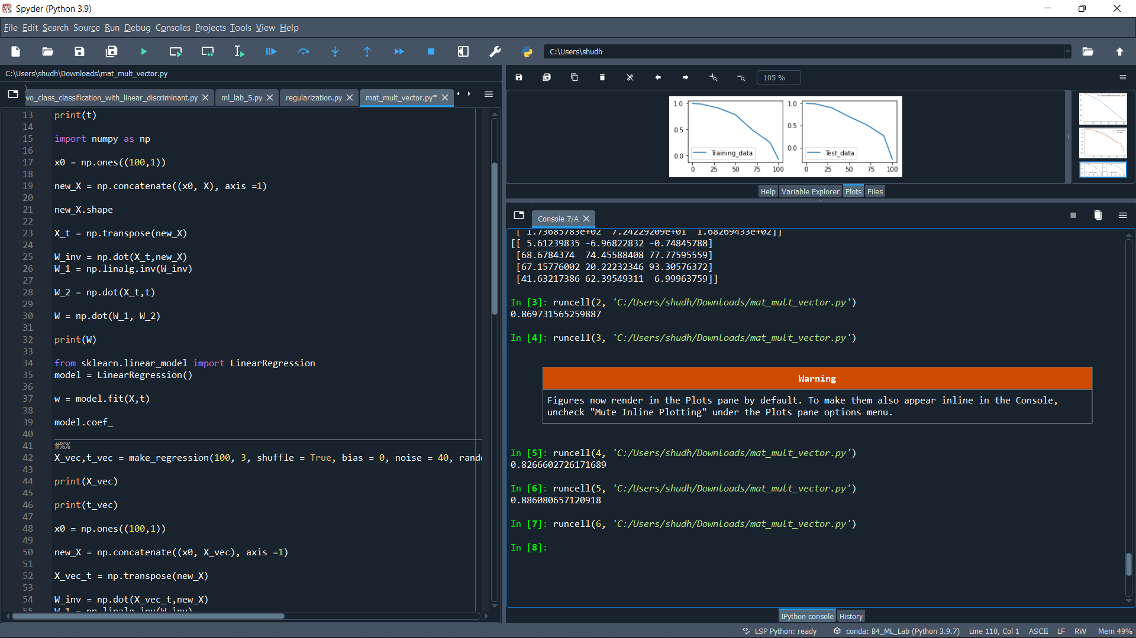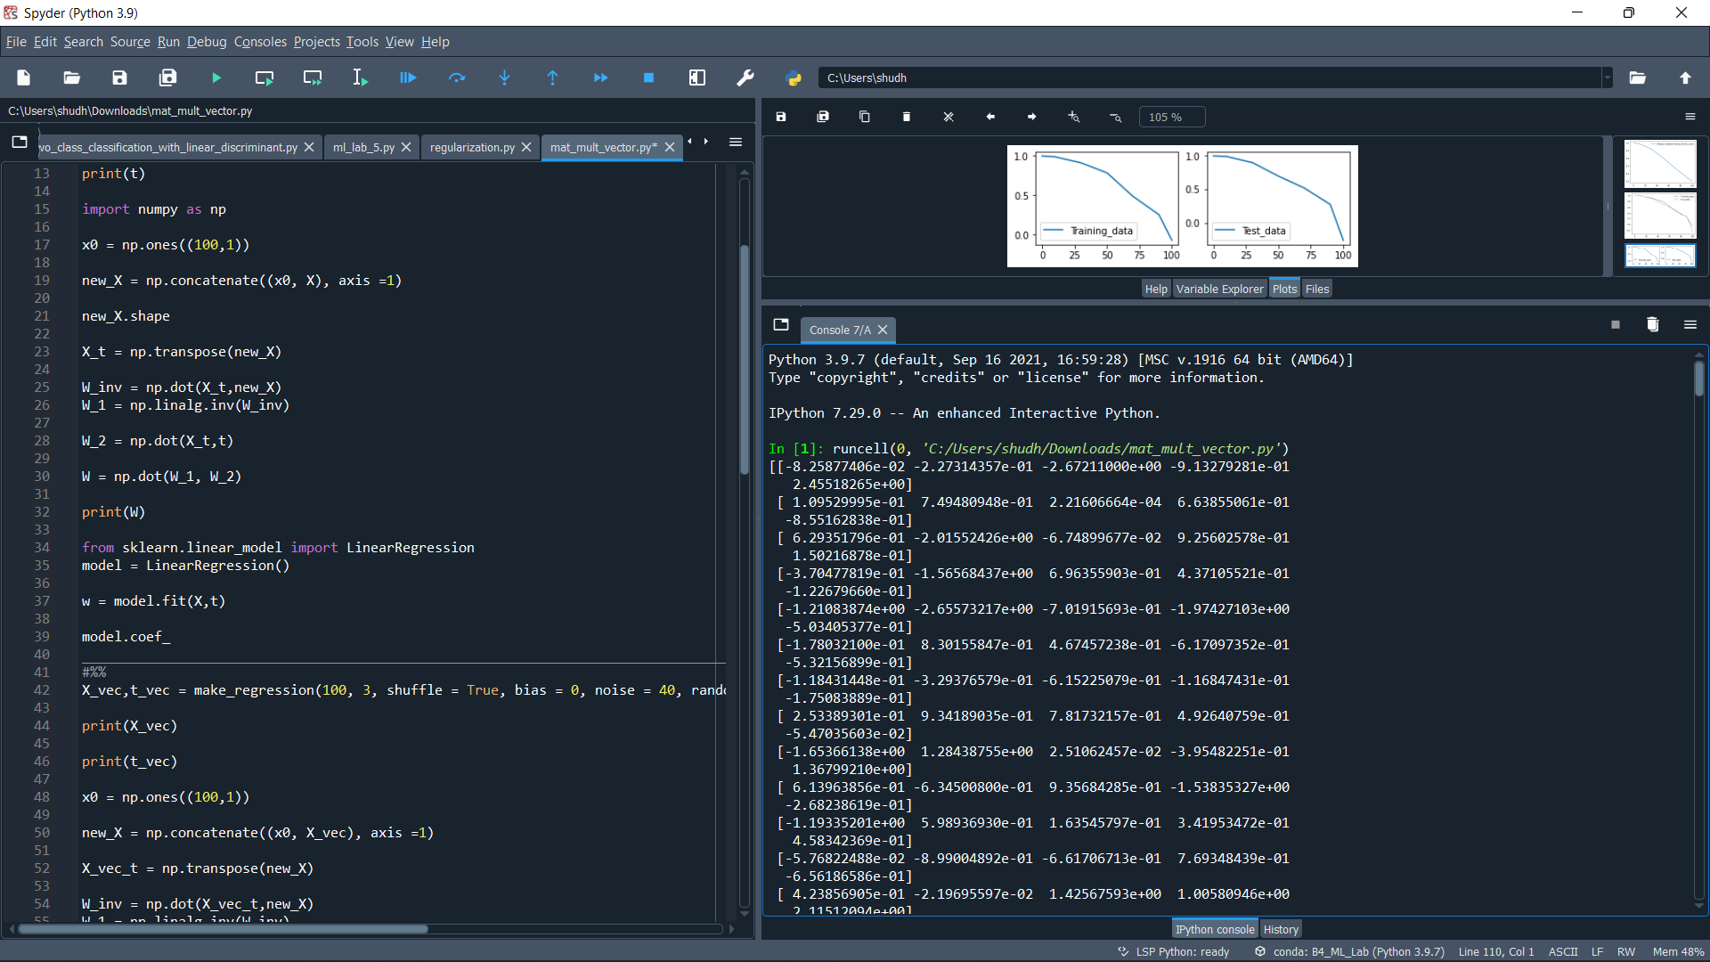

**Plots:**

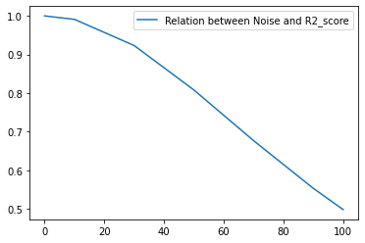

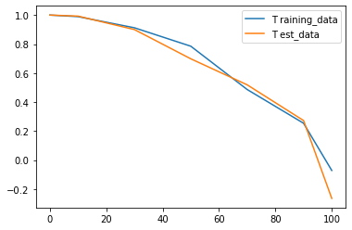

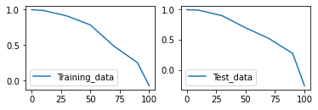

**Experiment-4**

**Objective:** To perform the Linear regression, Ridge regression, Lasso regression, Elastic Net regression and plot the R2 score vs Noise plots for training and test data.

**Code:**

from sklearn.datasets import make_regression

import matplotlib.pyplot as plt

from sklearn.model_selection import train_test_split

from sklearn.metrics import r2_score

from sklearn import linear_model

#%%

X, y = make_regression(100, 5, shuffle=True, random_state=4, noise=30, bias=0.5)

x_train, x_test, y_train, y_test= train_test_split(X, y , test_size=0.33)

Noise= [0,30,50,70,100]

#%%

#linear regression

from sklearn.linear_model import LinearRegression

lin_regressor = LinearRegression()

lin_regressor.fit(x_train, y_train)

#%%

y_pred_train= lin_regressor.predict(x_train)

score_train = r2_score(y_pred_train, y_train)

print(score_train)

#%%

y_pred_test= lin_regressor.predict(x_test)

score_test = r2_score(y_pred_test, y_test)

print (score_test)

#%%

R2_Score_Train=[1.0,0.9338632188959995,0.7681307987876425,0.5638818102318661,0.19341579821414578]

R2_Score_Test=[1.0,0.8780416755714645,0.807709667337179,0.5547090201137526,0.2435815002631775]

plt.plot(Noise,R2_Score_Train, color ='red', label = 'T rain_data')

plt.plot(Noise,R2_Score_Test, color= 'green', label = 'T est_data')

plt.legend()

plt.show()

#%%

**Output:**

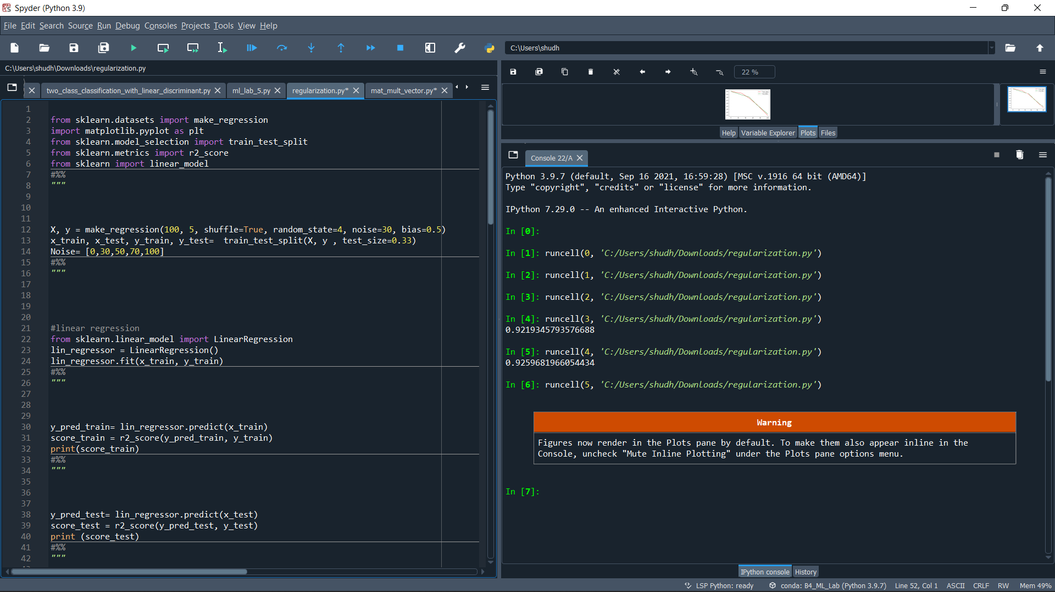

**Plots:**

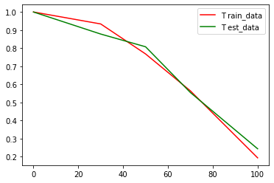

#Ridge Regression

from sklearn.linear_model import Ridge

ridge = Ridge()

ridge_regressor = linear_model.Lasso(alpha=0.1)

ridge_regressor.fit(x_train,y_train)

#%%

y_pred_train= ridge_regressor.predict(x_train)

score_train = r2_score(y_pred_train, y_train)

print(score_train)

#%%

y_pred_test= ridge_regressor.predict(x_test)

score_test = r2_score(y_pred_test, y_test)

print (score_test)

#%%

R2_Score_Train=[0.999995024924167,0.8966109961110564,0.7709951023565671,0.6109128967502577,0.10285665366728136]

R2_Score_Test=[0.9999960410078167,0.9299234763118096,0.7625033153069063,0.4257289171127968,-0.3506965355648457]

plt.plot(Noise,R2_Score_Train, color ='red', label = 'T rain_data')

plt.plot(Noise,R2_Score_Test, color= 'green', label = 'T est_data')

plt.legend()

plt.show()

#%%

**Output:**

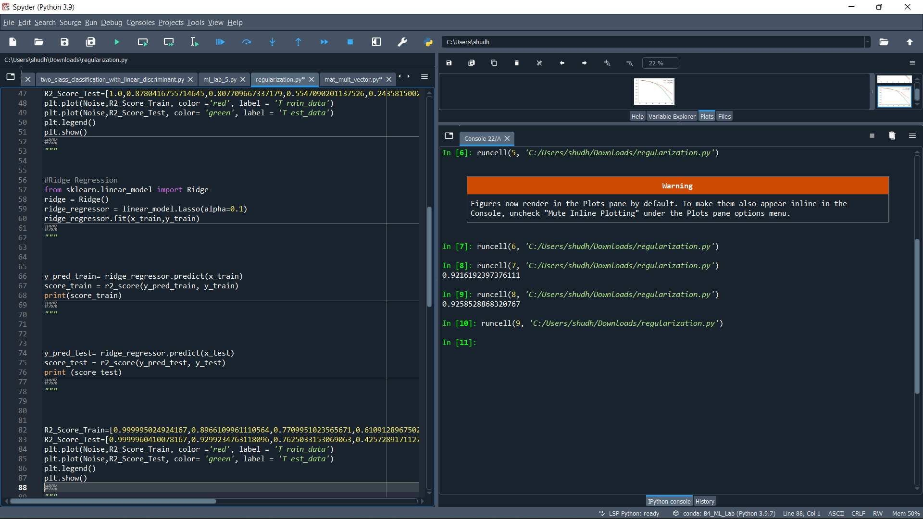

**Plots:**

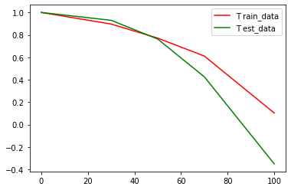

#Lasso Regression

from sklearn.linear_model import Lasso

lasso = Lasso()

lasso_regressor = linear_model.Lasso(alpha=0.1)

lasso_regressor.fit(x_train,y_train)

#%%

y_pred_train= lasso_regressor.predict(x_train)

score_train = r2_score(y_pred_train, y_train)

print(score_train)

#%%

y_pred_test= lasso_regressor.predict(x_test)

score_test = r2_score(y_pred_test, y_test)

print (score_test)

#%%

R2_Score_Train=[0.999993912857805,0.9215327005213542,0.7641070653813703,0.5207553752959468,0.18465374871908924]

R2_Score_Test=[0.999992817349997,0.9141181129090268,0.7464025562414421,0.5136900695122311,-0.2208005962922286]

plt.plot(Noise,R2_Score_Train, color ='red', label = 'T rain_data')

plt.plot(Noise,R2_Score_Test, color= 'green', label = 'T est_data')

plt.legend()

plt.show()

#%%

**Output:**

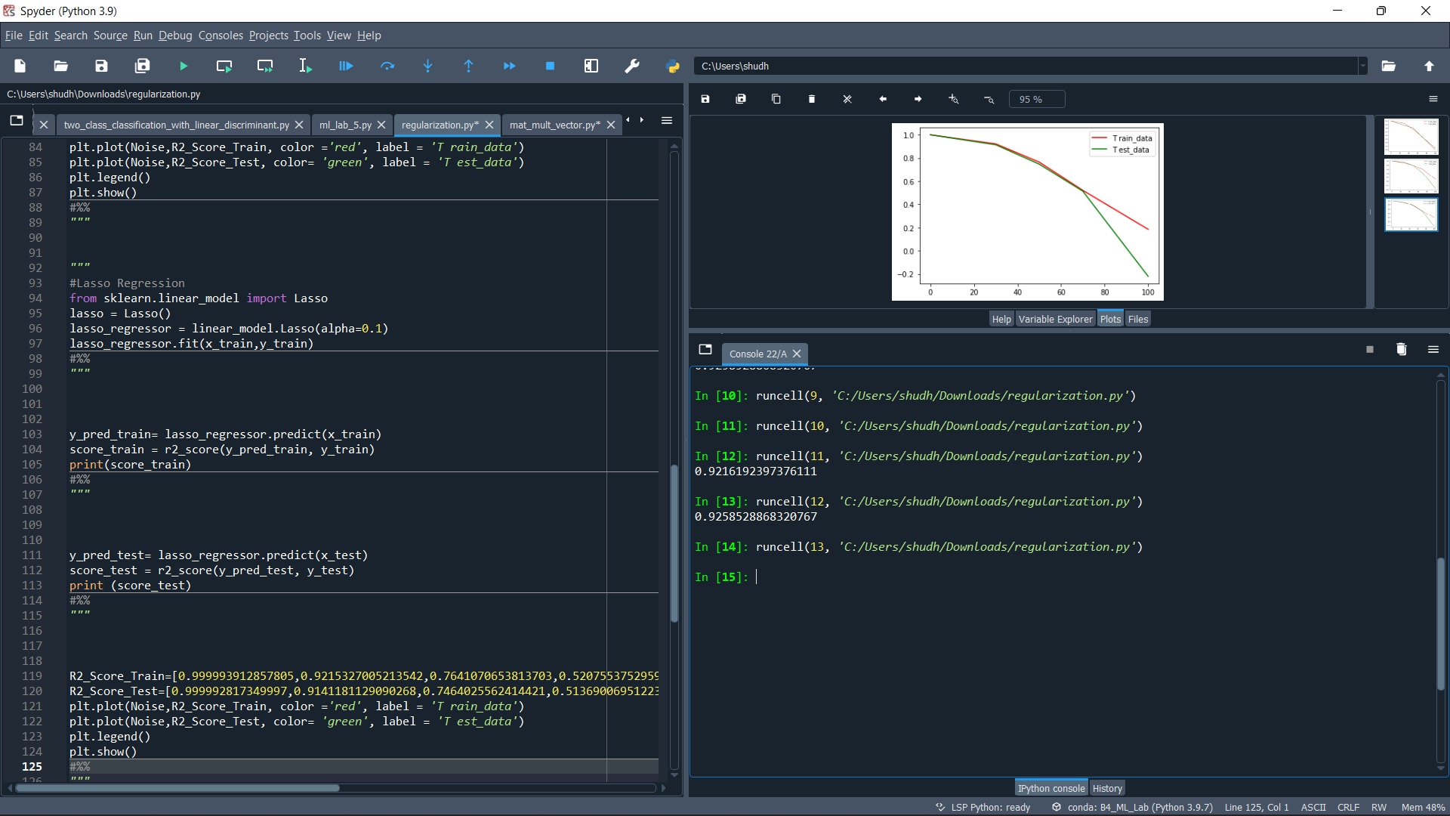

**Plots:**

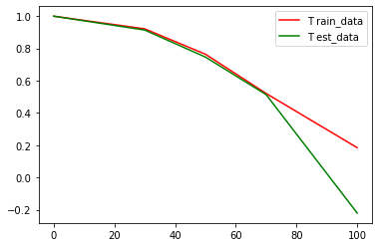

#Elastic Net Regression

from sklearn.linear_model import ElasticNet

elastic= ElasticNet()

elastic_regressor = linear_model.ElasticNet()

elastic_regressor.fit(x_train,y_train)

#%%

y_pred_train= elastic_regressor.predict(x_train)

score_train = r2_score(y_pred_train, y_train)

print(score_train)

#%%

y_pred_test= elastic_regressor.predict(x_test)

score_test = r2_score(y_pred_test, y_test)

print (score_test)

#%%

R2_Score_Train=[0.6816953388621252,0.4908848531758495,0.2002958355669644,-0.05786389200116937,-0.7035044333362195]

R2_Score_Test=[0.6590656871439343,0.18431401702049677,-0.3858669940297983,-0.05786389200116937,-2.0147826468034955]

plt.plot(Noise,R2_Score_Train, color ='red', label = 'T rain_data')

plt.plot(Noise,R2_Score_Test, color= 'green', label = 'T est_data')

plt.legend()

plt.show()

#%%

**Output:**

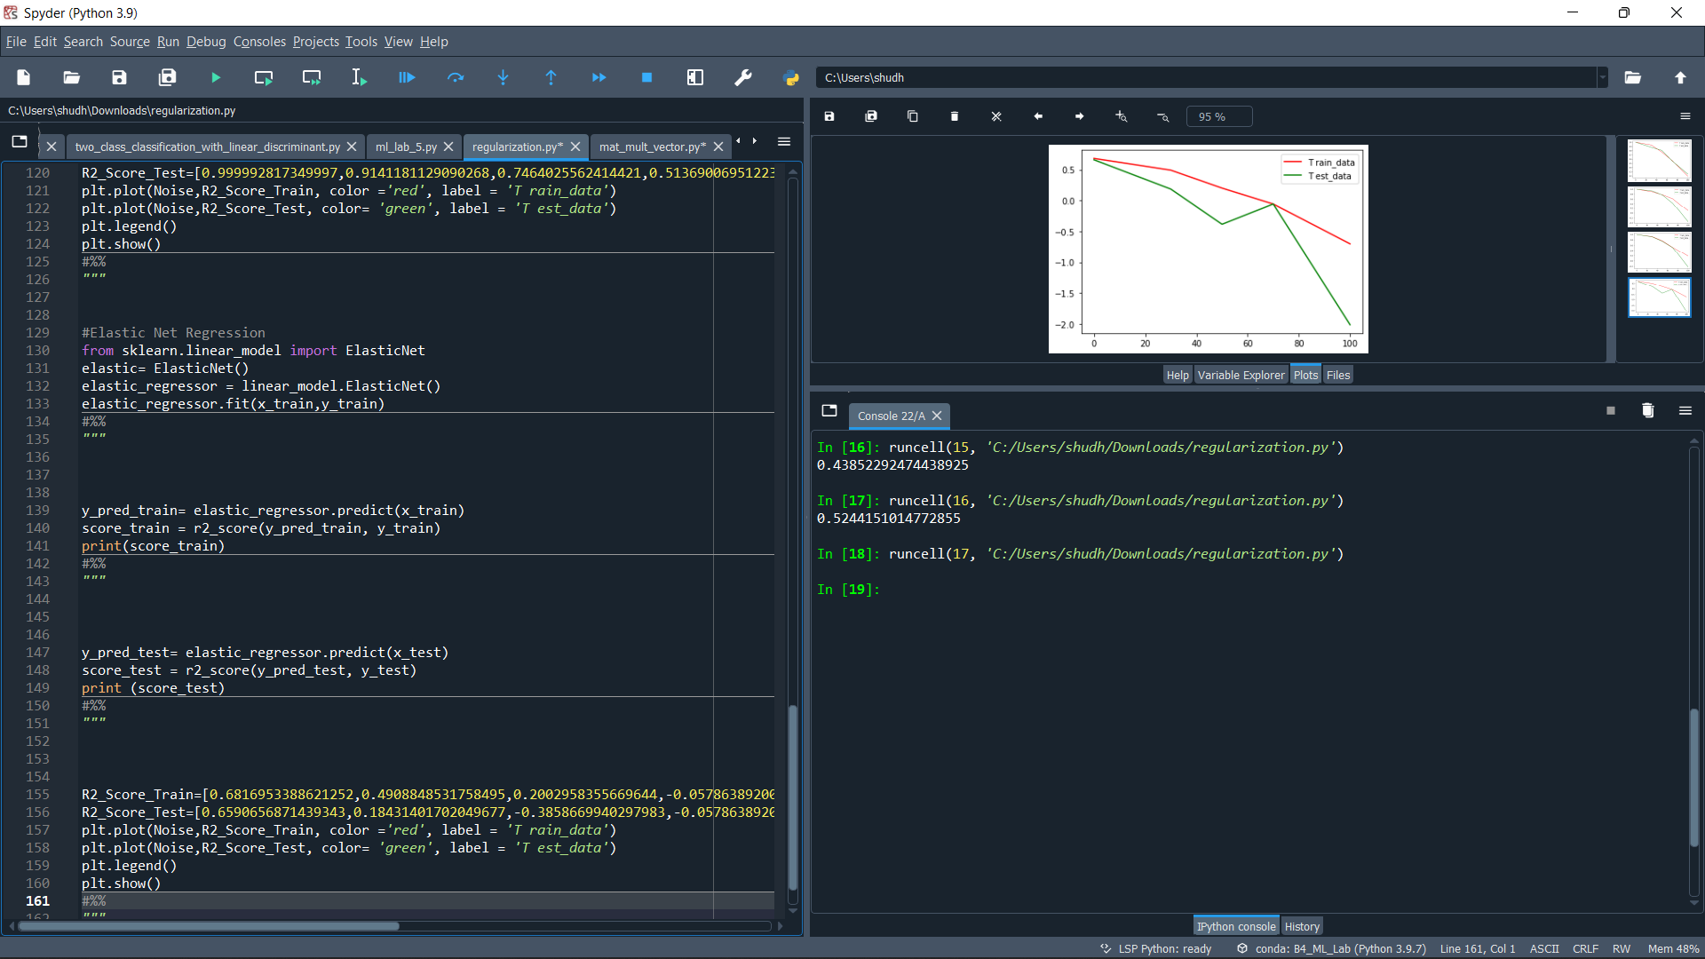

**Plots:**

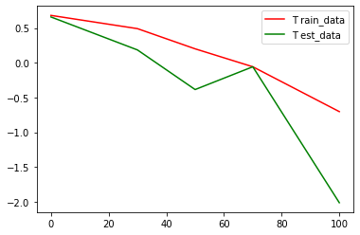

**Experiment-5**

**Objective:** To perform Logistic Regression, also interpret it’s accuracy.

**Code:**

#%%

import numpy as np

from sklearn.datasets import make_classification

from sklearn.model_selection import train_test_split

#%%

X,t= make_classification(100, 5, n_classes = 2, random_state= 15, n_informative = 2, n_clusters_per_class = 1)

#%%

X_train, X_test, t_train, t_test = train_test_split(X , t, test_size=0.2)

X0=np.ones((80,1))

new_x = np.concatenate((X0,X_train), axis = 1)

X_transpose = new_x.transpose()

X_multiply = X_transpose.dot(new_x)

X_inverse = np.linalg.inv(X_multiply)

X_multiply1 = X_inverse.dot(X_transpose)

w = X_multiply1.dot(t_train)

#%%

Y_model_train = new_x.dot(w)

print(Y_model_train)

#%%

x_0 = np.ones((20,1))

new_x_test = np.concatenate((x_0, X_test), axis = 1)

y = np.dot(new_x_test, w)

print(y)

#%%

array = []

for i in y:

if i>=0:

array.append(1)

else:

array.append(0)

print(array)

#%%

from sklearn.metrics import accuracy_score

final_score = accuracy_score(array, t_test)

print(final_score)

**Output:** 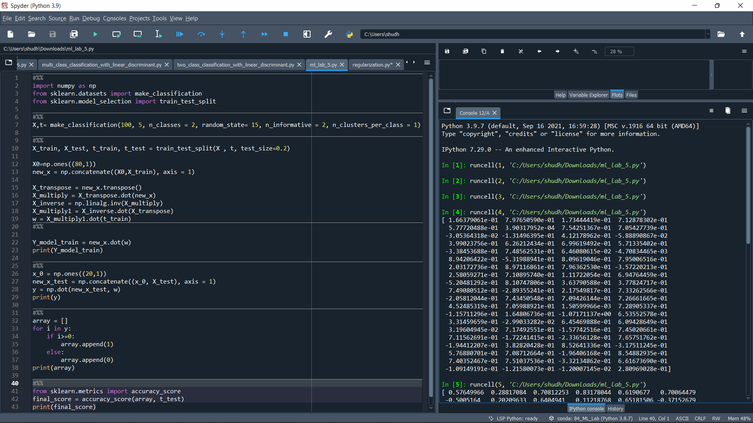

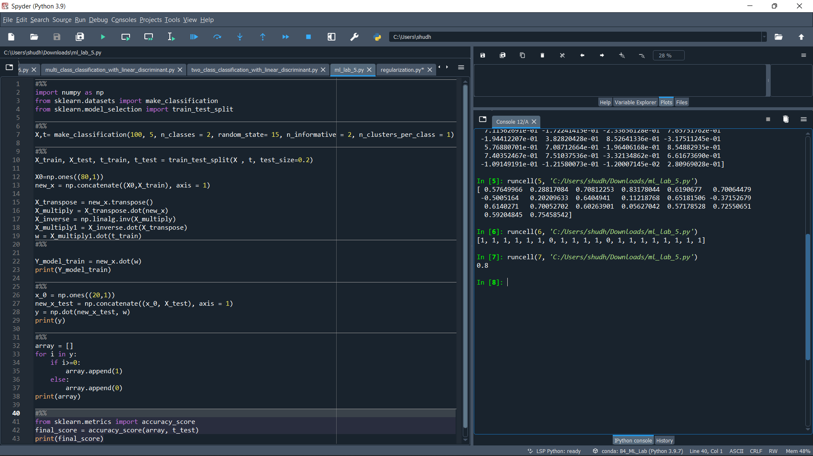

**Table:**

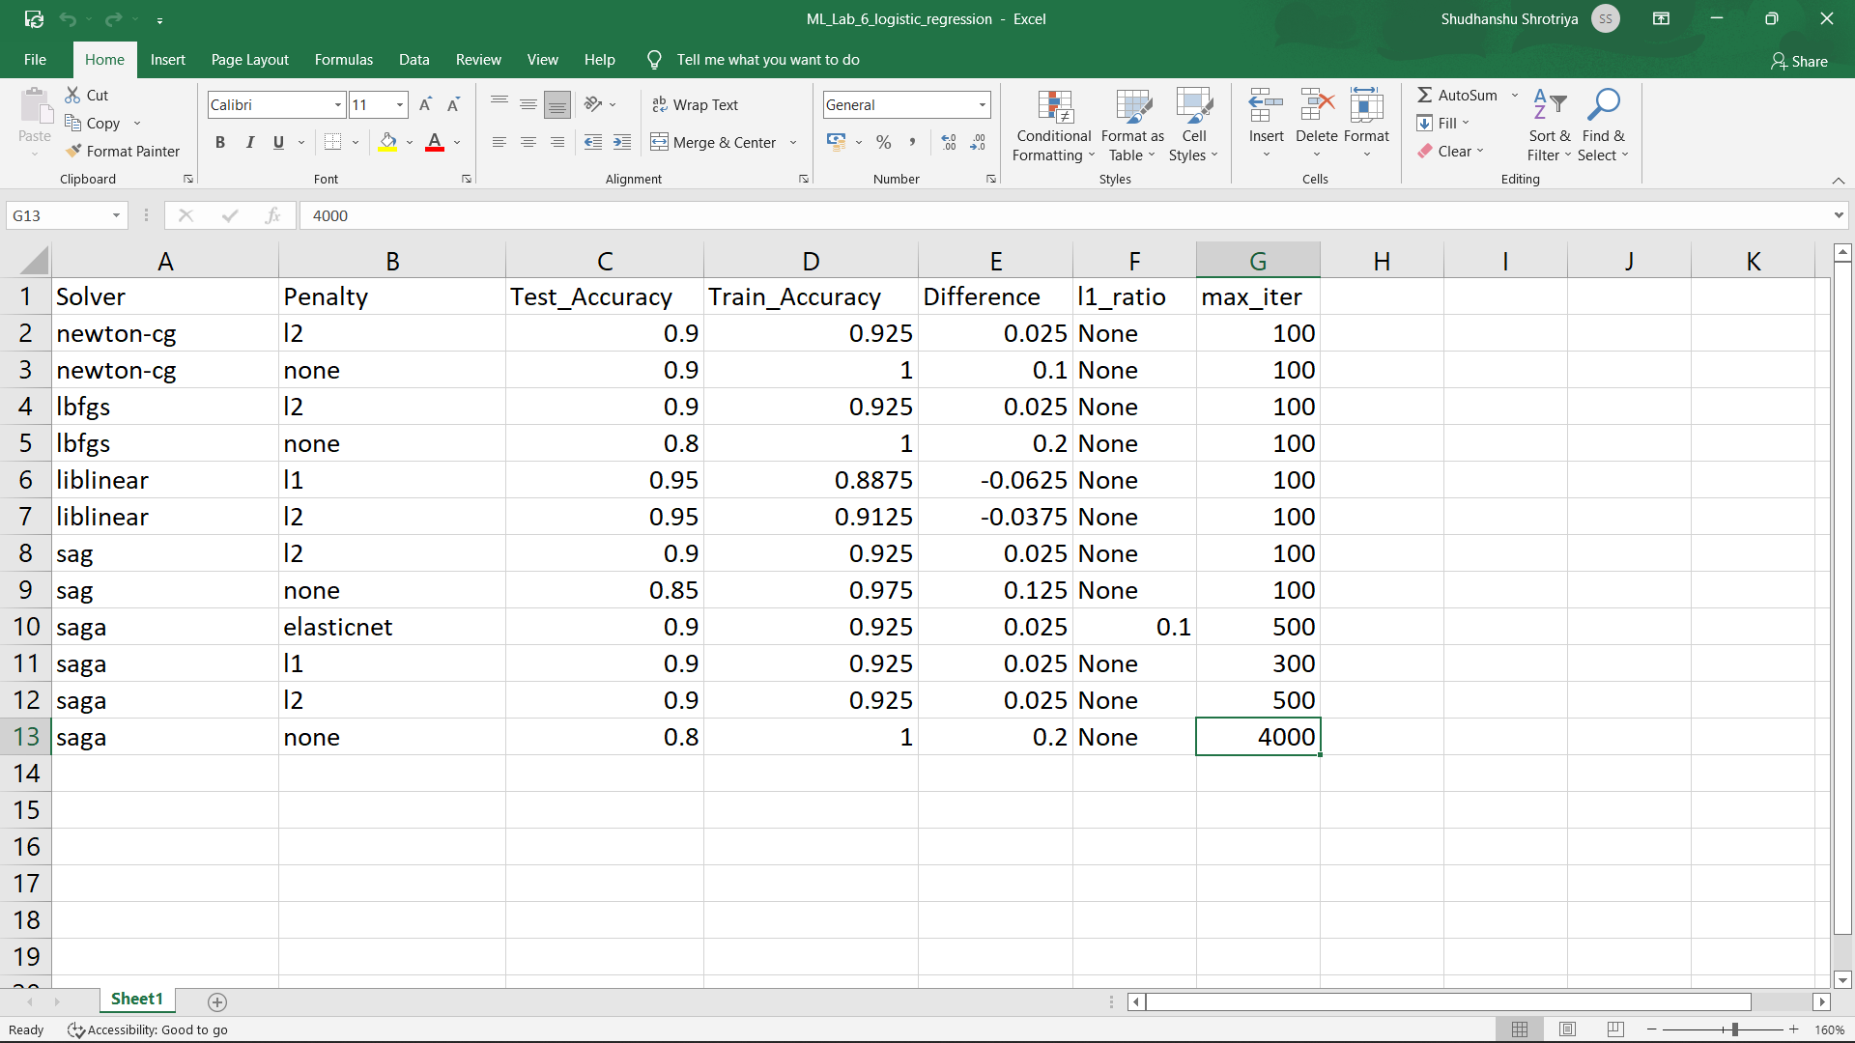

**Experiment-6**

**Objective:** To perform the classification in machine learning for 2 classes mathematically.

**Code:**

#%%

import numpy as np

from sklearn.datasets import make_classification

from sklearn.model_selection import train_test_split

#%%

X,t= make_classification(100, 5, n_classes = 2, random_state= 15, n_informative = 2, n_clusters_per_class = 1)

#%%

X_train, X_test, t_train, t_test = train_test_split(X , t, test_size=0.2)

X0=np.ones((80,1))

new_x = np.concatenate((X0,X_train), axis = 1)

X_transpose = new_x.transpose()

X_multiply = X_transpose.dot(new_x)

X_inverse = np.linalg.inv(X_multiply)

X_multiply1 = X_inverse.dot(X_transpose)

w = X_multiply1.dot(t_train)

#%%

Y_model_train = new_x.dot(w)

print(Y_model_train)

#%%

x_0 = np.ones((20,1))

new_x_test = np.concatenate((x_0, X_test), axis = 1)

y = np.dot(new_x_test, w)

print(y)

#%%

array = []

for i in y:

if i>=0:

array.append(1)

else:

array.append(0)

print(array)

#%%

from sklearn.metrics import accuracy_score

final_score = accuracy_score(array, t_test)

print(final_score)

**Output:**

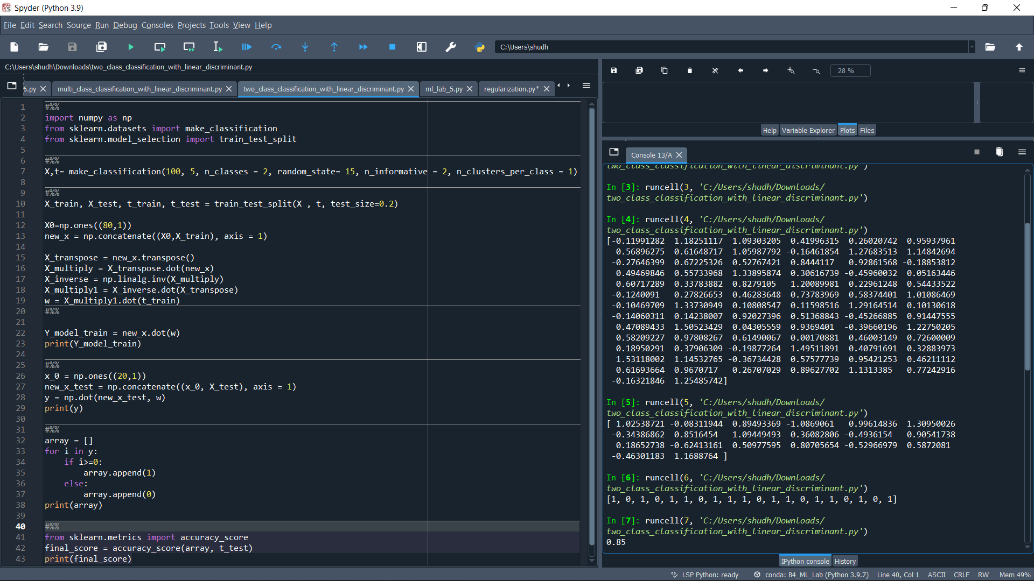

**Experiment-7**

**Objective:** To perform the classification in machine learning for multi classes mathematically.

**Code:**

#%%

import numpy as np

from sklearn.datasets import make_classification

from sklearn.model_selection import train_test_split

#%%

classes = 3

X, t = make_classification(100, 5, n_classes = classes, random_state= 40, n_informative = 2, n_clusters_per_class = 1)

res = np.zeros((t.shape[0], classes), dtype=int)

res[np.arange(t.shape[0]), t] = 1

print(res)

#%%

X_train, X_test, t_train, t_test = train_test_split(X , t, test_size=0.2)

#%%

X0 = np.ones((100,1))

new_x = np.concatenate((X0, X), axis = 1)

X_transpose = new_x.transpose()

X_multiply = X_transpose.dot(new_x)

X_inverse = np.linalg.inv(X_multiply)

X_multiply1 = X_inverse.dot(X_transpose)

#%%

w = X_multiply1.dot(res)

print(w)

#%%

x_0 = np.ones((20,1))

new_x_test = np.concatenate((x_0, X_test), axis = 1)

y = np.dot(new_x_test, w)

print(y)

#%%

z = np.argmax(y, axis = 1)

print(z)

#%%

res_z = np.zeros((z.shape[0], classes), dtype=int)

res_z[np.arange(z.shape[0]), z] = 1

print(res_z)

#%%

from sklearn.metrics import accuracy_score

final_score = accuracy_score(z, t_test)

print(final_score)

**Output:**

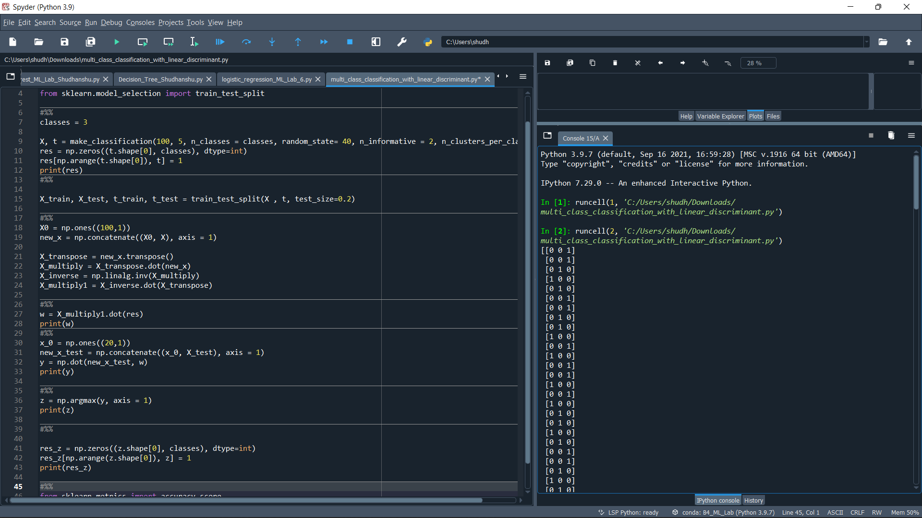

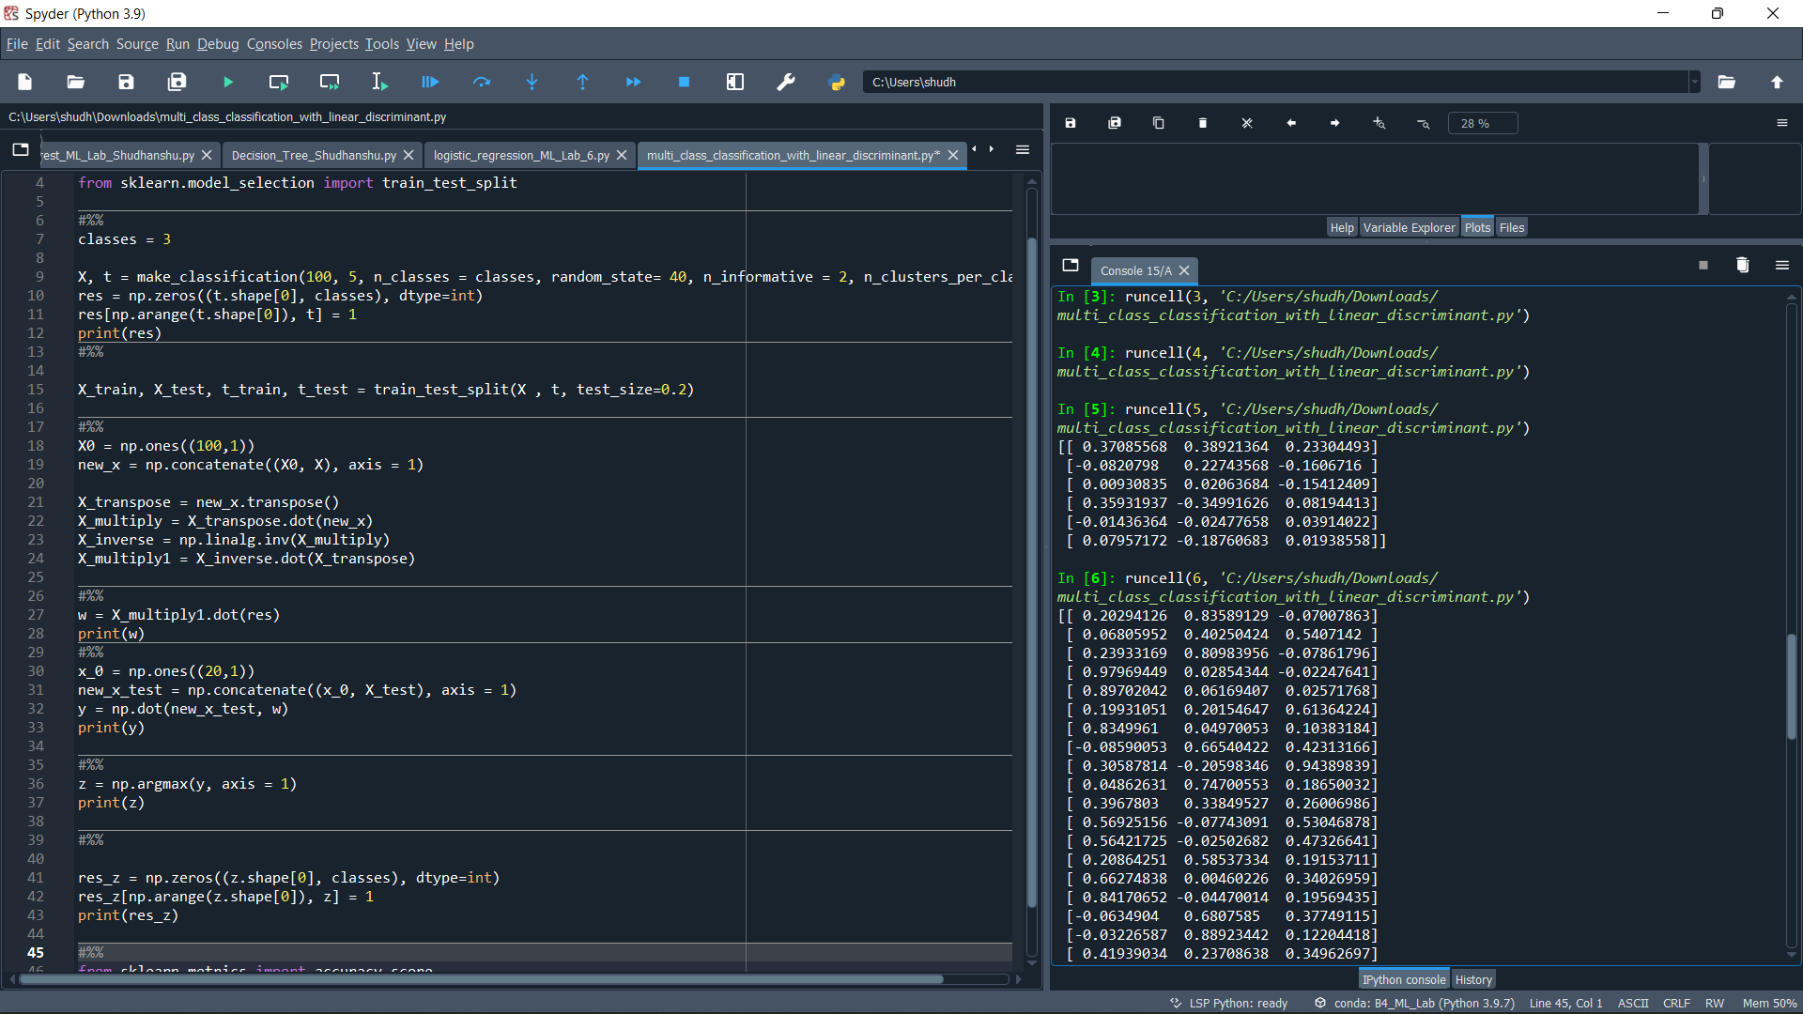

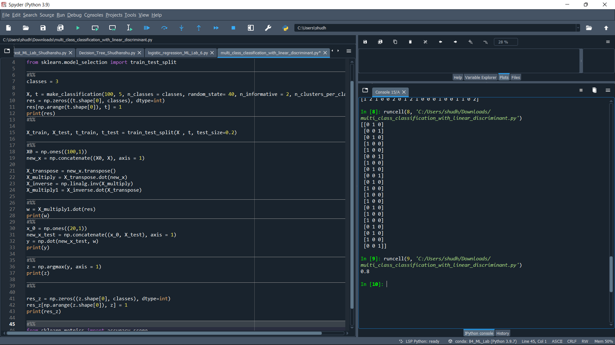

**Experiment-8**

**Objective:** To implement the Decision Tree model

**Code of Decision Tree:**

#%%

from sklearn.datasets import make_classification

from sklearn import tree

from sklearn.model_selection import train_test_split

#%%

X, t = make_classification(100, 5, n_classes = 2, shuffle = True, random_state= 10)

X_train, X_test, t_train, t_test = train_test_split(X, t, test_size=0.3, shuffle = True, random_state=1)

#%%

model = tree.DecisionTreeClassifier()

model = model.fit(X_train, t_train)

#%%

predicted_value = model.predict(X_test)

print(predicted_value)

#%%

tree.plot_tree(model)

#%%

zeroes = 0

ones = 0

for i in range(0,len(t_train)):

if t_train[i] == 0:

zeroes +=1

else:

ones +=1

#%%

print(zeroes)

print(ones)

#%%

val = 1 - ((zeroes/70)*2 + (ones/70)*2)

print("Gini :",val)

match = 0

UnMatch = 0

for i in range(30):

if predicted_value[i] == t_test[i]:

match += 1

else:

UnMatch += 1

accuracy = match/30

print("Accuracy is: ",accuracy)

**Output:**

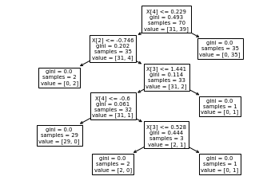

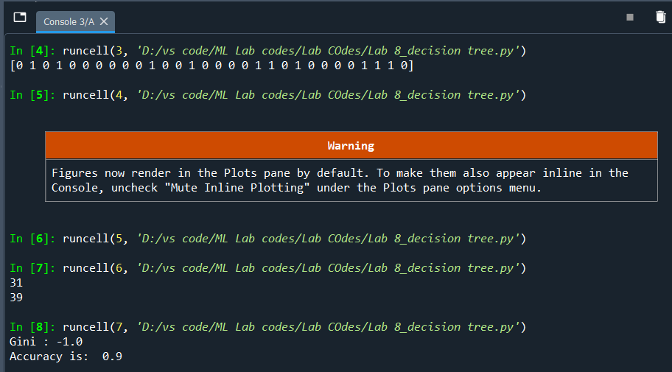

**Experiment-9**

**Objective:** To implement the Random Forest Model, Adaboost Model for Classification and Adaboost Model for Regression.

**Code of Random Forest:**

import pandas

from sklearn.preprocessing import LabelEncoder

from sklearn.model_selection import train_test_split

from sklearn.ensemble import RandomForestClassifier

#%%

data = {'CGPA':['g9','l9','g9','l9','g9'],

'Inter':['Y','N','N','N','Y'],

'PK':['++','==','==','==','=='],

'CS':['G','G','A','A','G'],

'Job':['Y','Y','N','N','Y']}

#%%

table=pandas.DataFrame(data,columns=["CGPA","Inter","PK","CS","Job"])

table.where(table["CGPA"]=="g9").count()

#%%

encoder=LabelEncoder()

for i in table:

table[i]=encoder.fit_transform(table[i])

#%%

#Use iloc property to select by position.

X=table.iloc[:,0:4].values

t=table.iloc[:,4].values

#%%

X_train,X_test,t_train,t_test=train_test_split(X,t,test_size=0.2,random_state=2)

#%%

model = RandomForestClassifier(n_estimators=3)

model.fit(X_train,t_train)

#%%

if model.predict([[0,1,1,1]])==1:

print("Got JOB")

else:

print("Didn't get JOB")

print(model.estimators_)

#%%

import matplotlib.pyplot as plt

from sklearn import tree

plt.figure(figsize=(15, 10))

tree.plot_tree(model.estimators_[2],

filled=True)

**Output:**

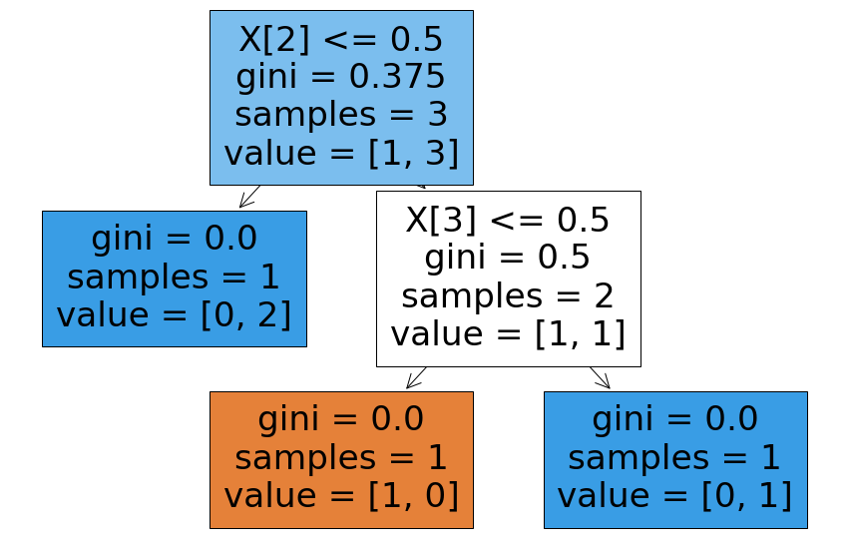

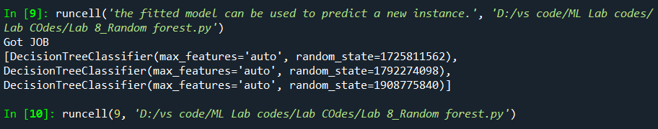

**Code of Adaboost Classification:**

import pandas

from sklearn.preprocessing import LabelEncoder

from sklearn.model_selection import train_test_split

from sklearn.ensemble import AdaBoostClassifier

#%%

data = {'CGPA':['g9','l9','g9','l9','g9'],

'Inter':['Y','N','N','N','Y'],

'PK':['++','==','==','==','=='],

'CS':['G','G','A','A','G'],

'Job':['Y','Y','N','N','Y']}

#%%

table=pandas.DataFrame(data,columns=["CGPA","Inter","PK","CS","Job"])

table.where(table["CGPA"]=="g9").count()

#%%

encoder=LabelEncoder()

for i in table:

table[i]=encoder.fit_transform(table[i])

#%%

X=table.iloc[:,0:4].values

t=table.iloc[:,4].values

#%%

X_train,X_test,t_train,t_test=train_test_split(X,t,test_size=0.2,random_state=2)

#%%

model = AdaBoostClassifier(n_estimators=3)

model.fit(X_train,t_train)

#%%

if model.predict([[0,1,1,1]])==1:

print("Got JOB")

else:

print("Didn't get JOB")

print(model.estimators_)

#%%

from sklearn import tree

tree.plot_tree(model.estimators_[0], filled=True)

**Output:**

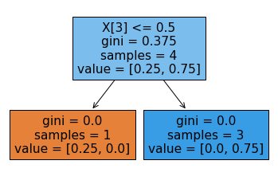

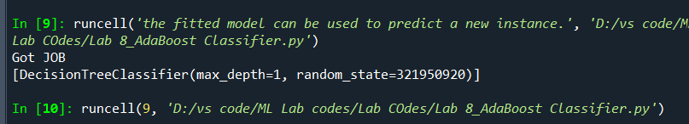

**Code of Adaboost Regression:**

#%%

from sklearn.datasets import make_regression

from sklearn.ensemble import AdaBoostRegressor

from sklearn.model_selection import train_test_split

from sklearn.metrics import r2_score

#%%

X_reg,t_reg = make_regression(100, 3, n_informative=15, noise=0.1, random_state=6)

X_train,X_test,t_train,t_test=train_test_split(X_reg,t_reg,test_size=0.3,random_state=2)

#%%

model_reg = AdaBoostRegressor()

model_reg.fit(X_train, t_train)

#%%

y_pred_train = model_reg.predict(X_train)

score_train = r2_score(y_pred_train, t_train)

print(score_train)

#%%

y_pred_test = model_reg.predict(X_test)

score_test = r2_score(y_pred_test, t_test)

print(score_test)

#%%

from sklearn import tree

tree.plot_tree(model_reg.estimators_[0], filled=True)

**Output:**

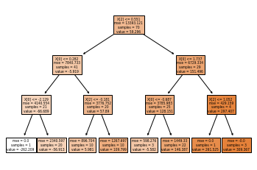

**Experiment-10**

**Objective:** To implement the Neural Network in machine learning mathematically.

**Code:**

import numpy as np

def abs(x):

return x if x>0 else -x

def sigmoid (x):

return 1/(1 + np.exp(-x))

def sigmoid_derivative(x):

return x * (1 - x)

def tanh_act(x):

return np.tanh(x)

def tanh_derivative(x):

return 1 - x**2

def checkError(predicted_output):

expected_output = [[0],[1],[1],[0]]

for i,j in zip(expected_output , predicted_output):

if abs(i[0]-j[0]) > 0.001:

return True

return False

#Input datasets

inputs = np.array([[0,0],[0,1],[1,0],[1,1]])

expected_output = np.array([[0],[1],[1],[0]])

epoch = 0

lr = 0.1

# inputLayerNeurons = 2

# hiddenLayerNeurons = 2

# outputLayerNeurons = 1

inputLayerNeurons = int(input("enter no of inputLayer"))

hiddenLayerNeurons = int(input("enter no of hiddenlayer "))

outputLayerNeurons = int(input("enter no of outputlayer "))

hidden_weights = []

for i in range(1,inputLayerNeurons+1):

hidden_weights_ind = []

for j in range(inputLayerNeurons+1,inputLayerNeurons+hiddenLayerNeurons+1):

hidden_weights_ind.append(float(input('w'+str(i)+str(j))))

hidden_weights.append(hidden_weights_ind)

output_weights = []

for i in range(inputLayerNeurons+1,inputLayerNeurons+hiddenLayerNeurons+1):

output_weights_ind = []

for j in range(inputLayerNeurons+hiddenLayerNeurons+1,inputLayerNeurons+hiddenLayerNeurons+outputLayerNeurons+1):

output_weights_ind.append(float(input('w'+str(i)+str(j))))

output_weights.append(output_weights_ind)

hidden_bias = []

output_bias = []

for i in range(inputLayerNeurons+1,inputLayerNeurons+hiddenLayerNeurons+outputLayerNeurons+1):

if i > inputLayerNeurons+hiddenLayerNeurons:

output_bias.append(float(input("o"+str(i))))

else:

hidden_bias.append(float(input("o"+str(i))))

hidden_weights = np.asarray(hidden_weights)

hidden_bias = np.asarray([hidden_bias])

output_weights = np.asarray(output_weights)

output_bias = np.asarray([output_bias])

print("Initial hidden weights: ",end='')

print(*hidden_weights)

print("Initial hidden biases: ",end='')

print(*hidden_bias)

print("Initial output weights: ",end='')

print(*output_weights)

print("Initial output biases: ",end='')

print(*output_bias)

predicted_output = [[0],[0],[0],[0]]

#Training algorithm

while checkError(predicted_output):

epoch += 1

#Forward Propagation

hidden_layer_activation = np.dot(inputs,hidden_weights)

hidden_layer_activation += hidden_bias

hidden_layer_output = tanh_act(hidden_layer_activation)

output_layer_activation = np.dot(hidden_layer_output,output_weights)

output_layer_activation += output_bias

predicted_output = tanh_act(output_layer_activation)

#Backpropagation

error = expected_output - predicted_output

d_predicted_output = error * tanh_derivative(predicted_output)

error_hidden_layer = d_predicted_output.dot(output_weights.T)

d_hidden_layer = error_hidden_layer * tanh_derivative(hidden_layer_output)

#Updating Weights and Biases

output_weights += hidden_layer_output.T.dot(d_predicted_output) * lr

output_bias += np.sum(d_predicted_output,axis=0,keepdims=True) * lr

hidden_weights += inputs.T.dot(d_hidden_layer) * lr

hidden_bias += np.sum(d_hidden_layer,axis=0,keepdims=True) * lr

print("Final hidden weights: ",end='')

print(*hidden_weights)

print("Final hidden bias: ",end='')

print(*hidden_bias)

print("Final output weights: ",end='')

print(*output_weights)

print("Final output bias: ",end='')

print(*output_bias)

print("\nOutput from neural network: ",end='')

print(*predicted_output)

print("\nNo of epochs")

print(epoch)

**Output:**

**For Activation Function -> tanh**

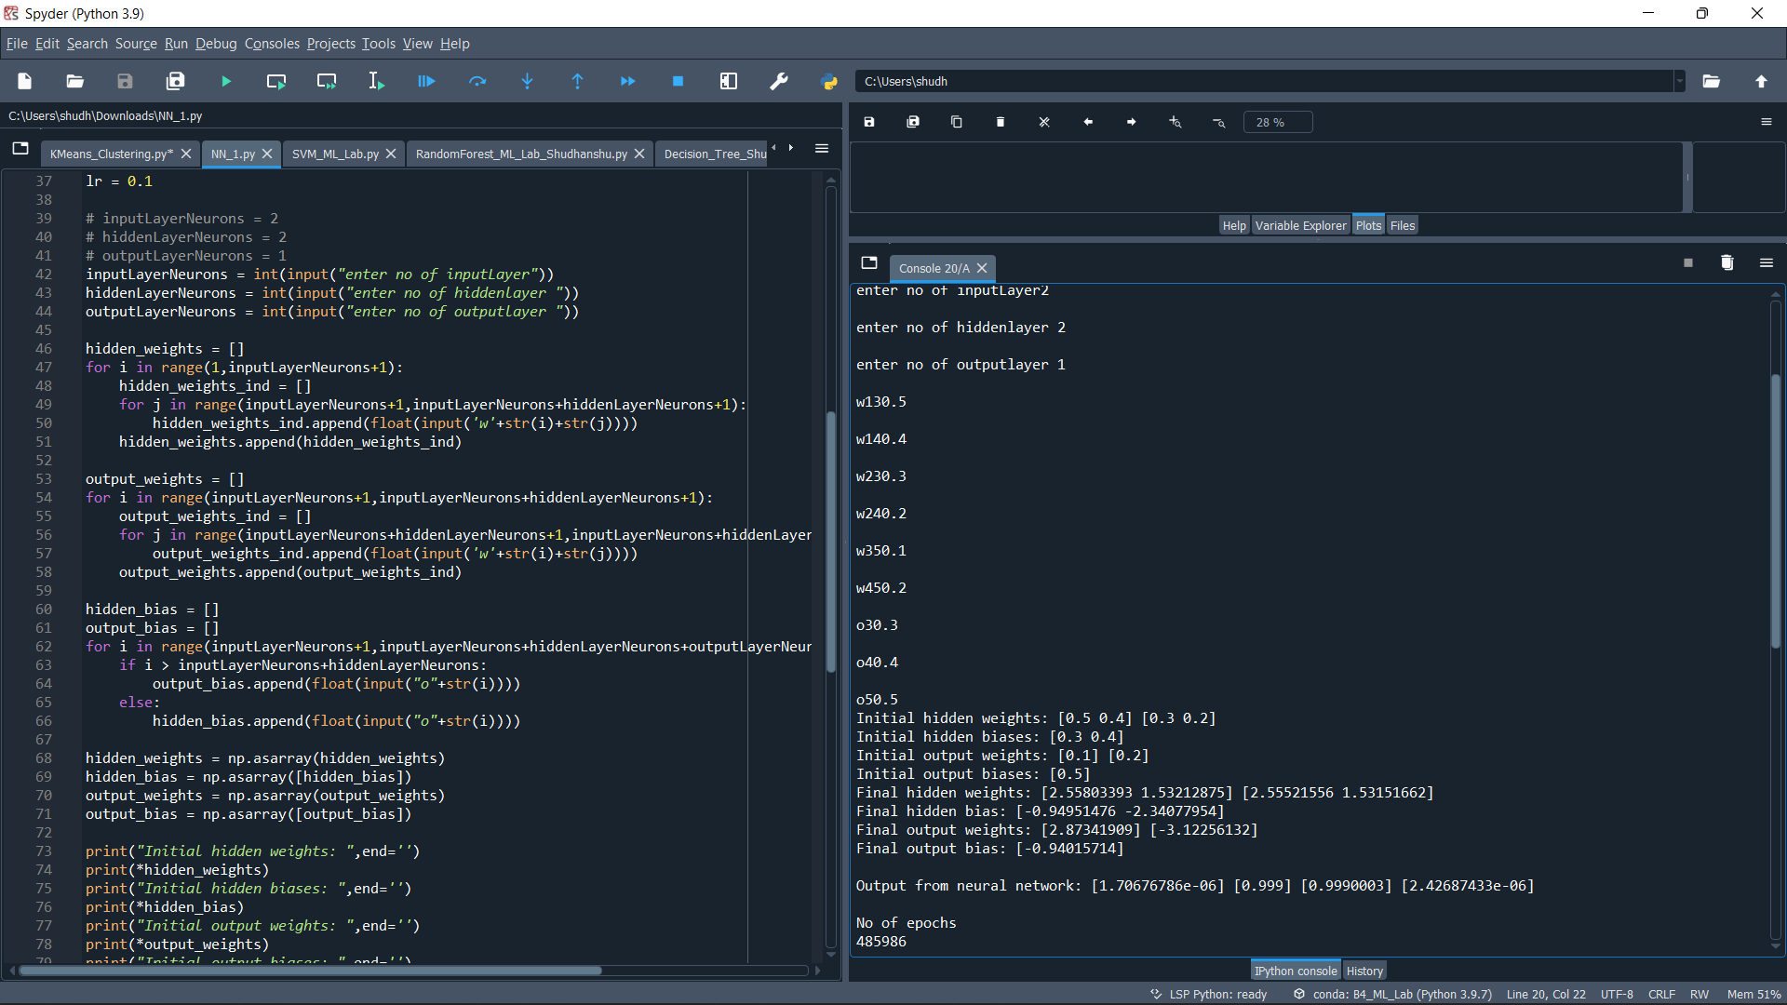

**For Activation Function -> sigmoid**

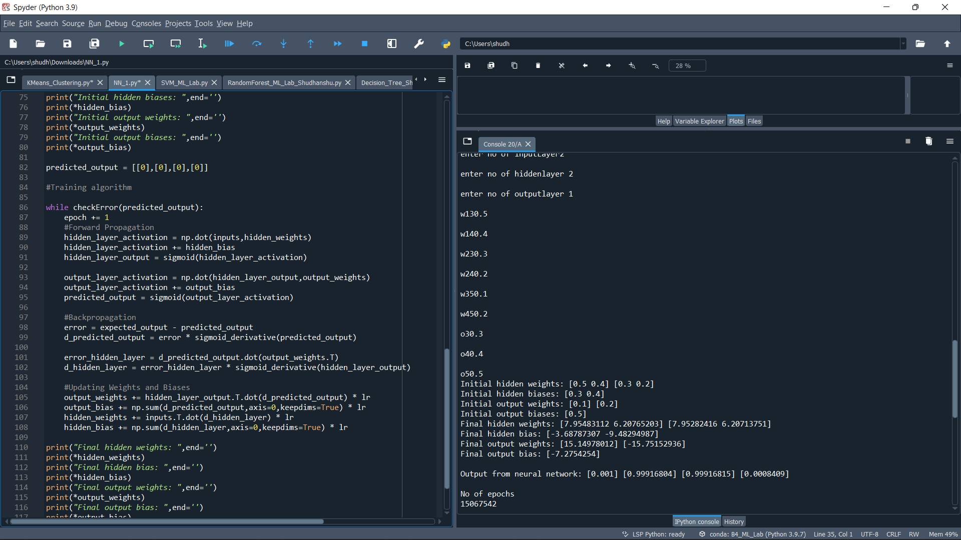

**Experiment-11**

**Objective:** To implement Support Vector Machine (SVM) in machine learning.

**Code for Support Vector Machine:**

#%%

import numpy as np

from sklearn.datasets import make_classification

from sklearn.model_selection import train_test_split

import matplotlib.pyplot as plt

import seaborn as sns

#%%

X,t= make_classification(500, 5, n_classes = 3, random_state= 50, n_informative = 3, n_clusters_per_class = 1)

#%%

X_train, X_test, t_train, t_test = train_test_split(X , t, test_size=0.2, random_state = 40)

#%%

plt.scatter(X_train[:, 0], X_train[:, 1], c = t_train, marker='.')

plt.show()

#%%

from sklearn import svm

model_svm = svm.SVC(kernel = "linear")

model_svm.fit(X_train, t_train)

y_pred = model_svm.predict(X_test)

#%%

from sklearn.metrics import accuracy_score

final_score = accuracy_score(t_test, y_pred)

print(final_score)

#%%

import random

import numpy as np

import pandas as pd

import matplotlib.pyplot as plt

def generate_random_dataset(size):

""" Generate a random dataset and that follows a quadratic distribution

"""

x = []

y = []

target = []

for i in range(size):

# class zero

x.append(np.round(random.uniform(0, 2.5), 1))

y.append(np.round(random.uniform(0, 20), 1))

target.append(0) # class one

x.append(np.round(random.uniform(1, 5), 2))

y.append(np.round(random.uniform(20, 25), 2))

target.append(1)

x.append(np.round(random.uniform(3, 5), 2))

y.append(np.round(random.uniform(5, 25), 2))

target.append(1)

df_x = pd.DataFrame(data=x)

df_y = pd.DataFrame(data=y)

df_target = pd.DataFrame(data=target)

data_frame = pd.concat([df_x, df_y], ignore_index=True, axis=1)

data_frame = pd.concat([data_frame, df_target], ignore_index=True, axis=1)

data_frame.columns = ['x', 'y', 'target']

return data_frame

# Generate dataset

size = 100

dataset = generate_random_dataset(size)

features = dataset[['x', 'y']]

label = dataset['target']# Hold out 20% of the dataset for training

test_size = int(np.round(size * 0.2, 0))# Split dataset into training and testing sets

x_train = features[:-test_size].values

y_train = label[:-test_size].values

x_test = features[-test_size:].values

y_test = label[-test_size:].values

#%%

fig, ax = plt.subplots(figsize=(12, 7))# removing to and right border

ax.spines['top'].set_visible(False)

ax.spines['left'].set_visible(False)

ax.spines['right'].set_visible(False)# adding major gridlines

ax.grid(color='grey', linestyle='-', linewidth=0.25, alpha=0.5)

ax.scatter(features[:-test_size]['x'], features[:-test_size]['y'], color="#8C7298")

plt.show()

#%%

from sklearn import svm

model = svm.SVC(kernel='linear')

model.fit(x_train, y_train)

#%%

fig, ax = plt.subplots(figsize=(12, 7))# Removing to and right border

ax.spines['top'].set_visible(False)

ax.spines['left'].set_visible(False)

ax.spines['right'].set_visible(False)# Create grid to evaluate model

xx = np.linspace(-1, max(features['x']) + 1, len(x_train))

yy = np.linspace(0, max(features['y']) + 1, len(y_train))

YY, XX = np.meshgrid(yy, xx)

xy = np.vstack([XX.ravel(), YY.ravel()]).T

train_size = len(features[:-test_size]['x'])# Assigning different colors to the classes

colors = y_train

colors = np.where(colors == 1, '#8C7298', '#4786D1')# Plot the dataset

ax.scatter(features[:-test_size]['x'], features[:-test_size]['y'], c=colors)# Get the separating hyperplane

Z = model.decision_function(xy).reshape(XX.shape)

# Draw the decision boundary and margins

ax.contour(XX, YY, Z, colors='k', levels=[-1, 0, 1], alpha=0.5, linestyles=['--', '-', '--'])# Highlight support vectors with a circle around them

ax.scatter(model.support_vectors_[:, 0], model.support_vectors_[:, 1], s=100, linewidth=1, facecolors='none', edgecolors='k')

plt.show()

**Output:**

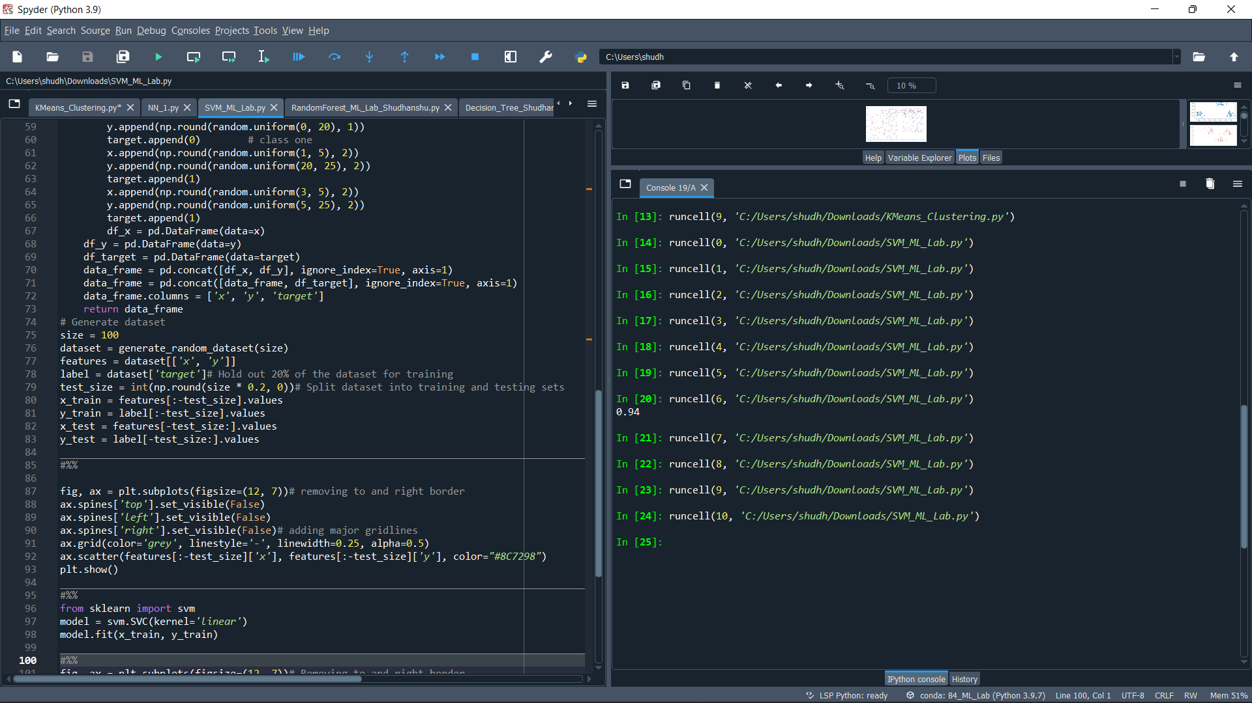

**Plots:**

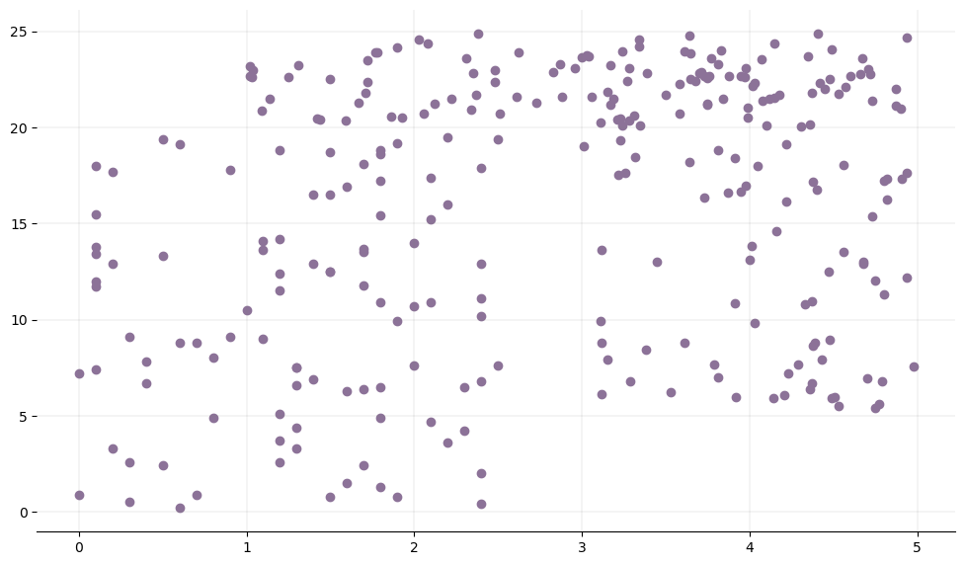

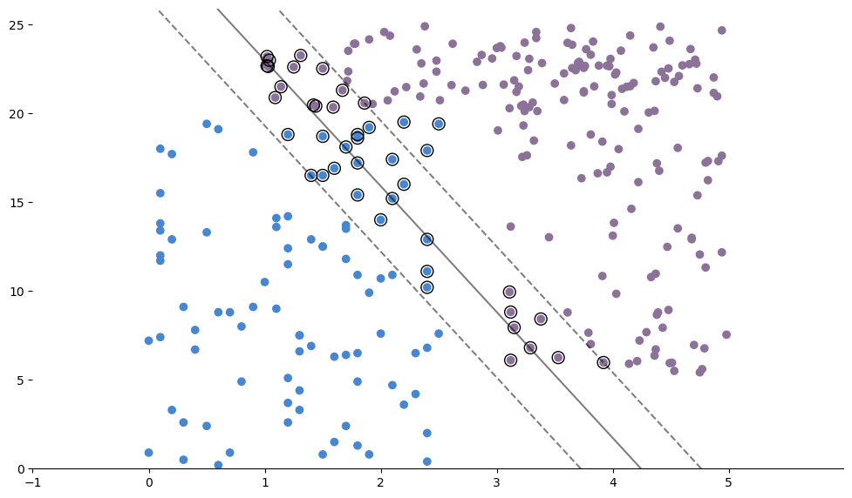

**Experiment-12**

**Objective:** To implement the K-Means Clustering Algorithm in Machine Learning

**Code for KMeans:**

#%%

import pandas as pd

import numpy as np

import matplotlib.pyplot as plt

import seaborn as sns

#%%

from sklearn.datasets import make_blobs

X, y = make_blobs(n_samples=100, centers=5, random_state=101)

#%%

# setting the number of training examples

m=X.shape[0]

n=X.shape[1]

n_iter=50

#%%

# computing the initial centroids randomly

K=5

import random

# creating an empty centroid array

centroids=np.array([]).reshape(n,0)

# creating 5 random centroids

for k in range(K):

centroids=np.c_[centroids,X[random.randint(0,m-1)]]

#%%

output={}

# creating an empty array

euclid=np.array([]).reshape(m,0)

# finding distance between for each centroid

for k in range(K):

dist=np.sum((X-centroids[:,k])**2,axis=1)

euclid=np.c_[euclid,dist]

# storing the minimum value we have computed

minimum=np.argmin(euclid,axis=1)+1

#%%

# computing the mean of separated clusters

cent={}

for k in range(K):

cent[k+1]=np.array([]).reshape(2,0)

# assigning of clusters to points

for k in range(m):

cent[minimum[k]]=np.c_[cent[minimum[k]],X[k]]

for k in range(K):

cent[k+1]=cent[k+1].T

# computing mean and updating it

for k in range(K):

centroids[:,k]=np.mean(cent[k+1],axis=0)

#%%

# repeating the above steps again and again

for i in range(n_iter):

euclid=np.array([]).reshape(m,0)

for k in range(K):

dist=np.sum((X-centroids[:,k])**2,axis=1)

euclid=np.c_[euclid,dist]

C=np.argmin(euclid,axis=1)+1

cent={}

for k in range(K):

cent[k+1]=np.array([]).reshape(2,0)

for k in range(m):

cent[C[k]]=np.c_[cent[C[k]],X[k]]

for k in range(K):

cent[k+1]=cent[k+1].T

for k in range(K):

centroids[:,k]=np.mean(cent[k+1],axis=0)

final=cent

#%%

plt.scatter(X[:,0],X[:,1])

plt.rcParams.update({'figure.figsize':(10,7.5), 'figure.dpi':100})

plt.title('Original Dataset')

#%%

for k in range(K):

plt.scatter(final[k+1][:,0],final[k+1][:,1])

plt.scatter(centroids[0,:],centroids[1,:],s=300,c='yellow')

plt.rcParams.update({'figure.figsize':(10,7.5), 'figure.dpi':100})

plt.show()

#%%

from sklearn.datasets.samples_generator import make_blobs

X, y = make_blobs(n_samples=100, centers=5, random_state=101)

#%%

#ELBOW_METHOD

import seaborn as sns

from sklearn.cluster import KMeans

elbow=[]

for i in range(1, 20):

kmeans = KMeans(n_clusters = i, init = 'k-means++', random_state = 101)

kmeans.fit(X)

elbow.append(kmeans.inertia_)

sns.lineplot(range(1, 20), elbow,color='blue')

plt.rcParams.update({'figure.figsize':(10,7.5), 'figure.dpi':100})

plt.title('ELBOW METHOD')

plt.show()

**Output:**

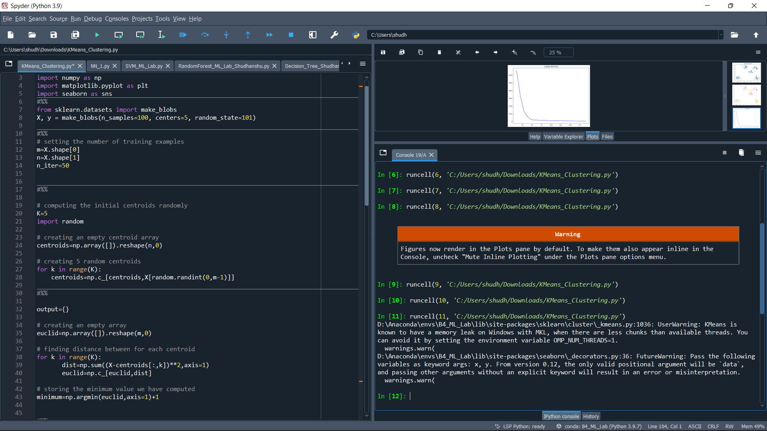

**Plots:**

