# Cats

1. Bengal
2. Ragdoll
3. Moggy

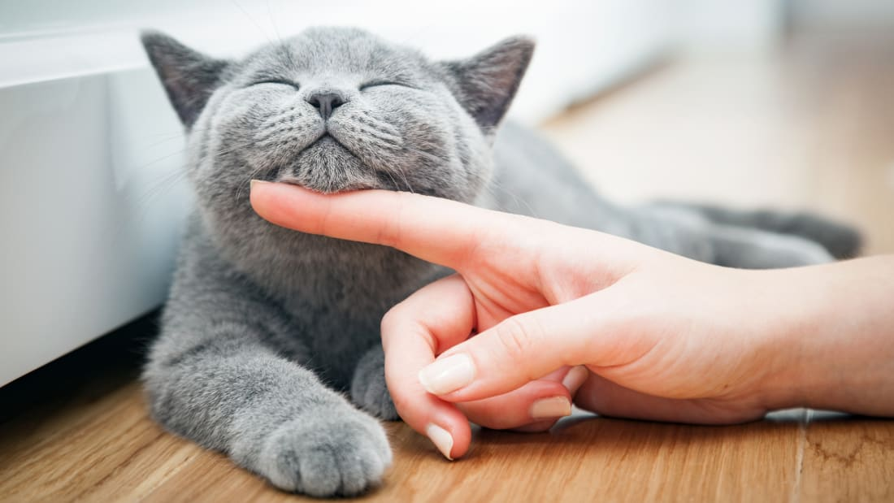

cat

[Hit me up if you have whiskers.](mailto:kristian.brock@gmail.com).