**Entwicklung des Tabak-, Alkohol- und illegalen Drogenkonsums bei 12- bis 25-Jährigen in Prozent der Befragten von 1973 - 2011.**

* Gliederungsmerkmale: Jahre, Deutschland, Geschlecht

*Mögliche Aufgaben:*

* Transformation in tidy data
* Vergleiche: weiblich – männlich, Substanzen
* Spread, gather
* Verläufe

**Nutzung von Informationsquellen über Gesundheit**

Nutzung von Informationsquellen zu gesundheitlichen Themen in Prozent nach Alter, Geschlecht und sozialer Schicht, 2002/2003

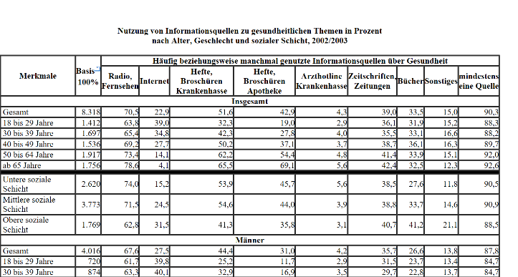<http://www.gbe-bund.de/gbe10/ergebnisse.prc_tab?fid=9778&suchstring=&query_id=&sprache=D&fund_typ=TAB&methode=&vt=&verwandte=1&page_ret=0&seite=1&p_lfd_nr=8&p_news=&p_sprachkz=D&p_uid=gast&p_aid=54366287&hlp_nr=2&p_janein=J#PAGE=22>

*Mögliche Aufgaben:*

* Transformation in tidy data
* Vergleiche: weiblich/männlich, Alter, Schicht, Medium
* Spread, gather

**Sleep and Eye witness memory**

<https://easy.dans.knaw.nl/ui/datasets/id/easy-dataset:73640>

Abstract: Inaccurate eyewitness identifications are the leading cause of known false convictions in the United States. Moreover, improving eyewitness memory is difficult and often unsuccessful. Sleep consistently strengthens and protects memory from interference, particularly when a recall test is used. However, the effect of sleep on recognition memory is more equivocal. Eyewitness identification tests are often recognition based, thus leaving open the question of how sleep affects recognition performance in an eyewitness context. In the current study, we investigated the effect of sleep on eyewitness memory. Participants watched a video of a mock-crime and attempted to identify the perpetrator from a simultaneous lineup after a 12-hour retention interval that either spanned a waking day or night of sleep. In Experiment 1, we used a target-present lineup and, in Experiment 2, we used a target-absent lineup in order to investigate correct and false identifications, respectively. Sleep reduced false identifications in the target-absent lineup (Experiment 2) but had no effect on correct identifications in the target-present lineup (Experiment 1). These results are discussed with respect to memory strength and decision making strategies.



**International Crime Victims Surveys - ICVS - 1989, 1992, 1996, 2000, 2005**

<https://easy.dans.knaw.nl/ui/datasets/id/easy-dataset:44578/tab/1>

Integrated Database from the International Crime Victims Survey - ICVS 1989-2005, and the European Survey on Crime and Safety - EU ICS 2005. The ICVS is a programme of standardised sample surveys to look at householders’ experience with crime, policing, crime prevention and feelings of unsafety in a large number of countries.

**ISSP: annual surveys on diverse topics relevant to social sciences.**

http://www.issp.org/data-download

**Youth cultural styles: a culture gap between the generations?**

This study examines the connection between adolescents' tastes and those of their parents and best friend. Central question: is there a culture gap between the generations?

<https://easy.dans.knaw.nl/ui/datasets/id/easy-dataset:45913/tab/1>

Vorteil: Paper verfügbar

Nachteil: Variablennamen auf Niederländisch

**Cultural orientations of youth**

<https://easy.dans.knaw.nl/ui/datasets/id/easy-dataset:45928/tab/2>

Vorteil: Paper + Fragebögen verfügbar

Nachteil: Variablennamen und Fragebögen auf Niederländisch