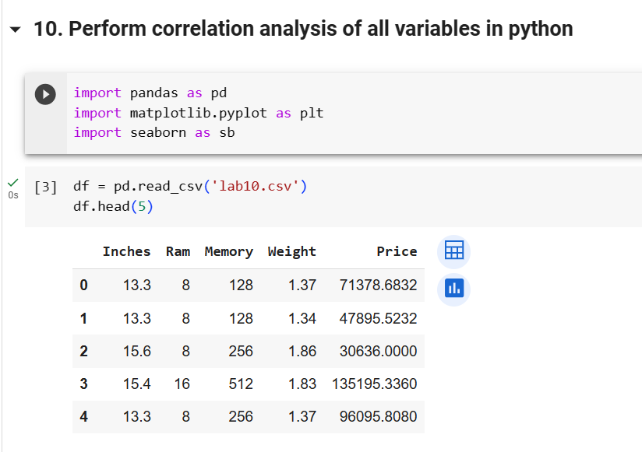

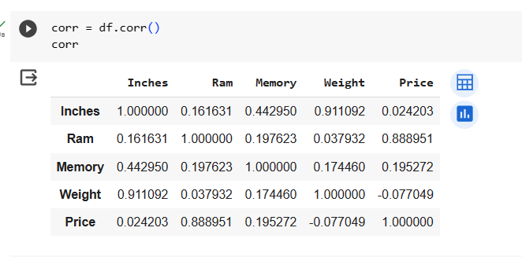

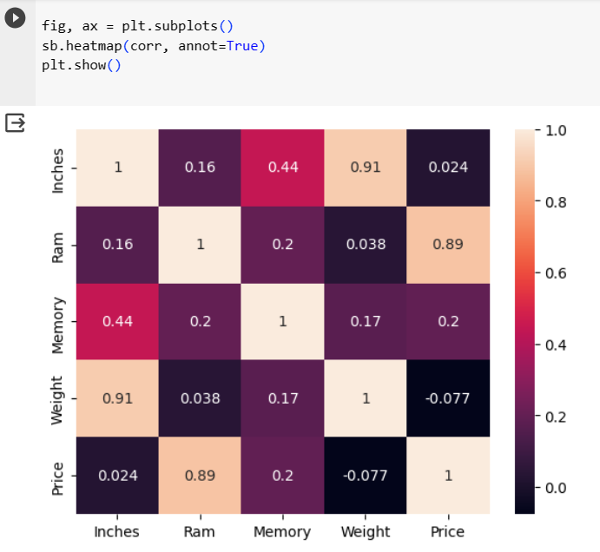

**Solve**

**Download heart-disease.csv**

**Perform all above operation**

**and Write About +Ve and -Ve correlation**