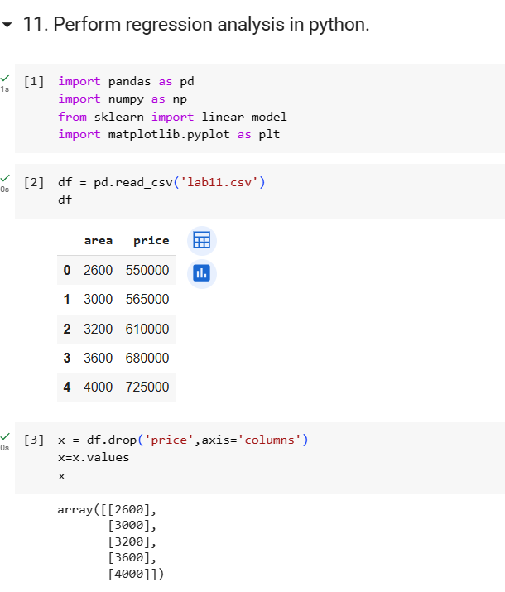

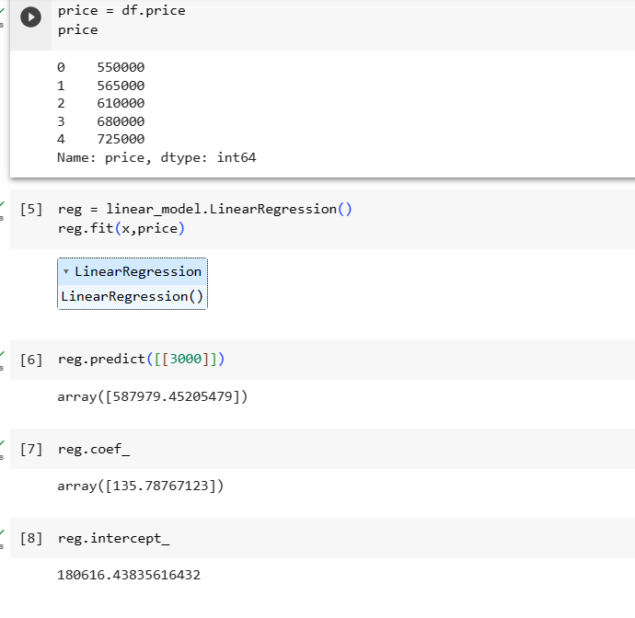

|  |  |  |  |  |  |  |
| --- | --- | --- | --- | --- | --- | --- |
|  |  |  |  |  |  |  |
|  |  | Area | Price |  |  |  |
|  |  | **X Value** | **Y Value** | **X*Y** | **X*X** |  |
|  | 1 | 2600 | 550000 | 1430000000 | 6760000 |  |
|  | 2 | 3000 | 565000 | 1695000000 | 9000000 |  |
|  | 3 | 3200 | 610000 | 1952000000 | 10240000 |  |
|  | 4 | 3600 | 680000 | 2448000000 | 12960000 |  |
|  | 5 | 4000 | 725000 | 2900000000 | 16000000 |  |
|  | Sum | 16400 | 3130000 | 10425000000 | 54960000 |  |
|  |  |  |  |  |  |  |
|  |  | coeff/Slope(m)= (NΣXY - (ΣX)(ΣY)) / (NΣX2 - (ΣX)2) | | 135.7876712 |  |  |
|  |  |  |  |  |  |  |
|  |  | Intercept(b) = (ΣY - m(ΣX)) / N | |  |  |  |
|  |  |  | 180616.4384 |  |  |  |
|  |  |  |  |  |  |  |
|  |  | y=mx+b | 135.7876*(4000)+180616.4384= | **587979.452** |  |  |
|  |  |  |  |  |  |  |
|  |  |  |  |  |  |  |

