Background
In 2019, Dr. Shuhan He paired up with Emojination.org to successfully advocate for the Anatomical heart and Anatomical Lung Emoji into Unicode 14.0, now available worldwide on Apple iOS, Windows, and Android devices. In 2021, Dr. He published a JAMA article entitled Emoji for the Medical Community, describing the importance of Emoji in medicine.

Today, Emoji occupies the same status as the English letter A, or pictorial Chinese symbols, within a universal system called Unicode. For example, the Chinese word for heart, Xin, is 5FC3, the Emoji for the anatomical heart is 1FAC0. This code allows common agreement and translation of language between all devices worldwide

Emoji are about Representation
“Being a doctor “means to listen, to hear their pain and hear their struggle, and to hear exactly what they’re trying to go through, and to help them,” He says. “If we can’t communicate, then we can’t be good doctors. And so this is at the very heart of being a good doctor.” –The Verge
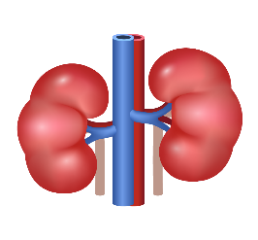 | 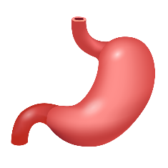 |  | 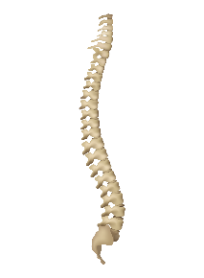 | 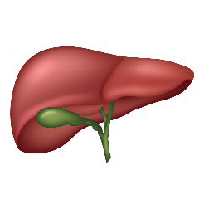
 | 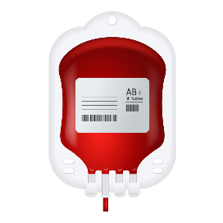 | 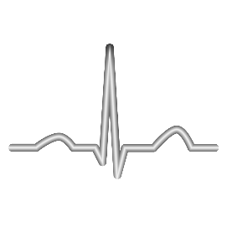 |  | 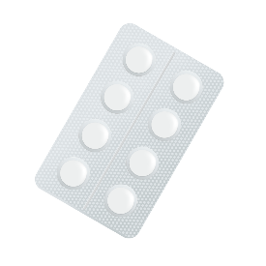
Over 10 Billion emoji are sent each day, yet as of 2022, there is no emoji for the anatomical liver, kidney, stomach, intestine, white blood cell, EKG, spine, RBC pack, pill pack and weight scale, just to name a few. Yet internal organ emoji for the anatomical brain, heart and lung all do exist. The Unicode consortium is standards-setting organization and leans on consensus. It is critical for physicians to advocate for these Emoji for the successful inclusion into future versions of Unicode. As physicians, we’ll be able to say, it’s ok to have a stomach, to talk about the kidney, and that it’s not the most embarrassing or scary thing to have a disease that may affect these things. Ultimately, this is an opportunity to promote, tolerance, inclusion and education about medicine in a modern, accessible, and international way.

Be Part of the Story
Get involved with the Medical Emoji Project by advocating for your specialty’s emoji. Visit MedicalEmoji.org and fill out the contact form and tell us which medical emoji you are interested in supporting, or email info@medicalemoji.org to get involved

A Few of Our Partners:
 |  |  | 

