Report Of Turing Machines Project

Li Tao & Shuhang Zhou

CSE5210: Formal Languages and Automata Theory
April 2013

OUTLINE
- Overview
- Main Content –
- Introduction to Software Development Environment
- Turing Machine Outline Design
- Project Management

- Appendix (hard copy code)

Report Of Turing Machines Project
Overview
We design a Turing machine main function is to identify the function of string. According to the rules in the read file, to determine reads the string is found the rules.

Introduction to Software Development Environment
- Visual Studio 2010——C + + development support tools

Turing Machine Outline Design
Turing machine designed mainly include the following three steps:
- Read the file, the first part in the file includes rules rows, reception state, the rules of the Turing machine and the input string.
- The Turing machine, we must first read the rules and string, use this rule to determine whether the input string is in line with the rule.
- Open the output file, the decision process is written to the output file.

Flaw Chart
Open input.txt, read rules, include number of rule, final state, rules, and string

String = String in the rule
State = state in the rule

Yes no
Use state2 which in rules rewrite current state. Rewrite input string, decide go left or right based on rules.

Stop. Print out “ The machine is holt”.

Handle all the strings
Open output.txt, write result in it.

By the following example to analyze the design Turing machine algorithm thinking:
Containing an equal number of a,b and c string recognition; { a^{n}b^{n}c^{n |} n≥0}
Analysis: Initially, the tape of the Turing machine M has been character a .. b .. c .. before and after are related to infinite multiple whitespace B
The following Form (a), M start with the first step in the operation of the first read leftmost a, and is rewritten as X, the following form (b). And shifts it to read the most left of the first b and is rewritten as Y, the following form (c). And shifts it to read the most left of the first c and is rewritten as Z, then go left, the following form (d). when found most edge X, then go right to find a.
... | B | B | a | a | … | b | b | … | c | c | … | B | B | B | …
(a)
… | B | B | X | a | … | b | b | … | c | c | … | B | B | B | …
(b)
… | B | B | X | a | … | Y | b | … | c | c | … | B | B | B | …
(c)
… | B | B | x | a | … | y | b | … | Z | c | … | B | B | B | …
(d)

Turing machine M by above process repeated movements, the following occurs:
After all a’s are rewrite to X, if we find B, it means M accept. If we find b or c before, M stop. It means M will not accept.

By the above analysis, can be configured Turing machine M = (Q, T, Σ, δ, q0, B, F,), where in:
Q = {q₀, q₁, q₂, q₃, q₄,q₅} T = {a, b, c}
Σ = {a, b, X, Y, Z, B}; F = {q₅}
δ function defined as follows:
δ (q₀, a) = (q₁, X, R)
δ (q₁, a) = (q₁, a, R)
δ (q₁, y) = (q₁, y, R)
δ (q₁, b) = (q₂, Y, R)
δ (q₂, b) = (q₂, b, R)
δ (q₂, Z) = (q₂, Z, R)
δ (q₂, c) = (q₃, Z, L)
δ (q₃, Z) = (q₃, Z, L)
δ (q₃, b) = (q₃, b, L)
δ (q₃, Y) = (q₃, Y, L)
δ (q₃, a) = (q₃, a, L)
δ (q₃, X) = (q₀, X, R)
δ (q₀, Y) = (q₄, Y, R)
δ (q₄, Y) = (q₄, Y, R)
δ (q₄, Z) = (q₄, Z, R)
δ (q₄, B) = (q₅, B, R)
When M accepts the sentence ‘aabbcc’, its course of action pattern:
q0aabbccB ┠ Xq1abbccB the functions usedδ (q₀, a) = (q₁, X, R)
┠ Xaq₁bbccB function is δ (q₁, a) = (q₁, a, R)
┠ XaYq₂bccB function is δ (q₁, b) = (q₂, Y, R)
┠ XaYbq₂ccB function is δ (q₂, b) = (q₂, b, R)
┠ XaYq₃bZcB function is δ (q₂, c) = (q₃, Z, L)
┠ Xaq₃YbZcB function is δ (q₃, Y) = (q₃, Y, L)
┠ Xq₃aYbZcB function is δ (q₃, a) = (q₃, a, L)
┠ Xq₀aYbZcB function is δ (q₃, X) = (q₀, X, R)
┠ XXq₁YbZcB function is δ (q₀, a) = (q₁, X, R)
┠ XXYq₁bZcB function is δ (q₁, y) = (q₁, y, R)
┠ XXYYq₂ZcB function is δ (q₁, b) = (q₂, Y, R)
┠ XXYYZq₂cB function is δ (q₂, Z) = (q₂, Z, R)
┠ XXYYq₃ZZB function is δ (q₂, c) = (q₃, Z, L)
┠ XXYq₃YZZB function is δ (q₃, Z) = (q₃, Z, L)
┠ XXq₃YYZZB function is δ (q₃, Y) = (q₃, Y, L)
┠ Xq₃XYYZZB function is δ (q₃, X) = (q₀, X, R)
┠ XXq₀YYZZB function is δ (q₃, X) = (q₀, X, R)
┠ XXYq₄YZZB function is δ (q₀, Y) = (q₄, Y, R)
┠ XXYYq₄ZZB function is δ (q₄, Y) = (q₄, Y, R)
┠ XXYYZq₄ZB function is δ (q₄, Z) = (q₄, Z, R)
┠ XXYYZZq₄B function is δ (q₄, Z) = (q₄, Z, R)
┠ XXYYZZBq₅ function is δ (q₄, B) = (q₅, B, R)

Input.txt
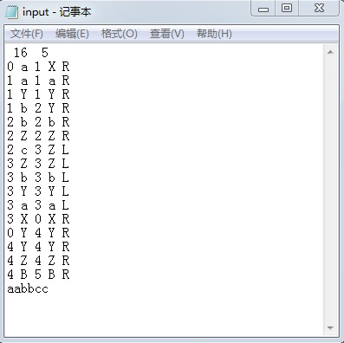

Output.txt
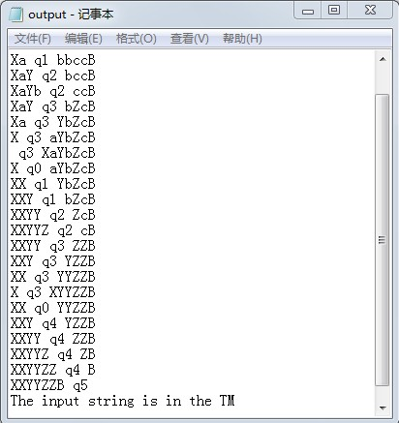

Now we try another string ‘acabcb’

Input.txt
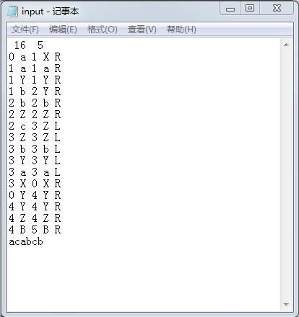

Output.txt
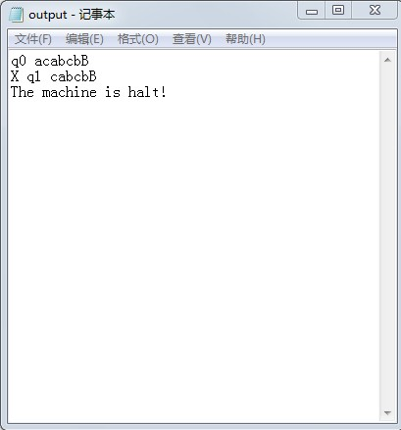

Project Management
Li Tao: Program Structure, Write test data, rules and Testing, Correct mistakes.
Shuhang Zhou: Writing program codes.

Appendix (hard copy code)
#include <stdio.h>
#include <string.h>
#include <conio.h>
#include <iostream>
#include <fstream>
#include <string>
using namespace std;
int n,fstate; // Rules of the number of rows, accepting state
int state1[100],state2[100]; //
char char1[100],char2[100]; // Current character, Changed characters
char lorr[100]; // left or right
char str[100]; // input string
void readDat()
{
int i;
ifstream fin;
fin.open("c:\\turing machine\\input.txt",ios::in);
if (!fin) cout<<"The input is empty\n";
else
{
fin>>n>>fstate;
for (i=0;i<n;i++)
{
fin>>state1[i]>>char1[i]>>state2[i]>>char2[i]>>lorr[i];
}
}
fin>>str;
fin.close();
}

int main()
{
int i;
readDat();
/* for (i=0;i<n;i++)
cout<<state1[i]<<" "<<char1[i]<<" "<<state2[i]<<" "<<char2[i]<<" "<<lorr[i]<<endl;*/
ofstream fout;
fout.open("c:\\turing machine\\output.txt",ios::out);
int point,state;
point=0;state=0;
int len=strlen(str);
str[len]='B';// add B at the end od the string
fout<<"q0 "<<str<<endl; // starting state
int count=0; // decide the count of loop
while (state!=fstate) // if the state is not the final state
{
int k;
bool t=false; // Determine whether there is compliance with the rules
for (k=0;k<n;k++)
if ((str[point]==char1[k])&&(state==state1[k])) // find rules
{
state=state2[k];
str[point]=char2[k];
if (lorr[k]=='R') point++;
else point--;
t=true;
break;
}
if (!t) { fout << "The machine is halt!"<<endl; return 0;} // if the string isnot in L, machine will halt
for (int ii=0;ii<len+1;ii++)
{
if (ii==point) fout<<" q"<<state<<" ";
fout<<str[ii];
}
if (state==fstate) fout<<" q"<<fstate<<""<<endl; else fout <<endl; // new version output
// fout<<str<<" point:"<<point+1<<" state:"<<state<<endl; old version output
count++;
if (count>100000) { fout << "The machine is loop!"<<endl; return 0;} // loop Counter overflow causes the loop
}
if (state==fstate) fout<<"The input string is in the TM"<<endl; // accept
fout.close();
// system("pause");
return 0;
}

