CFD Analysis of a Geothermal Steam-Water Separator:
Spiral-Inlet Reconstruction, DPM Tracking and Wall-Film Sensitivity
Technical results from controlled ANSYS Fluent simulations and automated PyFluent post-processing

Numerical model and automated workflow
The study used staged CFD comparisons to quantify liquid carryover in a vertical bottom-outlet cyclone separator [2]. The first model family reconstructed six operating conditions from Purnanto et al. (2013) on the available rectangular 90° spiral-inlet geometry [1]. Because the paper does not publish CAD-ready scroll geometry or its exact nine-injection table, this is a controlled reconstruction rather than an exact duplicate. A second family introduced split steam-liquid inlet and Eulerian wall-film (EWF) treatments to isolate model-form sensitivity.
Table 1. Principal numerical settings and controlled model differences.
Item | Spiral-inlet reconstruction | Split-inlet / EWF family
Mesh | 2,964,593 tetrahedral cells | 7,601,261 cells
Solver | Steady, pressure based; Mixture model | Steady, pressure based; Mixture + DPM/EWF
Turbulence | RNG k-ε; standard wall functions | RNG k-ε; standard wall functions
Thermal scope | Energy disabled; no flashing | Energy disabled; no flashing
Inlet | Single two-phase mass-flow inlet | Separate steam and liquid mass-flow regions
Outlet / lower boundary | 1.12 MPa pressure outlet / DPM trap | Pressure outlet / closed lower wall
Discrete phase | Nine Harwell-derived bins; one-way DPM | Deterministic/stochastic DPM and EWF branches

Operating-condition and injection reconstruction
Each enthalpy label selected the steam-liquid mass split reported by Purnanto; enthalpy was not solved as a thermal boundary condition [1]. The Harwell correlation set each case's Sauter/median diameter scale, while nine normalized diameter and mass bins were reconstructed from the paper's Figure 5. The spiral baseline's native surface-injection convention was preserved: inert liquid-water particles were released from the inlet using the local face-normal direction.
xₛₐ = 1.91 Dₜ (Re⁰·¹ / We⁰·⁶)(ρg / ρl)⁰·⁶, xₘₑd = 1.42 xₛₐ
The automated sequence loaded a fresh baseline, set and read back both phase mass flows, updated all nine injections, hybrid-initialised the carrier flow, completed 1500 verified iterations in 25-iteration blocks, saved a pre-DPM state, performed DPM tracking, and exported injection-level fates. Early residual stopping was disabled. Each case required nine populated injection rows and fate closure within 0.2%; the completed six-case sweep therefore required 54 rows.
ṁseparated = ṁtrapped + ṁincomplete, quality_Purnanto = ṁsteam /(ṁsteam + ṁescaped) × 100%

Completed spiral-inlet enthalpy sweep
All six operating conditions completed 1500 carrier-flow iterations on 15 Fluent ranks, followed by per-injection DPM tracking. Escaped liquid remained between 0.01655 and 0.02667 kg/s. Following Purnanto's treatment, all incomplete trajectories were assigned to the separated/trapped category and only escaped liquid was counted as carryover. This gives 99.96681% to 99.97949% steam quality. These values apply the published fate interpretation but are not independently audited outlet qualities. The present points form a nearly flat band and do not reproduce the 26.85 m/s dip in Purnanto's digitised spiral-inlet simulation series or its high-velocity calculation decline [1].
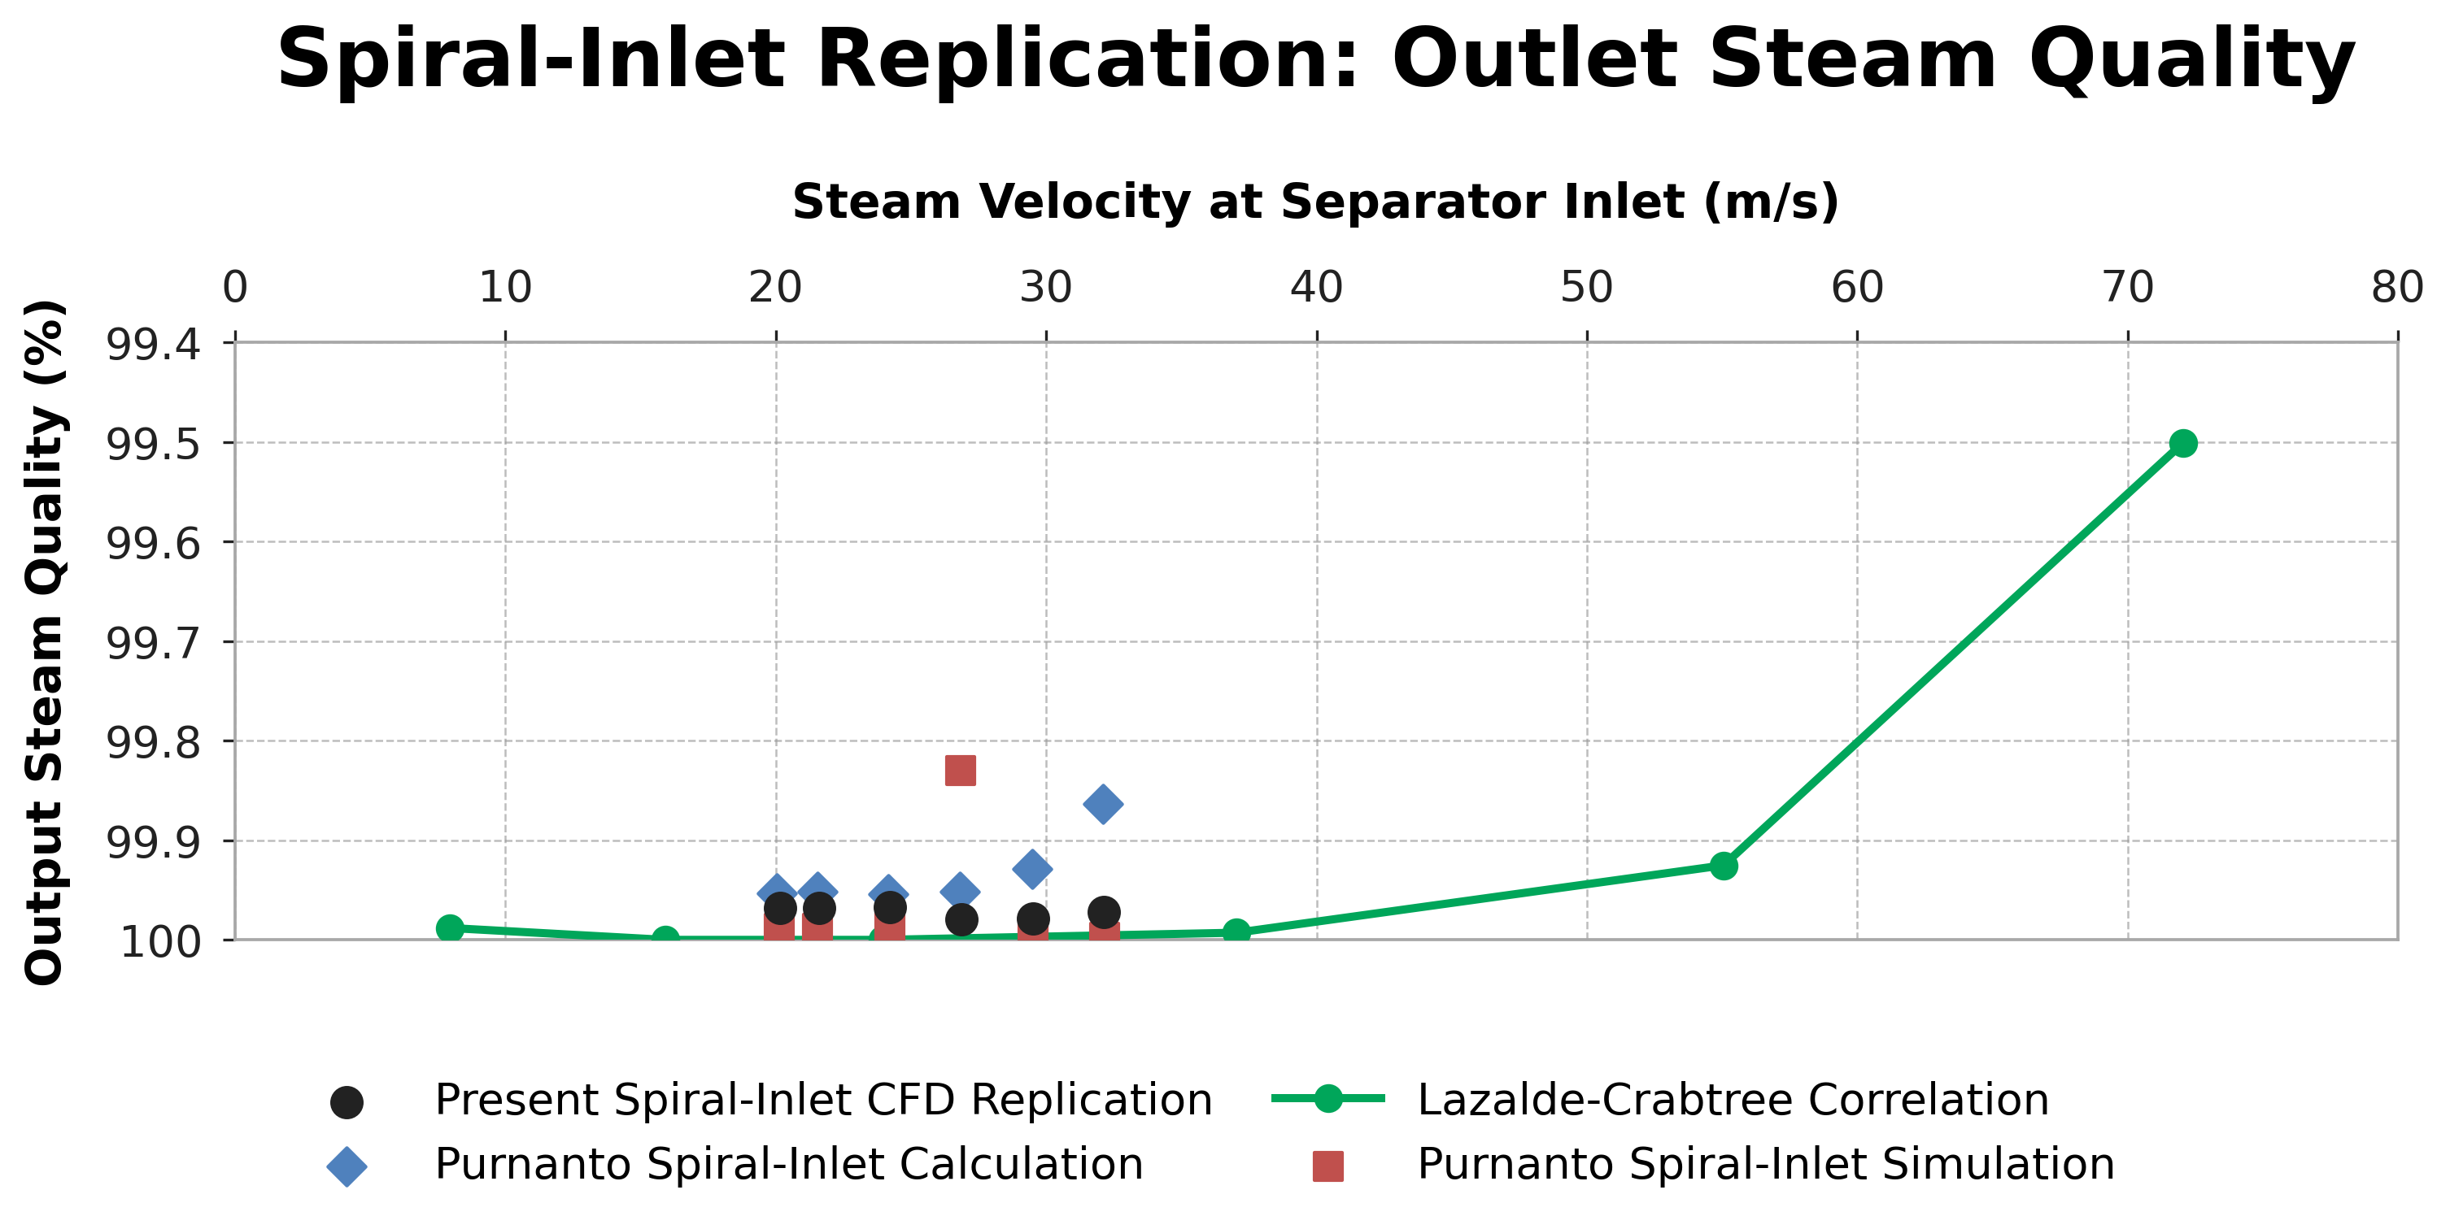
Figure 1. Present six-case spiral-inlet CFD results compared with digitised Purnanto Figure 20 calculation/simulation points and the Lazalde-Crabtree correlation. Black points treat trapped and incomplete trajectories as separated, following Purnanto; the quality axis is inverted to match the source.
Table 2. Completed spiral-inlet DPM outcomes and comparison with the nearest digitised Figure 20 simulation point.
Case | Condition | v (m/s) | Escaped  (kg/s) | Incomplete  (kg/s) | Quality  (%) | Δ vs ref.  (pp)
1 | 1600 -25% | 20.15 | 0.01941 | 2.068 | 99.9679 | -0.0201
2 | 1440 | 21.59 | 0.02088 | 3.307 | 99.9678 | -0.0202
3 | 1520 | 24.23 | 0.02416 | 3.120 | 99.9668 | -0.0208
4 | 1600 | 26.87 | 0.01655 | 3.907 | 99.9795 | +0.1498
5 | 1680 | 29.50 | 0.01896 | 5.235 | 99.9786 | -0.0143
6 | 1760 | 32.14 | 0.02667 | 6.680 | 99.9724 | -0.0253
Case 4 is the largest trend mismatch: the project predicts 99.9795% at 26.87 m/s, whereas the nearest digitised Purnanto simulation point is approximately 99.8297%. Agreement in magnitude for the other five points does not establish validation because the reference trend is not recovered, the numerator is prescribed inlet steam flow, and incomplete trajectories are assigned to the separated category rather than resolved to a physical endpoint.

Size-resolved DPM behaviour
Across all six spiral cases, completed outlet escape occurred only in the finest injection. The 5 µm-class tracks remain closely coupled to the rotating carrier flow, populate the upper recirculation region and exhibit the longest plotted residence-time scale. Increasing diameter shortens the displayed residence-time range and shifts the dominant fate toward bottom trapping, consistent with increasing inertial separation.
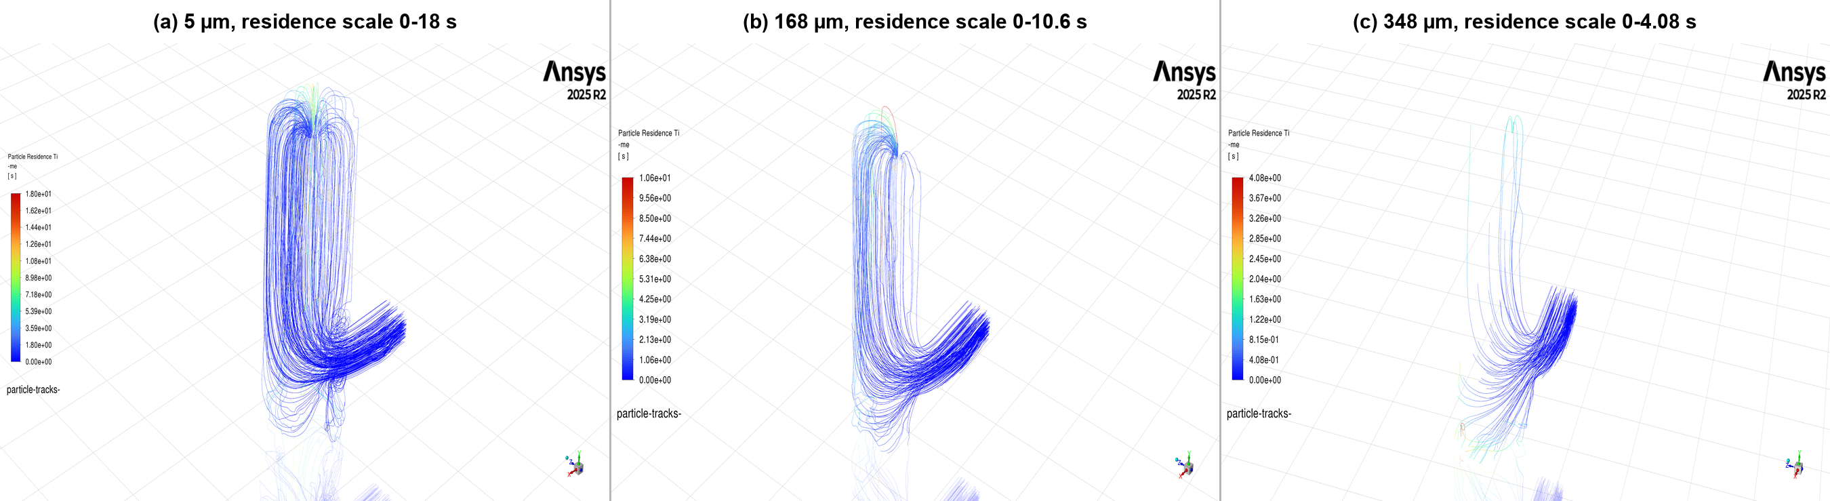
Figure 2. Particle-residence-time tracks for nominal 5, 168 and 348 µm injections. Colour scales differ between panels and therefore indicate within-panel residence time, not a shared quantitative scale.
Table 3. Selected Case 4 (1600 kJ/kg) injection-level fate accounting.
Nominal class  (µm) | Actual d  (µm) | Injected  (kg/s) | Escaped  (kg/s) | Trapped  (kg/s) | Incomplete  (kg/s) | Incomplete  (%)
5 | 5.6 | 0.1900 | 0.01655 | 0.0373 | 0.1362 | 71.7
168 | 168.6 | 1.9526 | 0.00000 | 1.1860 | 0.7670 | 39.3
348 | 348.5 | 23.3840 | 0.00000 | 22.4300 | 0.9562 | 4.1
The Case 4 finest bin is an important numerical exception: 0.01655 kg/s escaped, but 0.1362 kg/s remained incomplete, so incomplete mass was over eight times the escaped mass for that bin. No completed escape was recorded for the 168 or 348 µm classes. The 348 µm class instead delivered 22.43 kg/s to the bottom trap, while 0.9562 kg/s remained incomplete. The raw CSV retains incomplete as a separate Fluent fate for traceability; for the reported Purnanto-consistent quality, it is added to trapped mass and treated as separated.

Eulerian wall-film mechanism screening
The wall-film family partitioned the liquid input between Eulerian inlet liquid and DPM parcels before enabling deposition and drainage, avoiding double counting. Fluent's EWF formulation supports DPM collection, splash, edge separation and shear-driven stripping [3]. These branches are project mechanism screens, not Purnanto replication cases.
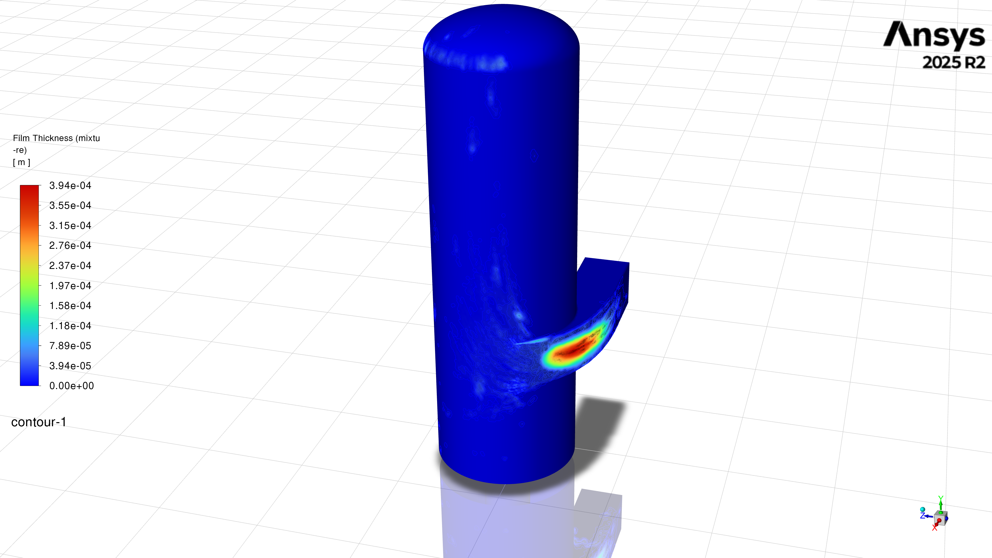
Figure 3. Wall-film thickness on the separator and spiral inlet. The plotted scale spans 0-3.94×10⁻⁴ m and shows the largest local accumulation at the inlet bend and first vessel-wall impact region.
Table 4. Captured film quantities from the mechanism-screening branches.
EWF branch | Inventory  (kg) | Maximum  (mm) | Area average  (µm)
Clean deposition | 0.07150 | 0.152 | 1.211
Splash only | 0.07431 | 0.164 | 1.259
Edge separation only | 0.05639 | 0.123 | 0.955
Stripping only | 0.05440 | 0.121 | 0.921
Combined mechanisms | 0.05668 | 0.125 | 0.960
Relative to the clean deposition control, splash increased inventory by 3.9% and maximum thickness by 7.9%, whereas edge separation and stripping reduced inventory by 21.1% and 23.9%, respectively. In the combined EWF branch, enabling global DPM interaction increased inventory, maximum thickness and area-average thickness by 41%, and increased derived mean film speed from 0.0533 to 0.0684 m/s (+28%). The interaction-on state also increased coarse-class splash events from 20 to 44, edge-separation events from 120 to 188, and introduced seven stripping events. Values are transcribed from the project's captured Fluent snapshots and were not rerun within the six-case sweep.
Event counts are not equivalent to re-entrained liquid mass. They demonstrate that the selected wall model changes the assigned liquid pathway, but a quantitative carryover claim requires the generated secondary parcels to be mass-accounted and compared from matched initial film states and physical times.

Technical interpretation and limitations

Iteration completion versus convergence
Every spiral case contains 1500 residual-history points and passed the workflow’s setup, save and DPM mass-closure checks. However, fixed iteration count is not convergence evidence. Final scaled continuity residuals remain between 0.145 and 0.229, far above the configured 10⁻⁴ criterion, while momentum residuals are approximately 1.1×10⁻⁵ to 1.7×10⁻⁵. The carrier fields are iteration-complete but not strictly converged.
Table 5. Final scaled residuals after 1500 iterations.
Case | Continuity | Liquid volume fraction | Maximum momentum
1 | 0.185 | 8.40e-04 | 1.33e-05
2 | 0.229 | 9.51e-04 | 1.66e-05
3 | 0.204 | 8.90e-04 | 1.45e-05
4 | 0.200 | 8.70e-04 | 1.50e-05
5 | 0.162 | 8.38e-04 | 1.19e-05
6 | 0.145 | 8.57e-04 | 1.19e-05

Treatment of incomplete trajectories
Incomplete liquid increases from 2.4% to 6.6% across the six spiral cases and is substantially larger than escaped liquid. Fluent defines an incomplete fate numerically: the maximum tracking-step limit was reached [4]. Purnanto encountered the same issue and assumed incomplete particles were separated to obtain a quality estimate [1]. The present report uses the same convention: all incomplete mass is combined with trapped mass, and only escaped mass is counted as liquid carryover. The separate incomplete field is retained to quantify tracking resolution and sensitivity to the maximum-step setting.

Evidence boundary
The completed sweep establishes a reproducible numerical pipeline and a size-selective carryover mechanism, but it does not validate separator efficiency. The exact nine-bin mass allocation is reconstructed because Purnanto did not publish the original injection table or CAD-ready scroll definition; the model is isothermal and omits flashing, breakup and coalescence; steam quality uses prescribed inlet steam and Purnanto's incomplete-as-separated convention rather than an audited outlet vapour monitor; and the reference trend is not recovered. The defensible mid-year result is therefore sensitivity to droplet size and wall treatment, not validated efficiency.

Technical verification required before final validation
The next numerical checks are to extend the carrier solutions while monitoring integral outlet mass flow and pressure drop, export incomplete-particle endpoints, repeat DPM tracking across step-length and stochastic-dispersion settings, and audit quality against Fluent outlet vapour flow. One representative case should also test mesh and RSM sensitivity; experiment-backed cyclone work uses RSM-DPM for anisotropic rotating flow, although its air-water values are not transferable here [5]. EWF interaction-off/on cases must be rerun from a common film state and physical time.
References: [1] Purnanto, Zarrouk & Cater (2013), IPENZ Transactions 40, 1-10. [2] Zarrouk & Purnanto (2014), Geothermics 53, 236-254, doi:10.1016/j.geothermics.2014.05.009. [3] Ansys Fluent Theory Guide 2025 R2, §§17.1-17.2.1.
[4] Ansys Fluent User's Guide 2025 R2, §§24.2.3 and 25.9.3. [5] Chen et al. (2025), Processes 13, 3732, doi:10.3390/pr13113732.

