Inlet setup
- Velocity inlet: 26.81m/s

Flow rate:
- Liquid: 116.92
- Steam: 80.69
Total: 197.61kg/s
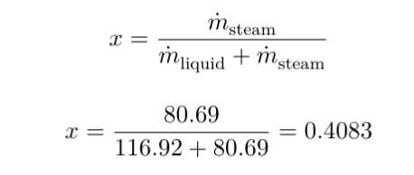
Starting steam quality by mass = 0.4083
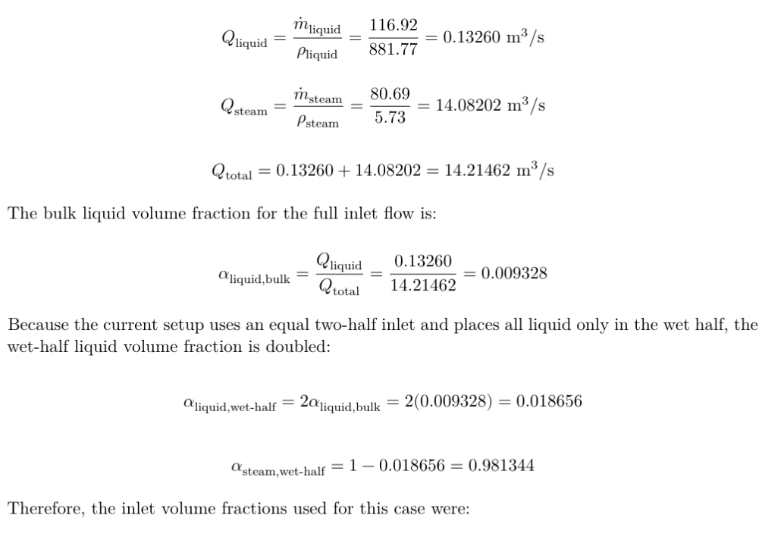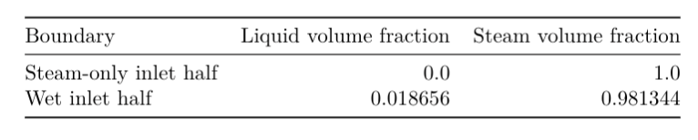

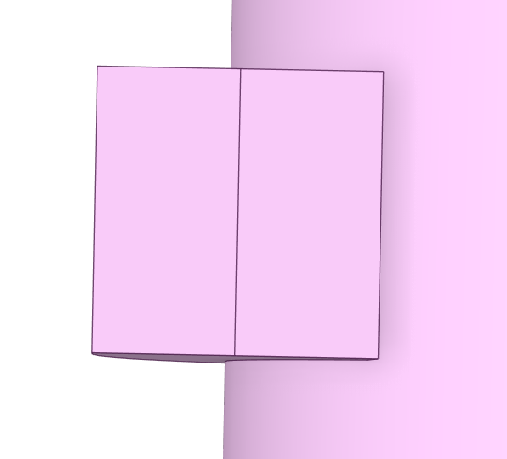

Flux report: Rough efficiency calculations
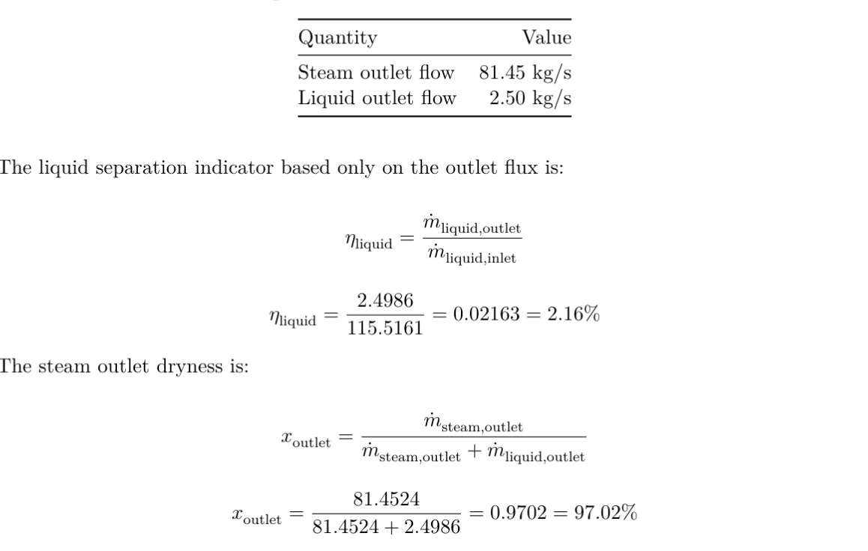

Injection Findings
The 9 injections:
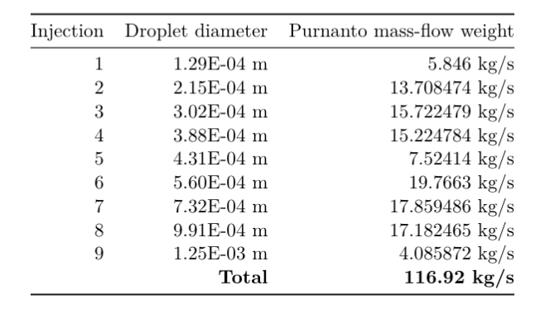
Tests done:
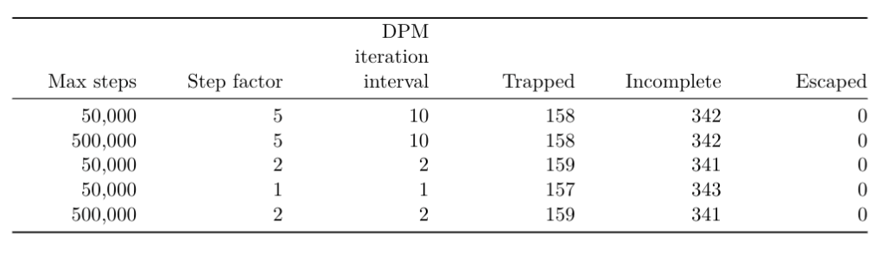
How the number of particle streams changes resulted:
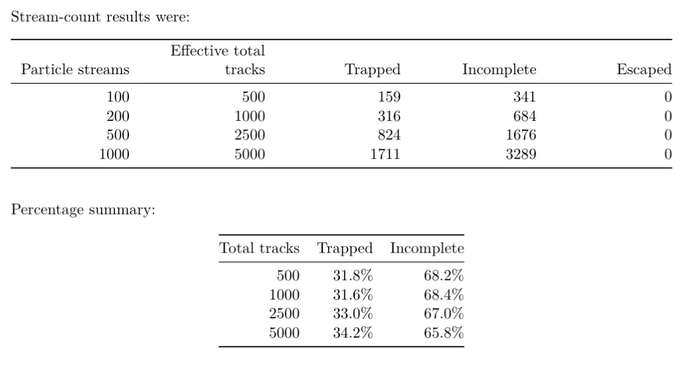

Figures:

Contours:
Pressure:
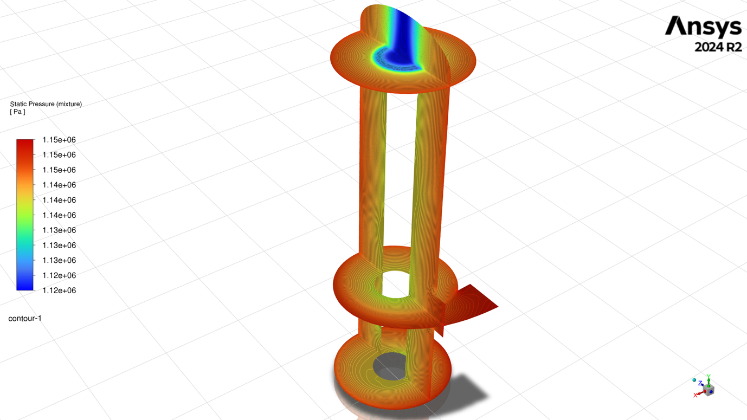
Lquid water – volume fraction
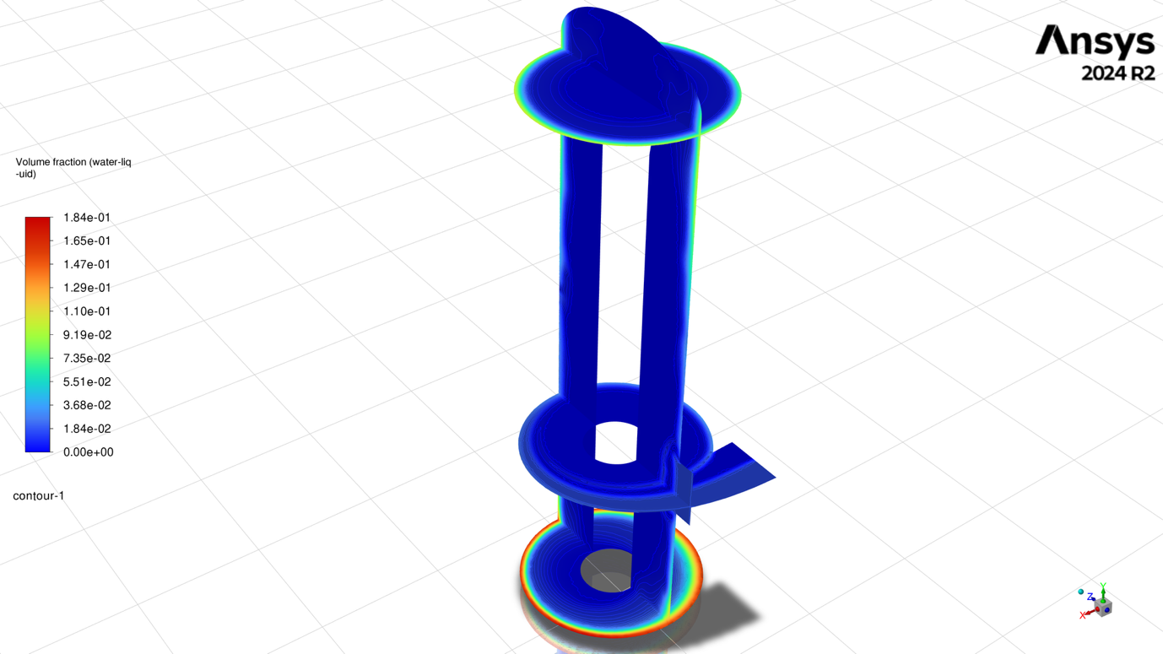
Velocity:
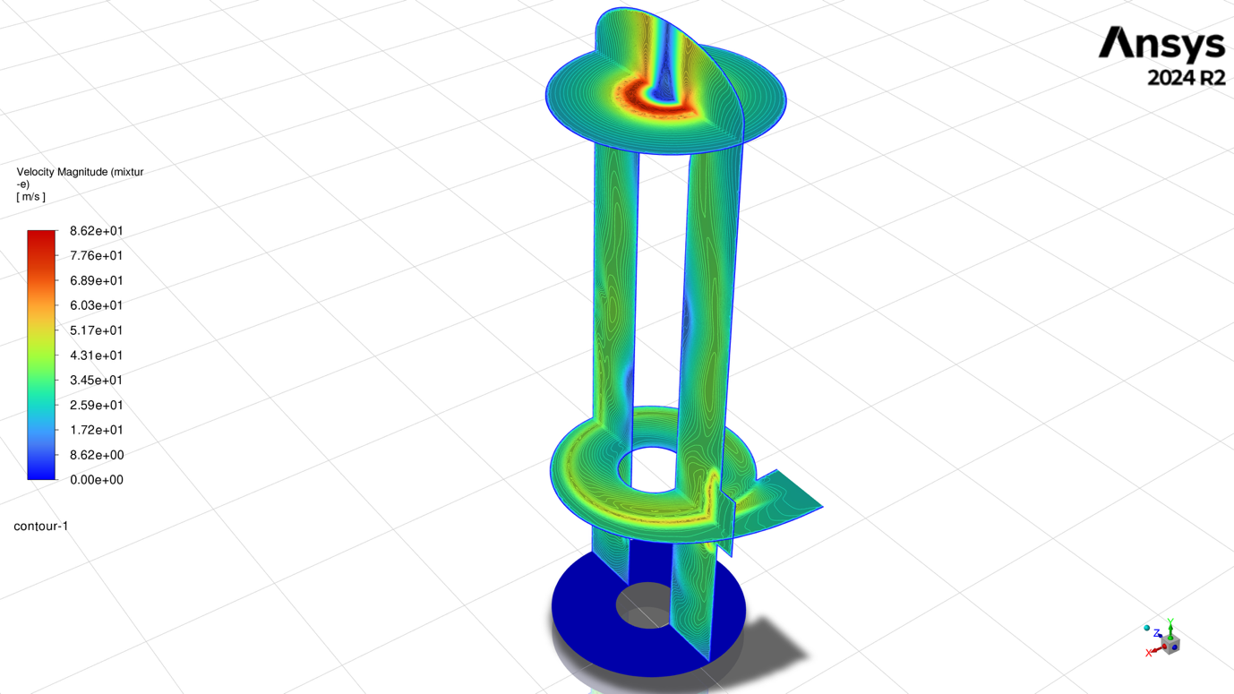

Vectors:
Inlet Velocity:
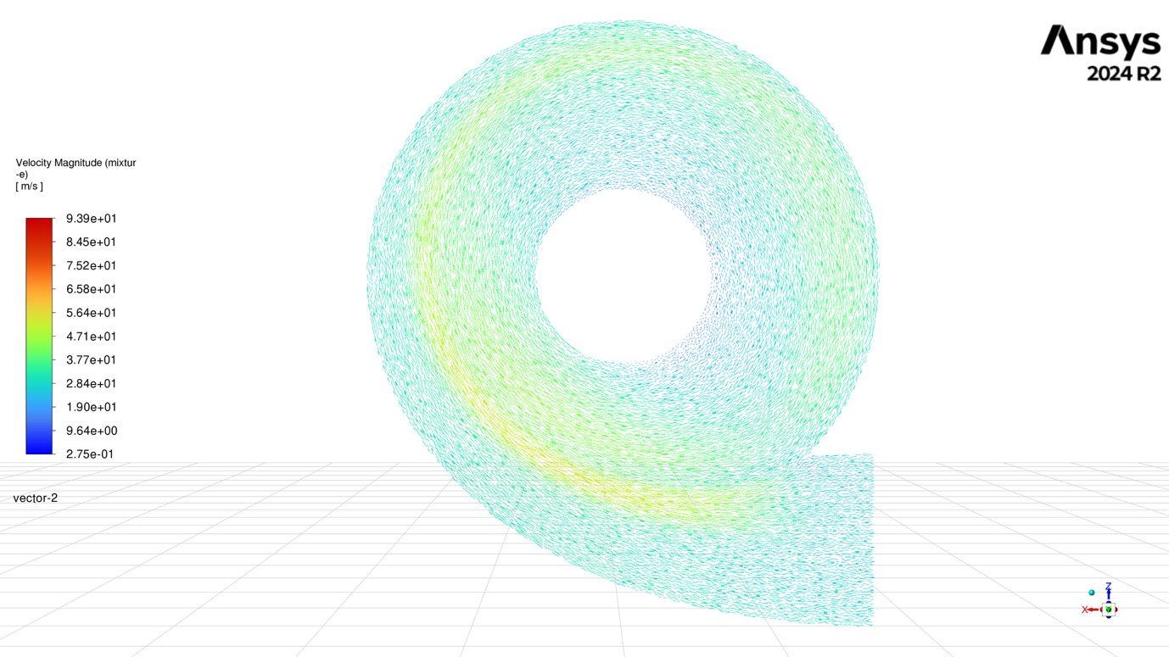
Outlet velocity
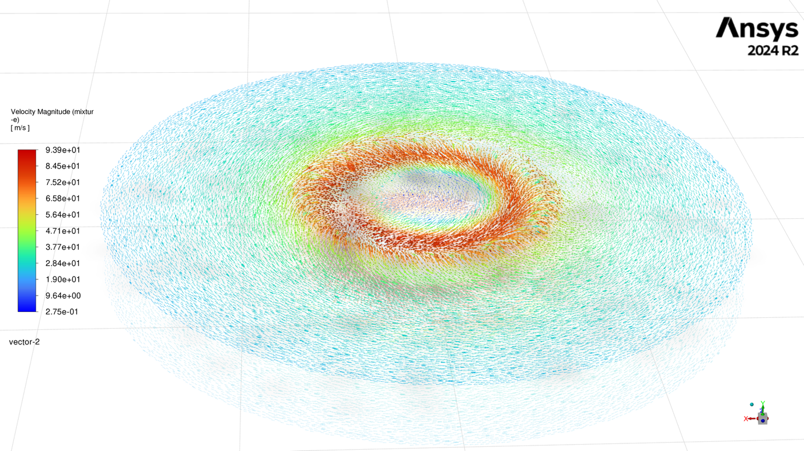

Path line:
Time based:
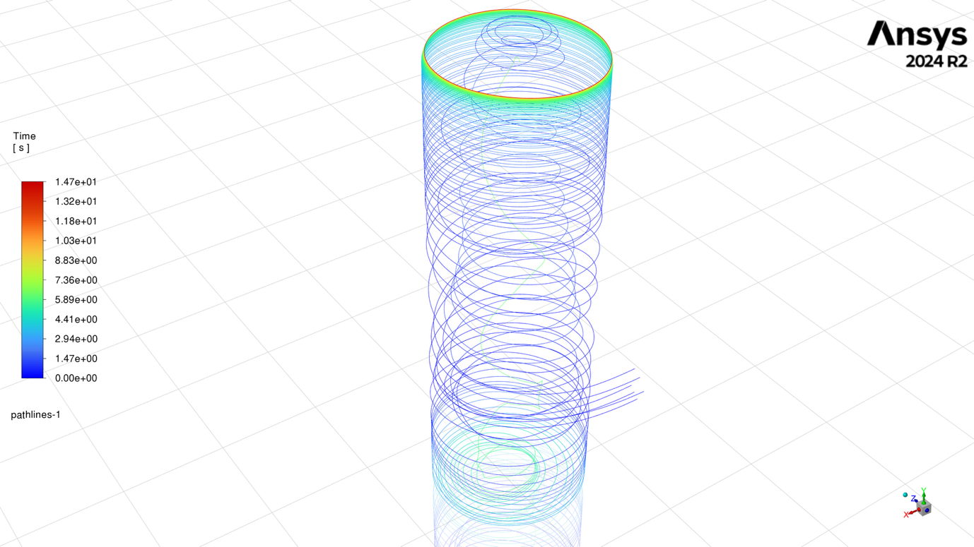
Particle ID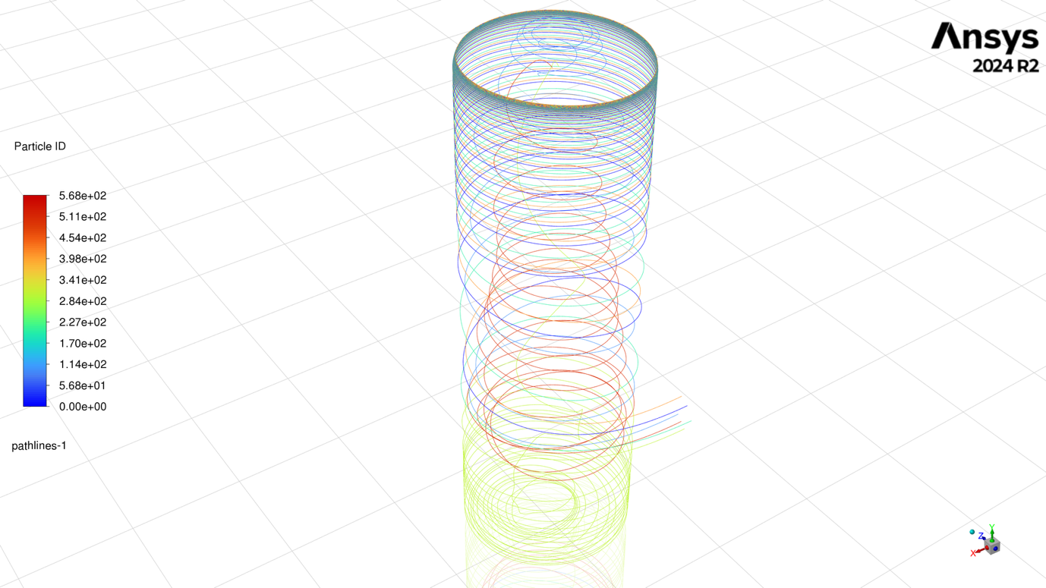
Steam