Image2Biomass: Predicting Pasture Biomass from Quadrat Photographs
Master's in Green Data Science — Practical Machine Learning (ISA, ULisboa)
Team: [Shuhrat Maksumov / ID: 28548], [Xavier Loreto / ID: 28648]

1. Introduction
Pasture biomass is a key input for grazing management: knowing how much dry matter is available helps farmers decide when and how to graze livestock without over- or under-using a paddock. Measuring biomass directly is labor-intensive, so estimating it from photographs is attractive — a farmer could photograph a field and get an instant estimate.
We use the CSIRO Image2Biomass dataset (Kaggle): where each 70x30 cm quadrat photograph is paired with five ground-truth biomass targets in grams: green, dead, clover, GDM (green dry matter), and total dry matter.
Beyond raw prediction, our central question is a modality comparison: how much does the image add over two cheap ground measurements already available in the data — NDVI and pasture height? This reframes the project from "train a CNN" to "quantify whether expensive pixel analysis beats cheap field measurements", which is both more scientifically interesting and more practically relevant.
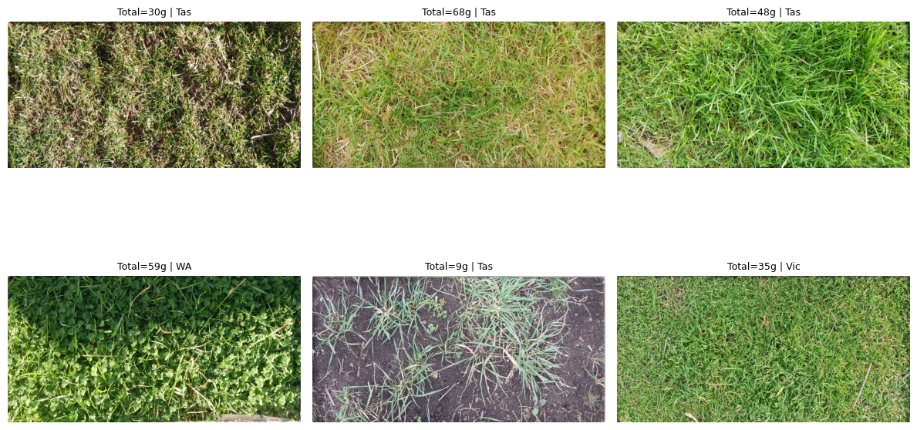
Figure 1. Example pasture quadrat photographs annotated with total biomass.

2. Data
Source. CSIRO Image2Biomass (Kaggle): 357 labelled quadrat photographs from 19 sites across four Australian states (Tasmania, NSW, WA, Victoria), collected 2014-2017. Each image carries metadata: state, pasture species, pre-grazing NDVI, average sward height, and sampling date.
Format. The raw CSV is in long format (1785 rows = 357 images x 5 targets). We pivot to wide format (one row per image, five target columns) and extract month from the date.
Target characteristics. All five targets are strongly right-skewed (skewness 1.4-2.8, kurtosis 3-9). Clover is the hardest: 37.8% zeros and the highest skew (2.84). We therefore model targets in log1p space and invert predictions with expm1, clipping to non-negative values.
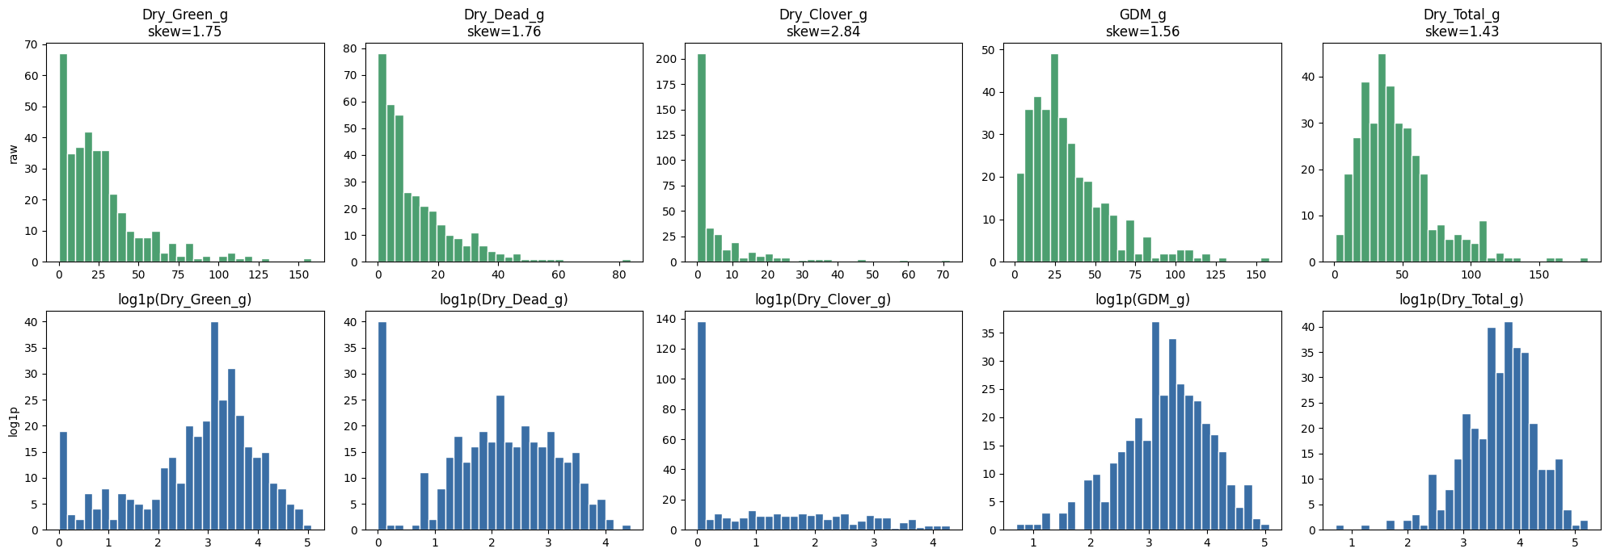
Figure 2. Target distributions in raw and log1p scale, showing the right-skew and the effect of the log transform.
Cleaning and feature engineering. No missing values in the metadata. We collapse rare species (<10 images) into an "Other" category to reduce categorical noise. We verified the physical constraint Total = Green + Dead + Clover holds in 99.7% of rows (one rounding violation).
Key correlations (motivation for the project). Height correlates with green mass (r=0.65) and total (r=0.50); NDVI correlates with GDM (r=0.47) and total (r=0.36). Together these two ground measurements form a strong predictor — but r=0.5 leaves most of the variance unexplained, which is the headroom an image could close. NDVI also shows heteroscedasticity (saturation on dense pasture), suggesting imagery might help where NDVI plateaus.
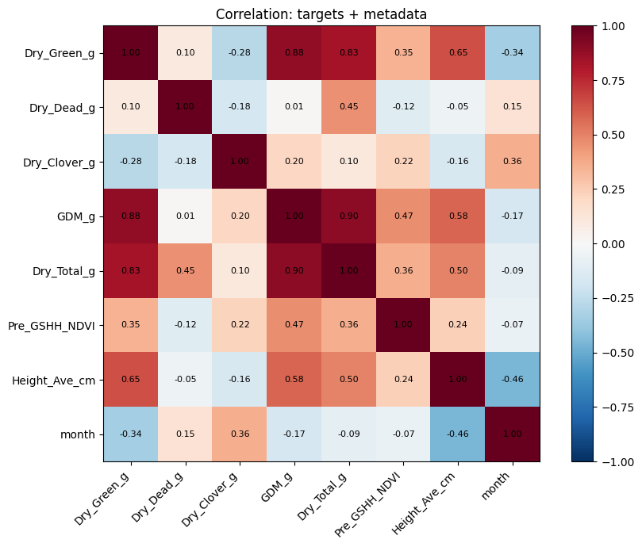
Figure 3. Correlation heatmap of targets and metadata (NDVI, height, month).
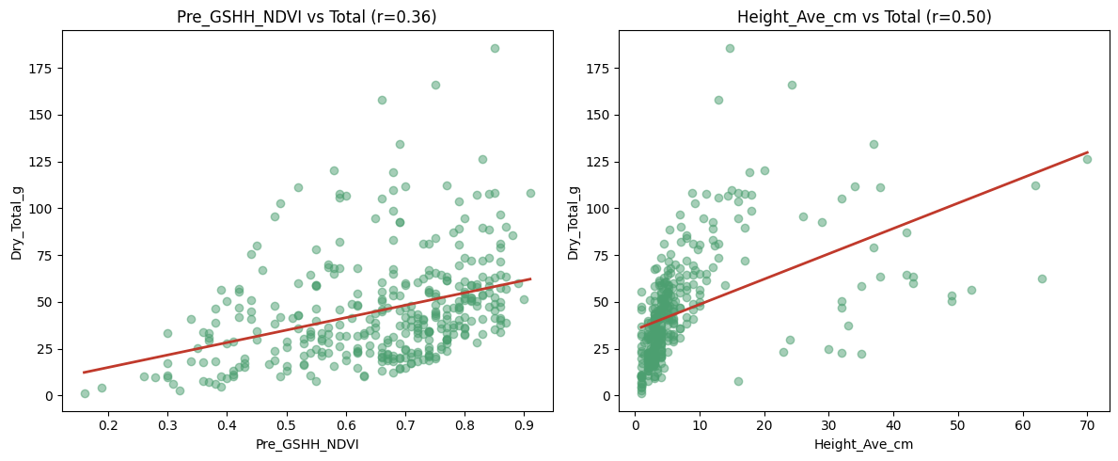
Figure 4. Scatter of NDVI and height against total biomass, with trend lines.

3. Data Organization
Observations are correlated within an image (5 target rows) and within a site (shared soil, lighting, species), so a naive random split would leak information and inflate scores. We use StratifiedGroupKFold with groups = image_id (all rows of one image stay in the same fold) and stratification = binned Dry_Total_g (the biomass range is balanced across folds).
We chose 5-fold cross-validation over a single train/test split for a more reliable estimate. GroupKFold by state was rejected because states are imbalanced (Tas 138 ... WA 32); the smallest state would yield an unstable fold. State is instead used for error analysis. The same folds are used for every model (tabular and image) so comparisons are fair.
Note on the Kaggle hidden test: it omits metadata, so a fair modality study must be done on the locally labelled data via cross-validation, not the leaderboard.

4. Methods
We build a four-tier comparison aligned with the course syllabus:
Tier 0 — Naive baseline. Predict the training-fold median per target. The reference floor any useful model must beat.
Tier 1 — Tabular models (sessions 4, 7). RandomForest and HistGradientBoosting on metadata features (NDVI, height, month, species, state), one model per target in log1p space. One-hot encoding for categoricals.
Tier 2 — CNN from scratch (session 10). A small 4-block convnet (conv-BN-ReLU-pool) with a regression head, trained on 224x224 RGB. Kept small because ~285 training images would overfit a large network.
Tier 3 — Transfer learning (session 12). A pretrained ResNet18 with a 5-output regression head, in two regimes: frozen (feature extraction, head only) and fine-tuned (whole backbone). ImageNet normalization; mild augmentation (flips, light jitter) chosen so as not to destroy the texture/density signal.
Training. Adam optimizer, MSE loss in log1p space, early stopping on validation weighted-RMSE (original scale). Fine-tuning uses a smaller learning rate (1e-4) since the whole backbone is updated. All image models share the dataset pipeline and CV folds.
Deployment (session 11). A Gradio app serving the image-only model, deployed to Hugging Face Spaces (see Section 7).

5. Results
Evaluation metric. Competition-style weighted RMSE (target weights 0.1/0.1/0.1/0.2/0.5, with Total weighted highest) plus per-target RMSE, MAE, and R2 on the original gram scale, aggregated over 5 folds (mean +/- std).
The main comparison is shown in Table 1. All weighted-RMSE values are means over 5 folds: fine-tune 18.23 +/- 2.83, simple_cnn 18.70 +/- 2.64, frozen 24.74 +/- 2.22. A final deployable model trained on an enlarged train split reached 15.94 on a single holdout; the table reports the more conservative cross-validated figure.
 | model | weighted_rmse
1 | RandomForest (tabular) | 11.828
2 | resnet18_finetune (image) | 18.232
3 | simple_cnn (image) | 18.699
4 | naive_median (tabular) | 24.117
5 | resnet18_frozen (image) | 24.742
Table 1. Model comparison by weighted RMSE (lower is better) and R2 on total biomass.
Tabular per-target R2 (RandomForest): Green 0.79, GDM 0.80, Total 0.72, Clover 0.65, Dead 0.39. Feature importance: Height (0.57) and NDVI (0.24) dominate (81% combined), consistent with the EDA.
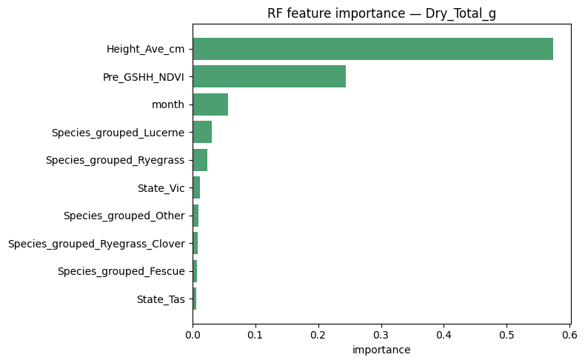
Figure 5. RandomForest feature importance for total biomass (Height and NDVI dominate).
Image per-target R2 (fine-tuned ResNet): Green 0.49, GDM 0.42, Total 0.33, Dead 0.27, Clover 0.30. The image model is beaten by the RandomForest on every single target; the largest gaps are GDM (0.42 vs 0.80) and clover (0.30 vs 0.65).

6. Analysis
1. Metadata outperforms imagery. The RandomForest on two cheap ground measurements (11.83) beats the best image model (18.23) by ~35%. On 357 samples, the direct physical signal in NDVI/height beats what a CNN extracts from raw pixels. This is the project's central, quantified conclusion.
2. Fine-tuning is essential; feature extraction fails. The frozen ResNet (24.74) performs worse than the naive median (24.12): unadapted ImageNet features are useless for pasture. Unfreezing the backbone cuts error sharply. This contrast directly demonstrates the value of fine-tuning on small, domain-shifted data.
3. A small from-scratch CNN matches fine-tuning. The compact network trained on-task (18.70) is statistically indistinguishable from fine-tuning (18.23) and clearly beats the frozen ResNet (24.74) — on small data, "small + adapted" beats "large + borrowed".
4. Where imagery is weakest. Dead matter (R2 0.27) and clover (0.30) have the lowest image R2: dead biomass and scattered clover are hard to read from a top-down photo. The image model is beaten by the RandomForest on every target.
Methodological note. Fine-tuning showed early-epoch validation instability; early stopping on validation weighted-RMSE was used to select the best epoch.
Interpretation. For this dataset and scale, the image does not add predictive value beyond cheap ground measurements — it underperforms them. Practically, where NDVI/height are available they are the better and cheaper predictor. The image-only model remains useful only in the field scenario where such measurements are unavailable, which is exactly what the deployed app targets.

7. Deployment
A Gradio app (src/app.py) serves the image-only fine-tuned ResNet: a user uploads a quadrat photo and receives the five biomass estimates plus a short grazing-quality summary (total biomass, green share). It is deployed to Hugging Face Spaces [link TBD].
[ INSERT Figure 6 HERE ] — source: Hugging Face Space — screenshot after deployment
Figure 6. Screenshot of the deployed Gradio app predicting biomass from an uploaded photo.
The app deliberately uses the image-only model: it represents the realistic field scenario where a farmer has only a phone photo, not NDVI or height. This is consistent with the analysis — the demo illustrates the practical use case, while the scientific comparison lives in the report.

8. Future Work
The image model underperforms metadata; promising directions to close the gap: (1) DINOv2 self-supervised features instead of ImageNet ResNet — features learned on vast unlabelled data may transfer better to pasture texture; (2) a segmentation approach — predict green/dead/soil masks, then derive component fractions, closer to how an agronomist assesses a sward; (3) multimodal fusion — combine image + metadata, expected to beat either modality alone on the labelled set; (4) cross-validation ensembling and test-time augmentation for cheap, low-risk gains.

9. References
CSIRO Image2Biomass dataset (Kaggle competition).
He et al., "Deep Residual Learning for Image Recognition" (ResNet), 2016.
Pedregosa et al., "Scikit-learn: Machine Learning in Python", JMLR 2011.
Paszke et al., "PyTorch", NeurIPS 2019. [Add any other sources used.]

10. Contributions
[Name 1]: [e.g. EDA, tabular baseline, report.] [Name 2]: [e.g. CNN pipeline, training, deployment.] (Fill in per actual division of work.)

