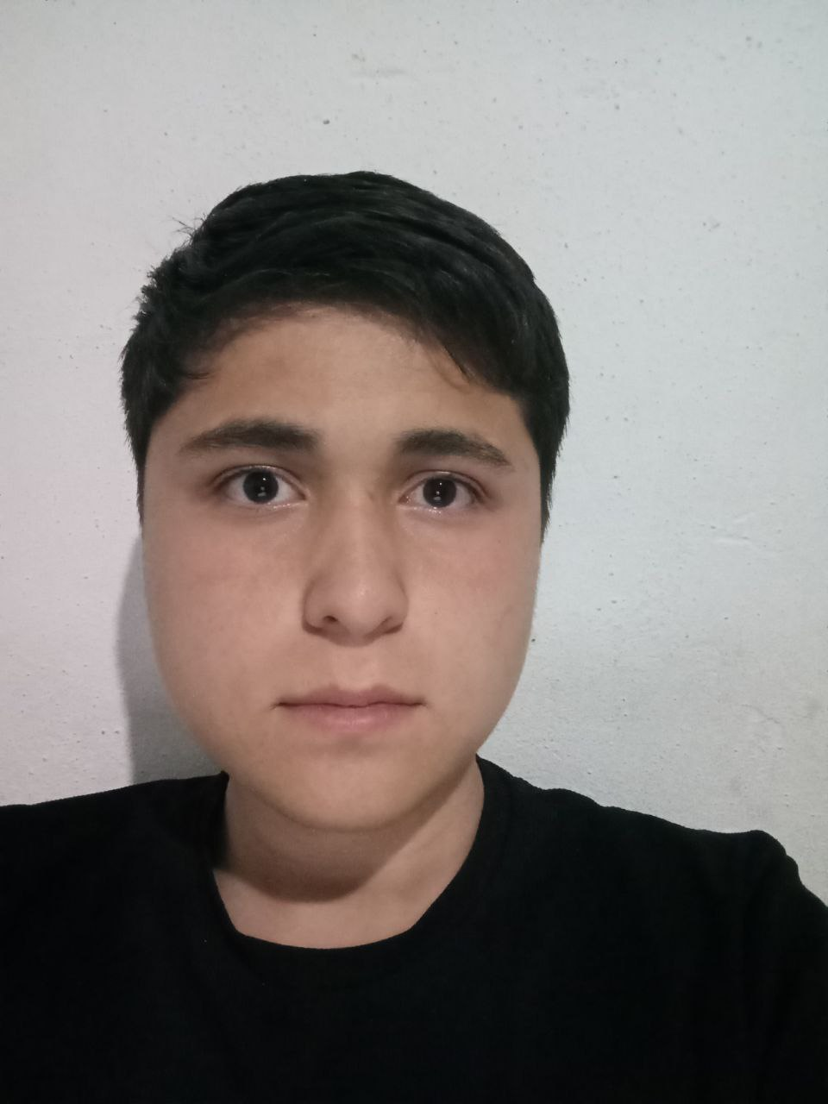 |  | Shuhrataliyev  Muhammadazim  Front-end developer
Education  2024.08 – 2025.04  Najot Talim  Frontent-React.js  Skills  HTML, CSS, SCSS, Bootstrap,  Tailwind.css  JavaScript, React, TypeScript  Zustand, Redux Toolkit  GitHub, Versal  Design tools: Figma  communication  Phone: +998 99 077 57 08  Email:Shuhrataliyevm@gmail.com  GitHub:Shuhrataliyevm  Telegram:@Shuhrataliyev |  | Profile  Fron-end developer with 10 month of experience building responsive, user-friendly web applications,  Proficient in HTML , CSS, JavaScript, React, TypeScript,  Next,Creat focus on performance optimization and user experience.Adept at collaborating with cross-functional teams to deliver high-quality products on time.  Projects  I have worked on several projects, one of which involved creating a clone version of the Asaxiy.uz website. The main goal of this project was to gain a deeper understanding of how e-commerce platforms function and to enhance my skills in working with modern technologies.  PROJECT GOAL  The Asaxiy.uz clone was developed to allow users to browse products, search for items, add them to the cart, and place orders. The primary focus was on ensuring the website’s speed and providing a seamless user experience.  Language  English

