Checkpoint 2 Description
Kevin Lee, Shuhua Xu, Xumeng Zhang

Progress
We integrated somatic mutation data with curated pathway annotations. Somatic mutation profiles were obtained from the TCGA pan-cancer dataset, and 110,492 breast cancer records were selected using associated clinical metadata. Pathway annotations were obtained from Reactome. We then performed an exact matching procedure based on gene and protein-level mutation annotations to identify variants shared between TCGA and Reactome. The final dataset links somatic variants to their associated biological pathways, functional effects, and disease associations as defined in Reactome. This resulted in 37 unique mutations and 9 unique pathways for breast cancer.

Gene | Mutation | Pathway | Effect
PIK3CA | p.E542K | Constitutive Signaling by Aberrant PI3K in Cancer | gain_of_function
ERBB2 | p.V777L | Signaling by ERBB2 KD Mutants | gain_of_function
PIK3CA | p.H1047L | Constitutive Signaling by Aberrant PI3K in Cancer | gain_of_function
RB1 | p.S829* | Defective translocation of RB1 mutants to the nucleus | loss_of_function|partial_loss_of_function
PIK3CA | p.H1047R | Constitutive Signaling by Aberrant PI3K in Cancer | gain_of_function
PIK3CA | p.H1047Y | Constitutive Signaling by Aberrant PI3K in Cancer | gain_of_function
PIK3CA | p.Q546R | Constitutive Signaling by Aberrant PI3K in Cancer | gain_of_function
PIK3CA | p.E545K | Constitutive Signaling by Aberrant PI3K in Cancer | gain_of_function
ERBB2 | p.R678Q | Signaling by ERBB2 TMD/JMD mutants | gain_of_function
ERBB2 | p.L755M | Signaling by ERBB2 KD Mutants | gain_of_function
ERBB2 | p.L755W | Signaling by ERBB2 KD Mutants | gain_of_function
PIK3CA | p.M1043I | Constitutive Signaling by Aberrant PI3K in Cancer | gain_of_function
ERBB2 | p.S310F | Signaling by ERBB2 ECD mutants | gain_of_function
PIK3CA | p.E545A | Constitutive Signaling by Aberrant PI3K in Cancer | gain_of_function
ERBB2 | p.G309A | Signaling by ERBB2 ECD mutants | gain_of_function
ERBB2 | p.V842I | Signaling by ERBB2 KD Mutants | gain_of_function
AKT1 | p.E17K | Constitutive Signaling by AKT1 E17K in Cancer | gain_of_function
ERBB2 | p.L755S | Signaling by ERBB2 KD Mutants | gain_of_function
PIK3CA | p.E545G | Constitutive Signaling by Aberrant PI3K in Cancer | gain_of_function
TP53 | p.R342P | Loss of function of TP53 in cancer due to loss of tetramerization ability | loss_of_function|partial_loss_of_function
PTEN | p.S59* | PTEN Loss of Function in Cancer | loss_of_function
PTEN | p.R130Q | PTEN Loss of Function in Cancer | loss_of_function
RB1 | p.R552* | Defective translocation of RB1 mutants to the nucleus | loss_of_function|partial_loss_of_function
PIK3CA | p.Q546K | Constitutive Signaling by Aberrant PI3K in Cancer | gain_of_function
PTEN | p.Y88* | PTEN Loss of Function in Cancer | loss_of_function
RB1 | p.S215* | Defective translocation of RB1 mutants to the nucleus | loss_of_function|partial_loss_of_function
RB1 | p.A74Efs*4 | Defective translocation of RB1 mutants to the nucleus | loss_of_function|partial_loss_of_function
PTEN | p.R130P | PTEN Loss of Function in Cancer | loss_of_function
ERBB2 | p.D769Y | Signaling by ERBB2 KD Mutants | gain_of_function
PTEN | p.S287* | PTEN Loss of Function in Cancer | loss_of_function
ERBB2 | p.D769H | Signaling by ERBB2 KD Mutants | gain_of_function
SMAD4 | p.Q245* | SMAD4 MH2 Domain Mutants in Cancer | loss_of_function
SMAD4 | p.E526* | SMAD4 MH2 Domain Mutants in Cancer | loss_of_function
ERBB2 | p.I767M | Signaling by ERBB2 KD Mutants | gain_of_function
RB1 | p.R455* | Defective translocation of RB1 mutants to the nucleus | loss_of_function|partial_loss_of_function
SMAD4 | p.Q334* | SMAD4 MH2 Domain Mutants in Cancer | loss_of_function
PTEN | p.Q149* | PTEN Loss of Function in Cancer | loss_of_function

The pathways were added to protege manually, and subclasses were classified by clarification through online literature review and AI prompts. We are currently exploring the linkage between pathways and biomarkers. It is currently unclear whether we can find any relationships between pathways, biomarkers, and breast cancer subtypes within the data we selected. We also added domains and ranges for all object properties.

So far we linked three tables that described the gene name, gene location, pathways, mutations, and mutation effects. This allows us to create a .ttl file that contains all the classes for breast cancer subtypes, genes, mutations, and pathways. Our initial ontology currently includes 5 breast cancer subtypes, 8 genes, three types of mutations (LoF, GoF, and Others, as instances), and 4 pathways and we think that more genes, mutations and pathways may be added. We also have the corresponding object properties of genes, mutations, and patients. Currently we require hasDownregulatedPathway to be disjoint with hasUpregulatedPathway to check for conflicts, but we may adjust this rule to reflect true biology later.
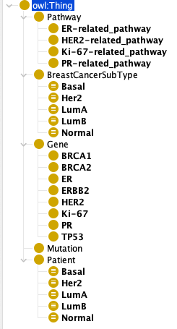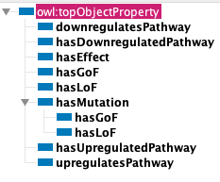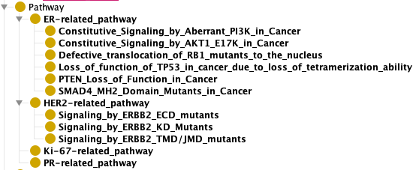
We defined axioms for each breast cancer subtype. Take the Basal subtype as an example, we require each individual to belong to the Patient class, have some types of mutations, and satisfy constraints in pathways. We also added disjunction between each of the breast cancer subtypes.
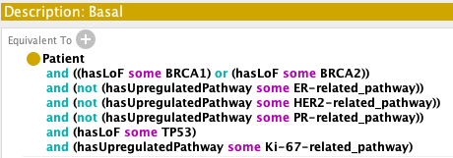
Finally, we designed SWRL rules for inferring the gene mutation effect and the pathway status of a patient:
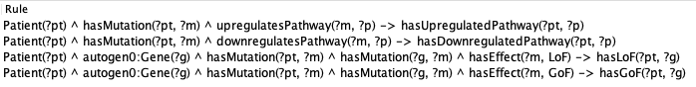
With these designs, we plan to build a complete chain of inference from gene mutations, to pathway changes, to disease subtypes.

Problems and next steps
However, we are still concerned about how we should model genes and pathways – whether they should be classes or instances. Our intuition is that they should be instances to facilitate inference from SWRL rules, but then we will have a problem of how we should design the axioms as they reflect class-level logic.

There are 2 gene mutation related pathways that are not present in our current dataset. According to our literature review, there should be some kinds of mutations that lead to upregulation or downregulation of Ki-67 and/or PR. We have not identified pathways that belong under these classes yet. We may need to rethink how we classify pathways as we have not yet identified pathways in the data set that are explicitly related to genes Ki-67 and PR. We also know that PR is the downstream product of ER, so the lack of expression of the PR gene in the presence of ER gene expression suggests that the ER-related pathway is faulty; this suggests that pathways can affect other pathways, and that relationships are not explicitly only between genes, mutations, and pathways.

Finally, we will have clearer pathway class names to specify whether these pathways are upstream or downstream of the genes.

