Sophia Wu

DXARTS 200 A

4/10/23

**Exploring the Benefits of Human and AI Collaboration:**

**The Creative Expression of Humanity**

**Project Description:**

In a world where technology becomes increasingly integrated with society, artists find themselves in conflict with generative ai art. As a cheat-code to make art pieces with simple phrases, a tension grows on the usage and copyright infringement of ai artwork. However, it is important to emphasize the benefits of using generative ai to enhance the creativity of artists. Rather than the notion of ai replacing humans, blurring the line between human and technology would allow the expansion of a new artform. I want to acknowledge that as technology continues to integrate more into our lives, humans will not lose their purpose for creative expression. As such, my art installation will provide a tactile experience for users to make art with the assistance of generative ai. By physically interacting with ai in a collaborative way, the I hope to encourage the user consider the roles of AI in creative expression.

**Bibliography:**

Schaldenbrand, P., McCann, J., & Oh, J. (2022, October 3). *FRIDA: A Collaborative Robot Painter with a Differentiable, Real2Sim2Real Planning Environmen*. arxiv.org. Retrieved April 10, 2023, from https://arxiv.org/pdf/2210.00664.pdf

AIArtists. (2021). *Generative art: 50 best examples, tools & artists (2021 guide)*. AIArtists.org. Retrieved April 10, 2023, from https://aiartists.org/generative-art-design

Chayka, K. (2023, February 10). *Is A.I. Art stealing from artists?* The New Yorker. Retrieved April 9, 2023, from https://www.newyorker.com/culture/infinite-scroll/is-ai-art-stealing-from-artists

Christies. (2018, December 12). *Is artificial intelligence set to become art's next medium?: Christie's*. The first piece of AI-generated art to come to auction | Christie's. Retrieved April 9, 2023, from https://www.christies.com/features/A-collaboration-between-two-artists-one-human-one-a-machine-9332-1.aspx

Chung, S. (2018, March 5). *Myths of human and Machine*. Sougwen Chung (愫君). Retrieved April 9, 2023, from https://sougwen.com/myths-of-human-and-machine

Follett, J. (2020, December 11). *Making art with ai*. Medium. Retrieved April 9, 2023, from https://towardsdatascience.com/making-art-with-ai-cc1acb332d0

Henry, D. (2019, May 24). *How artists use AI and ar: Collaborations with google arts & culture*. Google. Retrieved April 9, 2023, from https://blog.google/outreach-initiatives/arts-culture/how-artists-use-ai-and-ar-collaborations-google-arts-culture/

Jones, V. (2021, June 7). *Sougwen Chung: Human and machine collaboration*. Medium. Retrieved April 9, 2023, from https://medium.com/verisart/sougwen-chung-human-and-machine-collaboration-72d912d6b065

Kundu, R. (2023, March 2). *Ai-generated art: From text to images & beyond [examples]*. V7. Retrieved April 9, 2023, from https://www.v7labs.com/blog/ai-generated-art

Reben, A. (2022, November 28). *The weird and wonderful art created when AI and humans unite*. BBC Future. Retrieved April 9, 2023, from https://www.bbc.com/future/article/20221123-the-weird-and-wonderful-art-created-when-ai-and-humans-unite

RFID Card. (2021, April 22). *Italian art gallery improved customer interaction with NFC*. RFID Card. Retrieved April 10, 2023, from https://www.rfidcard.com/italian-art-gallery-improved-customer-interaction-with-nfc/

**Materials:**

* Arduino Uno
* Generative Art Software
* Clay
* Paper and pencil
* NFC chip? (only works for phone)
* Vision sensor, (huskylens, arducam)

**Dimensions:** Initial display as done on macbook air (11.97 in width, 8.36 in depth)

**References/Inspiration:**

<https://www.creativeapplications.net/member-submissions/shanshui-dada-ai-assists-human-creator-in-drawing-chinese-ink-wash-landscape-painting/> : ai assists artists with ink drawing, takes live and shows image reference

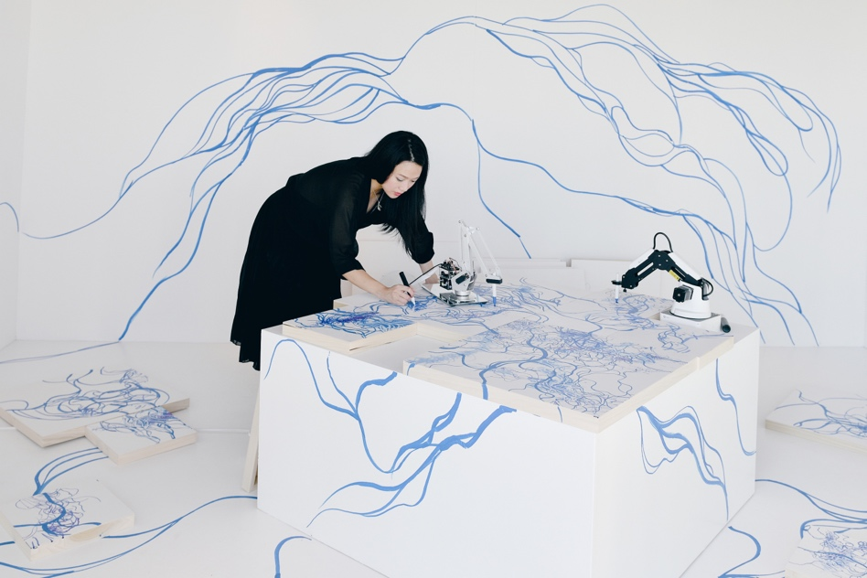

<https://aiartists.org/generative-art-design> : a guide to making generative art, and software that utilizes generative art ai

<https://www.rfidcard.com/italian-art-gallery-improved-customer-interaction-with-nfc/> : Italian art gallery that uses NFC tags in art pieces for interaction with users, showing the user the process of craftmanship behind a chosen piece

<https://arxiv.org/pdf/2210.00664.pdf> : a research document on the robot FRIDA, which paints according to a user’s expression of ideas (user provides sample images or words which the robot paints)

<https://amt-lab.org/blog/2022/4/integrating-nfc-technology-in-performing-arts-organizations> : using NFC chips in arts and interaction

<https://www.freecodecamp.org/news/how-to-build-a-simple-image-recognition-system-with-tensorflow-part-1-d6a775ef75d/> : how to code image recognition.

**Sketch:**

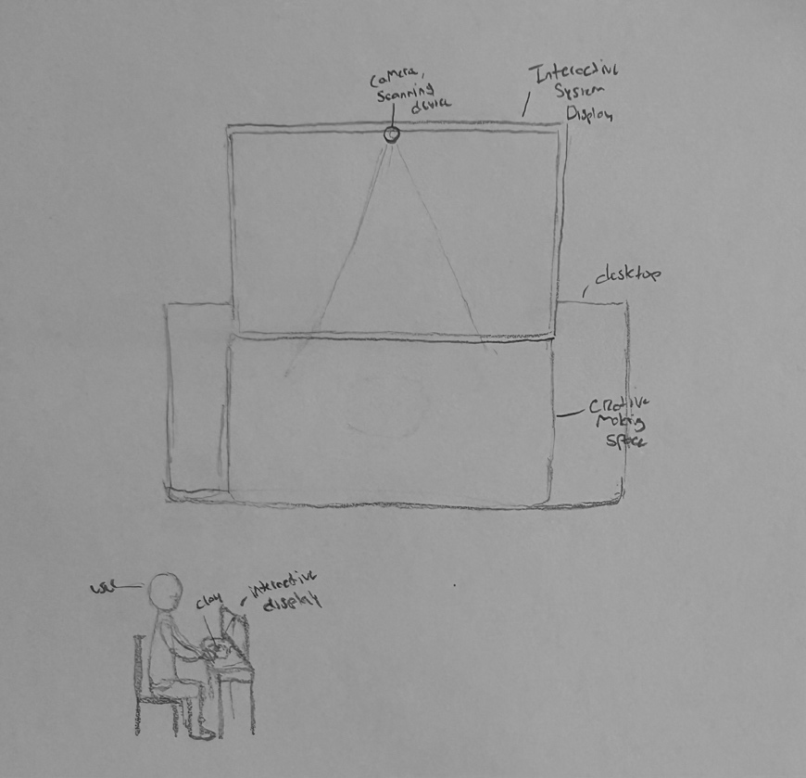

**Interaction Flow Chart:**

**Budget:** $150

Note: add mechatronic element in some way

Prompt making machine that can give ai

Computer generator and hook to a cnc (pen plotter or 3d printer that can generate image physically)

Verdict on project: it is too complicated, will need to be simplified to maintain the integrity of the object.

Notes:

* Do research, record data and transform into artifact
* Story draw: creates a conversational agent, generates text from drawing or images to make a story
* Make something of clay, keep it as a reference, and feed it into image generator
* Come up with specific idea of where you want to go, instead of using ai generator, it could just be a vision sensor with lcd screen.
* Needs to include usage of mechatronic, a mechatronic installation.
* Option: Making a pen plotter from scratch