Building a Tic-Tac-Toe AI Model

Data Collection:
Source:
I downloaded a Tic-Tac-Toe dataset from Kaggle, which contains historical game states and outcomes.
Goal:
The dataset represents board configurations (X) and optimal moves (Y) or game results, which you used to train a machine learning model.

Data Preparation:
Using a Python script, I preprocessed the dataset to generate two files:

X.npy: This file stored the board states represented as arrays of length 9.
Y.npy: This file contained the corresponding target outputs, indicating the best move.

Model Training:
To train the model efficiently, I used Google Colab, which provided access to free GPU resources. I performed the following steps:
- Multilayer Perceptron (MLP) using PyTorch
- Added Loss Function and Optimizer
- Trained the model for multiple epochs
- Computed the loss between the model’s predictions
- Model Saving

Notbook Link: https://colab.research.google.com/drive/1JyEN_GNS7X_Daym_QBhQCe_fi2_jGmD_?usp=sharing
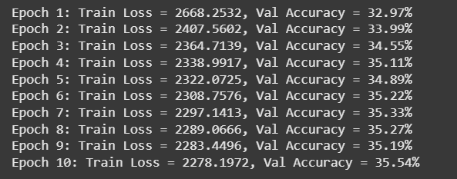

Integration with Tkinter Game UI:
After training the model, I built a GUI-based Tic-Tac-Toe game using Tkinter and integrated the model into the gameplay.

- Model Loading
- Bot Move Logic
- Gameplay and Strategy

Step | Tools / Techniques
Data Preparation | NumPy, Python
ML Framework | PyTorch
Model Type | Fully Connected Neural Network (MLP)
Loss Function | CrossEntropyLoss
Optimizer | Adam
Training Platform | Google Colab
Interface | Tkinter
Bot Strategy | ML model + rule-based blocking
Deployment | Desktop app via Python script

