**Software Construction and Development**

**Lab Manual-04**

**SCD LAB Booklet**



**Faculty of Information Technology**

**UCP Lahore Pakistan**

|  |  |
| --- | --- |
| Lab 04 | |
| **Topic** | * **Introduction to Azure DevOps as Application Lifecyle Management (ALM) Tool** |
| **Objective** | * Explanation of Azure DevOps key components: Boards, Repos, Pipelines, Test Plans, and Artifacts. * Creating an Azure DevOps account * Configuring basic account settings and organization details * Creating a new project within Azure DevOps. * Inviting team members to the project.Brief Introduction of UML |

**What is Azure DevOps?**

In a single sentence, [Azure DevOps](https://azure.microsoft.com/en-us/blog/introducing-azure-devops/) is a suite of offering in the cloud that you need to build your software product/project from beginning to end.

Azure DevOps, formerly known as Visual Studio Team System (VSTS). It helps you to plan your project, manage source code in repositories like Git, TFVC, Subversion, GitHub and deploys the code through the CI/CD pipeline system to cloud or in on-premise resources. Additionally, it gives a collaborative platform for developers, business users and test engineers, project managers under one umbrella to real time tracking of work and quick shipment of the product.

**Six pillars of Azure DevOps:**

Azure DevOps has six major pillars which helped it to shape as complete ALM offering in the the cloud.

1. Azure Boards
2. Azure Repos
3. Azure Pipelines
4. Azure Test Plans
5. Azure Artifacts
6. Azure Overview
7. **Azure Boards** is a place to manage and plan all of your work. All ideas and business requirements for your software can be captured here. You can create epics, features, user stories and then estimate them and plan capacity of your team members and start the sprint. Additionally, you can have a real time view of the work item progression in Kanban boards, sprint burn down charts.
8. **Azure Repos** supports various source control system like Azure Git, Public GitHub, GitHub Enterprise, Microsoft’s own Team foundation version control (TFVC), External Git. You can choose any one of the repositories for your choice for software development and source code. Once development is done developers can create a pull request with their changes, send it for code review and take part of a collaborative development environment
9. **Azure Pipelines** are used for continuous integration and continuous delivery (CI/CD) of your code. It allows you to ship your code faster. Once your code is developed and committed to the repos, a build gets triggered in the build pipeline. This build pipeline gets the latest code from the repos, builds them in the build agent. On a successful build, the build artifacts get published using Release pipeline in your targeted deployment environment.
10. **Azure Test Plans**is for planning and executing your manual, automated and load test cases. Once the build is succeeded test engineers can run a set of tests on the build for verification and validation of the desired functionality. And they can raise and log any defects or observation on failure of any of the planned test scenarios in the Azure Boards.
11. **Azure Artifacts** manages your private NuGet, npm, Maven packages in a private feed. You can integrate this feed in your favorite IDE such as Visual Studio or Visual Studio Code and restore the packages from this feed while development. Additionally, you can integrate this feed in the build pipeline and restore packages from this private repository. Azure Artifacts helps a lot where there are a lot of shared common packages in use in the application and you want to control standards, version of those cross-cutting artifacts
12. **Azure Overview**gives real time insights of the project such as teams velocity, CI/CD results, number of defects raised vs solved at any point of time to name a few. Executive dashboards can be created with inbuilt capability of it. These dashboard helps greatly for executive status reporting with risk and quality matrices.

#### **What is Application Lifecycle Management (ALM)?**

Application lifecycle management (ALM) is the product lifecycle management of computer programs. It encompasses requirements management, software architecture, computer programming, software testing, software maintenance, change management, continuous integration, project management, and release management.

An ALM tool should have the capability to maintain all the aspects of a software lifecycle, such as capturing the ideas, user’s requirement, planning of work, maintaining source code, deploying code using continuous integration and continuous delivery (CI/CD). It should also provide real time project insights to the key stake holders of a project. We can think of an ALM software as one stop shop for a software project/product management as a whole.

**ALM with Azure DevOps in action**

Now that we have fair understanding of six pillars of Azure DevOps, now let’s see how all of these helps in ALM with an example. refer to the [Infographic](https://subhankarsarkar.com/wp-content/uploads/2018/09/Azure-DevOps-SubhankarSarkar.png) of beginning of this post. This describes ALM in action with Azure DevOps very briefly.

In the beginning of the project or product it starts with an idea or some business requirement and after going through multiple steps it takes shape of a usable product. In this example infographic

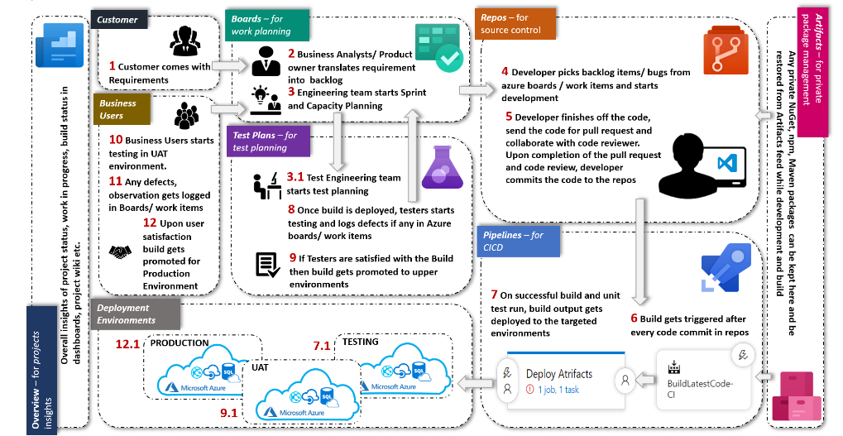

Figure 1: Application Lifecycle Management in Azure DevOps

* **Creating an Azure DevOps account:** start with the website <https://azure.microsoft.com/engb/products/devops/?nav=min>

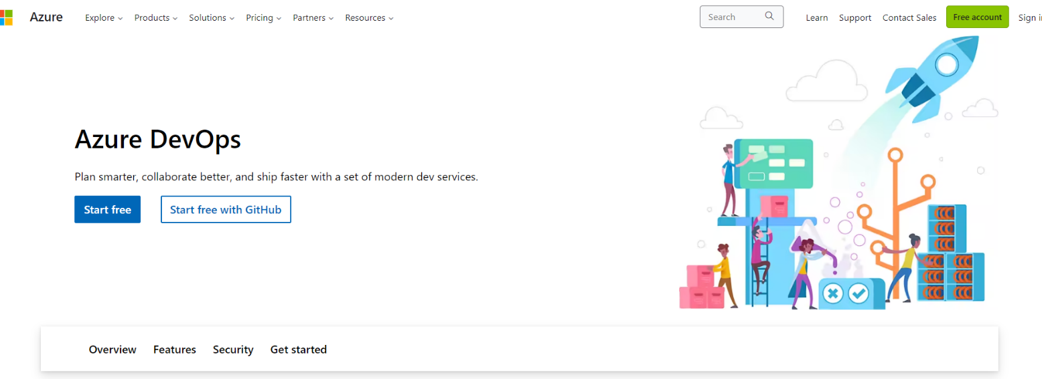

**Basic Configuration On DevOps**

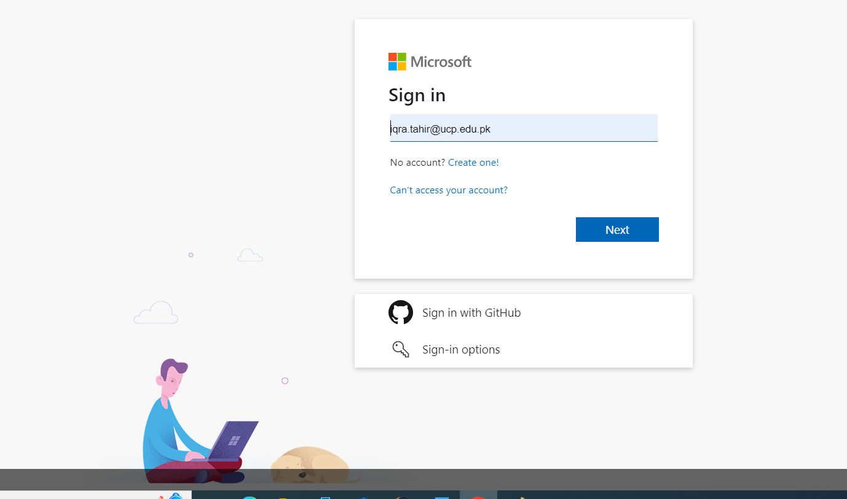

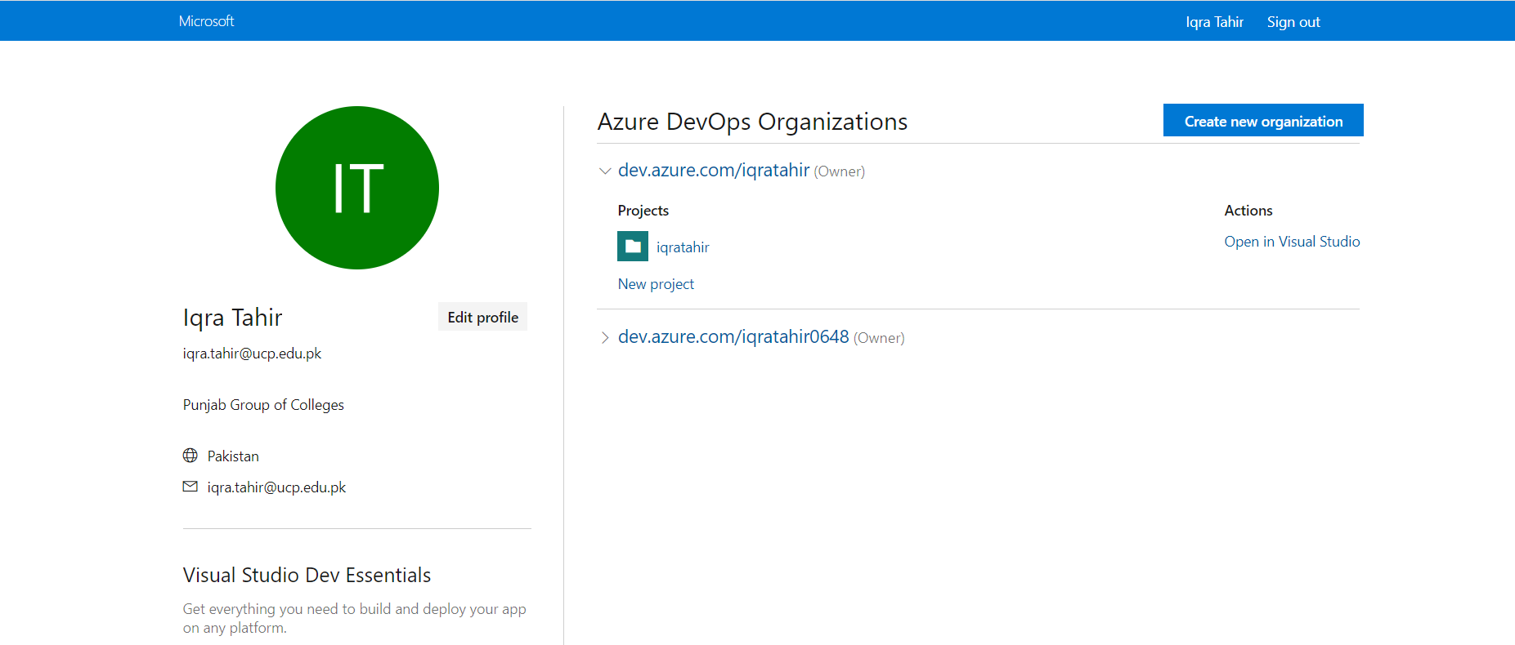

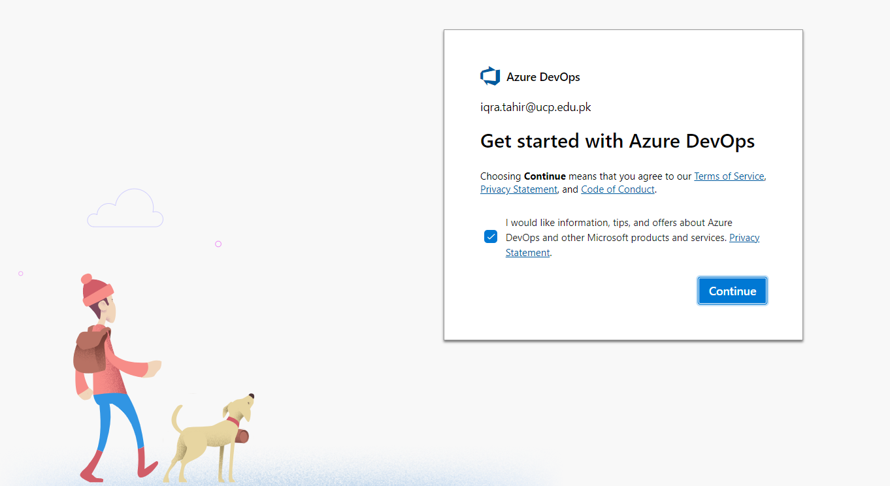

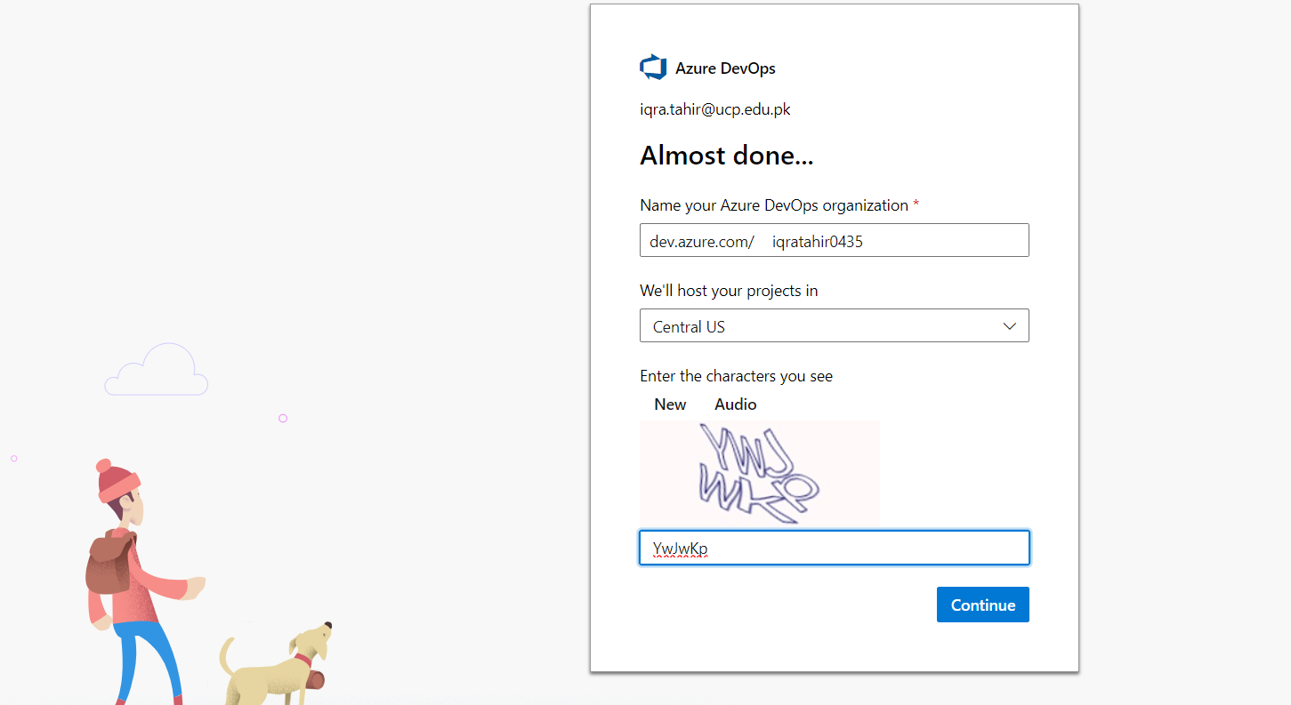

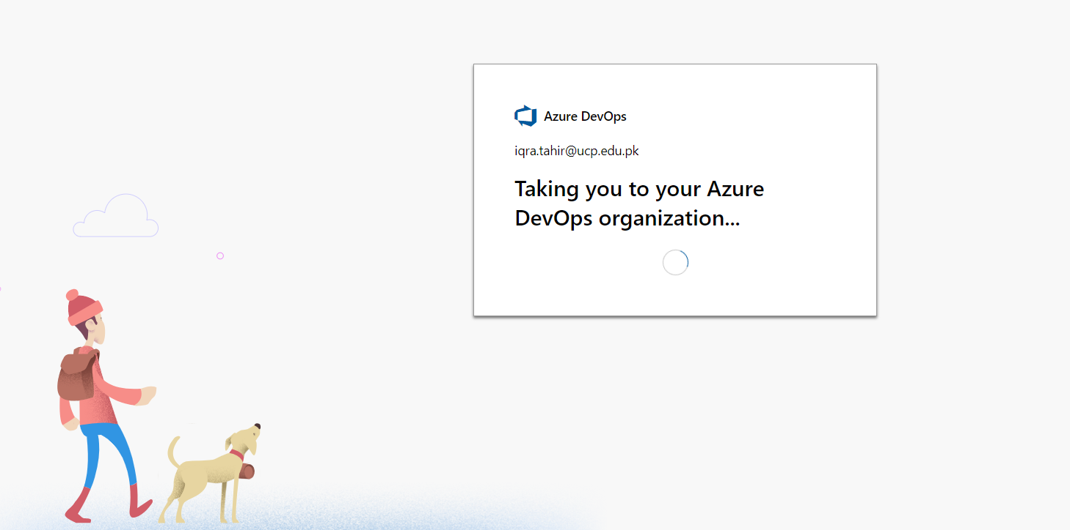

**Creating Project in Azure DevOps**

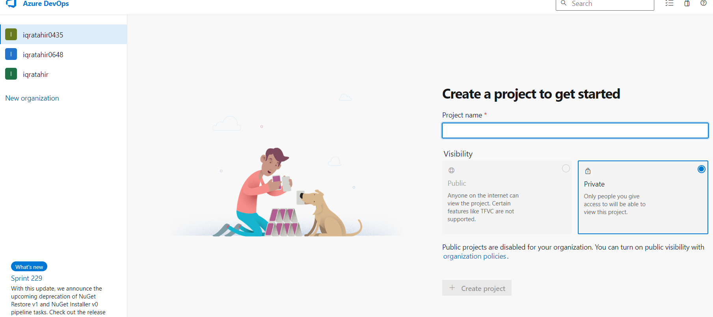

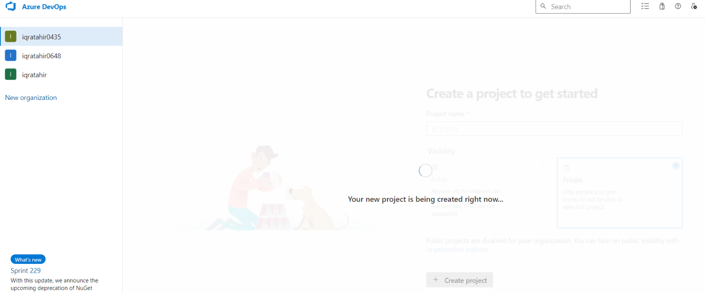

**Project Created**

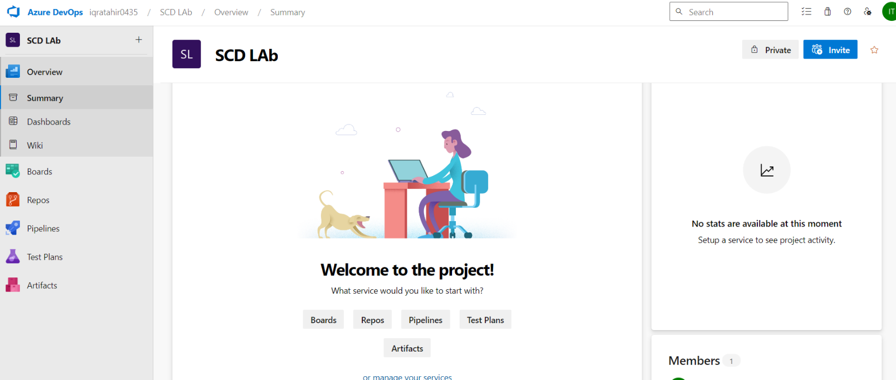

**Inviting Members to Project**

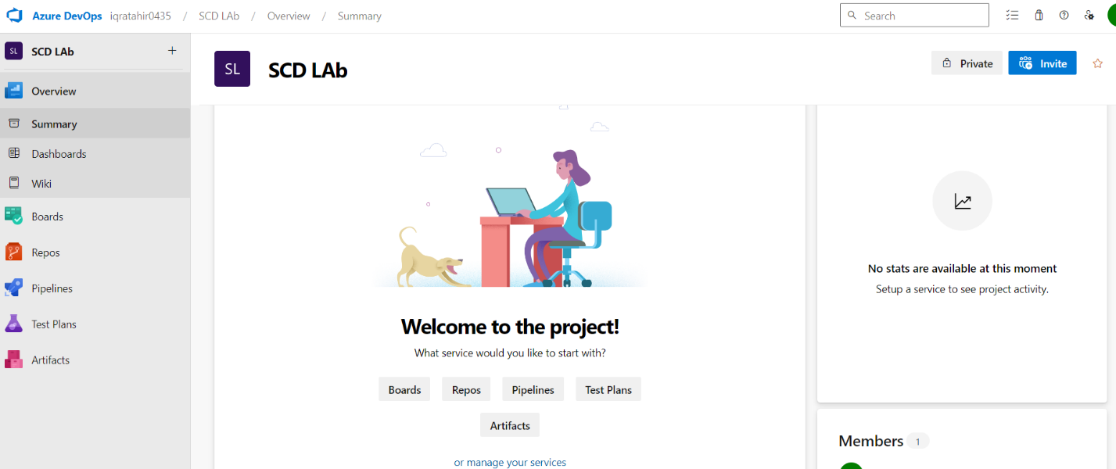

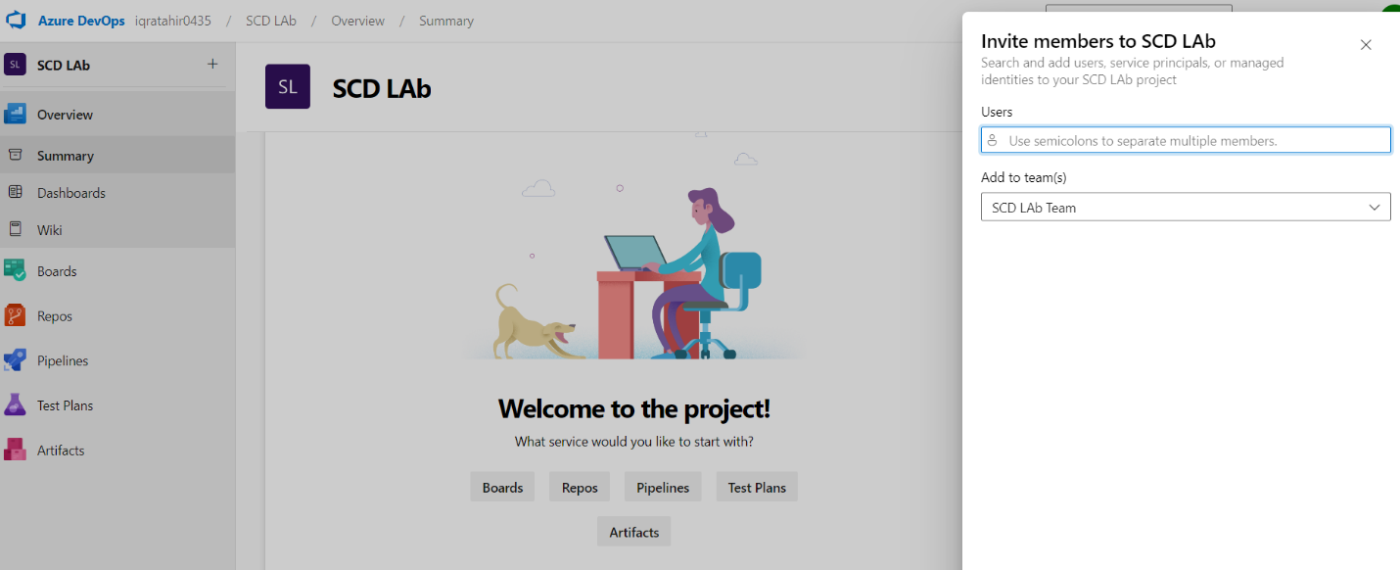

**Lab Practice Task**

* You are required to configure your DevOps Account
* You are required to create meeting
* You are required to invite your team and create a meeting