Computer Architecture Lab
(EL-2012)
LABORATORY REPORT

Fall 2026

(Lab#6)
Use of Venus Simulator for RISC-V Procedure Execution

Student Name: Shuja Abbas Roll No:24i-6539 Section: a

Date performed: 29th September, 2026

MARKS AWARDED: ________ / 10

Signature and date of Instructor: _________________
Lab Instructors: Dr. Nasir Ali Shah, Engr. Fasih Ahmad

______________________________________________________________________________________________________________________________________________________

NATIONAL UNIVERSITY OF COMPUTER AND EMERGING SCIENCES, ISLAMABAD
Prepared by: | Fasih Ahmad |  | Version: 1.0
Verified by: | Dr. Nasir Ali Shah |  | Updated: Fall 2026

Task 1:

Description:
The procedure is not displaying the correct value because it changes the value of s0 from 2500 to 3 inside the procedure. Since s0 is a saved register, its original value should be preserved when a procedure uses it. Therefore, after returning, s0 becomes 3, and add t1, s0, a0 calculates 3 + 1003 = 1006 instead of 2500 + 1003 = 3503. To fix this, use a temporary register such as t0 instead of s0 for storing 3, so that s0 remains 2500.
Since s0 is a saved register, a procedure should preserve its original value if it uses it. The easiest fix here is to use a temporary register f
Code:
.text
main:
li a0, 1
li s0, 2500
jal ra, procedure

add t1, s0, a0 # t1 = 2500 + 1003 = 3503

li a0, 1 # display command
mv a1, t1 # value to display
ecall

procedure:
li t0, 3
li t1, 1000
add a0, t0, t1 # a0 = 1003
jalr zero, ra, 0

Output:
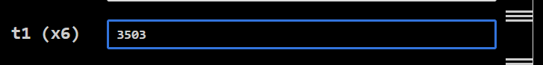

Task 2:

Description:
First, addi s0, zero, 5, addi t1, zero, 10, and addi t0, zero, 15 put the values 5, 10, and 15 into s0, t1, and t0. Then addi sp, sp, -12 reserves 12 bytes on the stack, since each register value takes 4 bytes. The three sw instructions save these values on the stack: s0 at 0(sp), t0 at 4(sp), and t1 at 8(sp). The lw instructions then retrieve these saved values into different registers: t4 gets 10, t2 gets 15, and t3 gets 5. Finally, addi sp, sp, 12 restores the stack pointer to its original position, effectively releasing the 12 bytes of stack space.
Code:
addi s0, zero, 5
addi t1, zero, 10
addi t0, zero,15
addi sp, sp, -12
sw s0, 0(sp)
sw t0, 4(sp)
sw t1, 8(sp)
lw t4, 8(sp)
lw t2, 4(sp)
lw t3, 0(sp)
addi sp, sp, 12

Output:
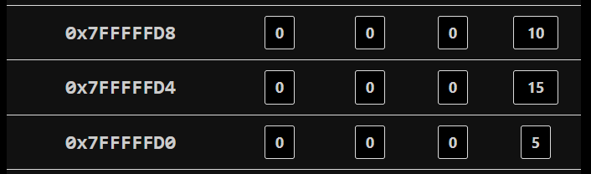

Task 3:

Description:
Here we wrote RISCV code for the C program which was provided

Code:
#int main(){
#x=EqSolver(a,b);
#}
#int EqSolver (int a, int b){
#return (a+b)(a-b);
#}
main:
addi a0,zero,20
addi a1,zero,10
jal ra,EqSolver
li a0,10
ecall

EqSolver:
add t0,a0,a1
sub t1,a0,a1
mul a1,t0,t1
ret

Output:
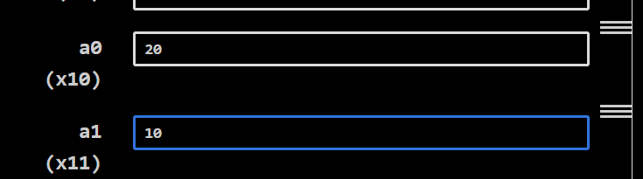
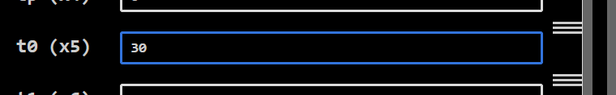
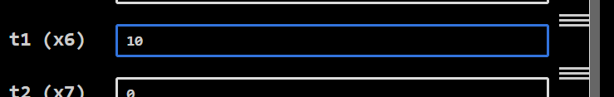
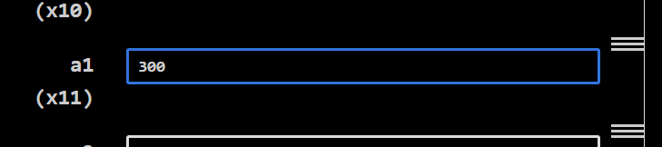

Task 4:

Description:
We wrote a RISCV assembly code to find the area and parameter of square , we did that by making to different functions and calling them in main
Code:
#Write RISC-V assembly code to find the area and perimeter of square. You need to
#write two procedures (i.e. AreaFinder and PerimeterFinder ) and call both functions in
#main module.

main:
li a1,10
li a2,10
jal ra,AreaFinder
jal ra,PerimeterFinder
li a0,10
ecall

AreaFinder:
mul a1,a1,a2
ret

PerimeterFinder:
slli a2,a2,2
ret

Output:
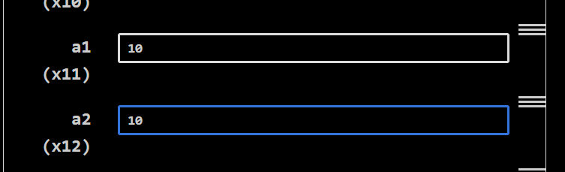

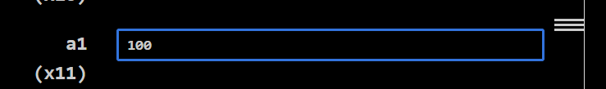
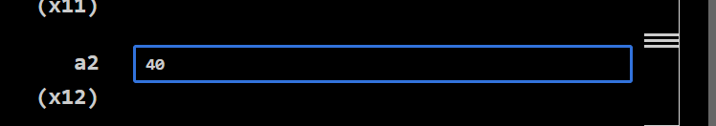

Task 5:

Description:
We converted the given C code into RISCV assembly code and ran the simulation
Code:
#Write RISC-V assembly code for given C code:
#int main(){
#y=EqSolver(x);
#}
#int EqSolver (int x){
#return (x^3+5x^2+6x);
#}

main:
li a1,10
jal ra,EqSolver
li a0,10
ecall

EqSolver:
addi t0,a1,0 #t0=x
mul t1,t0,t0 #t1=x^2
mul t2,t1,a1 #t2=x^3
li t3,5
li t4,6
mul t1,t3,t1 #t1=5*x^2
mul t0,t0,t4 #t0=6x
add t5,t1,t0
add t5,t2,t5
add a1,t5,zero
ret

Output:
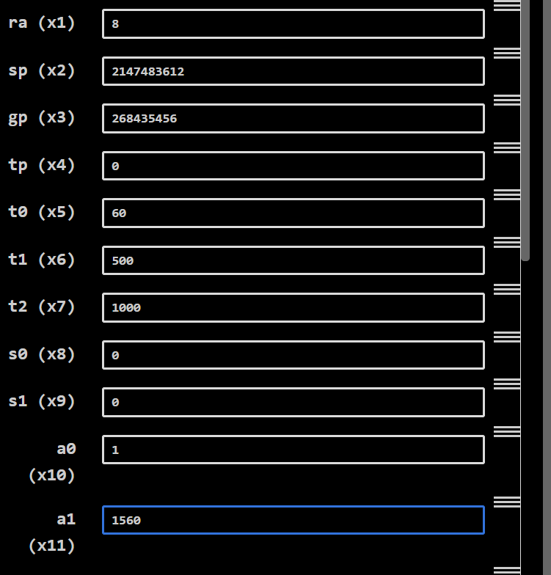

Task 6:

Description:
Here we again converted C code into RISC-V assembly code

Code:
#int main(int n, int k){
# if (k == 1)
#y=F1(n,k);
# else if (n &gt; k)
#y= F2(n);
# else
#y= F3(n);
#}
#int F1 (int x,int z){
#return (x 2 + z 2 );
#}
#int F2 (int z){
#return (z 3 );
#}
#int F3 (int w){
#return (w+5)
main:
li a0, 10 # n = 10
li a1, 20 # k = 20

li t0, 1
beq a1, t0, y1
blt a0, a1, y3

y2:
jal ra, F2
j display

y1:
jal ra, F1
j display

y3:
jal ra, F3

display:
addi a1, a0, 0
li a0, 1
ecall

li a0, 10
ecall

F1:
mul t0, a0, a0
mul t1, a1, a1
add a0, t0, t1
ret

F2:
mul t0, a0, a0
mul a0, t0, a0
ret
F3:
addi a0, a0, 5
ret

Output:
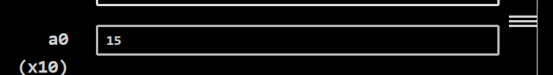

Task 7:

Description:
We converted the given C code into RISCV assembly code and ran the simulation
Code:
#int main(int n, int k){
# if (k == 0)
#y=fun1(n);
# else if (n == k)
#y= fun2(n);
# else
#y= fun3(n);
#}
#int fun1 (int x){
#return (x 2 );
#}
#int fun2 (int z){
#return (z 3 );
#}
#int fun3 (int w){
#return (w+1);
#}
main:
li a0, 10
li a1, 0
beq a1, zero, y1
beq a0, a1, y2
jal ra, fun3
j exit

y1:
jal ra, fun1
j exit

y2:
jal ra, fun2

exit:
addi a1, a0, 0
li a0, 1
ecall
li a0, 10
ecall

fun1:
mul a0, a0, a0
ret

fun2:
mul t0, a0, a0
mul a0, t0, a0
ret

fun3:
addi a0, a0, 1
ret

Output:
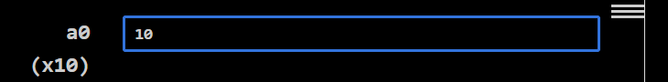

Task 8:

Description:
// Write description of the task here 👇 (max. five to seven lines)

Code:
(a)
main:
li a0, 10
jal ra, fib
j exit

fib:
beq a0, zero, base

li t0, 0
li t1, 1
li t2, 2

loop:
bgt t2, a0, done
add t3, t0, t1
add t0, t1, zero
add t1, t3, zero
addi t2, t2, 1
j loop

done:
add a0, t1, zero
ret

base:
addi a0, zero, 0
ret

exit:
addi a1, a0, 0
li a0, 1
ecall
li a0, 10
ecall

(b)
main:
li a0, 10
jal ra, fib
j exit

fib:
beq a0, zero, base0
li t0, 1
beq a0, t0, base1

addi sp, sp, -12
sw ra, 8(sp)
sw a0, 4(sp)

addi a0, a0, -1
jal ra, fib
sw a0, 0(sp)

lw a0, 4(sp)
addi a0, a0, -2
jal ra, fib

lw t0, 0(sp)
add a0, a0, t0

lw ra, 8(sp)
addi sp, sp, 12
ret

base0:
li a0, 0
ret

base1:
li a0, 1
ret

exit:
addi a1, a0, 0
li a0, 1
ecall
li a0, 10
ecall

Output:
