University of Azad Jammu & Kashmir
Muzaffarabad
Department of Software Engineering

MID TERM LAB EXAM
Name: | HAMMAD SHUJA
Roll Number: | 2024-CET-26
Session: | 2024-2028
Subject: | Graphic Designing
Lab Instructor: | Engr. Ahmed Khawaja
Dated: | 30-04-2026
Semester: | Spring-2026(4th sem)

MID TERM LAB EXAM - GRAPHIC DESIGNING
Note: Answer all questions. Do not use any ready-made template. Design must be created by yourself. Layout, structure, colors, and typography should be your own.

Question 1: Promotional Poster Design (5 Marks)
A new student society named “Creative Tech Society” has been launched in the Department of Software Engineering. The society wants to promote its first event, “Design Sprint 2026”, where students will learn basic poster designing, logo designing, and branding skills.
Design a promotional poster for the event. Apply the principles and elements of graphic design including balance, contrast, hierarchy, alignment, and color theory.
Design Solution:
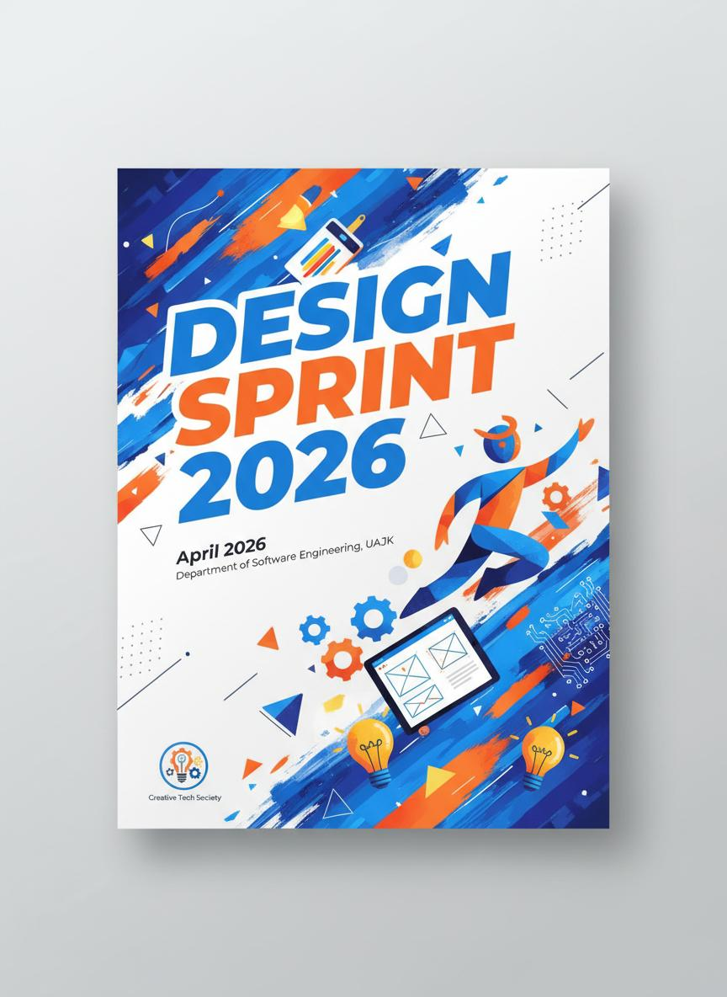
Figure 1: Promotional Poster for Design Sprint 2026 by Creative Tech Society

Question 2: Logo Design
Design a simple and meaningful logo for “Creative Tech Society.” The logo should represent creativity, technology, teamwork, or innovation. It should be suitable for use on posters, certificates, social media pages, and event banners.
Design Solution:

Figure 2: Logo Design for Creative Tech Society

Question 3: Campaign Poster Design (5 Marks)
A startup named “GreenByte Solutions” is launching an awareness campaign titled “Save Energy, Save Future.” The startup wants a poster to promote the campaign.
Design a campaign poster with proper structure, clear message, readable text, a suitable green/environmental color scheme, balanced spacing, and professional alignment. Use relevant visual elements such as leaves, bulbs, earth, energy icons, or eco-friendly symbols.
Design Solution:
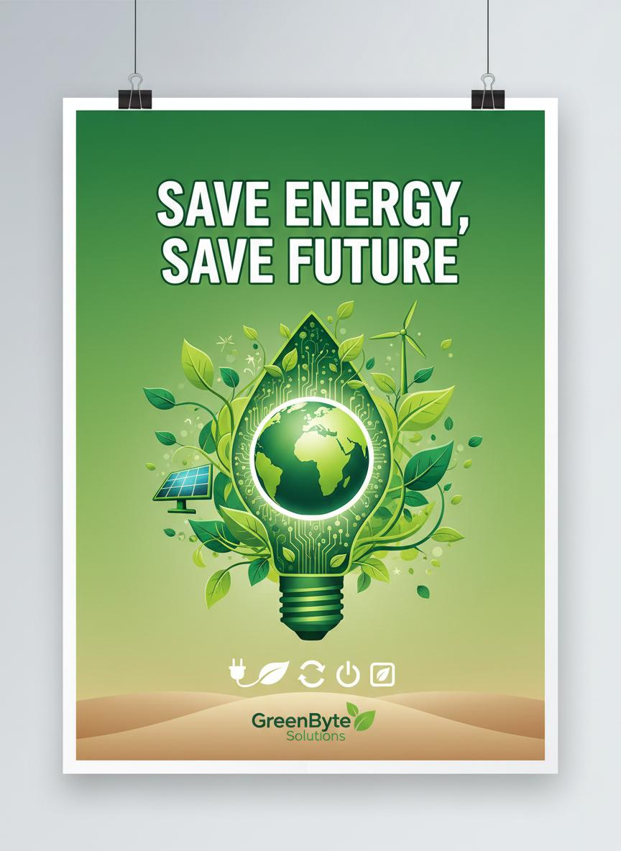
Figure 3: Campaign Poster for GreenByte Solutions - Save Energy, Save Future

