
University of Azad Kashmir
Graphic Design / UI-UX
Quiz 1 Submission

Student Name | Hammad Shuja
Roll Number | 2024-CET-26
Semester | 4th Semester
Date | 15-05-2026
Topic | Introduction to UI/UX | UI vs UX | Wireframes | Mockups
Question | Create a readable mobile app login wireframe with the required UI elements and a short UX explanation.

Quiz Requirement: Design a low-fidelity wireframe for a mobile app login screen and write 3-4 lines explaining how the design improves user experience.
Required Elements: app logo/title, username or email field, password field, login button, forgot password option, and sign-up option.
Instructions: Use simple boxes and labels only. Keep the layout readable, clear, and user-centered.

Solved Quiz

Student: Hammad Shuja
Question: Design a low-fidelity wireframe for a mobile app login screen and explain how it improves user experience.
Low-Fidelity Wireframe

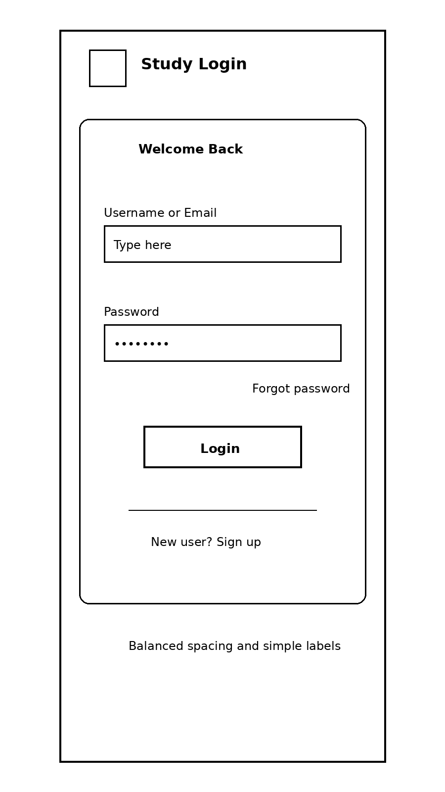

UX Explanation
- This design keeps all important items in one clean section, so the user does not feel distracted.
- The spacing between fields makes the screen readable and gives a smooth flow from top to bottom.
- The forgot password link is close to the password box, which helps the user recover access faster.
- The sign-up option stays visible at the bottom, so a first-time user can create an account without searching around.

Note: This solution is written in a simple student style and follows the quiz instructions with boxes and labels only.

