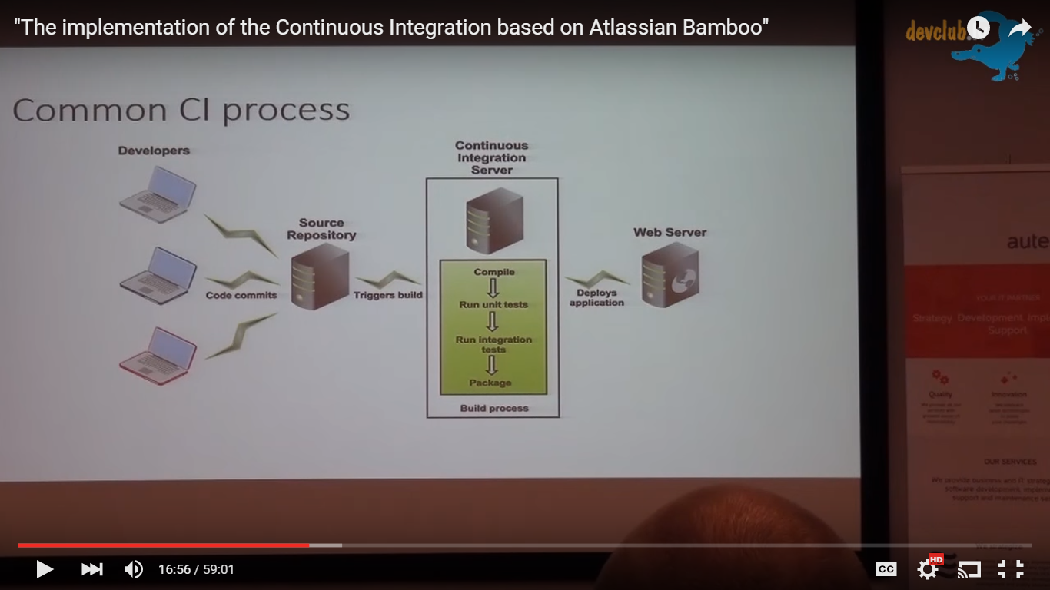

This is a demo of the CI based on Atlassian Bamboo.

**Continuous Integration** (CI) is a development practice that requires developers to integrate code into a shared repository several times a day. Each check-in is then verified by an automated build, allowing teams to detect problems early.

**Continuous Delivery** is a software development discipline where you build software in such a way that the software can be released to production at any time. You're doing **continuous delivery** when: [1] Your software is deployable throughout its lifecycle