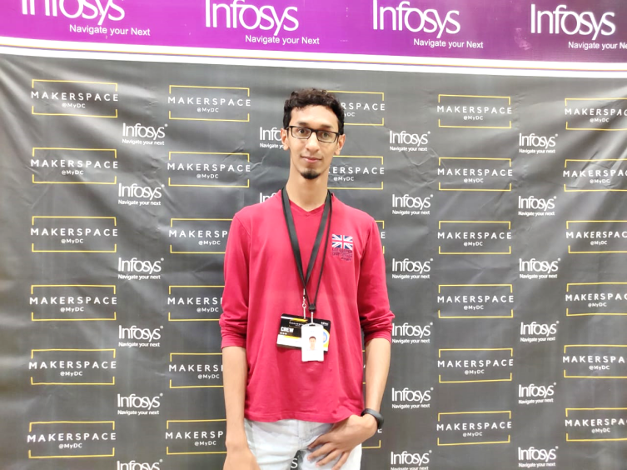

`

**SHUJATH KHAN**

**AI/VR Developer | Full Stack Developer | Tech-Aficionado | Mentor**

+91 82482 19416 shujathkhan@live.com

Github.com/shujathkhan Linkedin.com/in/shujath-khan

Hackerrank.com/Xukah shujath.me

world-512160_Hackerrank_logo_logos-512********­­­­

**SRM University**, Chennai (2018)

B.tech IT | CGPA: **8.7**

Published papers:

* **Real-time Human Posture Recognition** in Journal of Emerging Technologies and Innovative Research. [ bit.ly/2AwSpST ]
* **Autonomous Smart Waste Collection System** using IoT. (IEEE) [ bit.ly/2RmNU6H ]

Achieved **zonal level** ranking in **India’s Biggest Networking championship** by I-MEDITA and CISCO.

Completed a specialization course on **Advanced Machine Learning using Tensorflow** with GCP by **Google cloud.**

**Microsoft certified** in Programming with HTML5, CSS3 and JavaScript.

Relevant skills

**TECHNICAL SKILLS**

**ACHIEVEMENTS**

**EDUCATION**

**Infosys** (Jan ’18-Present)

* Completed 4-month internship
* Part of Research and Innovation team, Lab42.
* Mentoring trainees in developing and evaluating products to be deployed into production.

Key projects undertaken:

* Developed an AI-enabled smart mirror from ground up, which included facial recognition, voice and gesture control and a centralized cloud control for updates and maintenance. [Built with two tech stacks, Alexa+AWS and the other Intel+AWS]
* Contributed to a proctoring application by implementing an object detection and recognition API to detect any form of suspicious activity.
* **Retail store application** powered by *Alexa’s* voice service.
* Cloud enabled application that provides statistical analysis of the growth and attrition rates of a division of the firm.
* Developed a software search engine which saved time for the employees and is currently being used by the entire company.

Other notable projects:

* **Realtime human posture recognition system**, developed as part of my major project, completely built from ground up and currently recognizes standing and sitting postures.
* Developed a POC, **Music playback using emotion recognition** using Tensorflow.
* **RE-Design** a POC developed over night, to convert 2D building/shape drawings into 3D Models using OpenCV.
* **Automated Learning management system** which also includes a DMS, estimated to reduce 50% of educator’s workload.*­­*

**WORK EXPERIENCE**