LAB REPORT
OF
WEB TECHNOLOGY

Subject Code: CSC329

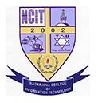

NAGARJUNA COLLEGE OF IT
(Affiliated to Tribhuvan University)
Sankhamul, Lalitpur

Submitted By: Submitted To:
NAME : Chirag Sharma Yubaraj Rai
ROLL NO : 6
SEMESTER : 5th (Fifth)
PROGRAM : B.Sc.CSIT

