Code:
HTML
<!DOCTYPE html>
<html lang="en">
<head>
<meta charset="UTF-8">
<meta name="viewport" content="width=device-width, initial-scale=1.0">
<title>Image Gallery</title>
<style>
.gallery {
width: 450px;
margin: auto;
}

.box {
width: 200px;
height: 150px;
border: 2px solid black;
float: left;
margin: 10px;
}

.box img {
width: 100%;
height: 100%;
}
</style>
</head>
<body>
<h2 align="center">Image Gallery</h2>
<div class="gallery">
<div class="box">
<img src="image1.jpg" alt="Image 1">
</div>
<div class="box">
<img src="image2.jpg" alt="Image 2">
</div>
<div class="box">
<img src="image3.jpg" alt="Image 3">
</div>
<div class="box">
<img src="image4.jpg" alt="Image 4">
</div>
</div>
</body>
</html>
Output: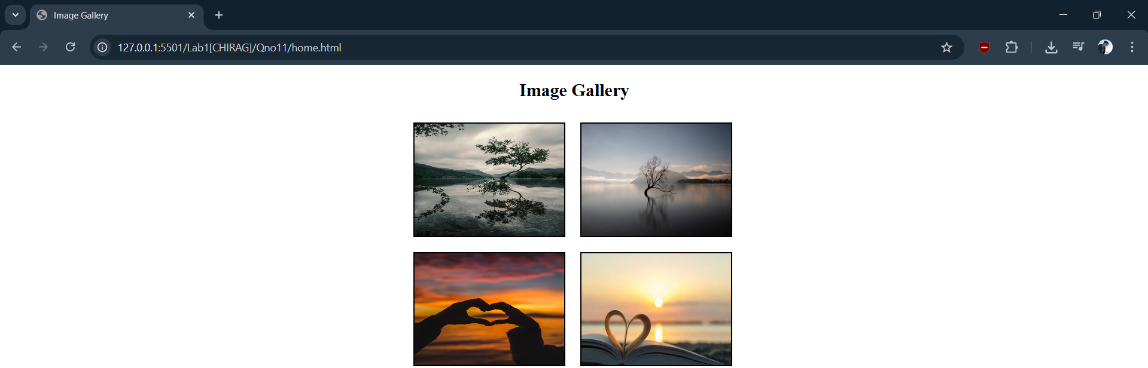

Code:
HTML
<!DOCTYPE html>
<html lang="en">
<head>
<meta charset="UTF-8">
<meta name="viewport" content="width=device-width, initial-scale=1.0">
<title>Curriculum Vitae</title>
<style>
body {
font-family: Arial, sans-serif;
}
.container {
width: 70%;
margin: auto;
border: 2px solid black;
padding: 20px;
}
h1, h2 {
text-align: center;
}
hr {
border: 1px solid black;
}
table {
width: 100%;
}
table td {
padding: 5px;
vertical-align: top;
}
</style>
</head>
<body>
<div class="container">
<h1>Curriculum Vitae</h1>
<hr>
<h2>Personal Information</h2>
<table>
<tr>
<td><b>Name</b></td>
<td>Chirag Sharma</td>
</tr>
<tr>
<td><b>Address</b></td>
<td>Lalitpur, Nepal</td>
</tr>
<tr>
<td><b>Email</b></td>
<td>chirag@example.com</td>
</tr>
<tr>
<td><b>Phone</b></td>
<td>98XXXXXXXX</td>
</tr>
</table>
<hr>
<h2>Education</h2>
<ul>
<li>Bachelor in Information Technology</li>
<li>+2 Science</li>
<li>SEE</li>
</ul>
<hr>
<h2>Skills</h2>
<ul>
<li>HTML</li>
<li>CSS</li>
<li>JavaScript</li>
<li>Basic Programming</li>
</ul>
<hr>
<h2>Hobbies</h2>
<ul>
<li>Coding</li>
<li>Music</li>
<li>Sports</li>
</ul>
<hr>
<h2>Declaration</h2>
<p>
I hereby declare that the above information is true to the best of my knowledge.
</p>
<p><b>Date:</b> ____________</p>
<p><b>Signature:</b> ____________</p>
</div>
</body>
</html>

Output:
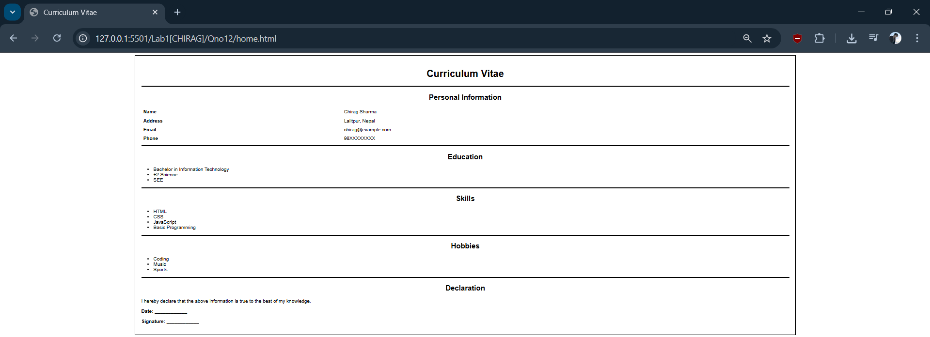

Code:
HTML
<!DOCTYPE html>
<html lang="en">

<head>
<meta charset="UTF-8">
<meta name="viewport" content="width=device-width, initial-scale=1.0">
<title>Navigation Menu</title>
<style>
body {
margin: 0;
font-family: Arial, sans-serif;
}
.navbar {
background-color: #FFFF66;
overflow: hidden;
padding: 10px 20px;
}
.navbar a {
text-decoration: none;
color: #000;
padding: 8px 16px;
margin: 0 4px;
display: inline-block;
border-right: 1px solid #555;
}
.navbar a:last-child {
border-right: none;
}
.navbar a.active {
background-color: #4B4BFF;
color: #fff;
}
</style>
</head>

<body>
<div class="navbar">
<a href="#" class="active">Home</a>
<a href="#">About</a>
<a href="#">Services</a>
<a href="#">Gallery</a>
<a href="#">Contact</a>
</div>
</body>

</html>

Output:

Code:
HTML
<!DOCTYPE html>
<html lang="en">
<head>
<meta charset="UTF-8">
<meta name="viewport" content="width=device-width, initial-scale=1.0">
<title>Registration Form</title>
<link rel="stylesheet" href="style.css">
</head>
<body>
<div class="form-container">
<h1 class="form-title">Registration Form</h1>
<form>
<fieldset>
<legend>Personal Details</legend>
<table width="100%">
<tr>
<td class="label">Name</td>
<td><input type="text" placeholder="Enter Name"></td>
</tr>
<tr>
<td class="label">Address</td>
<td><input type="text"></td>
</tr>
<tr>
<td class="label">Phone</td>
<td><input type="text"></td>
</tr>
<tr>
<td class="label">Gender</td>
<td class="radio-group">
<input type="radio" name="gender" id="male"> <label for="male">Male</label>
<input type="radio" name="gender" id="female"> <label for="female">Female</label>
</td>
</tr>
<tr>
<td class="label">Country</td>
<td>
<select>
<option>Select Country</option>
</select>
</td>
</tr>
<tr>
<td class="label">Message</td>
<td><textarea rows="4"></textarea></td>
</tr>
<tr>
<td class="label">Image</td>
<td><input type="file"></td>
</tr>
<tr>
<td colspan="2" class="checkbox-row">
<input type="checkbox"> I Accept Term & Condition
</td>
</tr>
<tr>
<td colspan="2" class="button-row">
<button type="submit" class="btn-register">Register</button>
<button type="reset" class="btn-clear">Clear</button>
</td>
</tr>
</table>
</fieldset>
</form>
</div>

</body>
</html>

CSS
body {
font-family: Arial, sans-serif;
display: flex;
justify-content: center;
padding-top: 20px;
}
.form-container {
width: 700px;
border: 1px solid #777;
padding: 20px;
}
.form-title {
color: #ff6666; /* Light Red/Coral color */
font-size: 28px;
margin-bottom: 10px;
margin-top: 0;
}
fieldset {
border: 1px solid #777;
padding: 10px;
}
legend {
text-align: center;
padding: 0 5px;
}
table {
border-collapse: collapse;
}
td {
padding: 8px;
border: 1px solid #ddd; /* Light grey grid lines */
}.label {
width: 120px;
font-weight: normal;
}
/* Specific Input Styling */
input[type="text"], select, textarea {
width: 98%;
padding: 5px;
border: 1px solid #ffcc99; /* Light orange border */
outline: none;
}
.radio-group {
font-size: 15px;
}
.radio-group input {
width: 13px;
height: 13px;
vertical-align: middle;
}
/* Buttons */
.button-row {
padding-top: 15px;
}
button {
padding: 8px 15px;
border: none;
color: white;
cursor: pointer;
font-size: 14px;
margin-right: 5px;
}
.btn-register {
background-color: #0055ff; /* Blue */
}
.btn-clear {
background-color: #ff0055; /* Red/Pink */
}
.checkbox-row {
font-size: 14px;
}

Output:
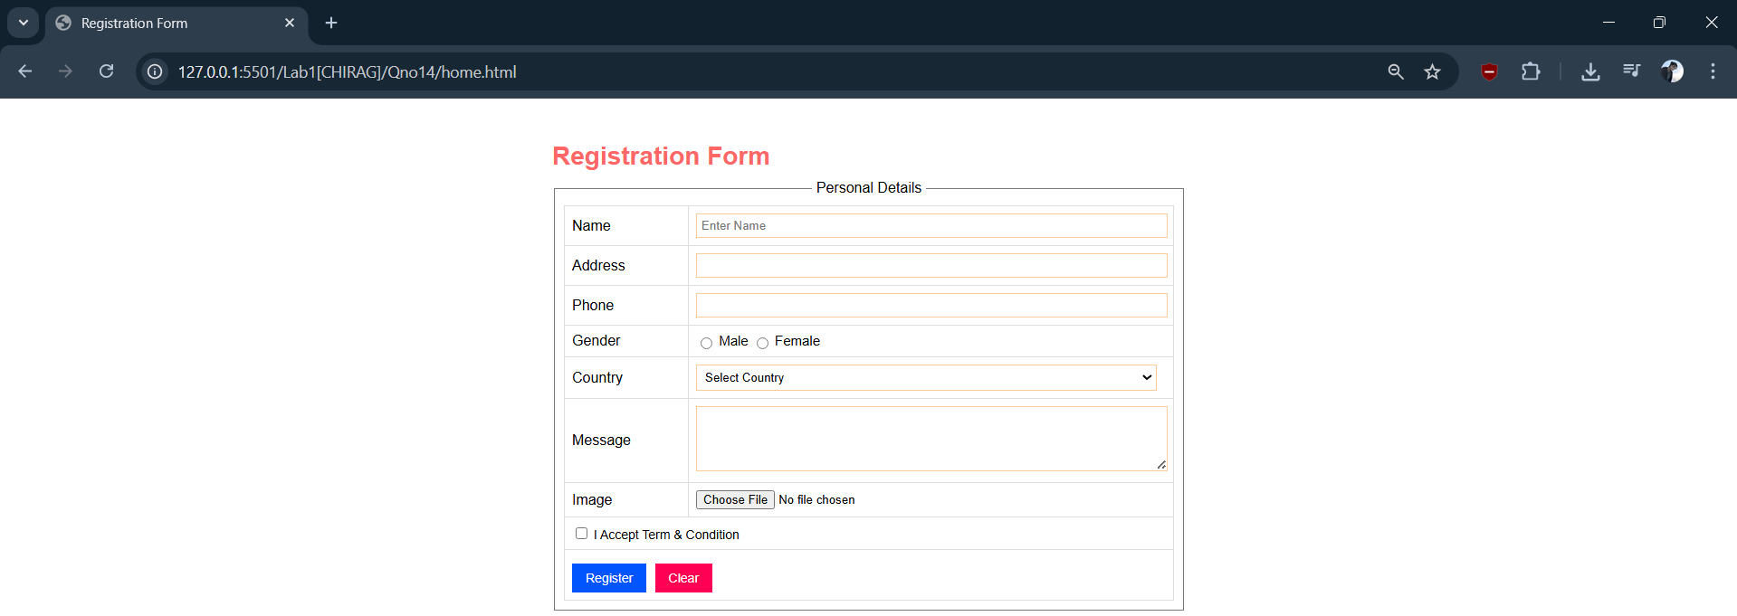

Code:
HTML
<!DOCTYPE html>
<html lang="en">
<head>
<meta charset="UTF-8">
<meta name="viewport" content="width=device-width, initial-scale=1.0">
<title>Div Based Layout</title>
<link rel="stylesheet" href="">
</head>
<body>
<div class="header">Header</div>
<div class="menu">Menu</div>
<div class="container">
<div class="left">Left side</div>
<div class="content">Content</div>
<div class="right">Right</div>
</div>
<div class="footer">Footer</div>
</body>
</html>

CSS
body {
margin: 0;
font-family: Arial;
}
.header {
height: 80px;
background-color: #56588a;
text-align: center;
line-height: 80px;
color: black;
font-weight: bold;
}
.menu {
height: 40px;
background-color: #8fa18c;
line-height: 40px;
padding-left: 10px;
}
.container {
width: 100%;
height: 400px;
}
.left {
width: 25%;
height: 400px;
float: left;
background-color: #a45656;
}
.content {
width: 50%;
height: 400px;
float: left;
background-color: #00aaff;
}
.right {
width: 25%;
height: 400px;
float: left;
background-color: #8c84ff;
}
.footer {
clear: both;
height: 50px;
background-color: #9a9a9a;
line-height: 50px;
padding-left: 10px;
}

Output:
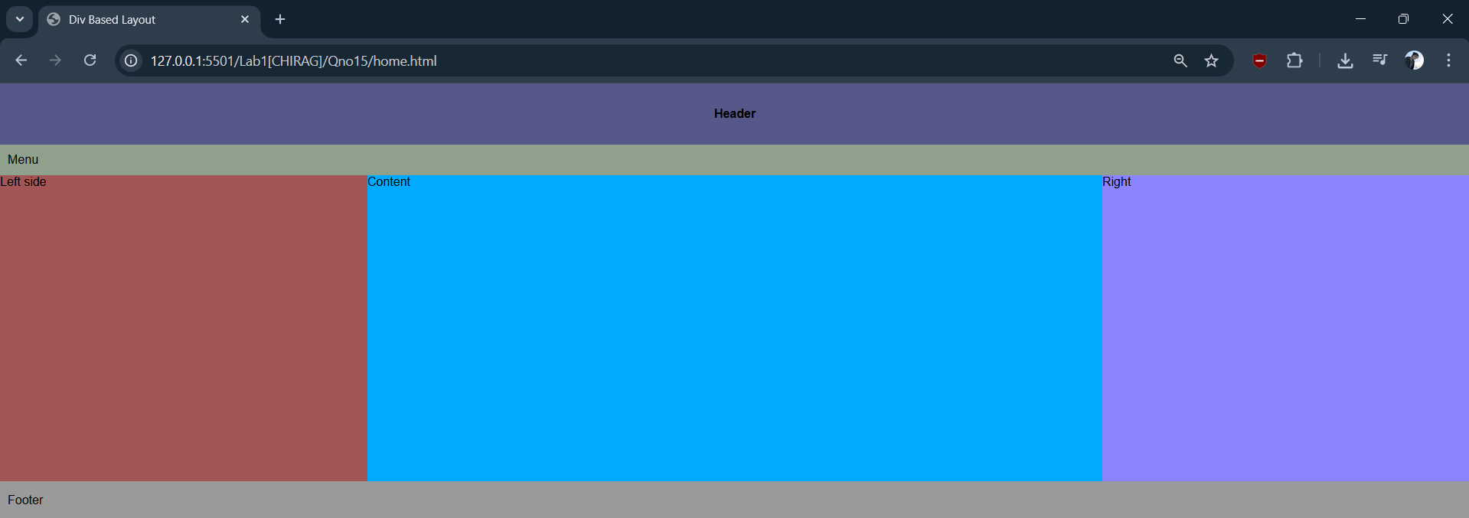

Code:
HTML:
<!DOCTYPE html>
<html lang="en">
<head>
<meta charset="UTF-8">
<meta name="viewport" content="width=device-width, initial-scale=1.0">
<title>Lok Sewa Aayog</title>
<link rel="stylesheet" href="">
</head>
<body>
<h2>Lok Sewa Aayog Online Registration Form</h2>

<form>
<fieldset>
<legend>Applicant Details</legend>
<div class="row">
<label>Full Name</label>
<input type="text">
</div>
<div class="row">
<label>Date of Birth</label>
<input type="date">
</div>
<div class="row">
<label>Gender</label>
<input type="radio" name="gender"> Male
<input type="radio" name="gender"> Female
</div>

<div class="row">
<label>Address</label>
<textarea></textarea>
</div>

<div class="row">
<label>Phone</label>
<input type="text">
</div>

<div class="row">
<label>Email</label>
<input type="email">
</div>

<div class="row">
<label>Post Applied</label>
<select>
<option>Select Post</option>
<option>Officer</option>
<option>Section Officer</option>
<option>Assistant</option>
</select>
</div>

<div class="row">
<label>Citizenship No</label>
<input type="text">
</div>

<div class="row">
<label>Upload Photo</label>
<input type="file">
</div>

<div class="row">
<label>Upload Citizenship</label>
<input type="file">
</div>

<div class="row">
<input type="checkbox"> I declare all information is correct
</div>

<div class="row buttons">
<button class="submit">Submit</button>
<button class="reset" type="reset">Reset</button>
</div>

</fieldset>
</form>
</body>
</html>

CSS:
body {
font-family: Arial;
background-color: #f2f2f2;
}

h2 {
text-align: center;
}

form {
width: 700px;
margin: auto;
background-color: white;
padding: 20px;
}

fieldset {
border: 1px solid gray;
}

legend {
padding: 0 10px;
font-weight: bold;
}

.row {
margin-bottom: 15px;
}

label {
display: inline-block;
width: 150px;
}
input[type="text"],
input[type="email"],
input[type="date"],
select,
textarea {
width: 400px;
padding: 6px;
}

textarea {
height: 60px;
}

.buttons {
margin-left: 150px;
}

button {
padding: 6px 15px;
border: none;
color: white;
}

.submit {
background-color: green;
}

.reset {
background-color: red;
}

Output:
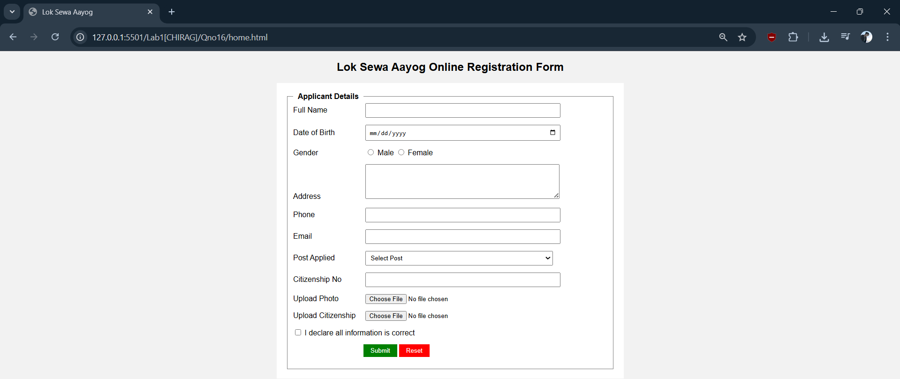
Code:
HTML
<!DOCTYPE html>
<html lang="en">
<head>
<meta charset="UTF-8">
<title>Tribhuvan University - Student Grade Sheet</title>
<link rel="stylesheet" href="style.css">
</head>
<body>

<div class="grade-card">
<div class="header-section">
<h1>Tribhuvan University</h1>
<p class="subtitle">Second Semester Grade Sheet</p>
</div>

<div class="student-info">
<p><strong>Student's Name:</strong> Chirag Sharma</p>
<p><strong>Symbol No:</strong> 80011009</p>
</div>

<table>
<thead>
<tr>
<th>Subject Code</th>
<th>Subject Name</th>
<th>Credit Hour</th>
<th>Grade</th>
<th>Grade Point</th>
</tr>
</thead>
<tbody>
<tr><td>CSC165</td><td>Discrete Structure</td><td>3</td><td>B+</td><td>3.3</td></tr>
<tr><td>CSC166</td><td>Object Oriented Programming</td><td>3</td><td>B+</td><td>3.3</td></tr>
<tr><td>CSC167</td><td>Microprocessor</td><td>3</td><td>B+</td><td>3.3</td></tr>
<tr><td>CSC168</td><td>Mathematics II</td><td>3</td><td>A</td><td>4</td></tr>
<tr><td>CSC169</td><td>Statistics I</td><td>3</td><td>B+</td><td>3.3</td></tr>
</tbody>
</table>

<div class="result-box">
<div class="result-item">
<span class="label">Total Credit Hours:</span>
<span class="value">15</span>
</div>
<div class="result-divider"></div>
<div class="result-item">
<span class="label">Final GPA:</span>
<span class="value">3.38</span>
</div>
</div>
</div>

</body>
</html>
CSS
body {
font-family: 'Segoe UI', Tahoma, Geneva, Verdana, sans-serif;
background-color: #f4f7f6;
display: flex;
justify-content: center;
padding-top: 50px;
}

.grade-card {
background: white;
width: 650px;
padding: 30px;
border-radius: 8px;
box-shadow: 0 4px 15px rgba(0,0,0,0.1);
border-top: 5px solid #2c3e50;
}

.header-section {
text-align: center;
margin-bottom: 25px;
}

h1 {
margin: 0;
color: #2c3e50;
font-size: 24px;
text-transform: uppercase;
}

.subtitle {
margin: 5px 0;
color: #7f8c8d;
font-weight: bold;
}

table {
width: 100%;
border-collapse: collapse;
margin-bottom: 20px;
}

th {
background-color: #f8f9fa;
color: #34495e;
text-align: left;
padding: 12px 8px;
border-bottom: 2px solid #eee;
}

td {
padding: 10px 8px;
border-bottom: 1px solid #f1f1f1;
color: #2c3e50;
}

/* The Result Box */
.result-box {
margin-top: 20px;
padding: 15px;
background-color: #eef2f7;
border: 1px solid #d1d8e0;
border-radius: 6px;
display: flex;
justify-content: space-around;
align-items: center;
}

.total-item {
font-size: 18px;
color: #2c3e50;
}

.total-item strong {
color: #2980b9;
}

Output:
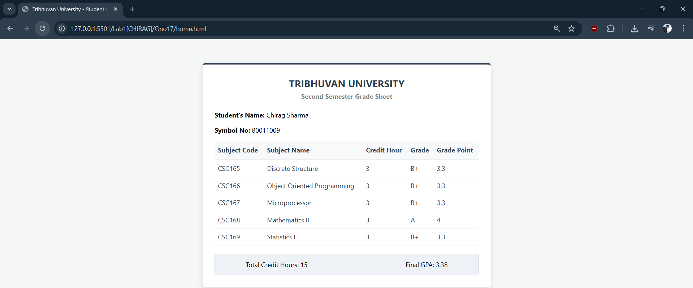

CODE:
HTML:
<!DOCTYPE html>
<html lang="en">
<head>
<meta charset="UTF-8">
<meta name="viewport" content="width=device-width, initial-scale=1.0">
<title>Invioce</title>
<link rel="stylesheet" href="">
</head>
<body>
<div class="invoice-container">
<div class="top-bar"></div>
<header>
<div class="company-section">
<div class="logo-placeholder">LOGO</div>
<div class="company-details">
<span class="company-name">&lt;Your Company Name&gt;</span>
<div class="contact-info">
&lt;Your address&gt;<br>
&lt;Your contact details&gt;
</div>
</div>
</div>
<div class="invoice-meta">
<h1>INVOICE</h1>
<div class="meta-field"><span>DATE</span></div>
<div class="meta-field"><span>INVOICE NO.</span></div>
</div>
</header>

<div class="payment-terms">&lt;Payment terms (due on receipt; due in X days)&gt;</div>
<div class="billing-section">
<div class="bill-to">
<h3>BILL TO</h3>
<p>&lt;Contact Name&gt;</p>
<p>&lt;Client Company Name&gt;</p>
<p>&lt;Address&gt;</p>
<p>&lt;Phone&gt;</p>
<p>&lt;Email&gt;</p>
</div>
<div class="ship-to">
<h3>SHIP TO</h3>
<p>&lt;Name / Dept&gt;</p>
<p>&lt;Client Company Name&gt;</p>
<p>&lt;Address&gt;</p>
<p>&lt;Phone&gt;</p>
</div>
</div>
<table class="invoice-table">
<thead>
<tr>
<th style="width: 45%;">DESCRIPTION</th>
<th style="width: 15%;">QTY</th>
<th style="width: 20%;">UNIT PRICE</th>
<th style="width: 20%;">TOTAL</th>
</tr>
</thead>
<tbody>
<tr>
<td>&nbsp;</td>
<td></td>
<td></td>
<td>0.00</td>
</tr>
<tr>
<td>&nbsp;</td>
<td></td>
<td></td>
<td>0.00</td>
</tr>
<tr>
<td>&nbsp;</td>
<td></td>
<td></td>
<td>0.00</td>
</tr>
<tr>
<td>&nbsp;</td>
<td></td>
<td></td>
<td>0.00</td>
</tr>
<tr>
<td>&nbsp;</td>
<td></td>
<td></td>
<td>0.00</td>
</tr>
<tr>
<td>&nbsp;</td>
<td></td>
<td></td>
<td>0.00</td>
</tr>
<tr>
<td>&nbsp;</td>
<td></td>
<td></td>
<td>0.00</td>
</tr>
<tr>
<td>&nbsp;</td>
<td></td>
<td></td>
<td>0.00</td>
</tr>
<tr>
<td>&nbsp;</td>
<td></td>
<td></td>
<td>0.00</td>
</tr>
<tr>
<td>&nbsp;</td>
<td></td>
<td></td>
<td>0.00</td>
</tr>
</tbody>
</table>
<div class="footer-section">
<div class="remarks">
Remarks / Payment Instructions:
</div>
<div class="totals-area">
<div class="total-row"><span>SUBTOTAL</span> <span>0.00</span></div>
<div class="total-row"><span>DISCOUNT</span> <span>0.00</span></div>
<div class="total-row"><span>SUBTOTAL LESS DISCOUNT</span> <span>0.00</span></div>
<div class="total-row"><span>TAX RATE</span> <span>0.00%</span></div>
<div class="total-row"><span>TOTAL TAX</span> <span>0.00</span></div>
<div class="total-row underline"><span>SHIPPING/HANDLING</span> <span>0.00</span></div>
<div class="balance-due">
<span>Balance Due</span>
<span class="price-box">$ -</span>
</div>
</div>
</div>
<div class="bottom-bar"></div>
</div>
</body>
</html>
CSS:
/* General Reset and Page Setup */
body {
font-family: 'Arial', sans-serif;
background-color: #f4f4f4;
padding: 20px;
font-size: 11px;
color: #333;
line-height: 1.4;
}
.invoice-container {
width: 800px;
margin: 0 auto;
background: #fff;
padding-bottom: 20px;
box-shadow: 0 0 10px rgba(0,0,0,0.1);
}
/* Orange Top and Bottom Borders */
.top-bar, .bottom-bar {
height: 15px;
background-color: #e06631;
width: 100%;
}
/* Header Section */
header {
display: flex;
justify-content: space-between;
padding: 30px 50px;
background-color: #f8f8f8;
align-items: flex-start;
}
.company-section {
display: flex;
align-items: flex-start;
gap: 15px;
}
.logo-placeholder {
width: 85px;
height: 85px;
background: #7a7a7a;
border-radius: 50%;
display: flex;
align-items: center;
justify-content: center;
color: white;
font-weight: bold;
font-size: 18px;
flex-shrink: 0;
}
.company-details {
margin-top: 12px; /* Vertically aligns the text with the top half of the logo */
}
.company-name {
display: block;
width: fit-content; /* Specific width to force the wrap between '<Your' and 'Company Name>' */
font-weight: bold;
font-size: 14px;
color: #444;
line-height: 1.1;
margin-bottom: 4px;
}
.contact-info {
font-size: 11px;
color: #555;
line-height: 1.4;
}
.invoice-meta {
text-align: right;
width: 200px;
}
.invoice-meta h1 {
font-size: 26px;
color: #999;
margin-bottom: 25px;
font-weight: normal;
letter-spacing: 1px;
}
.meta-field {
border-bottom: 1px solid #ddd;
margin-bottom: 10px;
padding-bottom: 2px;
color: #777;
font-weight: bold;
text-align: center;
width: 120px;
margin-left: auto;
}
/* Billing Section */
.payment-terms {
text-align: right;
padding-right: 50px;
margin: 15px 0;
font-style: italic;
color: #666;
}
.billing-section {
display: flex;
padding: 0 50px 30px 50px;
}
.bill-to, .ship-to {
width: 50%;
}
.bill-to h3, .ship-to h3 {
font-size: 10px;
color: #2a5a9a;
border-bottom: 1px solid #ddd;
width: 80%;
padding-bottom: 5px;
margin-bottom: 10px;
}
.billing-section p {
margin: 2px 0;
}
/* Table Design */
.invoice-table {
width: calc(100% - 100px);
margin: 0 50px 20px 50px;
border-collapse: collapse;
}
.invoice-table th {
background-color: #e06631;
color: white;
padding: 10px;
text-align: center;
font-weight: bold;
}
.invoice-table td {
border-left: 1px solid #ddd;
border-right: 1px solid #ddd;
border-bottom: 1px solid #eee;
padding: 10px;
height: 22px;
}
.invoice-table td:last-child {
background-color: #fcfcfc;
text-align: right;
}
.invoice-table tr:nth-child(even) {
background-color: #f9f9f9;
}
/* Footer Totals */
.footer-section {
display: flex;
justify-content: space-between;
padding: 0 50px;
}
.remarks {
width: 50%;
font-style: italic;
color: #666;
font-size: 10px;
}
.totals-area {
width: 40%;
}
.total-row {
display: flex;
justify-content: space-between;
padding: 5px 0;
font-weight: bold;
color: #555;
}
.total-row span:last-child {
min-width: 80px;
text-align: right;
border-bottom: 1px solid #eee;
}
.underline {
border-bottom: 2px solid #999;
margin-bottom: 10px;
}
.balance-due {
display: flex;
justify-content: space-between;
align-items: center;
background-color: #f2dede; /* Light pink/red background */
padding: 12px;
}
.balance-due span:first-child {
font-size: 14px;
font-weight: bold;
}
.price-box {
font-size: 18px;
font-weight: bold;
}
.bottom-bar {
margin-top: 60px;
}
Output Printed:
