Question 1: What is JavaScript and DOM Manipulation? Explain the concept, structure, and importance of the Document Object Model (DOM) with DOM Tree.
Introduction
JavaScript is a high-level, interpreted programming language that serves as one of the core technologies of the World Wide Web. While HTML defines structure and CSS defines style, JavaScript provides interactivity, allowing developers to create dynamic content that updates in real-time without refreshing the page.
DOM Manipulation is the process by which JavaScript interacts with the browser to change the document's structure, style, and content. The Document Object Model (DOM) acts as a programming interface for web documents. When a web page is loaded, the browser creates a DOM of the page, representing the document as a logical tree where each branch ends in a node, and each node contains objects.
The DOM represents the HTML document as a hierarchical tree structure:
• Window Object: The top-level object in the hierarchy, representing the browser window.
• Document: The root of the actual HTML document.
• Elements: HTML tags (like <body>, <div>) become element nodes.
• Attributes: Properties of tags (like href or src) are nodes attached to elements.
• Text: The actual content inside tags becomes text nodes.
Importance of the DOM:
1. Dynamic Updates: It allows JavaScript to add, change, or remove HTML elements and attributes on the fly.
2. Event Handling: It enables the page to react to user actions like clicks, keyboard input, or mouse movements.
3. Live CSS Modification: It allows for the real-time alteration of CSS styles based on user interaction or logic.
4. Language Neutrality: While most commonly used with JavaScript, the DOM is designed to be independent of any particular programming language.
Tags and Attributes
- <!DOCTYPE html>: A declaration that informs the browser that the document is being rendered as HTML5.
- <html>: The root element that wraps all the content on the entire web page.
- <head>: A container for machine-readable metadata, such as the document's title and character set, which isn't displayed to the user.
- <title>: Defines the text shown in the browser's tab or title bar for the webpage.
- <body>: Contains all the visible content of the HTML document, including text, images, and buttons.
- <h1>: Represents a level-one heading, used here to display the main title of the page.
- <p>: Defines a paragraph of text used to display information or instructions to the user.
- <button>: Creates a clickable element that users can interact with to trigger specific actions.
- <script>: Used to embed or reference executable client-side JavaScript code within the HTML file.
- id: A global attribute that provides a unique identifier for an element, allowing it to be targeted by JavaScript or CSS.
- onclick: An event handler attribute that executes a specific JavaScript function when the user clicks the element.
Code
<!doctype html>
<html>
<head>
<title>Lab 1</title>
</head>
<body>
<h1 id="header">Original Title</h1>
<p id="description">Click the button to change this text using the DOM.</p>
<button onclick="changeContent()">Update Page</button>
<script>
function changeContent() {
let title = document.getElementById("header");
let text = document.getElementById("description");
title.innerHTML = "DOM has been Manipulated!";
text.style.color = "blue";
text.style.fontWeight = "bold";
text.innerHTML =
"The JavaScript function successfully accessed the DOM tree.";
}
</script>
</body>
</html>
Output
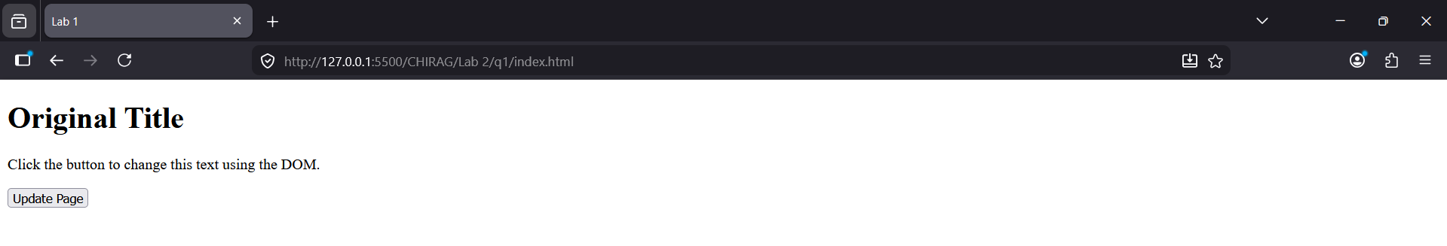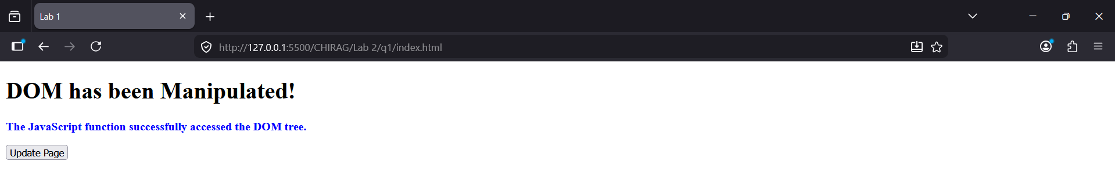
Question 2: Write a JavaScript to print largest & smallest among 10 elements of an array. And, write a script to print largest & smallest among 5 digits of a number.
Introduction
In programming, an array is a specialized data structure used to store a collection of elements, typically of the same type, under a single variable name. Each element in an array is accessed via a numerical index, making it efficient for bulk data operations. Beyond arrays, identifying patterns or extreme values within individual numbers requires type conversion, where a numeric value is treated as a string or an iterable object to access each individual digit for comparison.
Tags and Attributes
- let: A keyword used to declare block-scoped local variables that can be reassigned.
- const: A keyword used to declare variables that remain constant and cannot be reassigned.
- for: A loop structure used to repeat a block of code a specific number of times.
- Math.max: A built-in function that returns the largest of the numbers provided as input.
- Math.min: A built-in function that returns the smallest of the numbers provided as input.
- toString: A method that converts a numeric value into a string for character manipulation.
- split: A string method used to divide a string into an ordered list of substrings.
- Array.from: A static method that creates a new array instance from an iterable or array-like object.
- push: An array method used to add one or more elements to the end of an array.
Code
<!DOCTYPE html>
<html lang="en">
<head>
<meta charset="UTF-8">
<title>Lab Report - Question 2</title>
</head>
<body>
<h1>Array and Digit Analysis</h1>
<div id="array-output"></div>
<div id="digit-output"></div>

<script>
const numbers = [45, 12, 89, 2, 67, 34, 91, 56, 23, 10];
let largestArr = numbers[0];
let smallestArr = numbers[0];

for (let i = 1; i < numbers.length; i++) {
if (numbers[i] > largestArr) largestArr = numbers[i];
if (numbers[i] < smallestArr) smallestArr = numbers[i];
}

document.getElementById("array-output").innerHTML =
"Array: " + numbers.join(", ") + "<br>" +
"Largest in Array: " + largestArr + "<br>" +
"Smallest in Array: " + smallestArr;

const num = 73915;
const digits = Array.from(String(num), Number);
const largestDigit = Math.max(...digits);
const smallestDigit = Math.min(...digits);

document.getElementById("digit-output").innerHTML =
"<br>Number: " + num + "<br>" +
"Largest Digit: " + largestDigit + "<br>" +
"Smallest Digit: " + smallestDigit;
</script>
</body>
</html>

Output
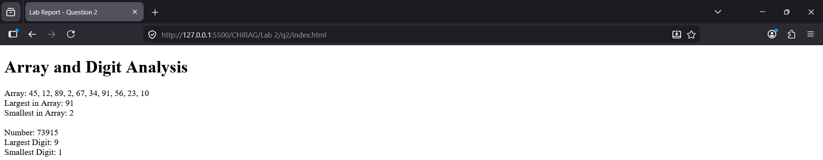

Question 3: Write a script to demonstrate popup boxes in JavaScript. And, write script to change background color of<p> tag on button click & append <span> as childNode of <p> created from JS to demonstrate prepend &remove DOM element with JS.
Introduction
The Document Object Model (DOM) is a programming interface for web documents that represents the page so that programs can change the document structure, style, and content. JavaScript can dynamically manipulate these elements by creating new nodes, such as a span, and inserting them into the tree using methods like prepend or append. Additionally, JavaScript provides built-in functions to interact with the user through popup boxes, which are modal windows used for displaying alerts, confirming actions, or gathering text input.
Tags and Attributes
- alert: A method used to display a simple message box with an OK button.
- confirm: A method that displays a dialog box with OK and Cancel options, returning a true or false value.
- prompt: A method that opens a dialog box for the user to type in a text value.
- style.backgroundColor: A property used to change the background color of an element via JavaScript.
- document.createElement: A method used to create a new HTML element node.
- prepend: A method used to insert a new node as the very first child of a parent element.
- remove: A method used to delete an element from the document.
- span: An inline container used to group or style a specific portion of text.
- id: An attribute used to uniquely identify an element so it can be targeted by a script.
- onclick: An event attribute that runs a function when the user clicks on an element.
Code
<!DOCTYPE html>
<html>
<head>
<title>Popups and DOM</title>
</head>
<body>

<button onclick="alert('Hello!')">Alert</button>
<button onclick="confirm('Proceed?')">Confirm</button>
<button onclick="prompt('Name?')">Prompt</button>

<p id="myP">Original Text</p>

<button onclick="addAndChange()">Modify</button>
<button onclick="document.getElementById('myP').remove()">Remove</button>

<script>
function addAndChange() {
let p = document.getElementById("myP");
p.style.backgroundColor = "cyan";

let s = document.createElement("span");
s.innerHTML = "New Info: ";
p.prepend(s);
}
</script>
</body>
</html>
Output
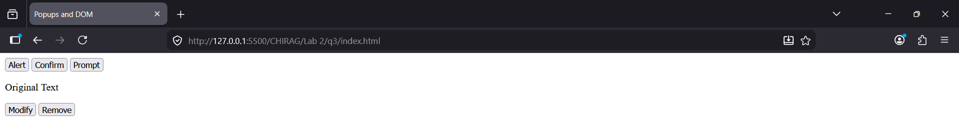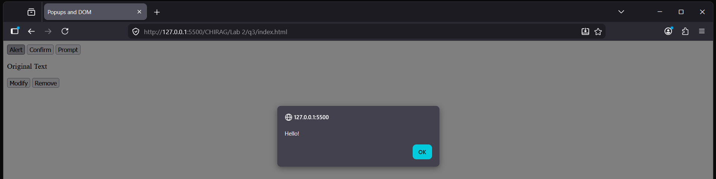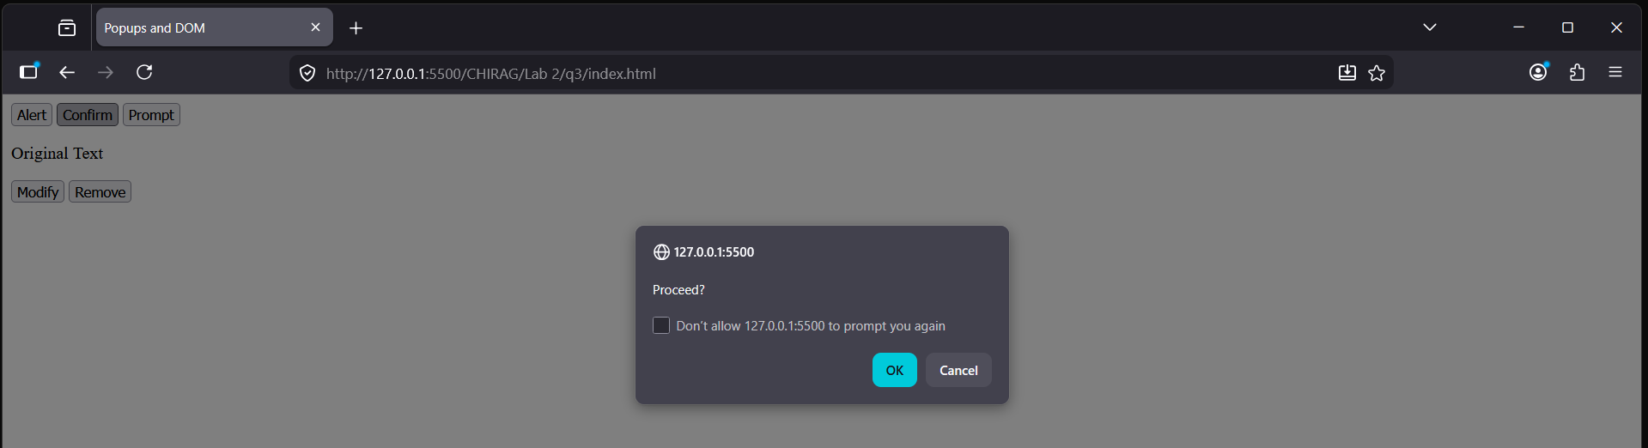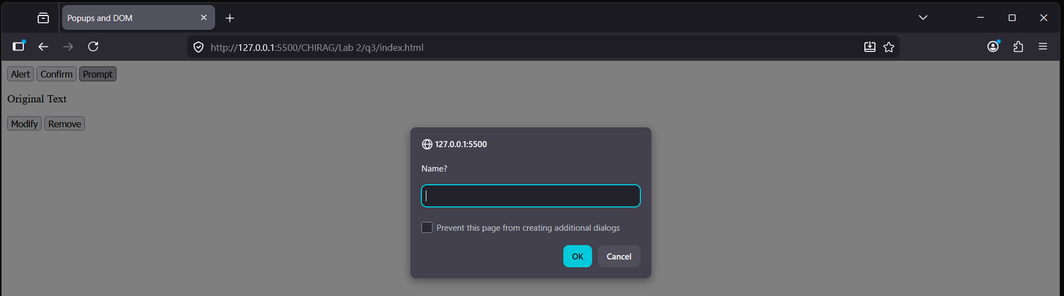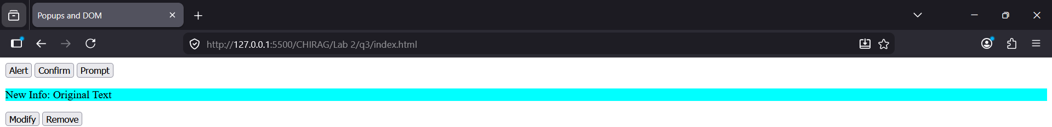
Question 4: Write a JavaScript to show/hide paragraph content. Demonstrate show/hide with jQuery also.
Introduction
Visibility manipulation is a fundamental aspect of interactive web design, allowing content to appear or disappear based on user input. In vanilla JavaScript, this is typically achieved by modifying the display or visibility properties of an element's style object. jQuery, a popular JavaScript library, simplifies this process by providing dedicated methods that handle the logic of toggling states, often including built-in animation effects to smooth the transition between visible and hidden states.
Tags and Attributes
- display: A CSS property used to define how an element is rendered on the page, with "none" being used to hide it.
- getElementById: A method used to select a specific HTML element by its unique ID attribute.
- style: An object representing the inline style attributes of an element.
- script src: An attribute used within a script tag to load an external JavaScript library like jQuery.
- $: The shorthand identifier used to access jQuery functions and selectors.
- click: A jQuery method used to attach an event handler to the click event of an element.
- toggle: A jQuery method that automatically switches between showing and hiding an element.
- show: A jQuery method used to make a hidden element visible.
- hide: A jQuery method used to make a visible element hidden.
- function: A block of code designed to perform a particular task when invoked by an event or another script.
Code
<!DOCTYPE html>
<html>
<head>
<title>Show and Hide Content</title>
<script src="https://code.jquery.com/jquery-3.6.0.min.js"></script>
</head>
<body>

<h2>Vanilla JavaScript Show/Hide</h2>
<p id="jsPara">This paragraph is controlled by Vanilla JS.</p>
<button onclick="toggleJS()">Toggle with JS</button>
<hr>
<h2>jQuery Show/Hide</h2>
<p id="jqPara">This paragraph is controlled by jQuery.</p>
<button id="jqBtn">Toggle with jQuery</button>

<script>
function toggleJS() {
let p = document.getElementById("jsPara");
if (p.style.display === "none") {
p.style.display = "block";
} else {
p.style.display = "none";
}
}

$(document).ready(function() {
$("#jqBtn").click(function() {
$("#jqPara").toggle();
});
});
</script>
</body>
</html>

Output
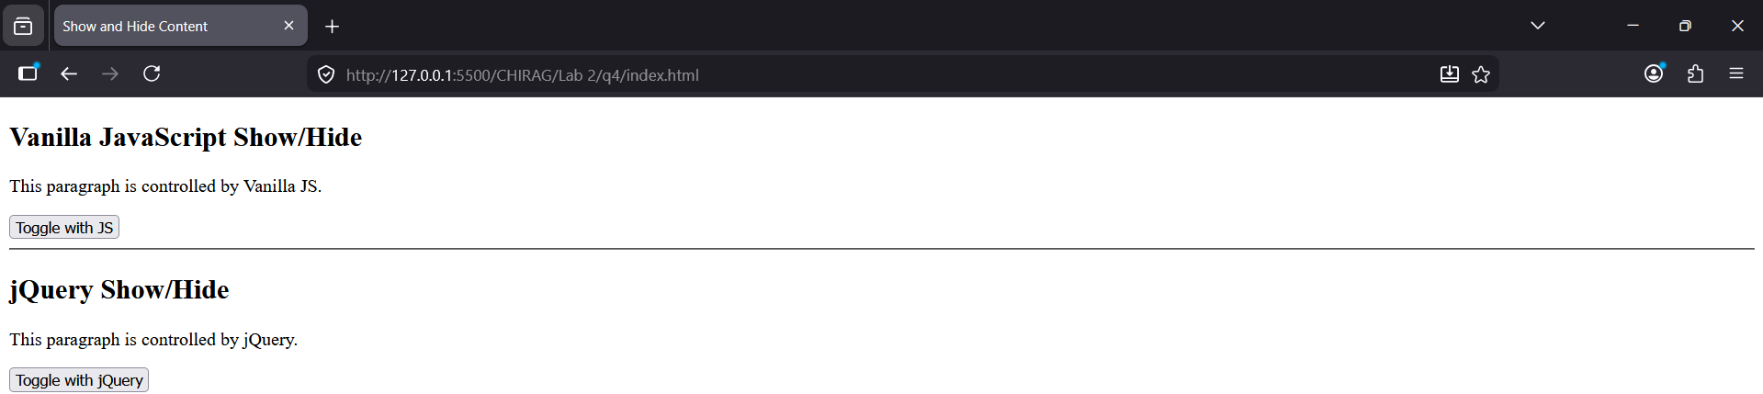
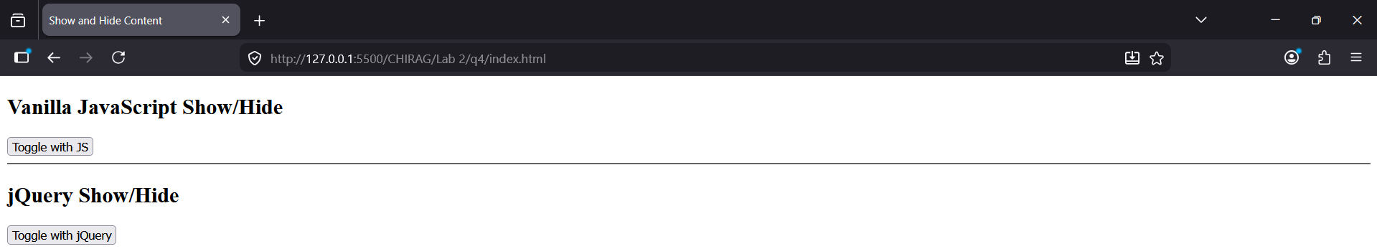

Question 5: What is an Array? Write a program to demonstrate array with multiple-ways of creating an array including listed tasks using property and methods from prototype:
- Check prototypes of Array()
- Add data as a first element on existing array.
- Add data as a last element on existing array.
- Remove first element/data from existing array.
- Remove last element/data from existing array.
- Add data on any middle position on existing array.
- Remove from any middle position from existing array.
- Write a program to demonstrate forEach (), map (), filter (), reduce () methods on an array.
- Write a program to display data from array with for-loop
- Check length of array
- Display single element of array without loop
- Write a JavaScript to demonstrate array de-structuring.
Introduction
An array is a global object in JavaScript used to store multiple values in a single variable. It is a high-level, list-like object whose prototype has methods to perform traversal and mutation operations. Unlike basic variables that hold one piece of data, arrays can store strings, numbers, objects, or even other arrays. Every array instance inherits from Array.prototype, providing it with built-in functionality to modify its contents, calculate its length, and iterate through its data efficiently using various functional programming patterns.
Tags and Attributes
- Array.prototype: An object that allows the addition of properties and methods to all array instances.
- unshift: A method used to add one or more elements to the beginning of an array.
- push: A method used to add one or more elements to the end of an array.
- shift: A method used to remove the first element from an array.
- pop: A method used to remove the last element from an array.
- splice: A versatile method that can add or remove elements at any specific index in an array.
- forEach: A method that executes a provided function once for each array element.
- map: A method that creates a new array populated with the results of calling a function on every element.
- filter: A method that creates a shallow copy of a portion of an array, filtered down to elements that pass a test.
- reduce: A method that executes a reducer function on each element, resulting in a single output value.
- length: A property that returns the number of elements in an array.
Code
<!DOCTYPE html>
<html>
<head>
<title>Array Mastery</title>
</head>
<body>
<h1>JavaScript Array Operations</h1>
<script>
let arr1 = ["Apple", "Banana"];
let arr2 = new Array("Cherry", "Date");

console.log(Object.getPrototypeOf(arr1));
arr1.unshift("Mango");
arr1.push("Orange");
arr1.shift();
arr1.pop();

arr1.splice(1, 0, "Grapes");
arr1.splice(1, 1);

let numbers = [10, 20, 30, 40];
numbers.forEach(n => console.log("Item: " + n));
let doubled = numbers.map(n => n * 2);
let bigOnes = numbers.filter(n => n > 25);
let sum = numbers.reduce((total, n) => total + n, 0);

console.log("Array length: " + numbers.length);
for (let i = 0; i < numbers.length; i++) {
console.log("Loop element: " + numbers[i]);
}
console.log("Second element: " + numbers[1]);

let [first, second] = numbers;
console.log("Destructured: " + first + ", " + second);
</script>
</body>
</html>
Output
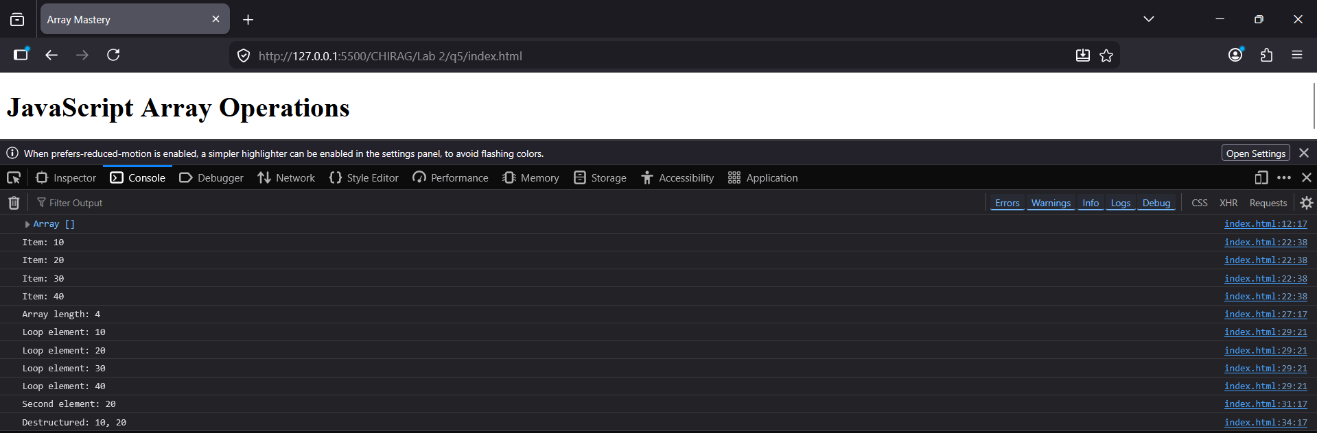
Question 6: What is an Object? Write a program to demonstrate built-in and user-defined object with multiple-ways of creating an object including listed tasks using property and methods from prototype:
- Check prototypes of Object()
- Add data as a first element on existing object.
- Add data as a last element on existing object.
- Remove first element/data from existing object.
- Remove last element/data from existing object.
- Add data on any middle position on existing object.
- Remove from any middle position from existing object.
- Write a program to display data from object with for-loop
- Display single element of array without loop
- Write a JavaScript to demonstrate object de-structuring.

Introduction
In JavaScript, an object is a standalone entity that holds a collection of related data and functionality. It consists of properties, which are associations between a name (or key) and a value. Unlike arrays which are ordered by index, objects are unordered collections where data is retrieved using specific keys. Every object in JavaScript is an instance of the built-in Object constructor and inherits methods and properties from Object.prototype. Objects can be created using literal notation, the new keyword, or the Object.create method, allowing for complex data modeling.
Tags and Attributes
- Object.prototype: The prototype object from which all JavaScript objects inherit properties and methods.
- Object.keys: A method that returns an array of a given object's own enumerable property names.
- delete: An operator used to remove a property from an object.
- Object.assign: A method used to copy all enumerable own properties from one or more source objects to a target object.
- for...in: A loop used to iterate over all enumerable string properties of an object.
- Object.create: A method that creates a new object, using an existing object as the prototype of the newly created object.
- Destructuring: A syntax used to extract multiple properties from an object and bind them to variables.
- JSON.stringify: A method that converts a JavaScript object or value to a JSON string.
- Object.entries: A method that returns an array of a given object's own enumerable string-keyed property [key, value] pairs.
Code
<!DOCTYPE html>
<html>
<head>
<title>Object Mastery</title>
</head>
<body>
<h1>JavaScript Object Operations</h1>
<script>
let obj1 = { brand: "Toyota", model: "Corolla" };
let obj2 = new Object();
obj2.type = "Electric";
console.log(Object.getPrototypeOf(obj1));
obj1 = { id: 1, ...obj1 };
obj1.year = 2024;
let firstKey = Object.keys(obj1)[0];
delete obj1[firstKey];
let keys = Object.keys(obj1);
delete obj1[keys[keys.length - 1]];
obj1.color = "Blue";
delete obj1.model;
for (let key in obj1) {
console.log(key + ": " + obj1[key]);
}
console.log("Brand property: " + obj1.brand);
const student = { name: "John", age: 20, city: "Kathmandu" };
const { name, city } = student;
console.log("Destructured: " + name + " from " + city);
let dateObj = new Date();
console.log("Built-in Date Object: " + dateObj.getFullYear());
</script>
</body>
</html>

Output
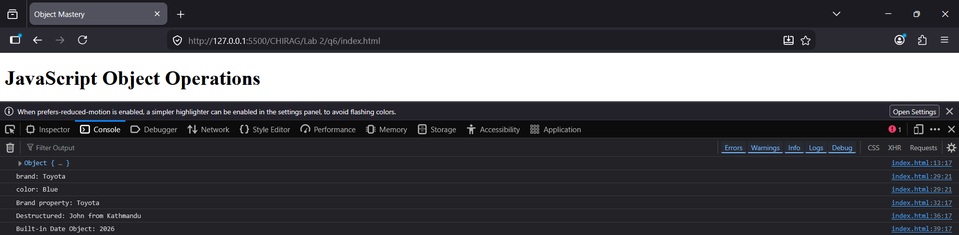

Question 7: Design the following form in HTML and display the value in the result box after calculating basic arithmetic operations based on user input with use of JavaScript.
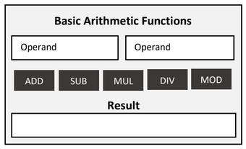
Introduction
An arithmetic calculator in web development combines HTML form elements with JavaScript logic to perform mathematical computations. The process involves capturing numerical values from input fields, often referred to as operands, and processing them using arithmetic operators. JavaScript functions are triggered by button clicks to execute specific operations like addition, subtraction, multiplication, division, or modulo. The resulting value is then dynamically injected back into the user interface, typically within a read-only input field or a specific display container.
Tags and Attributes
- type="number": An input attribute that restricts the user to entering numerical values and often provides increment/decrement arrows.
- placeholder: A short hint displayed in the input field before the user enters a value.
- value: An attribute used to set or retrieve the current data contained within an input element.
- id: A unique identifier used by JavaScript to target and manipulate specific HTML elements.
- onclick: An event attribute that executes a function when a user clicks a button.
- parseFloat: A JavaScript function that parses a string argument and returns a floating-point number.
- readOnly: An attribute that prevents the user from modifying the content of an input field.
- <div>: A block-level container used to group elements and apply layout styles.
- <button>: An interactive element used to trigger the arithmetic functions defined in the script.
Code
<!DOCTYPE html>
<html>
<head>
<title>Basic Arithmetic Functions</title>
<style>
.calc-box {
width: 350px;
padding: 20px;
border: 2px solid #333;
background-color: #f4f4f4;
text-align: center;
font-family: sans-serif;
}
.inputs {
display: flex;
justify-content: space-between;
margin-bottom: 15px;
}
input {
width: 45%;
padding: 8px;
box-sizing: border-box;
}
.buttons {
display: flex;
justify-content: space-between;
margin-bottom: 15px;
}
button {
background-color: #444;
color: white;
border: none;
padding: 10px;
cursor: pointer;
flex: 1;
margin: 0 2px;
}
.result-box {
width: 100%;
padding: 10px;
margin-top: 10px;
border: 1px solid #333;
background-color: white;
}
</style>
</head>
<body>
<div class="calc-box">
<h3>Basic Arithmetic Functions</h3>

<div class="inputs">
<input type="number" id="op1" placeholder="Operand">
<input type="number" id="op2" placeholder="Operand">
</div>

<div class="buttons">
<button onclick="calc('add')">ADD</button>
<button onclick="calc('sub')">SUB</button>
<button onclick="calc('mul')">MUL</button>
<button onclick="calc('div')">DIV</button>
<button onclick="calc('mod')">MOD</button>
</div>

<h4>Result</h4>
<input type="text" id="res" class="result-box" readonly>
</div>

<script>
function calc(operation) {
let n1 = parseFloat(document.getElementById("op1").value);
let n2 = parseFloat(document.getElementById("op2").value);
let result = 0;

if (isNaN(n1) || isNaN(n2)) {
alert("Please enter both numbers");
return;
}

switch(operation) {
case 'add': result = n1 + n2; break;
case 'sub': result = n1 - n2; break;
case 'mul': result = n1 * n2; break;
case 'div': result = n2 !== 0 ? n1 / n2 : "Error (Div by 0)"; break;
case 'mod': result = n1 % n2; break;
}

document.getElementById("res").value = result;
}
</script>

</body>
</html>

Output
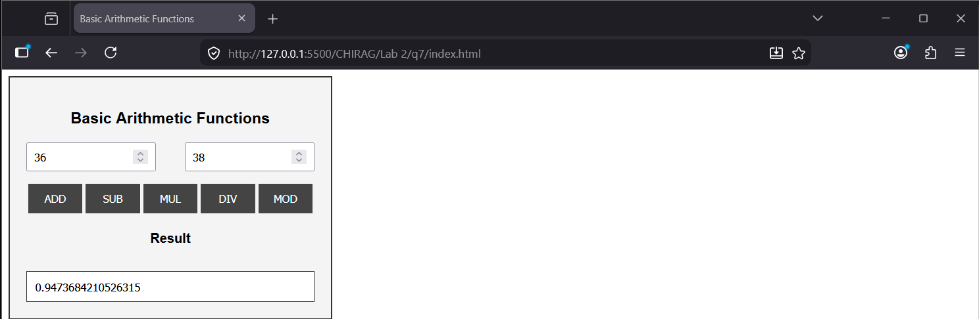

Question 8: Design following form in HTML and write the satisfying following validation rules using JavaScript.
a) Check required fields are empty or not on form submission at first.
b) Length of full name up to 20 character using normal validation method with keyboard event.
b) E-Mail must be valid using Regular Express (additionally: number should be optional).
c) Username must be start with string followed by number using Regular Express.
d) Password length must be more than eight character using normal method with keyboard event.
e) Compare and validate confirm password field data.
f) Validate services combo-box (drop-down / select-box) using onchange event.
g) Limit message length upto 200 character.
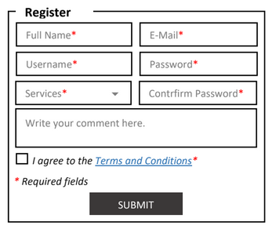
Introduction
Form validation is a critical aspect of client-side programming that ensures data submitted by users is accurate, complete, and formatted correctly. By using JavaScript to validate inputs before they reach a server, developers can provide immediate feedback, reduce server load, and improve the overall user experience. This process involves a combination of event listeners, such as keyboard and change events, and regular expressions to enforce specific patterns for complex data like email addresses or structured usernames.
Tags and Attributes
- <fieldset>: A tag used to group several controls and labels within a web form.
- <legend>: A tag that defines a caption or title for the fieldset element.
- <select>: A tag used to create a drop-down list of options for the user.
- <textarea>: A tag that defines a multi-line text input control, often used for comments or messages.
- type="checkbox": An input attribute that creates a box that can be toggled by the user.
- onsubmit: An event attribute that triggers a function when the form's submit button is clicked.
- onkeyup: A keyboard event attribute that executes a script when the user releases a key.
- onchange: An event attribute that fires when the value of an element has been changed.
- test(): A JavaScript method that searches a string for a pattern and returns true or false.
- preventDefault(): A method used to stop the default action of an element, such as stopping a form from submitting if validation fails.
Code

<!DOCTYPE html>
<html>
<head>
<title>Registration Form Validation</title>
<style>
.error { color: red; font-size: 11px; display: block; height: 15px; }
.form-container { width: 500px; padding: 20px; font-family: sans-serif; }
.row { display: flex; gap: 15px; margin-bottom: 5px; }
.col { flex: 1; }
input, select, textarea { width: 100%; padding: 8px; box-sizing: border-box; border: 1px solid #333; }
.required { color: red; }
fieldset { border: 1px solid black; padding: 20px; }
legend { font-weight: bold; padding: 0 5px; font-size: 1.2em; }
.submit-btn { background: #3d3d3d; color: white; padding: 10px 40px; border: none; cursor: pointer; display: block; margin: 20px auto 0; }
.terms-row { display: flex; align-items: center; gap: 5px; margin-top: 10px; }
.terms-row input { width: auto; }
</style>
</head>
<body>

<div class="form-container">
<form id="regForm" onsubmit="return validateForm(event)">
<fieldset>
<legend>Register</legend>

<div class="row">
<div class="col">
<input type="text" id="fullName" placeholder="Full Name*" onkeyup="checkName()">
<span id="nameErr" class="error"></span>
</div>
<div class="col">
<input type="text" id="email" placeholder="E-Mail*">
<span id="emailErr" class="error"></span>
</div>
</div>

<div class="row">
<div class="col">
<input type="text" id="username" placeholder="Username*">
<span id="userErr" class="error"></span>
</div>
<div class="col">
<input type="password" id="pass" placeholder="Password*" onkeyup="checkPass()">
<span id="passErr" class="error"></span>
</div>
</div>

<div class="row">
<div class="col">
<select id="services" onchange="validateService()">
<option value="">Services*</option>
<option value="Web Design">Web Design</option>
<option value="App Development">App Development</option>
</select>
<span id="serviceErr" class="error"></span>
</div>
<div class="col">
<input type="password" id="confirmPass" placeholder="Confirm Password*">
<span id="confirmErr" class="error"></span>
</div>
</div>

<textarea id="message" placeholder="Write your comment here." maxlength="200" rows="4"></textarea>
<span id="msgErr" class="error"></span>

<div class="terms-row">
<input type="checkbox" id="terms">
I agree to the <a href="#">Terms and Conditions</a><span class="required">*</span>
</div>
<span id="termsErr" class="error"></span>

<p class="required">* Required fields</p>

<button type="submit" class="submit-btn">SUBMIT</button>
</fieldset>
</form>
</div>

<script>
function checkName() {
let name = document.getElementById("fullName").value;
let err = document.getElementById("nameErr");
err.innerHTML = name.length > 20 ? "Limit: 20 characters" : "";
}

function checkPass() {
let pass = document.getElementById("pass").value;
let err = document.getElementById("passErr");
err.innerHTML = pass.length > 0 && pass.length <= 8 ? "Must be > 8 characters" : "";
}

function validateService() {
let service = document.getElementById("services").value;
document.getElementById("serviceErr").innerHTML = service === "" ? "Please select a service" : "";
}

function validateForm(e) {
let isValid = true;

let name = document.getElementById("fullName").value;
let email = document.getElementById("email").value;
let user = document.getElementById("username").value;
let pass = document.getElementById("pass").value;
let cpass = document.getElementById("confirmPass").value;
let terms = document.getElementById("terms").checked;
let service = document.getElementById("services").value;

let emailPattern = /^[a-zA-Z0-9._-]+@[a-zA-Z0-9.-]+\.[a-zA-Z]{2,6}$/;
let userPattern = /^[a-zA-Z]+[0-9]+$/;

document.querySelectorAll(".error").forEach(el => el.innerHTML = "");

if (!name || !email || !user || !pass || !cpass || !terms || !service) {
alert("Please fill all required fields");
isValid = false;
}

if (name.length > 20) isValid = false;

if (!emailPattern.test(email)) {
document.getElementById("emailErr").innerHTML = "Invalid email format";
isValid = false;
}

if (!userPattern.test(user)) {
document.getElementById("userErr").innerHTML = "Starts with letters then numbers";
isValid = false;
}

if (pass.length <= 8) isValid = false;

if (pass !== cpass) {
document.getElementById("confirmErr").innerHTML = "Passwords do not match";
isValid = false;
}

if (!isValid) {
e.preventDefault();
return false;
}

alert("Form submitted successfully!");
return true;
}
</script>

</body>
</html>

Output
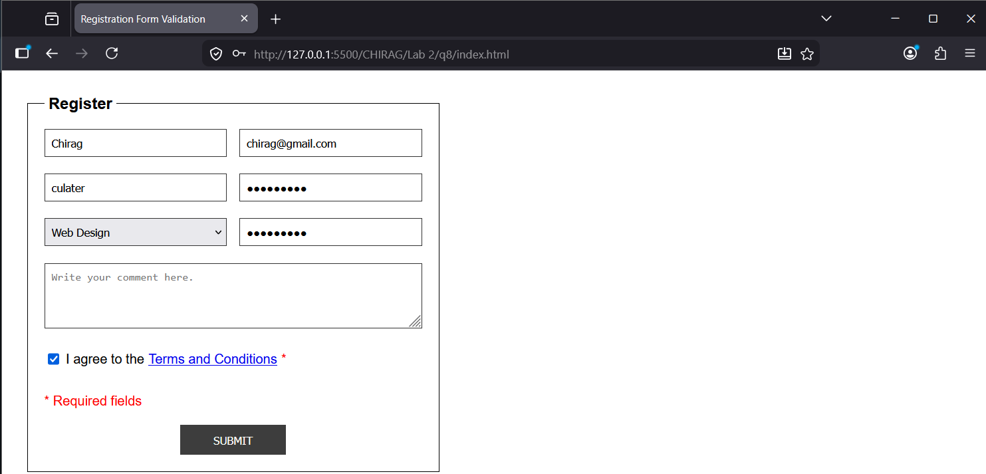

Question 9: Explain Windows and Frames with example HTML and JavaScript properly. Demonstrate noscript tag.
Introduction
In web development, the Window object represents the browser's window or a tab, serving as the global root for all JavaScript activities. It provides methods to control the browser, such as opening new windows or resizing the current one. Frames (and more commonly iFrames) allow you to embed one HTML document inside another, creating a nested browsing context. While standard frames are largely deprecated in modern HTML5 in favor of flexible layouts, iframe remains a standard for embedding third-party content like maps or videos. Additionally, the noscript tag is a fallback mechanism that displays specific content only to users who have disabled JavaScript in their browser settings.
Tags and Attributes
- window: The global object in the browser that contains the DOM, history, and location.
- <iframe>: An inline frame used to embed another document within the current HTML page.
- src: An attribute of the iframe that specifies the URL of the page to embed.
- window.open(): A JavaScript method used to open a new browser window or tab.
- window.close(): A method used to close the current window or a window that was opened by a script.
- <noscript>: A container for HTML that is rendered only if the browser does not support or has disabled JavaScript.
- target: An attribute used in links to specify where the linked document should open (e.g., in a specific frame).
- height and width: Attributes used to define the dimensions of an iframe.
Code
<!DOCTYPE html>
<html>
<head>
<title>Windows, Frames, and Noscript</title>
<style>
.frame-container { border: 2px solid #333; padding: 10px; margin-top: 20px; }
iframe { width: 100%; height: 200px; border: 1px dashed red; }
.no-js-banner { background: #ffcccc; padding: 10px; border: 1px solid red; font-weight: bold; }
</style>
</head>
<body>
<h1>Windows & Frames Demonstration</h1>
<noscript>
<div class="no-js-banner">
Warning: JavaScript is disabled! Some features on this page will not work.
</div>
</noscript>
<div>
<h3>Window Operations</h3>
<button onclick="openWin()">Open New Window</button>
<button onclick="closeWin()">Close New Window</button>
</div>
<div class="frame-container">
<h3>IFrame Content</h3>
<iframe src="about:blank" id="myFrame"></iframe>
<br><br>
<button onclick="updateFrame()">Load Content into Frame</button>
</div>
<script>
let newWindow;
function openWin() {
newWindow = window.open("", "TestWindow", "width=400,height=400");
newWindow.document.write("<h2>This is a new window!</h2>");
}
function closeWin() {
if (newWindow) {
newWindow.close();
} else {
alert("No window is currently open.");
}
}
function updateFrame() {
let frame = document.getElementById("myFrame");
frame.src = "https://www.wikipedia.org";
}
</script>
</body>
</html>

Output
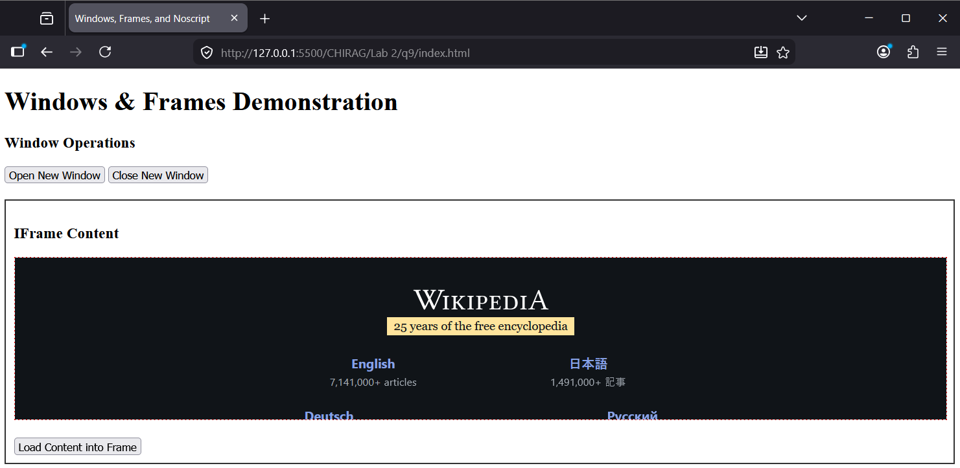
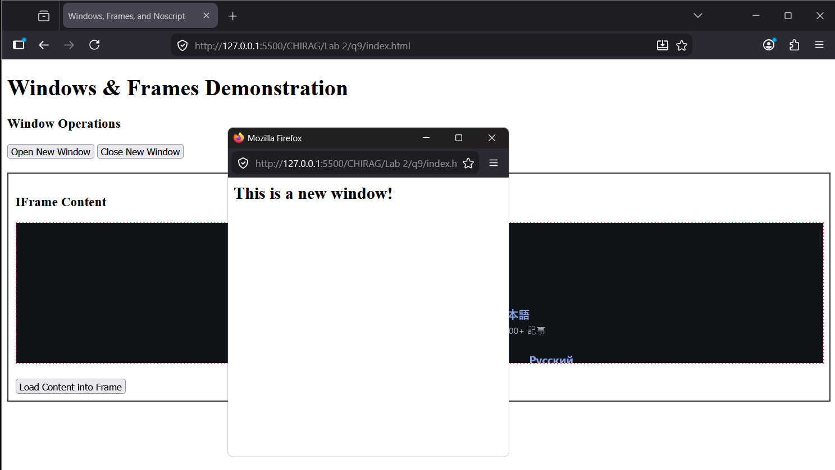

Question 10: Write a HTML, CSS, and JavaScript to create Digital Date/Time. And, demonstrate Math() object also.
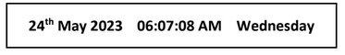
Introduction
A digital clock in web development is created by using the JavaScript Date object to fetch the current system time and date. Since the Date object only provides a static snapshot of the time at the moment it is called, the setInterval function is used to refresh the data every second, creating a live "ticking" effect. To enhance the functionality of such applications, the Math object is often employed to perform mathematical tasks, such as generating random numbers, rounding values, or calculating powers, which are essential for various algorithmic processes within a script.
Tags and Attributes
- new Date(): A constructor that creates a new date object with the current date and time.
- getFullYear(): A method used to retrieve the four-digit year from a date object.
- getMonth(): A method that returns the month (0-11) for the specified date.
- getDay(): A method that returns the day of the week (0-6) for the specified date.
- Math.floor(): A method that rounds a number downwards to the nearest integer.
- Math.random(): A method that returns a floating-point, pseudo-random number between 0 and 1.
- Math.pow(): A method used to return the value of a base raised to a specific power.
- innerHTML: A property used to set or get the HTML content inside an element.
- padding: A CSS property used to create space around an element's content, inside of any defined borders.
Code
<!DOCTYPE html>
<html>
<head>
<title>Digital Clock and Math Object</title>
<style>
.clock-container {
border: 2px solid black;
padding: 20px;
width: 500px;
text-align: center;
font-family: Arial, sans-serif;
font-weight: bold;
font-size: 24px;
margin-bottom: 20px;
}
</style>
</head>
<body>

<div class="clock-container" id="display">
Loading...
</div>

<div id="math-demo">
<h3>Math Object Demo</h3>
<p id="math-res"></p>
</div>

<script>
function updateClock() {
let d = new Date();

let date = d.getDate();
let year = d.getFullYear();

let months = ["January", "February", "March", "April", "May", "June",
"July", "August", "September", "October", "November", "December"];
let monthName = months[d.getMonth()];

let days = ["Sunday", "Monday", "Tuesday", "Wednesday", "Thursday", "Friday", "Saturday"];
let dayName = days[d.getDay()];

let h = d.getHours();
let m = d.getMinutes();
let s = d.getSeconds();
let ampm = h >= 12 ? 'PM' : 'AM';

h = h % 12;
h = h ? h : 12;
h = h < 10 ? '0' + h : h;
m = m < 10 ? '0' + m : m;
s = s < 10 ? '0' + s : s;

let suffix = "th";
if (date === 1 || date === 21 || date === 31) suffix = "st";
else if (date === 2 || date === 22) suffix = "nd";
else if (date === 3 || date === 23) suffix = "rd";

let dateStr = date + suffix + " " + monthName + " " + year;
let timeStr = h + ":" + m + ":" + s + " " + ampm;

document.getElementById("display").innerHTML = dateStr + " &nbsp;&nbsp; " + timeStr + " &nbsp;&nbsp; " + dayName;
}

function demoMath() {
let randomNum = Math.floor(Math.random() * 100);
let powerVal = Math.pow(2, 3);
let piVal = Math.PI;

document.getElementById("math-res").innerHTML =
"Random (0-99): " + randomNum + "<br>" +
"2 to the power of 3: " + powerVal + "<br>" +
"Value of PI: " + piVal.toFixed(2);
}

setInterval(updateClock, 1000);
updateClock();
demoMath();
</script>

</body>
</html>

Output
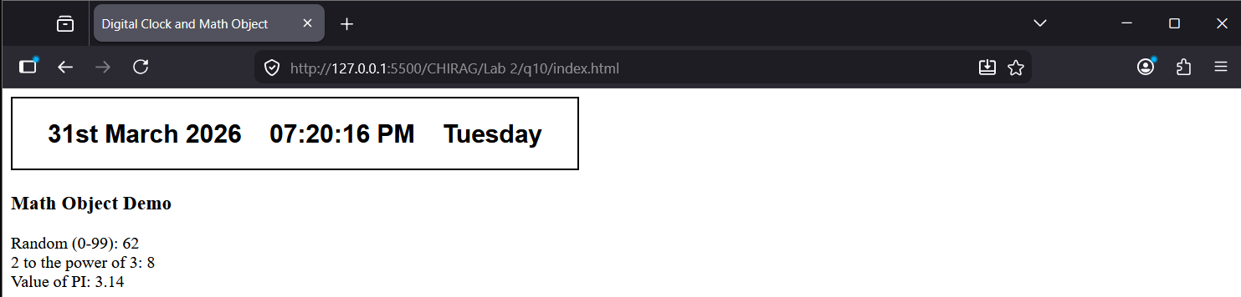

Question 11: Write a program to demonstrate Cookies in JavaScript.
Introduction
Cookies are small text files stored on a user's computer by a web browser to hold data specific to a particular client or website. They are primarily used for session management, personalization, and tracking user behavior across different pages. In JavaScript, cookies are managed through the document.cookie property, which allows developers to create, read, and delete data. Each cookie consists of a name-value pair and can include optional attributes such as expires or max-age to determine its lifespan, and path to define its scope within the website's directory structure.
Tags and Attributes
- document.cookie: A property used to get and set cookies associated with the current document.
- expires: An attribute that sets a specific date and time when the cookie will be automatically deleted.
- max-age: An alternative attribute to expires that sets the cookie's lifetime in seconds.
- path: An attribute that defines the URL path that must exist in the requested URL for the cookie to be sent.
- split(): A JavaScript string method used to break a cookie string into an array based on a separator like a semicolon.
- toUTCString(): A method used to convert a Date object into a string, which is the required format for the expires attribute.
- encodeURIComponent(): A function used to ensure that special characters within a cookie value are properly formatted for storage.
- decodeURIComponent(): A function used to revert the encoding of a cookie value back to its original state when reading it.
Code
<!DOCTYPE html>
<html>
<head>
<title>JavaScript Cookies Demo</title>
</head>
<body>

<h2>Cookie Management</h2>

<input type="text" id="username" placeholder="Enter Username">
<button onclick="setCookie()">Set Cookie</button>
<button onclick="getCookie()">Show Cookie</button>
<button onclick="deleteCookie()">Delete Cookie</button>

<p id="output"></p>

<script>
function setCookie() {
let name = document.getElementById("username").value;
let d = new Date();
d.setTime(d.getTime() + (24 * 60 * 60 * 1000));
let expires = "expires=" + d.toUTCString();

document.cookie = "user=" + name + ";" + expires + ";path=/";
alert("Cookie has been set!");
}

function getCookie() {
let name = "user=";
let decodedCookie = decodeURIComponent(document.cookie);
let ca = decodedCookie.split(';');
let foundValue = "No cookie found";

for(let i = 0; i < ca.length; i++) {
let c = ca[i].trim();
if (c.indexOf(name) == 0) {
foundValue = "Saved User: " + c.substring(name.length, c.length);
}
}
document.getElementById("output").innerHTML = foundValue;
}

function deleteCookie() {
document.cookie = "user=; expires=Thu, 01 Jan 1970 00:00:00 UTC; path=/;";
alert("Cookie deleted!");
document.getElementById("output").innerHTML = "";
}
</script>

</body>
</html>

Output
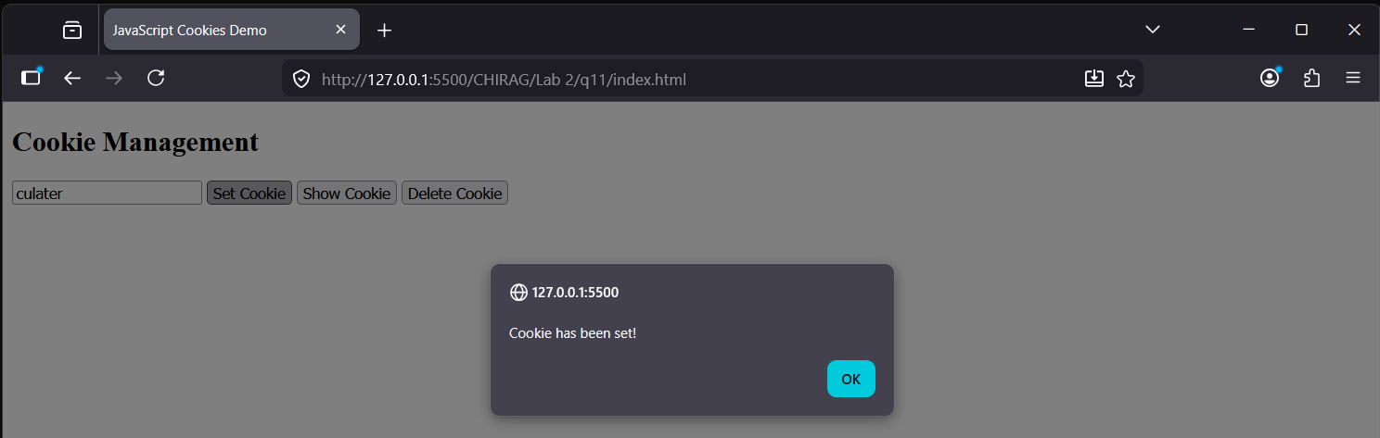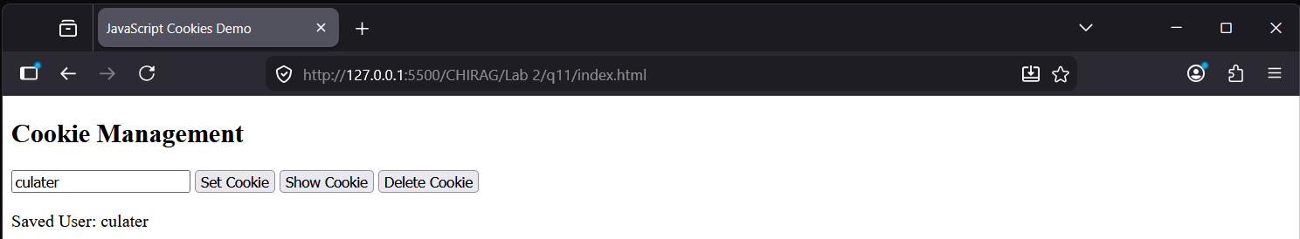
Question 12: Write a program to demonstrate JavaScript animation.
Introduction
JavaScript animation involves making gradual changes to an element's style properties over a period of time, creating the illusion of motion. While CSS transitions and animations are useful for simple effects, JavaScript offers much finer control, allowing for complex physics, multi-staged movements, and interactive triggers. The primary engine for modern web animation is requestAnimationFrame, a window method that tells the browser you wish to perform an animation and requests that the browser calls a specified function to update an animation before the next repaint. This results in smoother movements and better battery efficiency compared to older methods like setInterval.
Tags and Attributes
- requestAnimationFrame(): A command that tells the browser to run a specific piece of code right before the next screen update.
- cancelAnimationFrame(): A command used to stop a running animation.
- left: A CSS property that controls how far an element is from the left side of its container.
- position: relative: A setting for the container that allows us to track where the moving object is inside it.
- position: absolute: A setting for the moving object that lets us move it anywhere within its container.
- border-radius: A style used to turn a square box into a circle (50%).
- background-color: A property used to give the moving object a specific color so it is visible.
- onclick: A trigger that starts the animation code when a user clicks a button.
Code
<!DOCTYPE html>
<html>
<head>
<title>Simple Animation</title>
<style>
#box {
width: 400px;
height: 100px;
border: 1px solid black;
position: relative;
}
#ball {
width: 40px;
height: 40px;
background: red;
border-radius: 50%;
position: absolute;
left: 0;
top: 30px;
}
</style>
</head>
<body>

<div id="box">
<div id="ball"></div>
</div>

<br>
<button onclick="moveBall()">Start</button>
<button onclick="stopBall()">Stop</button>

<script>
let ball = document.getElementById("ball");
let position = 0;
let animation;

function frame() {
position = position + 2;
ball.style.left = position + "px";

if (position < 360) {
animation = requestAnimationFrame(frame);
} else {
position = 0;
ball.style.left = "0px";
animation = requestAnimationFrame(frame);
}
}

function moveBall() {
if (!animation) {
frame();
}
}

function stopBall() {
cancelAnimationFrame(animation);
animation = null;
}
</script>

</body>
</html>

Output
