Question 1: Write an XML file, which will display the Book information. It includes the following:
Title of the book
Author Name
ISBN number
Publisher name
Edition
Price

Write a Schema to validate the above XML file.
Introduction
XML (Extensible Markup Language) is a versatile format used to store and transport data in a structured, hierarchical manner. Unlike HTML, which focuses on how data looks, XML focuses on what the data is. To ensure that an XML file follows a specific set of rules, such as requiring certain fields like an ISBN or Price, we use an XML Schema (XSD). An XSD defines the legal building blocks of an XML document, specifying the arrangement of elements and the data types (strings, numbers, etc.) each element must contain.
Tags and Attributes
- <bookstore>: A root element used to wrap the entire collection of book records.
- <book>: An element representing an individual book entry.
- <title>: An element used to store the name of the publication.
- <author>: An element used to store the name of the individual who wrote the book.
- <ISBN>: An element for the International Standard Book Number, often used as a unique identifier.
- <publisher>: An element identifying the company that produced the book.
- <edition>: An element indicating the specific version or release of the book.
- <price>: An element containing the cost of the book, usually defined as a decimal or double type in the schema.
- xmlns:xs: An attribute in the schema file that points to the standard XML Schema definition.
- elementFormDefault: A schema attribute that ensures all elements in the XML are properly associated with the schema namespace.
Code [XML]
<?xml version="1.0" encoding="UTF-8"?>
<bookstore>
<book>
<title>JavaScript: The Good Parts</title>
<author>Douglas Crockford</author>
<ISBN>978-0596517748</ISBN>
<publisher>O'Reilly Media</publisher>
<edition>1st Edition</edition>
<price>29.99</price>
</book>
<book>
<title>Eloquent JavaScript</title>
<author>Marijn Haverbeke</author>
<ISBN>978-1593279509</ISBN>
<publisher>No Starch Press</publisher>
<edition>3rd Edition</edition>
<price>35.50</price>
</book>
</bookstore>

[XSD]
<?xml version="1.0" encoding="UTF-8"?>
<xs:schema xmlns:xs="http://www.w3.org/2001/XMLSchema">
<xs:element name="bookstore">
<xs:complexType>
<xs:sequence>
<xs:element name="book" maxOccurs="unbounded">
<xs:complexType>
<xs:sequence>
<xs:element name="title" type="xs:string"/>
<xs:element name="author" type="xs:string"/>
<xs:element name="ISBN" type="xs:string"/>
<xs:element name="publisher" type="xs:string"/>
<xs:element name="edition" type="xs:string"/>
<xs:element name="price" type="xs:decimal"/>
</xs:sequence>
</xs:complexType>
</xs:element>
</xs:sequence>
</xs:complexType>
</xs:element>
</xs:schema>

[index.php]
<?php
$xml = new DOMDocument();
if (!$xml->load('book.xml')) {
die("Error: Cannot find or load book.xml");
}
echo "<h1>XML Validation Report</h1>";

libxml_use_internal_errors(true);

if ($xml->schemaValidate(__DIR__ . '/book.xsd')) {
echo "<div style='color: green; padding: 10px; border: 2px solid green;'>";
echo "<strong>Success:</strong> The XML file is valid against the provided XSD schema.";
echo "</div>";
} else {
echo "<div style='color: red; padding: 10px; border: 2px solid red;'>";
echo "<strong>Validation Failed:</strong> The XML does not match the schema rules.<br><br>";

$errors = libxml_get_errors();
foreach ($errors as $error) {
echo "- " . $error->message . "<br>";
}
libxml_clear_errors();
echo "</div>";
}
?>

Output
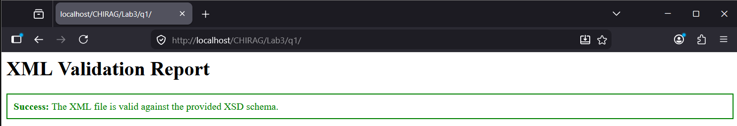

Question 2: Write XML code to store at least 4 songs with details (name, singer, compose_by, length)
Introduction
XML is a highly organized way to store data, making it easy for different systems to share information. In this example, we use a root element to contain a collection of song records. Each song is described by its own set of tags, such as the title, the performer, the composer, and the duration. Because XML is "extensible," we can name these tags anything we want if we follow the rules of opening and closing them correctly. This structure allows a music player or a database to easily "read" the library and sort songs by singer or length.
Tags and Attributes
- <music_library>: The root element that acts as a container for all the song data in the file.
- <song>: A repeating element that represents a single entry or track in the library.
- <name>: An element used to store the title of the song.
- <singer>: An element used to identify the primary vocal artist or band.
- <compose_by>: An element used to credit the songwriter or producer who created the music.
- <length>: An element used to record the duration of the track, typically in a minute and seconds format.
- version="1.0": An attribute in the XML declaration that specifies the version of the XML standard being used.
- encoding="UTF-8": An attribute that tells the computer which character set to use to display the text correctly.
Code
<?xml version="1.0" encoding="UTF-8"?>
<music_library>
<song>
<name>Bohemian Rhapsody</name>
<singer>Queen</singer>
<compose_by>Freddie Mercury</compose_by>
<length>5:55</length>
</song>
<song>
<name>Blinding Lights</name>
<singer>The Weeknd</singer>
<compose_by>Max Martin</compose_by>
<length>3:20</length>
</song>
<song>
<name>Shape of You</name>
<singer>Ed Sheeran</singer>
<compose_by>Steve Mac</compose_by>
<length>3:53</length>
</song>
<song>
<name>Hotel California</name>
<singer>Eagles</singer>
<compose_by>Don Felder</compose_by>
<length>6:30</length>
</song>
</music_library>

Output
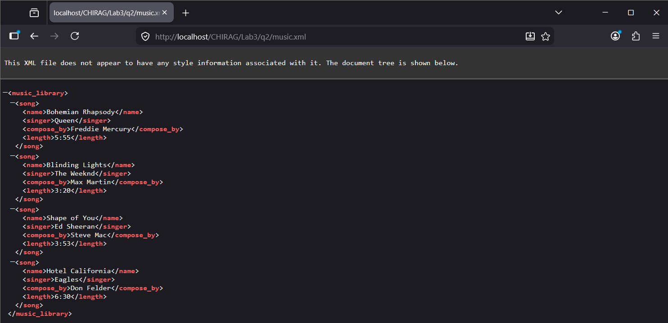

Question 3: Write a valid xml to validate following details – XML & XSD with Facets.
Validate record of books with (name, email, author, page_no, price)
Names have first name, middle name, and last name.
All fields are required and page_no is optional.
Author can be multiple.
And highest price limit is 600.
Book have isbn as an attribute.
Introduction
In XML Schema, Facets are a powerful way to add specific constraints or rules to the data. While basic schemas only define the type of data (like a string or a number), facets allow us to set boundaries, such as a maximum price or a specific pattern for an email address. This ensures the data is not only the correct type but also makes logical sense for the application. Additionally, using nested elements for a name allows for more granular data management, such as separating a first name from a last name, which is a common practice in professional database design.
Tags and Attributes
- xs:restriction: A tag used to define a base type that will have additional limits or rules applied to it.
- xs:maxInclusive: A facet that sets the upper limit for a numeric value, including the number itself.
- xs:pattern: A facet used to define a Regular Expression (Regex) that the data must match, such as a valid email format.
- minOccurs and maxOccurs: Attributes that define how many times an element can appear.
- xs:attribute: A tag used to define data that is stored as an attribute within an opening tag rather than as a separate element.
- xs:complexType: A container for elements that contain other elements or attributes.
- xs:sequence: A compositor that requires the child elements to appear in the exact order they are listed.
Code [XML]
<?xml version="1.0" encoding="UTF-8"?>
<book_records xmlns:xsi="http://www.w3.org/2001/XMLSchema-instance" xsi:noNamespaceSchemaLocation="books.xsd">
<book isbn="980-365-6470">
<name>
<first>John</first>
<middle>Ram</middle>
<last>Doe</last>
</name>
<email>example@example.com</email>
<author>Author One</author>
<author>Author Two</author>
<page_no>450</page_no>
<price>550.00</price>
</book>
</book_records>
[XSD]
<?xml version="1.0" encoding="UTF-8"?>
<xs:schema xmlns:xs="http://www.w3.org/2001/XMLSchema">
<xs:element name="book_records">
<xs:complexType>
<xs:sequence>
<xs:element name="book" maxOccurs="unbounded">
<xs:complexType>
<xs:sequence>
<xs:element name="name">
<xs:complexType>
<xs:sequence>
<xs:element name="first" type="xs:string"/>
<xs:element name="middle" type="xs:string"/>
<xs:element name="last" type="xs:string"/>
</xs:sequence>
</xs:complexType>
</xs:element>

<xs:element name="email">
<xs:simpleType>
<xs:restriction base="xs:string">
<xs:pattern value="[^@]+@[^\.]+\..+"/>
</xs:restriction>
</xs:simpleType>
</xs:element>

<xs:element name="author" type="xs:string" maxOccurs="unbounded"/>

<xs:element name="page_no" type="xs:integer" minOccurs="0"/>

<xs:element name="price">
<xs:simpleType>
<xs:restriction base="xs:decimal">
<xs:maxInclusive value="600"/>
</xs:restriction>
</xs:simpleType>
</xs:element>
</xs:sequence>
<xs:attribute name="isbn" type="xs:string" use="required"/>
</xs:complexType>
</xs:element>
</xs:sequence>
</xs:complexType>
</xs:element>
</xs:schema>

Output
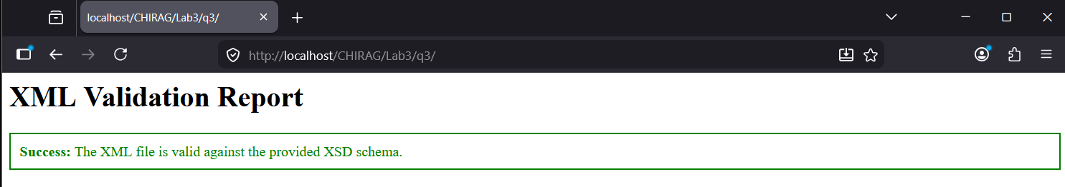

Question 4: Write a valid xml to validate following details.
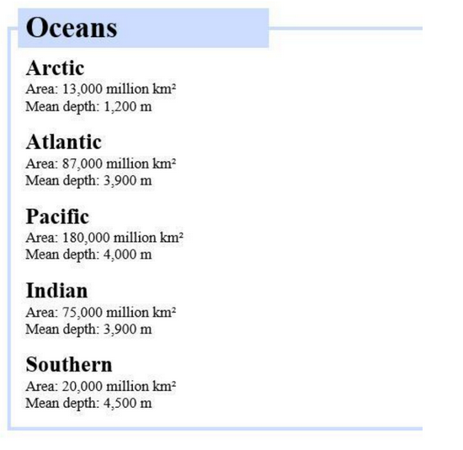
Introduction
XML (Extensible Markup Language) and XSLT (Extensible Stylesheet Language Transformations) work together to separate data from presentation. While XML is used to store structured information, XSLT acts as a processor that transforms that raw data into a readable format, such as an HTML document. This is particularly useful for displaying statistical or scientific records because it allows for a single data source to be rendered in various styles without changing the underlying XML file itself.
Tags and Attributes
- xsl:stylesheet: The root element that defines a document as an XSLT transformation file.
- xsl:template: A rule applied to a specific part of the XML to define how it should be converted.
- xsl:for-each: A loop used to iterate through a repeated set of XML elements, such as multiple ocean records.
- xsl:value-of: A command that extracts the text content from a specific XML tag and inserts it into the output.
- select: An attribute used to specify the path to the XML data being targeted.
- match="/": An attribute used to indicate that the transformation should begin from the root of the XML document.
- table: An HTML tag used to organize data into rows and columns for a clear visual layout.
- bgcolor: An attribute used within table headers to provide a background color for better readability.
Code [XML]
<?xml version="1.0" encoding="UTF-8"?>
<?xml-stylesheet type="text/xsl" href="ocean_style.xsl"?>
<ocean_data>
<ocean>
<name>Arctic</name>
<area>13,000 million km2</area>
<depth>1,200 m</depth>
</ocean>
<ocean>
<name>Atlantic</name>
<area>87,000 million km2</area>
<depth>3,900 m</depth>
</ocean>
<ocean>
<name>Pacific</name>
<area>180,000 million km2</area>
<depth>4,000 m</depth>
</ocean>
<ocean>
<name>Indian</name>
<area>75,000 million km2</area>
<depth>3,900 m</depth>
</ocean>
<ocean>
<name>Southern</name>
<area>20,000 million km2</area>
<depth>4,500 m</depth>
</ocean>
</ocean_data>

[XSL]
<?xml version="1.0" encoding="UTF-8"?>
<xsl:stylesheet version="1.0" xmlns:xsl="http://www.w3.org/1999/XSL/Transform">
<xsl:template match="/">
<html>
<body style="font-family: Arial, sans-serif;">
<h2 style="background-color: #ccd9ff; padding: 10px; display: inline-block;">Oceans</h2>
<xsl:for-each select="ocean_data/ocean">
<div style="margin-bottom: 20px;">
<h3 style="margin-bottom: 5px;"><xsl:value-of select="name"/></h3>
<p style="margin: 2px 0;">Area: <xsl:value-of select="area"/></p>
<p style="margin: 2px 0;">Mean depth: <xsl:value-of select="depth"/></p>
</div>
</xsl:for-each>
</body>
</html>
</xsl:template>
</xsl:stylesheet>

Output
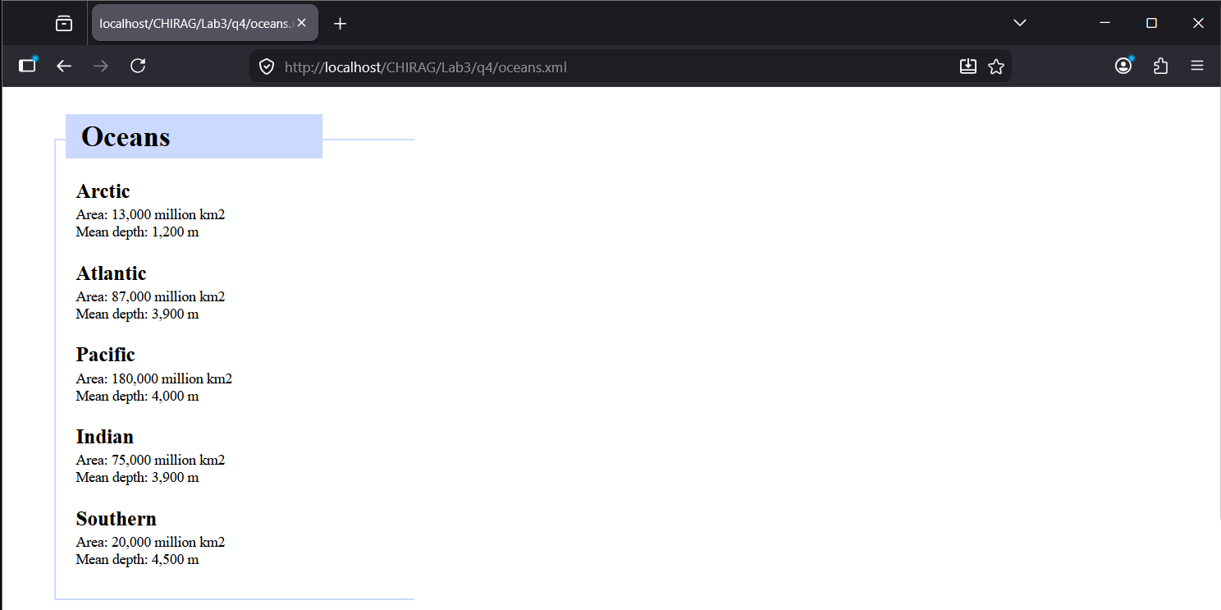

Question 5: Write valid XML and CSS to display the following output. First define xml Define CSS to display following details.
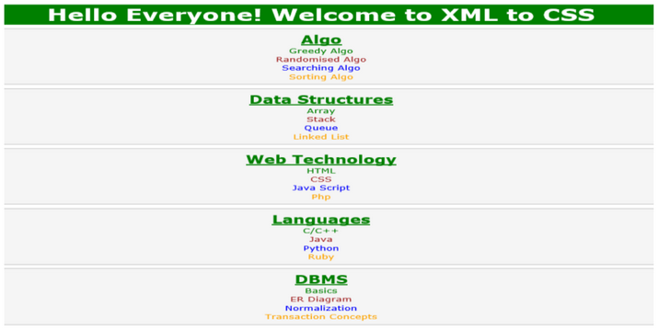
Introduction
While XSLT is used to transform XML into HTML, it is also possible to style an XML document directly using CSS (Cascading Stylesheets). This method tells the browser how to render specific XML tags as if they were standard HTML elements like headers or paragraphs. By setting the display property to block, we ensure that each XML element starts on a new line. We can then apply colors, alignments, and borders to create a structured visual interface.
Tags and Attributes
- xml-stylesheet: A processing instruction used to link an external CSS file to an XML document.
- display: block: A CSS property that makes an XML element behave like a container, taking up the full width available.
- text-align: center: A property used to align the text within the XML elements to the middle of the screen.
- font-weight: bold: A styling property used to make headers stand out, as seen in the green category titles.
- border: A property used to create the grey boxes surrounding each category in the list.
- color: A property used to differentiate individual items within a category.
- margin and padding: Properties used to create space around and inside the elements to match the layout of the screenshot.
Code [courses.xml]
<?xml version="1.0" encoding="UTF-8"?>
<?xml-stylesheet type="text/css" href="style.css"?>
<root>
<header>Hello Everyone! Welcome to XML to CSS</header>

<category>
<title>Algo</title>
<item1>Greedy Algo</item1>
<item2>Randomised Algo</item2>
<item3>Searching Algo</item3>
<item4>Sorting Algo</item4>
</category>

<category>
<title>Data Structures</title>
<item1>Array</item1>
<item2>Stack</item2>
<item3>Queue</item3>
<item4>Linked List</item4>
</category>

<category>
<title>Web Technology</title>
<item1>HTML</item1>
<item2>CSS</item2>
<item3>Java Script</item3>
<item4>Php</item4>
</category>

<category>
<title>Languages</title>
<item1>C/C++</item1>
<item2>Java</item2>
<item3>Python</item3>
<item4>Ruby</item4>
</category>

<category>
<title>DBMS</title>
<item1>Basics</item1>
<item2>ER Diagram</item2>
<item3>Normalization</item3>
<item4>Transaction Concepts</item4>
</category>
</root>
[style.css]
root {
display: block;
font-family: Arial, sans-serif;
text-align: center;
}

header {
display: block;
background-color: #008000;
color: white;
font-size: 30px;
font-weight: bold;
padding: 10px;
margin-bottom: 5px;
}

category {
display: block;
border: 2px solid #ddd;
background-color: #f9f9f9;
margin: 5px 0;
padding: 10px 0;
}

title {
display: block;
color: #008000;
font-size: 24px;
font-weight: bold;
text-decoration: underline;
margin-bottom: 5px;
}

item1 { display: block; color: #008000; font-weight: bold; }
item2 { display: block; color: #a52a2a; font-weight: bold; }
item3 { display: block; color: #0000ff; font-weight: bold; }
item4 { display: block; color: #daa520; font-weight: bold; }

Output
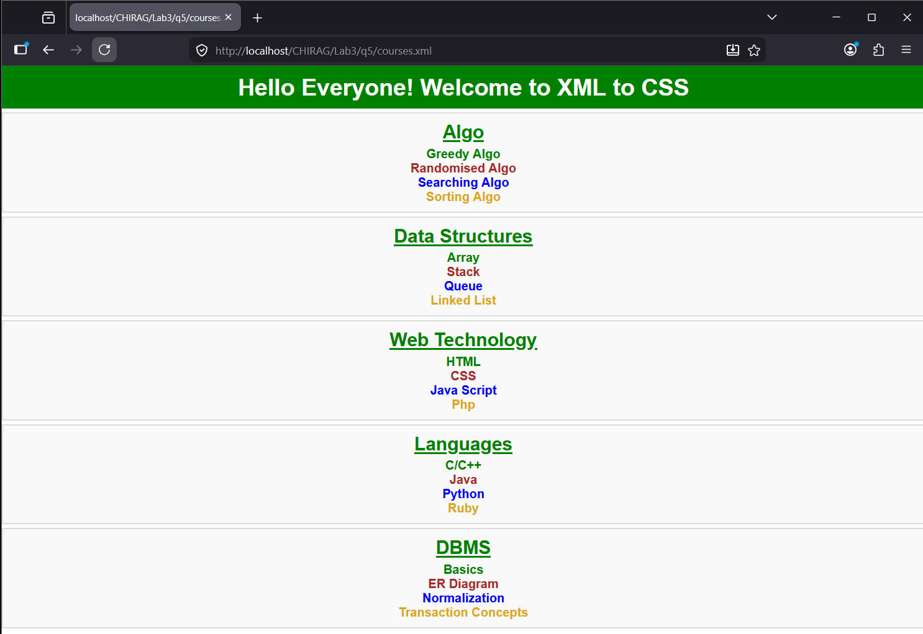
Question 6: Display following output using XML & XSLT.
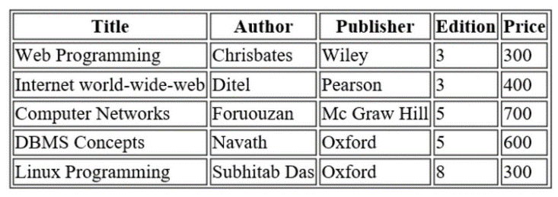
And,
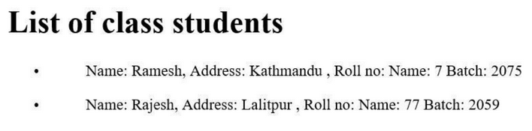
Introduction
XSLT (Extensible Stylesheet Language Transformations) is a declarative language used to convert XML documents into different formats, most commonly HTML for web display. By using a template-based approach, it can navigate through complex data structures and reorganize them into various visual components, such as tables or lists. This separation of concerns allows the underlying data to remain in a clean, machine-readable XML format while providing the flexibility to render it in a way that is easily consumable by humans, including the ability to apply different styles and layouts to distinct data sets within the same document.
Tags and Attributes
- xsl:template: Defines a set of rules to be applied to specific nodes in the XML document.
- match: An attribute that specifies which XML element the template should target.
- xsl:apply-templates: Instructs the XSLT processor to find and execute the appropriate templates for child elements.
- xsl:for-each: A looping construct used to repeat an HTML structure for every instance of a selected XML node.
- xsl:value-of: A command that extracts text from a specific XML tag and places it into the output.
- select: An attribute used to navigate to a specific path within the XML hierarchy (e.g., book_list/book).
- table and tr/td: Standard HTML tags used by the XSLT template to organize data into a grid format.
- ul and li: HTML tags used to create bulleted lists from XML repeating elements.
Code [data.xml]
<?xml version="1.0" encoding="UTF-8"?>
<?xml-stylesheet type="text/xsl" href="format.xsl"?>
<root>
<book_list>
<book>
<title>Web Programming</title>
<author>Chrisbates</author>
<publisher>Wiley</publisher>
<edition>3</edition>
<price>300</price>
</book>
<book>
<title>Internet world-wide-web</title>
<author>Ditel</author>
<publisher>Pearson</publisher>
<edition>3</edition>
<price>400</price>
</book>
<book>
<title>Computer Networks</title>
<author>Forouzan</author>
<publisher>Mc Graw Hill</publisher>
<edition>5</edition>
<price>700</price>
</book>
<book>
<title>DBMS Concepts</title>
<author>Navath</author>
<publisher>Oxford</publisher>
<edition>5</edition>
<price>600</price>
</book>
<book>
<title>Linux Programming</title>
<author>Subhitab Das</author>
<publisher>Oxford</publisher>
<edition>8</edition>
<price>300</price>
</book>
</book_list>
<student_list>
<student>
<name>Ramesh</name>
<address>Kathmandu</address>
<roll>7</roll>
<batch>2075</batch>
</student>
<student>
<name>Rajesh</name>
<address>Lalitpur</address>
<roll>77</roll>
<batch>2059</batch>
</student>
</student_list>
</root>
[format.xsl]
<?xml version="1.0" encoding="UTF-8"?>
<xsl:stylesheet version="1.0" xmlns:xsl="http://www.w3.org/1999/XSL/Transform">
<xsl:template match="/">
<html>
<body style="font-family: 'Times New Roman', serif; padding: 20px; color: #000;">
<h1 style="font-size: 32px; margin-bottom: 20px;">Book List</h1>
<table border="1" cellspacing="2" cellpadding="4" style="border-collapse: separate; width: auto; border: 1px solid black;">
<tr style="text-align: center; font-weight: bold; background-color: #fff;">
<th style="border: 1px solid black; padding: 2px 10px;">Title</th>
<th style="border: 1px solid black; padding: 2px 10px;">Author</th>
<th style="border: 1px solid black; padding: 2px 10px;">Publisher</th>
<th style="border: 1px solid black; padding: 2px 5px;">Edition</th>
<th style="border: 1px solid black; padding: 2px 5px;">Price</th>
</tr>
<xsl:for-each select="root/book_list/book">
<tr style="white-space: nowrap;">
<td style="border: 1px solid black; padding: 2px 5px;"><xsl:value-of select="title"/></td>
<td style="border: 1px solid black; padding: 2px 5px;"><xsl:value-of select="author"/></td>
<td style="border: 1px solid black; padding: 2px 5px;"><xsl:value-of select="publisher"/></td>
<td style="border: 1px solid black; padding: 2px 5px; text-align: center;"><xsl:value-of select="edition"/></td>
<td style="border: 1px solid black; padding: 2px 5px; text-align: center;"><xsl:value-of select="price"/></td>
</tr>
</xsl:for-each>
</table>
<h1 style="font-size: 28px; margin-top: 20px;">List of class students</h1>
<ul style="list-style-type: disc; margin-left: 50px;">
<xsl:for-each select="root/student_list/student">
<li style="margin-bottom: 10px; font-size: 16px;">
Name: <xsl:value-of select="name"/>,
Address: <xsl:value-of select="address"/> ,
Roll no: <xsl:value-of select="roll"/>
Batch: <xsl:value-of select="batch"/>
</li>
</xsl:for-each>
</ul>
</body>
</html>
</xsl:template>
</xsl:stylesheet>
Output