Question 1: Write server-side program to create calculator form, validate two input field and calculate result according to button pressed.
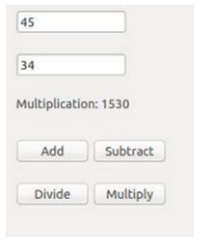
Introduction
Server-side scripting allows a web server to process user input and generate dynamic content before sending it back to the browser. In this approach, a form is used to collect numerical data, which is then sent to a PHP script for processing. The script performs three critical functions: it captures the data from the input fields, validates that both fields contain valid numbers, and determines which mathematical operation to execute based on the specific button clicked by the user. This logic ensures that calculations are performed accurately on the server, providing a robust way to handle data that does not rely solely on the client's browser capabilities.
Functions and PHP Syntax
- form method="post": An attribute that tells the browser to send the form data to the server securely within the body of the HTTP request.
- input type="number": A specialized input field that restricts user entry to numerical values, providing basic client-side validation.
- name: A required attribute for form elements that acts as a key for accessing the data in the PHP global arrays.
- isset(): A PHP function used to determine if a variable (or a specific button click) has been declared and is not null.
- $_POST: A PHP superglobal array used to collect values submitted through an HTML form using the "post" method.
- switch/case: A control structure used to execute different blocks of code based on the value of a specific variable, such as the operation button pressed.
- echo: A PHP command used to output text or calculated results directly onto the web page.
Code
<!DOCTYPE html>
<html>
<head>
<title>PHP Calculator</title>
</head>
<body style="background-color: #f0f0f0; font-family: sans-serif; padding: 20px;">
<?php
$num1 = "";
$num2 = "";
$result = "";
$operation_label = "";
if ($_SERVER["REQUEST_METHOD"] == "POST") {
$num1 = $_POST['num1'];
$num2 = $_POST['num2'];
if (is_numeric($num1) && is_numeric($num2)) {
if (isset($_POST['add'])) {
$result = $num1 + $num2;
$operation_label = "Addition";
} elseif (isset($_POST['subtract'])) {
$result = $num1 - $num2;
$operation_label = "Subtraction";
} elseif (isset($_POST['divide'])) {
if ($num2 != 0) {
$result = $num1 / $num2;
$operation_label = "Division";
} else {
$result = "Error (Div by 0)";
}
} elseif (isset($_POST['multiply'])) {
$result = $num1 * $num2;
$operation_label = "Multiplication";
}
} else {
$result = "Please enter valid numbers";
}
}
?>
<form method="post" action="">
<input type="number" name="num1" value="<?php echo $num1; ?>" required><br><br>
<input type="number" name="num2" value="<?php echo $num2; ?>" required><br><br>
<?php if ($result !== ""): ?>
<p><?php echo $operation_label . ": " . $result; ?></p>
<?php endif; ?>
<div style="display: grid; grid-template-columns: 100px 100px; gap: 10px;">
<button type="submit" name="add">Add</button>
<button type="submit" name="subtract">Subtract</button>
<button type="submit" name="divide">Divide</button>
<button type="submit" name="multiply">Multiply</button>
</div>
</form>
</body>
</html>
Output
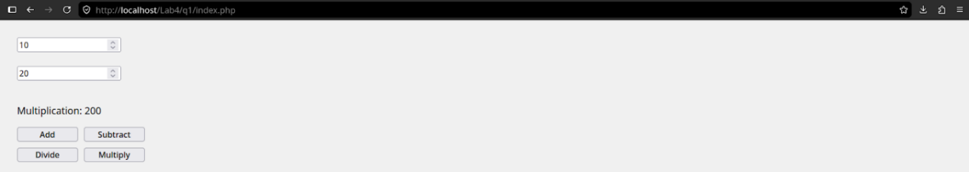Question 2: Write server-side program to create following calculator form, validate given input field and calculate result according to button pressed.
Introduction
Financial calculations on the web require a structured interface to collect user data and a logical backend to process numerical formulas. In this implementation, a form is used to capture the principal amount, interest rate, and time duration. The server-side script then applies the mathematical formula for simple interest. By processing this on the server, the application can validate that the inputs are positive numbers and provide two distinct results: the interest earned and the total sum (principal plus interest). This ensures that the user receives an immediate, accurate breakdown of their financial data without manual calculation.
Functions and PHP Syntax
- form action="": An attribute used to submit the form data back to the same PHP file for processing.
- input type="text": Used here to collect numerical input, which is then validated as a float or integer in PHP.
- $_POST['calculate']: A conditional check used to trigger the math logic only after the user clicks the "Calculate" button.
- number_format(): A PHP function used to format the resulting numbers with decimal places for a professional currency-like appearance.
- placeholder: A descriptive attribute used within input tags to guide the user on what data to enter.
- border-radius: A CSS property used to create the rounded corners for the form container and buttons seen in the interface.
Code
<!DOCTYPE html>
<html>
<head>
<title>Simple Interest Calculator</title>
<style>
body { background-color: #5500aa; display: flex; justify-content: center; padding: 50px; font-family: sans-serif; }
.card { background: white; width: 350px; padding: 30px; border-radius: 30px; text-align: left; }
h2 { text-align: center; color: #333; margin-bottom: 30px; }
label { color: #aaa; font-size: 14px; display: block; margin-bottom: 5px; }
input { width: 100%; padding: 12px; margin-bottom: 20px; border: 1px solid #ccc; border-radius: 10px; box-sizing: border-box; }
.result-label { color: #aaa; font-size: 14px; margin: 5px 0; }
.btn { width: 100%; background: #332d4a; color: white; border: none; padding: 15px; border-radius: 15px; font-size: 16px; cursor: pointer; margin-top: 20px; }
</style>
</head>
<body>
<?php
$p = $r = $t = $interest = $total = "";

if (isset($_POST['calculate'])) {
$p = $_POST['principal'];
$r = $_POST['rate'];
$t = $_POST['time'];

if (is_numeric($p) && is_numeric($r) && is_numeric($t)) {
$interest = ($p * $r * $t) / 100;
$total = $p + $interest;
}
}
?>
<div class="card">
<h2>Simple Interest</h2>
<form method="post" action="">
<label>Principal</label>
<input type="text" name="principal" value="<?php echo $p; ?>" required>
<label>Rate Of Interest</label>
<input type="text" name="rate" value="<?php echo $r; ?>" required>
<label>Time</label>
<input type="text" name="time" value="<?php echo $t; ?>" required>
<div class="result-label">Interest: <b><?php echo $interest; ?></b></div>
<div class="result-label">Total Plus Interest: <b><?php echo $total; ?></b></div>
<button type="submit" name="calculate" class="btn">Calculate</button>
</form>
</div>
</body>
</html>

Output
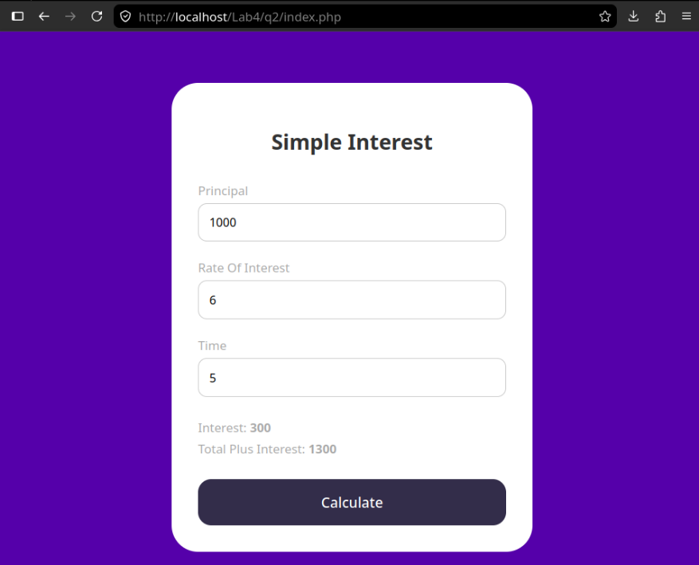
Question 3: Write server-side script to create following form and calculate tax based on following condition.
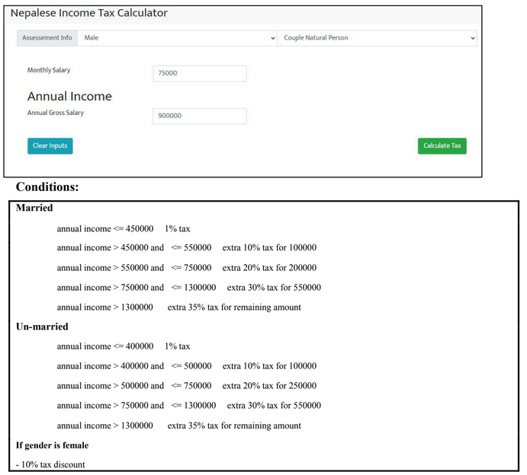
Introduction
Taxation systems often require complex logic to handle progressive tax brackets and demographic-based discounts. This server-side implementation uses a multi-step conditional process: first, it calculates the annual gross salary from monthly input; second, it identifies the correct tax slabs based on marital status; and third, it applies specific percentage-based charges to different portions of the income. By handling this via a PHP script, we can ensure that the calculation remains accurate and that specific legal discounts are applied automatically based on the selected assessment info.
Functions and PHP Syntax
- select: An HTML element used to create a drop-down list, allowing users to choose from multiple predefined options.
- option: Defines an item within a select list; the value attribute holds the data sent to the server, while the selected attribute determines the default choice.
- readonly: A boolean attribute that prevents the user from modifying the value of an input field while still allowing the form to display and submit the data.
- min(): A mathematical function used to determine the lower of two values, which is essential for calculating how much income fits within a specific tax bracket.
- is_numeric(): A validation function that verifies if a variable is a number or a numeric string, preventing errors during mathematical operations.
- number_format(): A built-in function that formats a numeric value into a string with grouped thousands and a specified number of decimals for better readability.
Code
<!DOCTYPE html>
<html>
<head>
<title>Nepalese Income Tax Calculator</title>
<style>
body { font-family: Arial, sans-serif; background-color: #f4f4f4; padding: 20px; }
.container { background: white; border: 2px solid #000; padding: 20px; width: 800px; margin: auto; }
.row { display: flex; gap: 10px; margin-bottom: 20px; align-items: center; }
select, input { padding: 8px; border: 1px solid #ccc; border-radius: 4px; }
.btn-clear { background: #17a2b8; color: white; border: none; padding: 10px 20px; border-radius: 5px; cursor: pointer; }
.btn-calc { background: #28a745; color: white; border: none; padding: 10px 20px; border-radius: 5px; float: right; cursor: pointer; }
.result { margin-top: 20px; padding: 15px; background: #e9ecef; border-left: 5px solid #28a745; font-weight: bold; }
</style>
</head>
<body>
<div class="container">
<h2 style="margin-top: 0;">Nepalese Income Tax Calculator</h2>
<?php
$monthly = $annual = $tax = "";
$gender = "Male";
$status = "Un-married";
if (isset($_POST['calculate'])) {
$monthly = $_POST['monthly'];
$gender = $_POST['gender'];
$status = $_POST['status'];
$annual = $monthly * 12;
$temp_income = $annual;
$total_tax = 0;
if ($status == "Married") {
$total_tax += min($temp_income, 450000) * 0.01;
$temp_income -= 450000;
if ($temp_income > 0) {
$slab = min($temp_income, 100000);
$total_tax += $slab * 0.10;
$temp_income -= $slab;
}
if ($temp_income > 0) {
$slab = min($temp_income, 200000);
$total_tax += $slab * 0.20;
$temp_income -= $slab;
}
if ($temp_income > 0) {
$slab = min($temp_income, 550000);
$total_tax += $slab * 0.30;
$temp_income -= $slab;
}
if ($temp_income > 0) {
$total_tax += $temp_income * 0.35;
}
} else {
$total_tax += min($temp_income, 400000) * 0.01;
$temp_income -= 400000;
if ($temp_income > 0) {
$slab = min($temp_income, 100000);
$total_tax += $slab * 0.10;
$temp_income -= $slab;
}
if ($temp_income > 0) {
$slab = min($temp_income, 250000);
$total_tax += $slab * 0.20;
$temp_income -= $slab;
}
if ($temp_income > 0) {
$slab = min($temp_income, 550000);
$total_tax += $slab * 0.30;
$temp_income -= $slab;
}
if ($temp_income > 0) {
$total_tax += $temp_income * 0.35;
}
}
if ($gender == "Female") {
$total_tax *= 0.90;
}
$tax = $total_tax;
}
?>
<form method="post">
<div class="row">
<span>Assessement Info</span>
<select name="gender">
<option value="Male" <?php if($gender=="Male") echo "selected"; ?>>Male</option>
<option value="Female" <?php if($gender=="Female") echo "selected"; ?>>Female</option>
</select>
<select name="status">
<option value="Un-married" <?php if($status=="Un-married") echo "selected"; ?>>Single Natural Person</option>
<option value="Married" <?php if($status=="Married") echo "selected"; ?>>Couple Natural Person</option>
</select>
</div>
<div class="row">
<label>Monthly Salary</label>
<input type="number" name="monthly" value="<?php echo $monthly; ?>" required>
</div>
<h3 style="margin: 10px 0;">Annual Income</h3>
<div class="row">
<label>Annual Gross Salary</label>
<input type="text" value="<?php echo $annual; ?>" readonly>
</div>
<?php if($tax !== ""): ?>
<div class="result">Total Annual Tax Payable: Rs. <?php echo number_format($tax, 2); ?></div>
<?php endif; ?>
<div style="overflow: auto; margin-top: 20px;">
<button type="reset" class="btn-clear" onclick="window.location.href=window.location.href">Clear Inputs</button>
<button type="submit" name="calculate" class="btn-calc">Calculate Tax</button>
</div>
</form>
</div>
</body>
</html>

Output
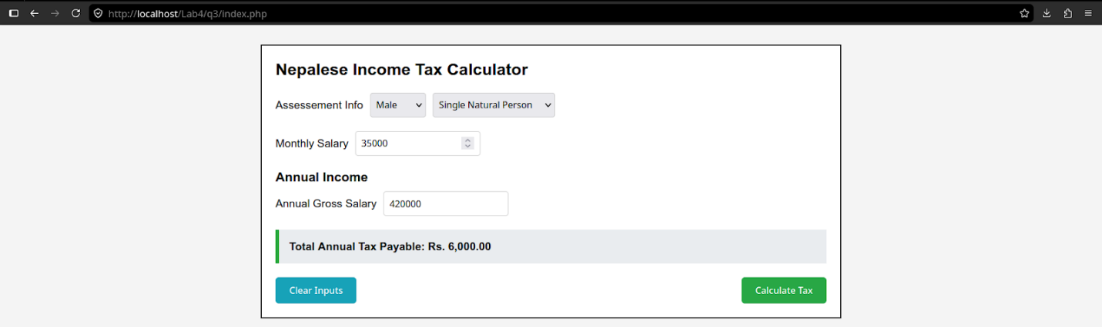

Question 4: Write Server-side script to design following registration form and validate using proper format.
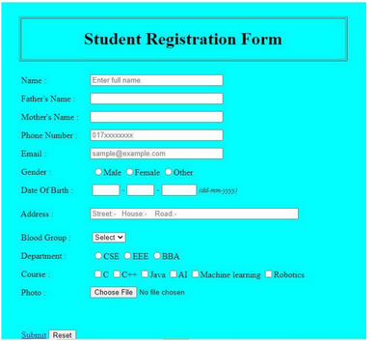
Introduction
A registration form is a fundamental tool for gathering user information and storing it on a server for administrative use. Building such a form requires a combination of structured HTML for the layout and server-side logic to handle the transmission of data. Beyond simply displaying input fields, a robust system must validate the information to ensure it follows specific formats, such as checking for valid email structures or ensuring that mandatory fields like names and phone numbers are not left blank. This process prevents corrupted or incomplete data from entering the database, maintaining the integrity of the student records system.
Functions and PHP Syntax
- form enctype="multipart/form-data": A specific attribute required when a form contains a file upload field, allowing the server to process binary data.
- input type="radio": A selection element that allows the user to choose exactly one option from a predefined set, such as Gender or Department.
- input type="checkbox": An element that allows the user to select multiple options simultaneously, ideal for a list of interests or courses.
- select and option: Used together to create a dropdown list, which saves screen space and provides a clean interface for picking a single value
- input type="file": A specialized field that opens a local file browser on the user's device to select an image or document for upload.
- placeholder: A descriptive text attribute that appears inside an empty input field to show the expected format
- $_FILES: A PHP array specifically used to handle uploaded file information, including the file name, type, and temporary storage path.

Code
<!DOCTYPE html>
<html>
<head>
<title>Student Registration Form</title>
<style>
body { background-color: #00ffff; font-family: 'Times New Roman', serif; padding: 20px; }
.form-container { width: 600px; margin: auto; border: 1px solid #333; padding: 20px; }
.header-box { border: 2px solid #333; padding: 10px; text-align: center; margin-bottom: 20px; }
.row { margin-bottom: 12px; display: flex; align-items: center; }
label { width: 150px; display: inline-block; font-weight: bold; }
input[type="text"], input[type="email"], select { width: 300px; padding: 3px; }
.date-input { width: 60px !important; margin-right: 5px; }
.btn-row { margin-top: 20px; border-top: 1px solid #333; padding-top: 10px; }
</style>
</head>
<body>

<?php
if ($_SERVER["REQUEST_METHOD"] == "POST") {
$errors = [];
if (empty($_POST['full_name'])) $errors[] = "Name is required.";
if (!filter_var($_POST['email'], FILTER_VALIDATE_EMAIL)) $errors[] = "Invalid email format.";
if (empty($_POST['gender'])) $errors[] = "Gender is required.";

if (empty($errors)) {
echo "<script>alert('Form Submitted Successfully!');</script>";
} else {
foreach ($errors as $error) {
echo "<p style='color:red;'>$error</p>";
}
}
}
?>
<div class="form-container">
<div class="header-box">
<h1 style="margin:0;">Student Registration Form</h1>
</div>
<form action="" method="post" enctype="multipart/form-data">
<div class="row">
<label>Name :</label>
<input type="text" name="full_name" placeholder="Enter full name">
</div>
<div class="row">
<label>Father's Name :</label>
<input type="text" name="father_name">
</div>
<div class="row">
<label>Mother's Name :</label>
<input type="text" name="mother_name">
</div>
<div class="row">
<label>Phone Number :</label>
<input type="text" name="phone" placeholder="017xxxxxxxxx">
</div>
<div class="row">
<label>Email :</label>
<input type="email" name="email" placeholder="sample@example.com">
</div>
<div class="row">
<label>Gender :</label>
<input type="radio" name="gender" value="Male"> Male
<input type="radio" name="gender" value="Female"> Female
<input type="radio" name="gender" value="Other"> Other
</div>
<div class="row">
<label>Date Of Birth :</label>
<input type="text" class="date-input"> -
<input type="text" class="date-input"> -
<input type="text" class="date-input" style="width:80px !important;"> (dd-mm-yyyy)
</div>
<div class="row">
<label>Address :</label>
<input type="text" name="address" placeholder="Street:- House:- Road:-" style="width:400px;">
</div>
<div class="row">
<label>Blood Group :</label>
<select name="blood_group">
<option>Select</option>
<option>A+</option>
<option>O+</option>
<option>B+</option>
</select>
</div>
<div class="row">
<label>Department :</label>
<input type="radio" name="dept" value="CSE"> CSE
<input type="radio" name="dept" value="EEE"> EEE
<input type="radio" name="dept" value="BBA"> BBA
</div>
<div class="row">
<label>Course :</label>
<input type="checkbox" name="course[]" value="C"> C
<input type="checkbox" name="course[]" value="C++"> C++
<input type="checkbox" name="course[]" value="Java"> Java
<input type="checkbox" name="course[]" value="AI"> AI
<input type="checkbox" name="course[]" value="ML"> Machine learning
<input type="checkbox" name="course[]" value="Robotics"> Robotics
</div>
<div class="row">
<label>Photo :</label>
<input type="file" name="student_photo">
</div>

<div class="btn-row">
<input type="submit" value="Submit">
<input type="reset" value="Reset">
</div>
</form>
</div>
</body>
</html>
Output
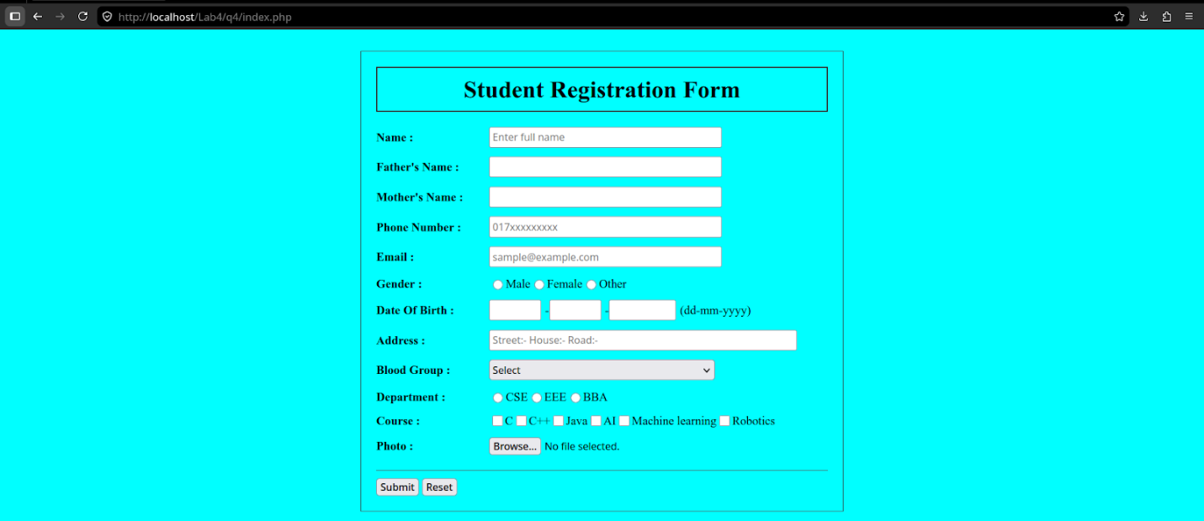

Question 5: Develop a simple web page that asks the users input for name, email, password, phone, gender, and faculty and validate, store into database project table registrations.
Introduction
Building a secure data entry system requires a coordinated workflow between a client-side interface and a server-side relational database. In this architecture, a web page provides a structured form to collect essential user details. Once submitted, a server-side script performs validation to ensure the data is complete and correctly formatted. After successful validation, the script establishes a connection to a database system, such as MySQL, and executes a structured query to permanently store the record. This process is the foundation of user account management and data persistence in modern web applications.
Functions and PHP Syntax
- mysqli_connect(): A function used in server-side scripting to open a new connection to a MySQL database server by providing the host, username, password, and database name.
- INSERT INTO: A structured query language command used to add new rows of data into a specific table within a database.
- $_POST: A global array that holds data sent through an HTTP POST request, allowing the script to access values entered into form fields.
- password_hash(): A security function that creates a one-way mathematical hash of a password, ensuring that sensitive credentials are never stored in plain text.
- type="password": An input attribute that masks the characters entered by the user, providing a basic layer of visual privacy during data entry.
- required: A client-side validation attribute that prevents a form from being submitted if the specific input field is empty.
- die(): A control function used to terminate the script execution and display an error message if a critical process, like a database connection, fails.
Code [index.php]
<!DOCTYPE html>
<html>
<head>
<title>Registration Form</title>
<style>
body { font-family: Arial, sans-serif; padding: 30px; }
.form-box { width: 400px; margin: auto; padding: 20px; border: 1px solid #ccc; }
.row { margin-bottom: 15px; }
label { display: block; margin-bottom: 5px; }
input[type="text"], input[type="email"], input[type="password"], select { width: 100%; padding: 8px; }
</style>
</head>
<body>

<div class="form-box">
<h2>User Registration</h2>

<?php
if (isset($_POST['register'])) {
$name = $_POST['name'];
$email = $_POST['email'];
$pass = $_POST['password'];
$phone = $_POST['phone'];
$gender = $_POST['gender'];
$faculty = $_POST['faculty'];

if (!empty($name) && !empty($email) && !empty($pass) && !empty($phone)) {

$conn = mysqli_connect("localhost", "root", "", "project");

if (!$conn) {
die("Connection failed: " . mysqli_connect_error());
}

$sql = "INSERT INTO registrations (name, email, password, phone, gender, faculty)
VALUES ('$name', '$email', '$pass', '$phone', '$gender', '$faculty')";

if (mysqli_query($conn, $sql)) {
echo "<p style='color:green;'>Data stored successfully!</p>";
} else {
echo "<p style='color:red;'>Error: " . mysqli_error($conn) . "</p>";
}

mysqli_close($conn);
} else {
echo "<p style='color:red;'>Please fill all required fields.</p>";
}
}
?>

<form method="post" action="">
<div class="row">
<label>Name</label>
<input type="text" name="name" required>
</div>
<div class="row">
<label>Email</label>
<input type="email" name="email" required>
</div>
<div class="row">
<label>Password</label>
<input type="password" name="password" required>
</div>
<div class="row">
<label>Phone</label>
<input type="text" name="phone" required>
</div>
<div class="row">
<label>Gender</label>
<input type="radio" name="gender" value="Male" checked> Male
<input type="radio" name="gender" value="Female"> Female
</div>
<div class="row">
<label>Faculty</label>
<select name="faculty">
<option value="Science">Science</option>
<option value="Management">Management</option>
<option value="Humanities">Humanities</option>
</select>
</div>
<button type="submit" name="register">Register</button>
</form>
</div>

</body>
</html>
[db.sql]
CREATE DATABASE project;
USE project;

CREATE TABLE registrations (
id INT AUTO_INCREMENT PRIMARY KEY,
name VARCHAR(100),
email VARCHAR(100),
password VARCHAR(255),
phone VARCHAR(20),
gender VARCHAR(10),
faculty VARCHAR(50)
);

Output
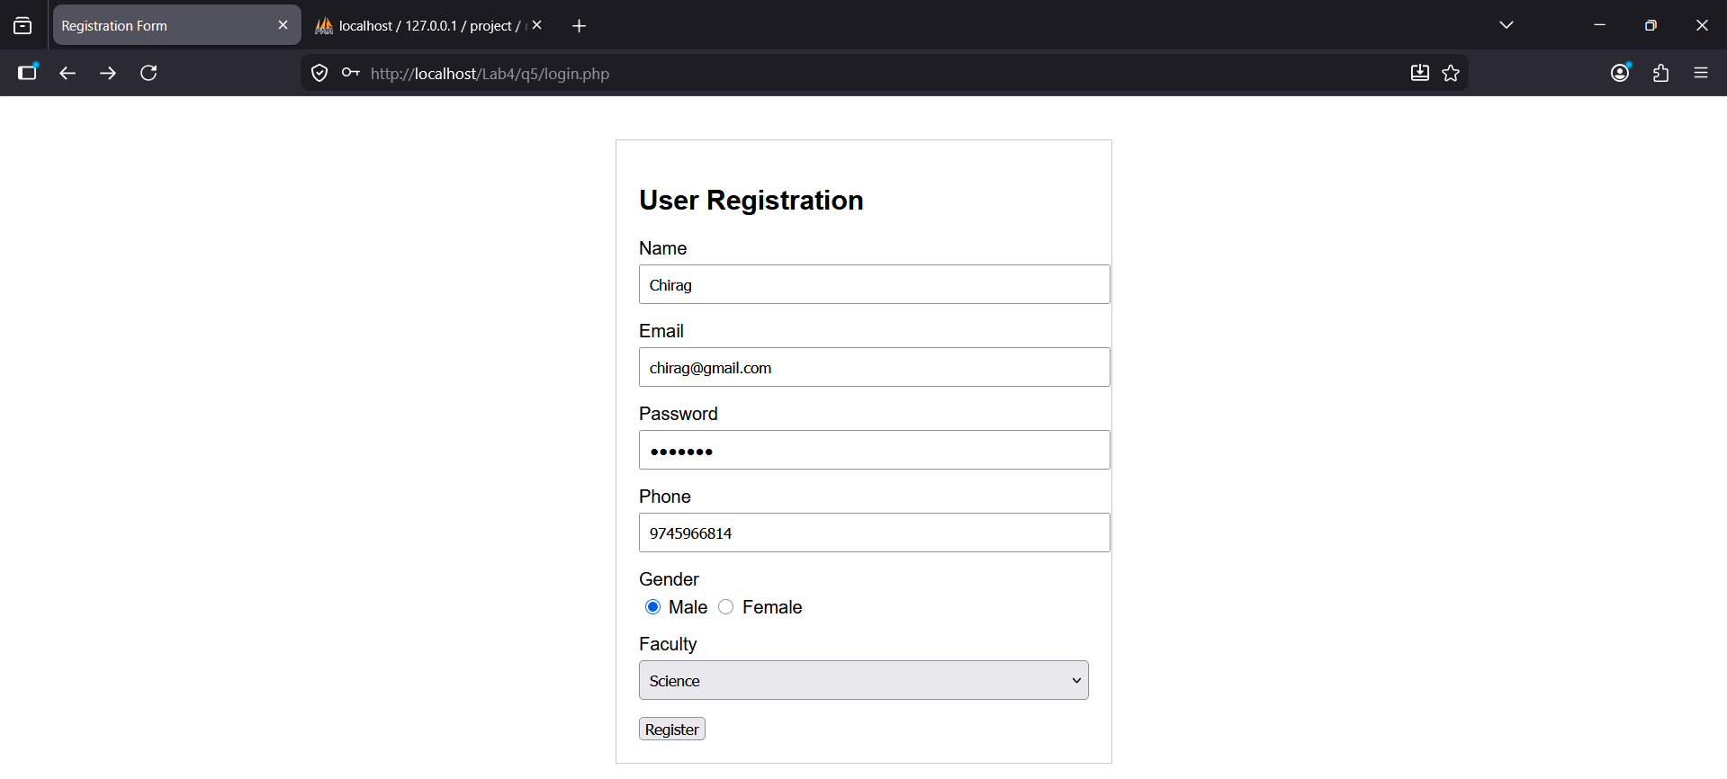
Question 6: Write a server-side script for the login process assuming that your data is already store from previous question no 5.
Introduction
A login system is a security mechanism designed to verify the identity of a user before granting access to protected areas of a website. This process involves comparing credentials provided by the user, typically an email and password, against the records previously stored in a database. A server-side script retrieves the matching record, checks if the credentials align, and then establishes a persistent state, often through sessions, to remember the user as they navigate different pages. This ensures that sensitive information or restricted features remain accessible only to authorized individuals.
Functions and PHP Syntax
- session_start(): A function that creates a new session or resumes an existing one, allowing data to be persisted across multiple page loads.
- $_SESSION: A global associative array used to store session variables, such as the user's ID or name, which can be accessed by any page on the server.
- mysqli_num_rows(): A function that returns the number of rows in a result set, commonly used to check if a user with a specific email exists in the database.
- mysqli_fetch_assoc(): A function that fetches a result row as an associative array, enabling the script to access specific column values like the stored password.
- header("Location: ..."): A PHP function used to send a raw HTTP header to the browser, typically used to redirect the user to a dashboard or welcome page after a successful login.
Code [login.php]
<?php
session_start();

if (isset($_POST['login'])) {
$email = $_POST['email'];
$pass = $_POST['password'];

$conn = mysqli_connect("localhost", "root", "", "project");

if (!$conn) {
die("Connection failed: " . mysqli_connect_error());
}

$sql = "SELECT * FROM registrations WHERE email='$email' AND password='$pass'";
$result = mysqli_query($conn, $sql);

if (mysqli_num_rows($result) == 1) {
$user = mysqli_fetch_assoc($result);

$_SESSION['user_name'] = $user['name'];

header("Location: welcome.php");
exit();
} else {
$error = "Invalid Email or Password!";
}

mysqli_close($conn);
}
?>

<!DOCTYPE html>
<html>
<head>
<title>User Login</title>
<style>
body { font-family: Arial, sans-serif; padding: 50px; }
.login-box { width: 300px; margin: auto; padding: 20px; border: 1px solid #ccc; }
.row { margin-bottom: 15px; }
label { display: block; margin-bottom: 5px; }
input { width: 100%; padding: 8px; box-sizing: border-box; }
.btn { width: 100%; padding: 10px; background: #007bff; color: white; border: none; cursor: pointer; }
</style>
</head>
<body>

<div class="login-box">
<h2>Login</h2>
<?php if(isset($error)) echo "<p style='color:red;'>$error</p>"; ?>

<form method="post" action="">
<div class="row">
<label>Email</label>
<input type="email" name="email" required>
</div>
<div class="row">
<label>Password</label>
<input type="password" name="password" required>
</div>
<button type="submit" name="login" class="btn">Login</button>
</form>
</div>

</body>
</html>
[welcome.php]
<?php
session_start();
if (!isset($_SESSION['user_name'])) {
header("Location: login.php");
exit();
}
?>
<!DOCTYPE html>
<html>
<body>
<h1>Welcome, <?php echo $_SESSION['user_name']; ?>!</h1>
<p>You have successfully logged in.</p>
<a href="logout.php">Logout</a>
</body>
</html>
Output
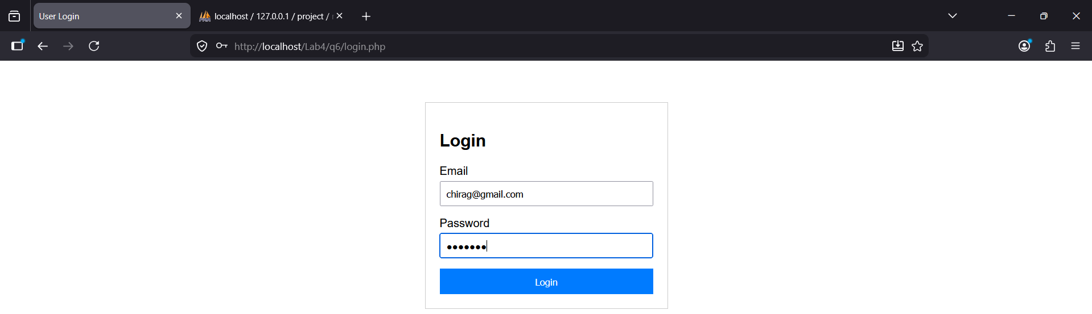
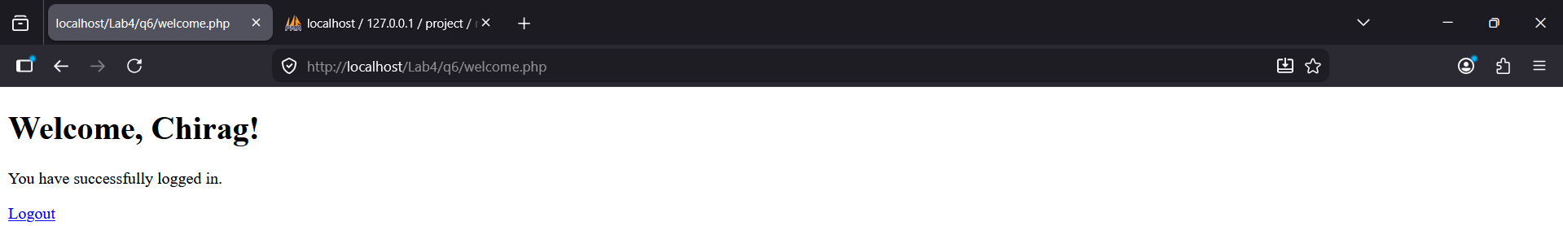

Question 7: Write a server-side script to store, retrieve, and destroy session data.
Introduction
Sessions are a server-side storage mechanism used to persist user data across multiple page requests. Unlike cookies, which are stored on the user's browser, session data is stored on the web server, making it a more secure way to handle sensitive information like login credentials or shopping cart contents. A unique session ID is typically stored in a browser cookie and sent to the server with every request, allowing the server to retrieve the correct data associated with that specific user. The lifecycle of a session involves initializing the engine, assigning values to a global array, and eventually clearing those values to ensure user privacy and security.
Functions and PHP Syntax
- session_start(): A required function that must be called at the very beginning of a script to either create a new session or resume an existing one.
- $_SESSION: A global associative array used to store and retrieve data that needs to be accessible across different pages of a website.
- isset(): A function used to check if a specific session variable has been defined before attempting to display or process it.
- session_id(): A function that returns the unique string assigned to the current session, which acts as the key for identifying the user's data on the server.
- unset(): A command used to remove a specific piece of data from the session array without ending the entire session.
- session_destroy(): A function that permanently deletes all data associated with the current session and terminates the session link.
- session_unset(): A function that clears all variables currently stored in the session, effectively emptying the global array.
Code
<?php
session_start();

echo "<h2>Session Management System</h2>";

$_SESSION['username'] = "JohnDoe";
$_SESSION['role'] = "Admin";
$_SESSION['start_time'] = date('Y-m-d H:i:s');

echo "<b>Status:</b> Session variables have been set.<br>";
echo "<b>Session ID:</b> " . session_id() . "<br><hr>";

if (isset($_SESSION['username'])) {
echo "<h3>Retrieved Data:</h3>";
echo "Username: " . $_SESSION['username'] . "<br>";
echo "User Role: " . $_SESSION['role'] . "<br>";
echo "Session Started: " . $_SESSION['start_time'] . "<br><hr>";
}

if (isset($_GET['action']) && $_GET['action'] == 'logout') {
session_unset();
session_destroy();
echo "<b>Status:</b> Session has been destroyed. Refresh to see changes.";
} else {
echo '<a href="?action=logout">Click here to Destroy Session (Logout)</a>';
}
?>

Output
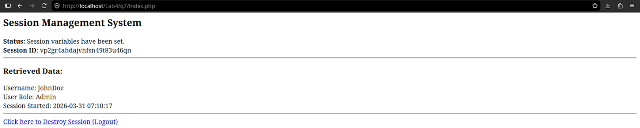
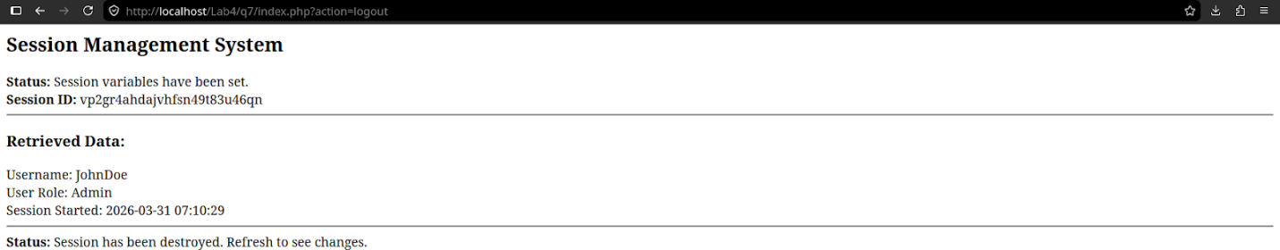

Question 8: Write a server-side script to store, retrieve and destroy cookies data.
Introduction
Cookies are small text files stored on the client's browser by the web server to track and identify users. Unlike sessions, which reside on the server, cookies are sent back to the server with every HTTP request, making them ideal for long-term data persistence like "Remember Me" features or language preferences. The lifecycle of a cookie involves setting a name and value with an optional expiration time, retrieving that value via a global array, and eventually deleting the cookie by setting its expiration date to a point in the past.
Functions and PHP Syntax
- setcookie(): A function used to send a cookie to the browser, requiring parameters for the name, value, and expiration time.
- $_COOKIE: A global associative array used to access the values of cookies sent by the browser in the current request.
- time(): A function that returns the current Unix timestamp, used as a baseline for calculating future expiration dates.
- Path: An optional parameter in setcookie() that defines the subset of URLs on the server where the cookie will be available.
- httponly: A security flag that, when set to true, prevents client-side scripts from accessing the cookie, reducing the risk of cross-site scripting attacks.
Code
<?php
$cookie_name = "user_preference";
$cookie_value = "Dark Mode";
setcookie($cookie_name, $cookie_value, time() + (86400 * 30), "/");
echo "<h2>Cookie Management System</h2>";
if (isset($_COOKIE[$cookie_name])) {
echo "<b>Status:</b> Cookie is set.<br>";
echo "<b>Cookie Name:</b> " . $cookie_name . "<br>";
echo "<b>Stored Value:</b> " . $_COOKIE[$cookie_name] . "<br><hr>";
} else {
echo "<b>Status:</b> Cookie is not found. (Note: Cookies require a page refresh to appear).<br><hr>";
}
if (isset($_GET['action']) && $_GET['action'] == 'delete') {
setcookie($cookie_name, "", time() - 3600, "/");
header("Location: cookie_test.php");
exit();
} else {
echo '<a href="?action=delete">Click here to Delete Cookie</a>';
}?>
Output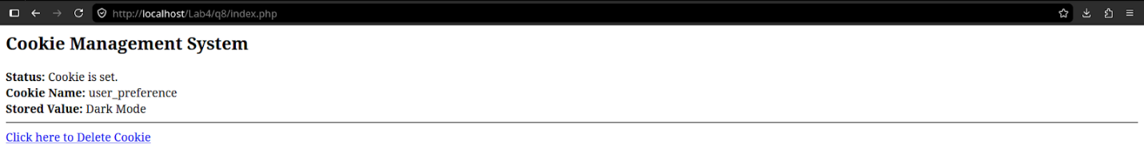
Question 9: Write a server-side script for complete authentication process (Register, Login, Access of Dashboard, Session and Cookie Storage and Logout).
Introduction
A complete authentication system integrates multiple server-side technologies to manage the full lifecycle of a user's interaction with a web application. The process begins with registration, where user data is collected and persisted in a database. The login phase then verifies these credentials against the stored records. To maintain a persistent state as the user moves from the login page to a restricted dashboard, the system utilizes sessions to store identity data on the server and cookies to identify the user's browser. Finally, the logout process ensures security by clearing all session variables and destroying the server-side record, effectively terminating the authorized access.
Functions and PHP Syntax
- mysqli_connect(): A function used to establish a connection between the PHP script and the MySQL database.
- $_POST: A superglobal array used to collect data submitted via an HTML form using the POST method.
- session_start(): A function that must be called to initialize session functionality, allowing for the storage of user data across pages.
- $_SESSION: An associative array used to store variables that remain active for the duration of the user's visit.
- setcookie(): A function used to store small pieces of data on the user's browser, often used for "Remember Me" functionality.
- header("Location: ..."): A PHP command used to redirect the browser to a different URL, such as moving from a login page to a dashboard.
- mysqli_num_rows(): A function used to verify if a specific record (like an email/password combination) exists in the database.
- session_destroy(): A function that removes all session data from the server to securely log a user out.
Code [db.php]
<?php
$conn = mysqli_connect("localhost", "root", "", "project");
if (!$conn) {
die("Connection failed: " . mysqli_connect_error());
}
?>
[login.php]
<?php
include('db.php');
session_start();
if (isset($_POST['login'])) {
$email = $_POST['email'];
$pass = $_POST['password'];

$sql = "SELECT * FROM registrations WHERE email='$email' AND password='$pass'";
$result = mysqli_query($conn, $sql);

if (mysqli_num_rows($result) == 1) {
$user = mysqli_fetch_assoc($result);
$_SESSION['user'] = $user['name'];
setcookie("last_login", date("Y-m-d H:i:s"), time() + 3600, "/");
header("Location: dashboard.php");
} else {
echo "Invalid Credentials";
}
}
?>
<form method="post">
<input type="email" name="email" placeholder="Email" required><br>
<input type="password" name="password" placeholder="Password" required><br>
<button type="submit" name="login">Login</button>
</form>
[register.php]
<?php
include('db.php');
if (isset($_POST['register'])) {
$name = $_POST['name'];
$email = $_POST['email'];
$pass = $_POST['password'];

$sql = "INSERT INTO registrations (name, email, password) VALUES ('$name', '$email', '$pass')";
if (mysqli_query($conn, $sql)) {
header("Location: login.php");
}
}
?>
<form method="post">
<input type="text" name="name" placeholder="Name" required><br>
<input type="email" name="email" placeholder="Email" required><br>
<input type="password" name="password" placeholder="Password" required><br>
<button type="submit" name="register">Register</button>
</form>
[dashboard.php]
<?php
session_start();
if (!isset($_SESSION['user'])) {
header("Location: login.php");
exit();
}
?>
<h1>Welcome to Dashboard, <?php echo $_SESSION['user']; ?></h1>
<p>Last login cookie set at: <?php echo $_COOKIE['last_login'] ?? 'Not set'; ?></p>
<a href="logout.php">Logout</a>

[logout.php]
<?php
session_start();
session_unset();
session_destroy();
header("Location: login.php");
exit();
?>

Output
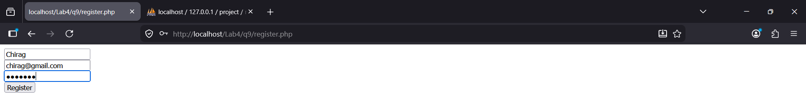
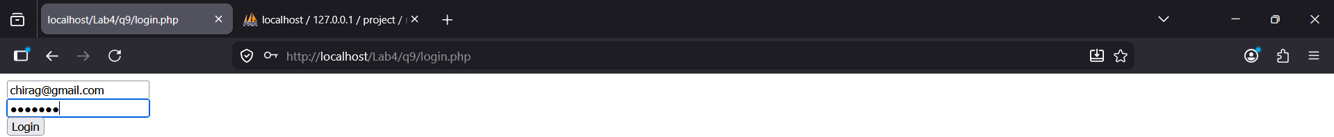
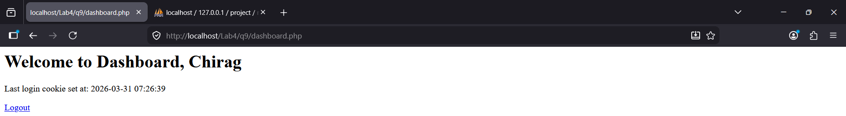

Question 10: Write a server-side script to store books data with following columns (id,title,publisher,author,edition,no_of_page,price,publish_date,isbn) .
Introduction
A digital repository for library or bookstore management requires a structured database to store detailed bibliographic information. This server-side script handles the collection of specific book attributes, ranging from unique identifiers like the ISBN to physical characteristics such as the page count and edition. By utilizing a standardized form and a backend processing script, the application ensures that each entry is validated and mapped to the correct data types before being permanently recorded in the database. This organization facilitates efficient searching, sorting, and inventory tracking within a larger information system.
Functions and PHP Syntax
- mysqli_real_escape_string(): A function used to escape special characters in a string for use in an SQL statement, providing a layer of protection against accidental query errors or syntax breaks.
- input type="date": A specialized form element that provides a calendar-style interface for selecting the publication date in a standard format.
- VARCHAR: A database data type used to store variable-length strings, such as book titles, authors, and publisher names.
- INT: A data type used for numerical fields that do not require decimals, such as the number of pages or the unique record ID.
- DECIMAL: A precise numeric data type used for financial values like price, ensuring that the currency amounts are stored without rounding errors.
- PRIMARY KEY: A database constraint that ensures each book has a unique identification number, preventing duplicate records.
- AUTO_INCREMENT: A property applied to the ID column that automatically generates a new, sequential number for every new book added to the table
Code [db.sql]
CREATE DATABASE library;
USE library;
CREATE TABLE books (
id INT AUTO_INCREMENT PRIMARY KEY,
title VARCHAR(255),
publisher VARCHAR(255),
author VARCHAR(100),
edition VARCHAR(50),
no_of_page INT,
price DECIMAL(10, 2),
publish_date DATE,
isbn VARCHAR(20)
);
[add_book.php]
<!DOCTYPE html>
<html>
<head>
<title>Add New Book</title>
<style>
body { font-family: Arial, sans-serif; padding: 20px; background-color: #f0f0f0; }
.form-container { background: white; padding: 20px; width: 450px; margin: auto; border: 1px solid #ccc; }
.field { margin-bottom: 10px; }
label { display: inline-block; width: 120px; font-weight: bold; }
input { padding: 5px; width: 280px; }
.btn { width: 100%; padding: 10px; background: #333; color: white; border: none; cursor: pointer; margin-top: 10px; }
</style>
</head>
<body>
<div class="form-container">
<h2>Book Information Entry</h2>
<?php
if (isset($_POST['save_book'])) {
$conn = mysqli_connect("localhost", "root", "", "library");

if (!$conn) {
die("Connection failed: " . mysqli_connect_error());
}
$title = $_POST['title'];
$publisher = $_POST['publisher'];
$author = $_POST['author'];
$edition = $_POST['edition'];
$pages = $_POST['no_of_page'];
$price = $_POST['price'];
$p_date = $_POST['publish_date'];
$isbn = $_POST['isbn'];
$sql = "INSERT INTO books (title, publisher, author, edition, no_of_page, price, publish_date, isbn)
VALUES ('$title', '$publisher', '$author', '$edition', '$pages', '$price', '$p_date', '$isbn')";
if (mysqli_query($conn, $sql)) {
echo "<p style='color:green;'>Book added successfully!</p>";
} else {
echo "<p style='color:red;'>Error: " . mysqli_error($conn) . "</p>";
}
mysqli_close($conn);
}
?>
<form method="post" action="">
<div class="field">
<label>Title:</label>
<input type="text" name="title" required>
</div>
<div class="field">
<label>Publisher:</label>
<input type="text" name="publisher" required>
</div>
<div class="field">
<label>Author:</label>
<input type="text" name="author" required>
</div>
<div class="field">
<label>Edition:</label>
<input type="text" name="edition">
</div>
<div class="field">
<label>No. of Pages:</label>
<input type="number" name="no_of_page">
</div>
<div class="field">
<label>Price:</label>
<input type="text" name="price">
</div>
<div class="field">
<label>Publish Date:</label>
<input type="date" name="publish_date">
</div>
<div class="field">
<label>ISBN:</label>
<input type="text" name="isbn">
</div>
<button type="submit" name="save_book" class="btn">Save Book Data</button>
</form>
</div>
</body>
</html>
Output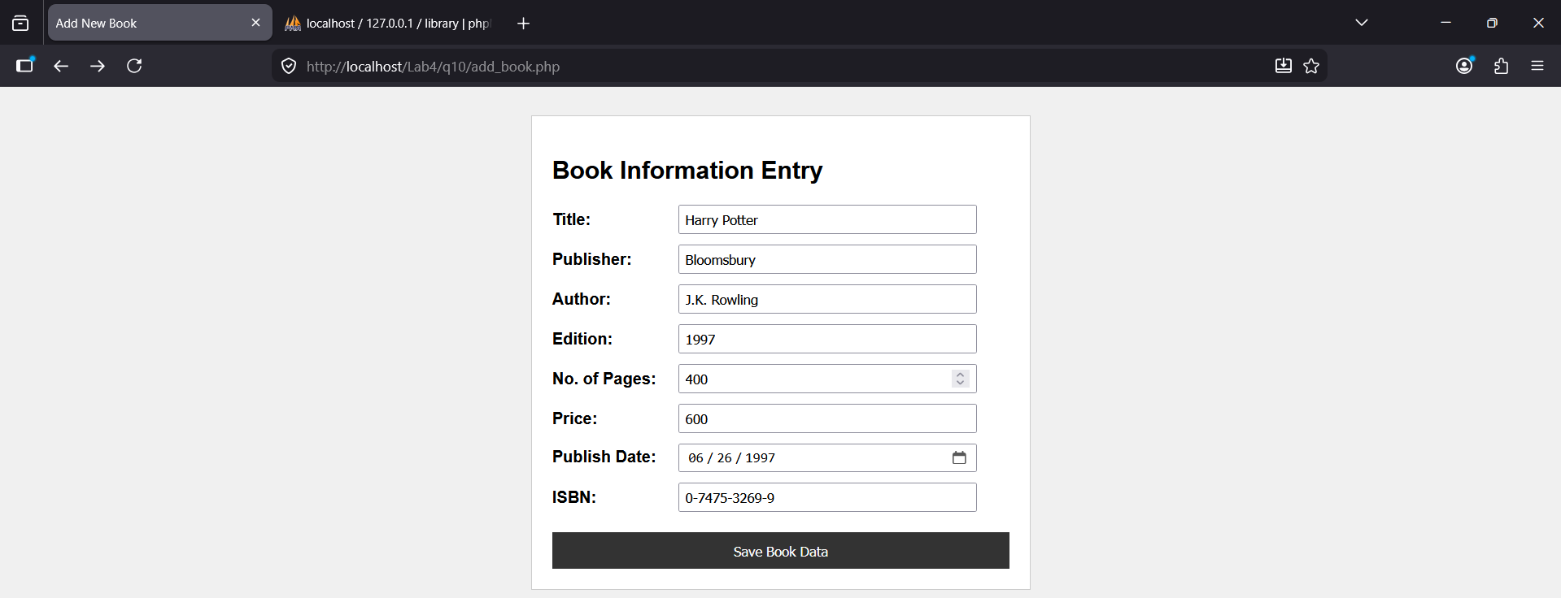
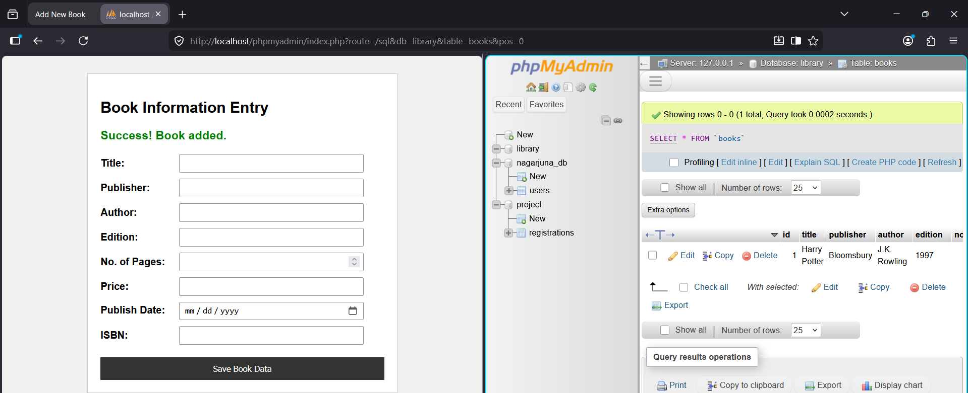
Question 11: Write a server-side script to retrieve books data stored form above question no 10.
Introduction
Data retrieval is the process of extracting stored information from a database to present it in a human-readable format on a web page. This involves establishing a connection to the database server, executing a selection query, and using a loop to iterate through the resulting data set. By organizing this data into a dynamic HTML table, the system allows users to view, compare, and manage the inventory of books efficiently. This bridge between the backend storage and the frontend display is a core component of any content management system.
Functions and PHP Syntax
- SELECT * FROM: An SQL command used to retrieve all columns and records from a specified table.
- mysqli_query(): A function that sends an SQL query to the currently active database associated with the link identifier.
- mysqli_fetch_assoc(): A function that fetches a result row as an associative array, where the keys match the column names of the table.
- while loop: A control structure used to repeat a block of code as long as the database continues to return new rows of data.
- border: An HTML attribute used with the table tag to define the thickness of the lines surrounding the cells and table.
- cellpadding: An attribute that specifies the space between the cell wall and the cell content for better readability.
- htmlspecialchars(): A function used to convert special characters to HTML entities, preventing data from being misinterpreted as code by the browser.
Code
<!DOCTYPE html>
<html>
<head>
<title>View Stored Books</title>
<style>
body { font-family: Arial, sans-serif; padding: 20px; }
table { width: 100%; border-collapse: collapse; margin-top: 20px; }
th, td { border: 1px solid #333; padding: 10px; text-align: left; }
th { background-color: #f2f2f2; }
tr:nth-child(even) { background-color: #fafafa; }
.no-data { text-align: center; padding: 20px; color: #888; }
</style>
</head>
<body>
<h2>Registered Books Inventory</h2>
<?php
$conn = mysqli_connect("localhost", "root", "", "library");
if (!$conn) {
die("Connection failed: " . mysqli_connect_error());
}
$sql = "SELECT id, title, publisher, author, edition, no_of_page, price, publish_date, isbn FROM books";
$result = mysqli_query($conn, $sql);
if (mysqli_num_rows($result) > 0) {
echo "<table>";
echo "<tr>
<th>ID</th>
<th>Title</th>
<th>Publisher</th>
<th>Author</th>
<th>Edition</th>
<th>Pages</th>
<th>Price</th>
<th>Date</th>
<th>ISBN</th>
</tr>";
while ($row = mysqli_fetch_assoc($result)) {
echo "<tr>";
echo "<td>" . $row['id'] . "</td>";
echo "<td>" . $row['title'] . "</td>";
echo "<td>" . $row['publisher'] . "</td>";
echo "<td>" . $row['author'] . "</td>";
echo "<td>" . $row['edition'] . "</td>";
echo "<td>" . $row['no_of_page'] . "</td>";
echo "<td>" . $row['price'] . "</td>";
echo "<td>" . $row['publish_date'] . "</td>";
echo "<td>" . $row['isbn'] . "</td>";
echo "<td><a href='../q13/delete_book.php?id=" . $row['id'] . "' onclick='return confirm(\"Are you sure?\")'>Delete</a></td>";
echo "</tr>";
}
echo "</table>";
} else {
echo "<p class='no-data'>No books found in the database.</p>";
}
mysqli_close($conn);
?>
<?php
if (isset($_GET['msg']) && $_GET['msg'] == 'deleted') {
echo "<p style='color:red; font-weight:bold;'>Entry successfully removed from library.</p>";
}?>
</body>
</html>

Output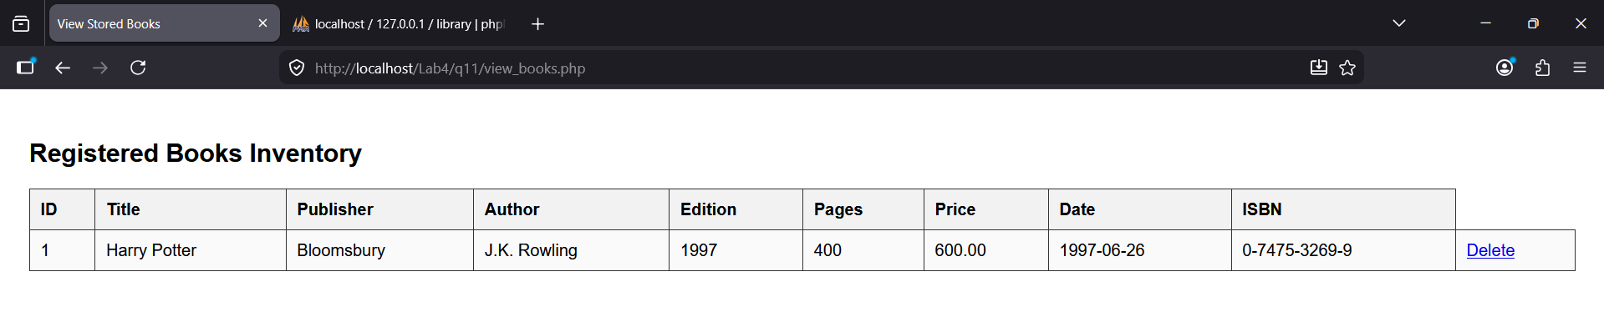

Question 12: Write a server-side script to modify books data stored form above question no 11.
Introduction
Data modification, or updating, allows users to change existing information in a database without deleting and recreating the record. This process typically involves two steps: first, retrieving the current data of a specific record based on its unique ID to populate an editable form; and second, executing an SQL UPDATE statement to save the new values. This ensures that the system can adapt to changes, such as price adjustments or corrections to typographical errors, while maintaining the integrity of the original record's ID.
Functions and PHP Syntax
- UPDATE ... SET: The SQL command used to modify existing records in a table by specifying the columns to be changed and their new values.
- WHERE id=: A critical clause that ensures only the specific record intended for modification is updated, preventing accidental changes to every row in the database.
- $_GET['id']: A method of retrieving the unique identifier from the URL, allowing the script to know which specific book to load for editing.
- value: An HTML attribute used within input tags to pre-fill form fields with current data from the database, providing a starting point for the user.
- mysqli_affected_rows(): A function that returns the number of rows changed by the last query, used to confirm if the update was processed by the server.
- type="hidden": An input type used to store the record's ID within the form without displaying it to the user, ensuring the ID is sent back during the submission.
- mysqli_real_escape_string(): A security function used to sanitize user input by escaping special characters, preventing SQL syntax errors like those caused by apostrophes.
Code
<!DOCTYPE html>
<html>
<head>
<title>Edit Book Data</title>
<style>
body { font-family: Arial, sans-serif; padding: 20px; }
.form-container { width: 400px; margin: auto; padding: 20px; border: 1px solid #ccc; }
.field { margin-bottom: 10px; }
label { display: block; font-weight: bold; }
input { width: 100%; padding: 5px; box-sizing: border-box; }
.btn { background: #28a745; color: white; padding: 10px; border: none; width: 100%; cursor: pointer; }
</style>
</head>
<body>

<div class="form-container">
<h2>Update Book Details</h2>

<?php
$conn = mysqli_connect("localhost", "root", "", "library");

if (isset($_GET['id'])) {
$id = (int)$_GET['id'];
$res = mysqli_query($conn, "SELECT * FROM books WHERE id=$id");
$data = mysqli_fetch_assoc($res);
}

if (isset($_POST['update_book'])) {
$id = (int)$_POST['id'];
$title = mysqli_real_escape_string($conn, $_POST['title']);
$publisher = mysqli_real_escape_string($conn, $_POST['publisher']);
$author = mysqli_real_escape_string($conn, $_POST['author']);
$price = (float)$_POST['price'];

$sql = "UPDATE books SET
title='$title',
publisher='$publisher',
author='$author',
price=$price
WHERE id=$id";

if (mysqli_query($conn, $sql)) {
echo "<p style='color:green;'>Record updated successfully!</p>";
echo "<a href='view_books.php'>Back to Inventory</a>";
} else {
echo "Error: " . mysqli_error($conn);
}
}
?>

<form method="post" action="">
<input type="hidden" name="id" value="<?php echo $data['id']; ?>">

<div class="field">
<label>Title</label>
<input type="text" name="title" value="<?php echo htmlspecialchars($data['title']); ?>">
</div>
<div class="field">
<label>Publisher</label>
<input type="text" name="publisher" value="<?php echo htmlspecialchars($data['publisher']); ?>">
</div>
<div class="field">
<label>Author</label>
<input type="text" name="author" value="<?php echo htmlspecialchars($data['author']); ?>">
</div>
<div class="field">
<label>Price</label>
<input type="text" name="price" value="<?php echo $data['price']; ?>">
</div>

<button type="submit" name="update_book" class="btn">Update Record</button>
</form>
</div>
</body>
</html>

Output
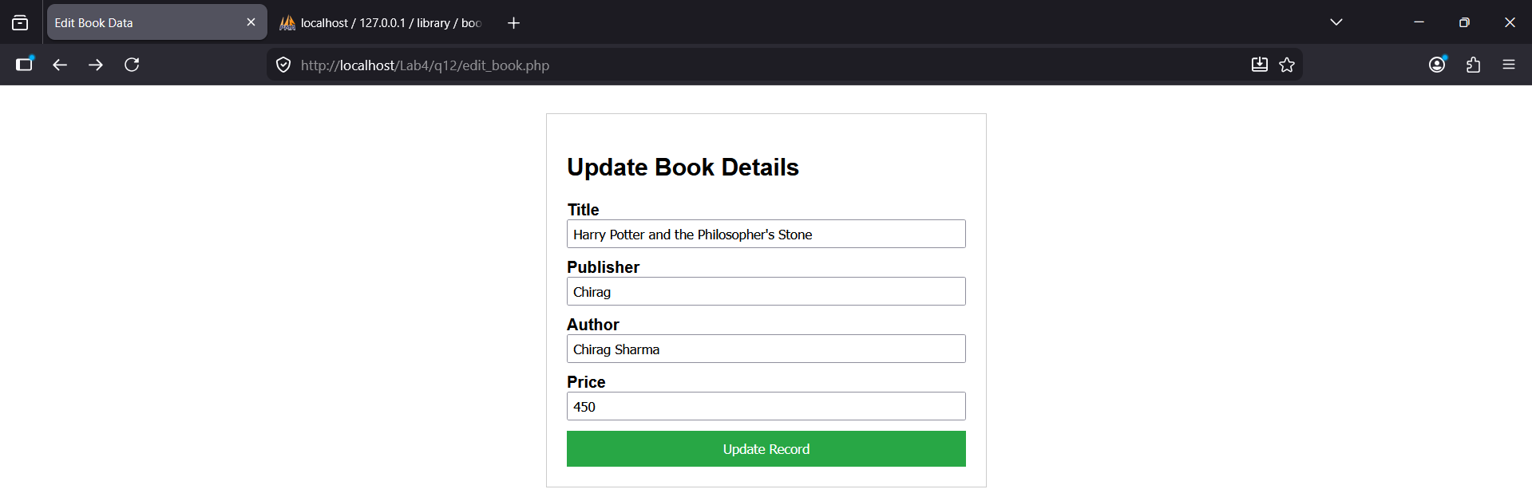
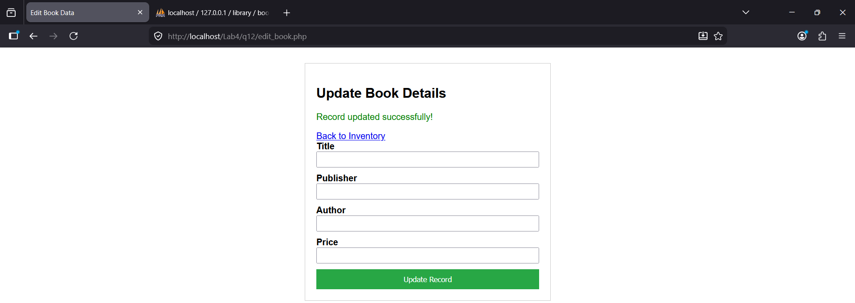

Question 13: Write a server-side script to remove books data stored form above question no 12.
Introduction
Data removal, or deletion, is the final phase of the CRUD (Create, Read, Update, Delete) cycle, allowing for the permanent extraction of records from a database. In a web application, this is typically triggered by a specific identifier, such as an ID, to ensure that only the intended record is removed. For security and usability, deletion scripts often include a confirmation step or a redirection back to the main inventory list to provide immediate feedback to the administrator that the operation was successful.
Functions and PHP Syntax
- DELETE FROM: The SQL command used to remove one or more existing records from a specific table within the database.
- WHERE id=: A vital clause used to filter the deletion process, ensuring the command only targets the exact record matching the provided ID.
- $_GET['id']: A method used to capture the unique record identifier from the URL, enabling the script to identify which book should be deleted.
- mysqli_query(): The function responsible for executing the deletion statement against the connected MySQL database.
- header("Location: ..."): A PHP function used to automatically redirect the user back to the inventory list after the deletion is completed.
- confirm(): A JavaScript function often used on the client-side to prompt the user for confirmation before the deletion script is executed.
Code
<?php
$conn = mysqli_connect("localhost", "root", "", "library");

if (!$conn) {
die("Connection failed: " . mysqli_connect_error());
}

if (isset($_GET['id'])) {
$id = (int)$_GET['id'];

$sql = "DELETE FROM books WHERE id = $id";

if (mysqli_query($conn, $sql)) {
header("Location: view_books.php?msg=deleted");
exit();
} else {
echo "Error deleting record: " . mysqli_error($conn);
}
}

mysqli_close($conn);
?>

Output
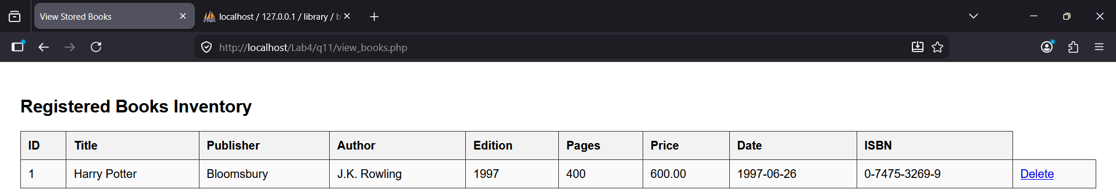
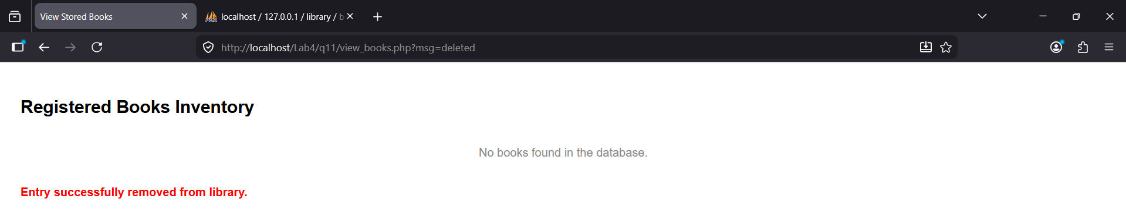

Question 14: Write a server-side script to store, retrieve and destroy sessions.
Introduction
Sessions are a server-side storage mechanism used to persist user data across multiple page requests during a single visit. Unlike cookies, which are stored on the user's browser and can be easily modified, session data is stored on the web server, making it more secure for sensitive information like login credentials or shopping cart contents. A session begins when the server generates a unique Session ID, which is typically stored in a temporary cookie on the client side to link the browser to the specific data file on the server.
Functions and PHP Syntax
- session_start(): This function must be executed at the very beginning of the script, before any HTML or white space, to initialize a new session or resume an existing one.
- $_SESSION['key'] = value: This is the syntax used to create a session variable. Since $_SESSION is a superglobal associative array, data is stored using a unique key string.
- echo $_SESSION['key']: This is the format used to retrieve and display data stored in the session from any page on the same server.
- isset($_SESSION['key']): This is a logical check used to verify if a session variable exists before accessing it, which prevents runtime errors.
- session_id(): A function that returns the unique alphanumeric string identifying the current session for the specific user.
- session_unset(): This function removes all global variables currently registered in the session, effectively clearing the data while keeping the session "container" alive.
- session_destroy(): This is the command used to completely terminate the session on the server-side, typically used during a logout process.
Code
<?php
session_start();

echo "<h2>Session Management System</h2>";

if (!isset($_SESSION['view_count'])) {
$_SESSION['view_count'] = 1;
$_SESSION['user_role'] = "Administrator";
echo "<b>Status:</b> Session initialized. Welcome!<br>";
} else {
$_SESSION['view_count']++;
echo "<b>Status:</b> Session active.<br>";
}

echo "<b>Session ID:</b> " . session_id() . "<br>";
echo "<b>User Role:</b> " . $_SESSION['user_role'] . "<br>";
echo "<b>Page Views in this session:</b> " . $_SESSION['view_count'] . "<br><hr>";

if (isset($_GET['action']) && $_GET['action'] == 'logout') {
session_unset();
session_destroy();
header("Location: index.php");
exit();
} else {
echo '<a href="?action=logout">Click here to Destroy Session (Logout)</a>';
}
?>

Output
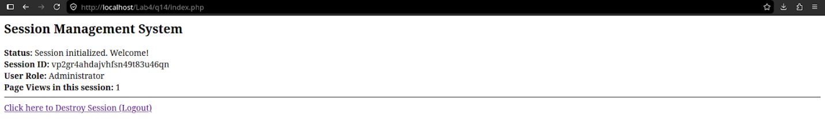
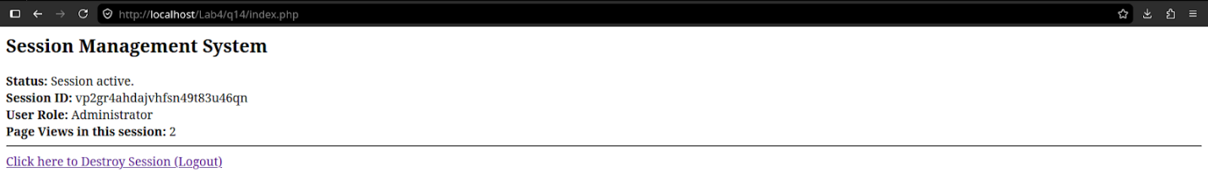

Question 15: Write a server-side script to store retrieve and destroy cookie.
Introduction
Cookies are small text files stored on the client's computer by the web browser at the request of the server. Unlike sessions, which store data on the server, cookies are used to store information locally to remember user preferences, track login states, or provide personalized content over a longer duration. Since cookies are sent back to the server with every HTTP request, they are ideal for maintaining state in a stateless protocol, though they should not be used to store sensitive information like passwords.
Functions and PHP Syntax
- setcookie(name, value, expire, path): This is the primary function used to create a cookie. It must be called before any HTML output. The name and value are strings, while expire is a Unix timestamp (usually calculated as time() + seconds).
- $_COOKIE['name']: This is the superglobal associative array used to retrieve the value of a cookie that was previously set and sent by the browser.
- time(): A function that returns the current time in seconds, used as a baseline to calculate when a cookie should expire (e.g., time() + 3600 for one hour).
- isset($_COOKIE['name']): A logical check used to verify if a cookie exists on the user's machine before attempting to read its value.
- setcookie(name, "", time() - 3600): The standard format used to destroy a cookie. By setting the expiration date to a time in the past, the browser is instructed to delete the file immediately.
- expire parameter: A numeric value defining the life of the cookie. If set to 0 or omitted, the cookie will expire at the end of the session when the browser is closed.
- path parameter: A string that defines the server path on which the cookie will be available. Using "/" makes the cookie available across the entire domain.
Code
<?php
if (!isset($_COOKIE['user_pref'])) {
setcookie("user_pref", "Dark_Mode", time() + 3600, "/");
$status = "Cookie has been set!";
} else {
$status = "Cookie is already active.";
}

if (isset($_GET['delete']) && $_GET['delete'] == '1') {
setcookie("user_pref", "", time() - 3600, "/");
header("Location: cookie_test.php");
exit();
}
?>

<!DOCTYPE html>
<html>
<head>
<title>Cookie Management</title>
</head>
<body>

<h2>PHP Cookie Handler</h2>
<p><strong>Status:</strong> <?php echo $status; ?></p>

<hr>

<h3>Retrieve Data:</h3>
<?php
if (isset($_COOKIE['user_pref'])) {
echo "The stored preference is: " . $_COOKIE['user_pref'];
echo "<br><br><a href='?delete=1'>Click here to Destroy Cookie</a>";
} else {
echo "No cookie found. Refresh the page to see the newly set cookie.";
}
?>

</body>
</html>

Output
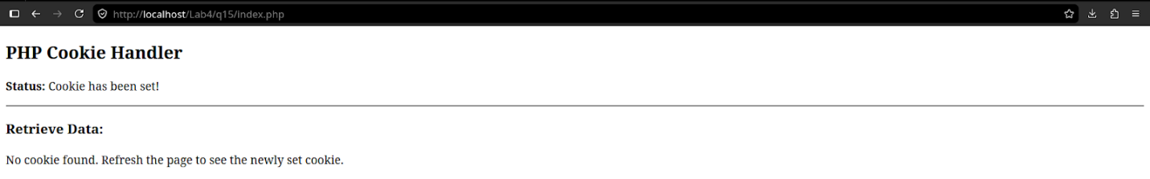
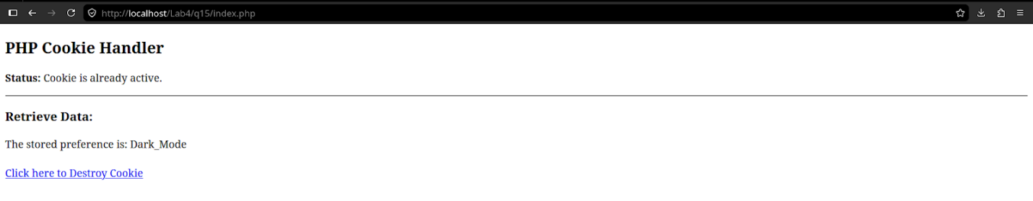

Question 16: Write a server-side script to perform user register operation using form with photo file.
Introduction
User registration with a profile photo involves handling both standard text data and binary file data in a single request. This process requires the HTML form to use a specific encoding type to package the file for the server. On the server-side, the script must perform two distinct actions: moving the uploaded image from a temporary directory to a permanent folder on the server, and storing the file's path, rather than the file itself, into the database alongside the user's textual information. This ensures the database remains lightweight while keeping the media accessible for display.
Functions and PHP Syntax
- enctype="multipart/form-data": An essential attribute for the HTML form tag that allows the browser to split the form data into multiple parts, enabling the transmission of file buffers.
- $_FILES['field_name']: A superglobal associative array specifically used to access uploaded items. it contains details like the file's name, temporary location, size, and error status.
- move_uploaded_file(tmp_name, destination): The standard PHP function used to securely transfer an uploaded file from its temporary server location to a designated permanent folder.
- pathinfo(): A function used to extract information about a file path, such as the extension (jpg, png), which is vital for validating that the user is only uploading images.
- uniqid(): A function used to generate a unique string, often prefixed to filenames to prevent different users' photos from overwriting each other if they have the same name.
- mkdir(): A command used to create a new directory on the server (like "uploads/") if it does not already exist, ensuring the storage path is valid.
- $_FILES['photo']['error']: A numeric value used to check if the upload was successful (0 indicates no error) or if it failed due to file size or server limits.
Code
<!DOCTYPE html>
<html>
<head>
<title>User Registration with Photo</title>
<style>
body { font-family: Arial, sans-serif; background: #f4f4f4; padding: 20px; }
.reg-box { background: white; padding: 20px; width: 400px; margin: auto; border: 1px solid #ddd; }
.field { margin-bottom: 15px; }
label { display: block; margin-bottom: 5px; font-weight: bold; }
input[type="text"], input[type="file"] { width: 100%; padding: 8px; box-sizing: border-box; }
.btn { background: #007bff; color: white; border: none; padding: 10px; width: 100%; cursor: pointer; }
</style>
</head>
<body>

<div class="reg-box">
<h2>Create Account</h2>

<?php
if (isset($_POST['register'])) {
$conn = mysqli_connect("localhost", "root", "", "library");

$username = mysqli_real_escape_string($conn, $_POST['username']);

$target_dir = "uploads/";
if (!is_dir($target_dir)) { mkdir($target_dir); }

$file_name = time() . "_" . basename($_FILES["photo"]["name"]);
$target_file = $target_dir . $file_name;

if (move_uploaded_file($_FILES["photo"]["tmp_name"], $target_file)) { $sql = "INSERT INTO users (username, photo_path) VALUES ('$username', '$target_file')";

if (mysqli_query($conn, $sql)) {
echo "<p style='color:green;'>Registration Successful!</p>";
echo "<img src='$target_file' width='100' height='100' style='border-radius:50%;'><br>";
}
} else {
echo "<p style='color:red;'>Error uploading photo.</p>";
}
mysqli_close($conn);
}
?>

<form method="post" enctype="multipart/form-data" action="">
<div class="field">
<label>Username:</label>
<input type="text" name="username" required>
</div>
<div class="field">
<label>Profile Photo:</label>
<input type="file" name="photo" accept="image/*" required>
</div>
<button type="submit" name="register" class="btn">Register Now</button>
</form>
</div>
</body>
</html>
Output
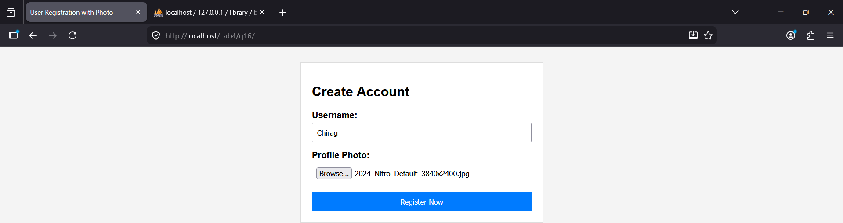
Question 17: Write a server-side script to perform login operation using form.
Introduction
A login operation is a security process that verifies the identity of a user by comparing their provided credentials against records stored in a database. When a user submits a login form, the server-side script retrieves the matching record and, if the credentials are valid, initializes a session to remember the user as they navigate different pages. This process acts as a gatekeeper, protecting restricted areas of an application and ensuring that personalized data is only accessible to the correct individual.
Functions and PHP Syntax
- mysqli_num_rows(): A function used to count how many records match the login query. If it returns 1, it confirms that a user with that specific username and password exists.
- $_POST['password']: The standard method for receiving sensitive data from a form. In a production environment, this should be used with password hashing functions like password_verify().
- session_start(): This must be called at the beginning of the login script so that once the user is verified, their status can be saved into the session.
- $_SESSION['user_id'] = $row['id']: The syntax used to log in the user by storing their unique database ID into a session variable for use on other pages.
- header("Location: dashboard.php"): A redirection command used to send the user to a members only area or dashboard immediately after a successful login.
- exit(): A command used after a header redirect to ensure no further code is executed by the server, preventing unauthorized access to the rest of the script.
- die() or error messages: Used to provide feedback to the user if the credentials do not match, usually displayed as a "Invalid Username or Password" alert.
Code
<!DOCTYPE html>
<html>
<head>
<title>User Login</title>
<style>
body { font-family: Arial, sans-serif; background: #f4f4f4; display: flex; justify-content: center; align-items: center; height: 100vh; margin: 0; }
.login-card { background: white; padding: 30px; border-radius: 8px; box-shadow: 0 4px 10px rgba(0,0,0,0.1); width: 350px; }
.field { margin-bottom: 15px; }
label { display: block; margin-bottom: 5px; font-weight: bold; }
input { width: 100%; padding: 10px; border: 1px solid #ccc; border-radius: 4px; box-sizing: border-box; }
.btn { background: #28a745; color: white; border: none; padding: 12px; width: 100%; border-radius: 4px; cursor: pointer; font-size: 16px; }
.error { color: red; margin-bottom: 15px; font-size: 14px; }
</style>
</head>
<body>
<div class="login-card">
<h2>Login</h2>
<?php
session_start();

if (isset($_POST['login'])) {
$conn = mysqli_connect("localhost", "root", "", "registrations");
$user = mysqli_real_escape_string($conn, $_POST['username']);
$pass = mysqli_real_escape_string($conn, $_POST['password']);
$sql = "SELECT id, username FROM users WHERE username='$user' AND password='$pass'";
$result = mysqli_query($conn, $sql);
if (mysqli_num_rows($result) == 1) {
$row = mysqli_fetch_assoc($result);
$_SESSION['user_id'] = $row['id'];
$_SESSION['username'] = $row['username'];
header("Location: ../q9/dashboard.php");
exit();
} else {
echo "<p class='error'>Invalid username or password.</p>";
}
mysqli_close($conn);
}
?>
<form method="post" action="">
<div class="field">
<label>Username</label>
<input type="text" name="username" required>
</div>
<div class="field">
<label>Password</label>
<input type="password" name="password" required>
</div>
<button type="submit" name="login" class="btn">Sign In</button>
</form>
</div>
</body>
</html>

Output
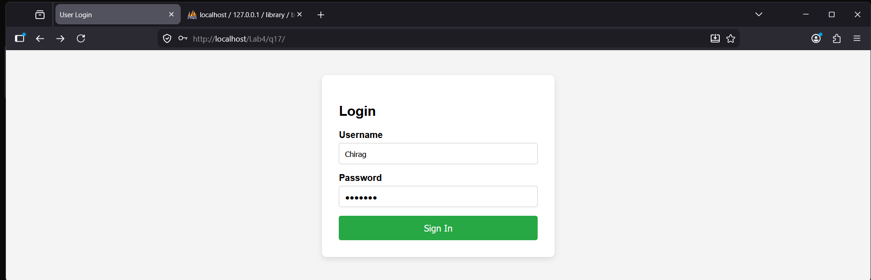

Question 18: Write a server-side script to perform CRUD operation.
Introduction
CRUD is an acronym that stands for Create, Read, Update, and Delete. These four functions represent the complete lifecycle of data management in any database-driven application. A Create operation adds new entries, Read retrieves and displays them, Update allows for modifications to existing records, and Delete removes data that is no longer relevant. By centralizing these operations, developers can build efficient systems to manage assets, such as a company's electronic inventory.
Functions and PHP Syntax
- INSERT INTO table_name: The SQL syntax used for the Create operation to inject new rows of data into the database.
- SELECT * FROM table_name: The SQL syntax used for the Read operation to fetch and display records from the database.
- UPDATE table_name SET: The SQL syntax used for the Update operation to modify existing values in specific columns based on a condition.
- DELETE FROM table_name: The SQL syntax used for the Delete operation to permanently remove a record from the table.
- WHERE id = $id: A mandatory clause for Update and Delete operations to ensure that only a specific record is targeted, preventing data loss across the entire table.
- mysqli_connect(): The function used to establish a link between the PHP script and the MySQL database server.
- $_GET and $_POST: Superglobal arrays used to collect data from the URL (for Read/Delete IDs) or from form submissions (for Create/Update data).
Code [database]
CREATE DATABASE IF NOT EXISTS shop_db;
USE shop_db;

CREATE TABLE products (
id INT AUTO_INCREMENT PRIMARY KEY,
p_name VARCHAR(100),
category VARCHAR(50),
price DECIMAL(10, 2)
);
[manage_products.php]
<?php
$conn = mysqli_connect("localhost", "root", "", "shop_db");

if (isset($_POST['add_product'])) {
$name = mysqli_real_escape_string($conn, $_POST['p_name']);
$cat = mysqli_real_escape_string($conn, $_POST['category']);
$price = (float)$_POST['price'];

mysqli_query($conn, "INSERT INTO products (p_name, category, price) VALUES ('$name', '$cat', $price)");
header("Location: manage_products.php");
}

if (isset($_GET['delete'])) {
$id = (int)$_GET['delete'];
mysqli_query($conn, "DELETE FROM products WHERE id=$id");
header("Location: manage_products.php");
}

$result = mysqli_query($conn, "SELECT * FROM products");
?>

<!DOCTYPE html>
<html>
<head>
<title>Product CRUD System</title>
<style>
body { font-family: Arial, sans-serif; padding: 20px; }
.form-box { background: #eee; padding: 15px; margin-bottom: 20px; border-radius: 5px; }
table { width: 100%; border-collapse: collapse; }
th, td { border: 1px solid #ccc; padding: 10px; text-align: left; }
th { background: #ddd; }
.del-btn { color: red; text-decoration: none; font-weight: bold; }
</style>
</head>
<body>

<div class="form-box">
<h3>Add New Product</h3>
<form method="post">
<input type="text" name="p_name" placeholder="Product Name" required>
<input type="text" name="category" placeholder="Category" required>
<input type="number" step="0.01" name="price" placeholder="Price" required>
<button type="submit" name="add_product">Save Product</button>
</form>
</div>

<h3>Inventory List</h3>
<table>
<tr>
<th>ID</th>
<th>Product Name</th>
<th>Category</th>
<th>Price</th>
<th>Actions</th>
</tr>
<?php while($row = mysqli_fetch_assoc($result)): ?>
<tr>
<td><?php echo $row['id']; ?></td>
<td><?php echo $row['p_name']; ?></td>
<td><?php echo $row['category']; ?></td>
<td>$<?php echo $row['price']; ?></td>
<td>
<a href="edit_product.php?id=<?php echo $row['id']; ?>">Edit</a> |
<a href="manage_products.php?delete=<?php echo $row['id']; ?>" class="del-btn" onclick="return confirm('Delete this product?')">Delete</a>
</td>
</tr>
<?php endwhile; ?>
</table>
</body>
</html>
[edit_product.php]
<!DOCTYPE html>
<html>
<head>
<title>Edit Product Details</title>
<style>
body { font-family: Arial, sans-serif; padding: 30px; background: #f4f4f4; }
.edit-container { background: white; padding: 20px; width: 400px; margin: auto; border-radius: 8px; box-shadow: 0 2px 10px rgba(0,0,0,0.1); }
.input-group { margin-bottom: 15px; }
label { display: block; font-weight: bold; margin-bottom: 5px; }
input { width: 100%; padding: 8px; box-sizing: border-box; }
.update-btn { background: #007bff; color: white; border: none; padding: 10px; width: 100%; cursor: pointer; border-radius: 4px; }
.back-link { display: block; text-align: center; margin-top: 15px; color: #666; text-decoration: none; }
</style>
</head>
<body>

<div class="edit-container">
<h2>Modify Product</h2>

<?php
$conn = mysqli_connect("localhost", "root", "", "shop_db");

if (isset($_GET['id'])) {
$id = (int)$_GET['id'];
$get_record = mysqli_query($conn, "SELECT * FROM products WHERE id=$id");
$data = mysqli_fetch_assoc($get_record);
}

if (isset($_POST['update_now'])) {
$id = (int)$_POST['product_id'];
$name = mysqli_real_escape_string($conn, $_POST['p_name']);
$cat = mysqli_real_escape_string($conn, $_POST['category']);
$price = (float)$_POST['price'];

$update_sql = "UPDATE products SET
p_name = '$name',
category = '$cat',
price = $price
WHERE id = $id";

if (mysqli_query($conn, $update_sql)) {
header("Location: manage_products.php");
exit();
} else {
echo "Update Failed: " . mysqli_error($conn);
}
}
?>

<form method="post" action="">
<input type="hidden" name="product_id" value="<?php echo $data['id']; ?>">

<div class="input-group">
<label>Product Name</label>
<input type="text" name="p_name" value="<?php echo htmlspecialchars($data['p_name']); ?>" required>
</div>

<div class="input-group">
<label>Category</label>
<input type="text" name="category" value="<?php echo htmlspecialchars($data['category']); ?>" required>
</div>

<div class="input-group">
<label>Price</label>
<input type="number" step="0.01" name="price" value="<?php echo $data['price']; ?>" required>
</div>

<button type="submit" name="update_now" class="update-btn">Save Changes</button>
<a href="manage_products.php" class="back-link">Cancel and Go Back</a>
</form>
</div>
</body>
</html>

Output
