Requirement Specification

Hipchat messaging for testing

Version | Change decription | Person | Date
1.0 | Initial version | Liu Shujun | 26.9.2017

Returned: _____________________
Checked: _____________________
Approved: _____________________

Table of Contents
1 Preword 3
2 General view 3
3 Functions 3
4 External interface 3
5 Other characteristics 4

Preword
Hipchat messaging for testing is made for software developer (test engineers) in ABB, and is a technology replacement artificial project. Our product will use this software instead of employees, which reduces investment funds. In addition, computer is just an automatic process. So, the more significant targets are efficient and low error rate.
Hipchat messaging for testing requirement specification has four chapters.
- There is a brief introduce to explain our major task in the work.
- Chapter has some further descriptions of how to run in system and use diagram to show specific function in each phase.
- Create a table to evaluate the priority of each function.
- Explain the whole process professionally. Supplement explanation of all other non-functional requirements

General view
TestRail provide an interface, getting the test result information, to connect the server and then analyse and transform this result into html which will be send to the Hipchhat.
Limitations to system
- The software need to be updated regularly.
- There will be some compatibility issues.
- Not flexible and intelligent
- The program is not absolutely safe.
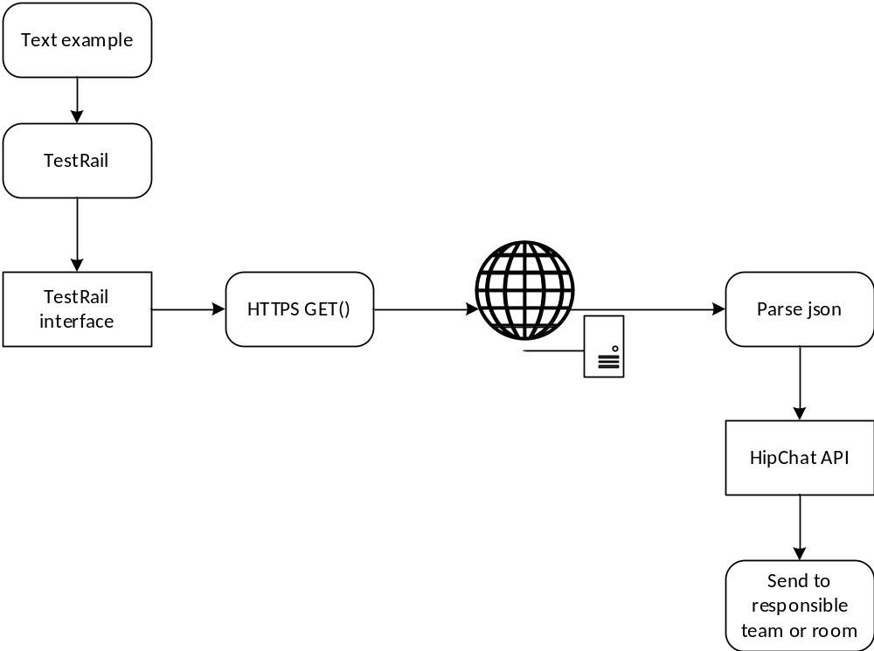diagram 1

Functions
Reference | Description | Priorize
F1 | Use http to read test results from TestRail | 1
F2 | Handle the message from TestRail with Hipchat | 1
F3 | Send message to the responsible room | 1
F4 | Change the time when messages are send | 3
F5 | Write a log file for send message status | 2
F6 | Update settings | 4

External interface
Reference | Description | Priorize
I1 | http Hipchat API | 1
I2 | Connect to TestRail | 1

Other characteristics
Characteristic | Describe | Priorize
Usability | System will complete the overall process automatically. Customers have authority to access system. | 1
Safety | General users cannot revise codes of system besides the managers. | 2
Response time |  | 2
Maintainability | The codes of system are easy to understand so that any software developer can update it. | 4
Portability | This system can be used by most of industries to manage their implement. | 3
Error detection and correction | Each iterative detects system errors and misunderstandings of requirement | 4

