DAA Lab
Practical 7
Amber Shukla
A1-B3-42

Aim: Construction of OBST
Task 1:
Code:
#include <bits/stdc++.h>
using namespace std;
typedef double db;

vector<db> keys, hit_prob, miss_prob;
int n;

db computeOBST()
{
vector<vector<db>> e(n + 1, vector<db>(n + 1, 0.0));
vector<vector<db>> w(n + 1, vector<db>(n + 1, 0.0));

for (int i = 0; i <= n; i++) // Fill Diagonals
{
e[i][i] = miss_prob[i];
w[i][i] = miss_prob[i];
}

for (int len = 1; len <= n; len++)
{
int j;
for (int i = 0; i + len <= n; i++)
{
j = i + len;
e[i][j] = INT_MAX;
w[i][j] = w[i][j - 1] + hit_prob[j - 1] + miss_prob[j];

for (int r = i; r < j; r++)
{
db cost = e[i][r] // Cost of left subtree [i, r) -> i to r-1
+ e[r + 1][j] // Cost of right subtree [r+1, j) -> r+1 to j-1
+ w[i][j]; // Total weight of current subtree

e[i][j] = min(e[i][j], cost);
}
}
}

return e[0][n];
}

int main()
{
cout << "Enter N: ";
cin >> n;

keys.resize(n);
hit_prob.resize(n);
miss_prob.resize(n + 1);

cout << "Enter Keys: ";
for (int i = 0; i < n; i++)
cin >> keys[i];

cout << "Enter P[] Array: ";
for (int i = 0; i < n; i++)
cin >> hit_prob[i];

cout << "Enter Q[] Array: ";
for (int i = 0; i <= n; i++)
cin >> miss_prob[i];

db minCost = computeOBST();

cout << setprecision(4) << minCost << '\n';

return 0;
}

Output:
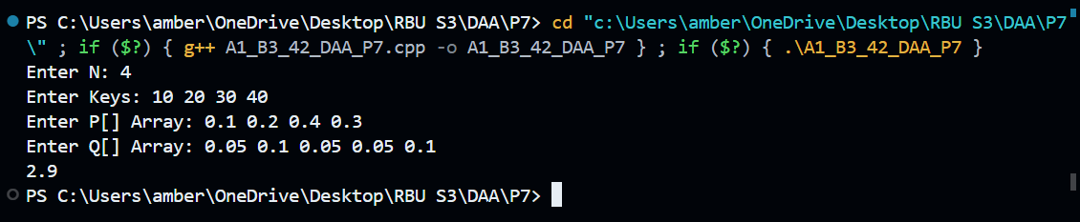

Task 2 (Online Submission):
Code:
#include <bits/stdc++.h>
using namespace std;

class Solution
{
public:
int optimalSearchTree(int keys[], int freq[], int n)
{
vector<vector<int>> dp(n, vector<int>(n, 0));
vector<int> prefix(n + 1, 0);

for (int i = 0; i < n; i++)
prefix[i + 1] = prefix[i] + freq[i];

for (int i = 0; i < n; i++)
dp[i][i] = freq[i];

for (int len = 2; len <= n; len++)
{
for (int i = 0; i + len - 1 < n; i++)
{
int j = i + len - 1;
int totalFreq = prefix[j + 1] - prefix[i];
int best = INT_MAX;

for (int r = i; r <= j; r++)
best = min(best, dp[i][r - 1] + dp[r + 1][j] + totalFreq);

dp[i][j] = best;
}
}
return dp[0][n - 1];
}
};
Output:
