A1-B3-42
Amber Shukla
DAA LAB

PRACTICAL NO. 3

Aim: Perform Fractional Knapsack for the given scenario

A. Load the truck using different methods: Minimum weight, Maximum profit,
Profit/weight ratio. Compute the total profit using each method and infer the best
performing method.
B. Compute the time required in each method.

Given Data:
• Capacity of truck 850 Kgs
• Weight in kg for each box:
[7, 0, 30, 22, 80, 94, 11, 81, 70, 64, 59, 18, 0, 36, 3, 8, 15, 42, 9, 0, 42, 47, 52, 32, 26, 48, 55,6, 29, 84, 2, 4, 18, 56, 7, 29, 93, 44, 71, 3, 86, 66, 31, 65, 0, 79, 20, 65, 52, 13]
• Profit in Rs for each box:
[ 360, 83, 59, 130, 431, 67, 230, 52, 93, 125, 670, 892, 600, 38, 48, 147, 78, 256, 63, 17, 120,164, 432, 35, 92, 110, 22, 42, 50, 323, 514, 28, 87, 73, 78, 15, 26, 78, 210, 36, 85, 189, 274,43, 33, 10, 19, 389, 276, 312 ]

Code:
#include <bits/stdc++.h>
#include <chrono>
using namespace std;
using namespace std::chrono;
#define pb push_back
#define pop pop_back

double trucksize = 850, n = 50;

// In Vector Box Dimention 1 is Weight || Dimention 2,0 is Profit || Dimention 2,1 is Profit/Weight

double max_profit(vector<vector<double>> box)
{
double profit = 0, current_weight = 0;

sort(box.begin(), box.end(), [](const vector<double> &a, const vector<double> &b)
{ return a[1] > b[1]; });

int i = 0;

while (current_weight < trucksize && i < n)
{
if (current_weight + box[i][0] >= trucksize)
{
double remaining_space = trucksize - current_weight;
if (box[i][0] > 0)
{ // Avoid division by zero
profit += (box[i][1] * (remaining_space / box[i][0]));
}
current_weight = trucksize;
break;
}

current_weight += box[i][0];
profit += box[i][1];
i++;
}

return profit;
}

double min_weight(vector<vector<double>> box)
{
double profit = 0, current_weight = 0;

sort(box.begin(), box.end(), [](const vector<double> &a, const vector<double> &b)
{ return a[0] < b[0]; });

int i = 0;

while (current_weight < trucksize && i < n)
{
if (current_weight + box[i][0] >= trucksize)
{
double remaining_space = trucksize - current_weight;
if (box[i][0] > 0)
{ // Avoid division by zero
profit += (box[i][1] * (remaining_space / box[i][0]));
}
current_weight = trucksize;
break;
}

current_weight += box[i][0];
profit += box[i][1];
i++;
}

return profit;
}

double pw_ratio(vector<vector<double>> box)
{
double profit = 0, current_weight = 0;

sort(box.begin(), box.end(), [](const vector<double> &a, const vector<double> &b)
{ return a[2] > b[2]; });

int i = 0;

while (current_weight < trucksize && i < n)
{
if (current_weight + box[i][0] >= trucksize)
{
double remaining_space = trucksize - current_weight;
if (box[i][0] > 0)
{ // Avoid division by zero
profit += (box[i][1] * (remaining_space / box[i][0]));
}
current_weight = trucksize;
break;
}

current_weight += box[i][0];
profit += box[i][1];
i++;
}

return profit;
}

int main()
{

vector<vector<double>> box(n, vector<double>(3, 0));

cout << "Enter Weight of all Boxes" << endl;

for (int i = 0; i < n; i++)
cin >> box[i][0];

cout << "Enter Profit Values of all Boxes" << endl;

for (int i = 0; i < n; i++)
{
cin >> box[i][1];
(box[i][0] != 0) ? (box[i][2] = (box[i][1] / box[i][0])) : (box[i][2] = 9999); // Profit/Weight Calculation
}

auto start_time = high_resolution_clock::now();
cout << "\n\nProfit By Maximum Profit Method: " << max_profit(box) << endl;
auto end_time = high_resolution_clock::now();
auto time_taken = duration_cast<microseconds>(end_time - start_time);
cout << "Time taken: " << time_taken.count() << " microseconds" << endl;

start_time = high_resolution_clock::now();
cout << "\nProfit By Minimum Weight Method: " << min_weight(box) << endl;
end_time = high_resolution_clock::now();
time_taken = duration_cast<microseconds>(end_time - start_time);
cout << "Time taken: " << time_taken.count() << " microseconds" << endl;

start_time = high_resolution_clock::now();
cout << "\nProfit By Profit/Weight Ratio Method: " << pw_ratio(box) << endl;
end_time = high_resolution_clock::now();
time_taken = duration_cast<microseconds>(end_time - start_time);
cout << "Time taken: " << time_taken.count() << " microseconds" << endl;

return 0;
}

Output:
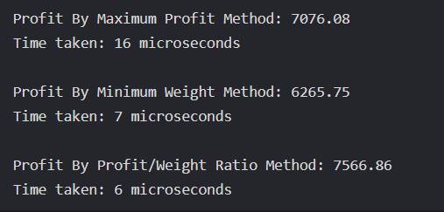
LeetCode:
class Solution {
public:
int maximumUnits(vector<vector<int>>& boxTypes, int truckSize) {

sort(boxTypes.begin(), boxTypes.end(), [](const vector<int>& a, const vector<int>& b) {
return a[1] > b[1];
});

int totalUnits = 0;
int Total_Boxes = 0;

for (auto& box : boxTypes) {
int Box_Count = box[0];
int Box_Units = box[1];

int Box_Min = min(Box_Count, truckSize - Total_Boxes);

totalUnits += Box_Min * Box_Units;
Total_Boxes += Box_Min;

if (Total_Boxes == truckSize) {
break;
}
}
return totalUnits;
}
};
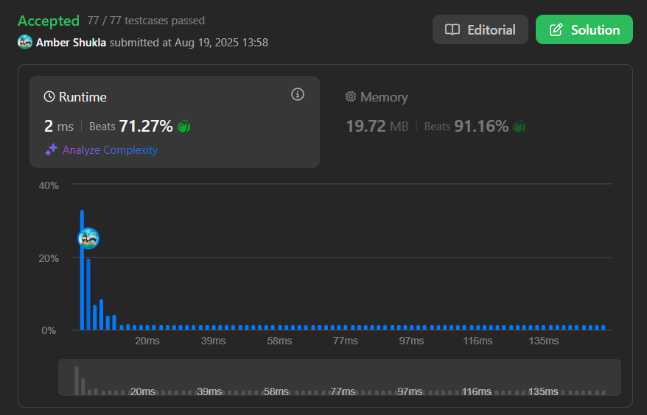

PART (B)
[SUBMISSION ON HackerRank]
Aim: Huffman coding and decoding
https://www.hackerrank.com/challenges/tree-huffman-decoding/problem

Code:
void decode_huff(node *root, string s)
{
node *temp = root;
char digit;

for (int i = 0; i <= s.size(); i++)
{
if (i == s.size())
digit = s[i - 1];
else
digit = s[i];

if (temp->left == NULL && temp->right == NULL)
{
cout << temp->data;
temp = root;
i--;
continue;
}

if (digit == '0')
temp = temp->left;
if (digit == '1')
temp = temp->right;
}
}

Outputs:


