DAA Lab
Practical 4
Amber Shukla
A1-B3-42

Aim: Implement maximum sum of subarray for the given scenario of resource allocation using the divide and conquer approach.

Code:
#include <bits/stdc++.h>
using namespace std;
typedef long long ll;

vector<ll> arr;

void Subarray(ll ans)
{
ll maxSum = INT_MIN;
ll start = 0, end = 0;

for (ll i = 0; i < arr.size(); i++)
{
for (ll j = i; j < arr.size(); j++)
{
ll currentSum = 0;
for (ll k = i; k <= j && currentSum <= ans; k++)
currentSum += arr[k];
if (currentSum == ans)
{
start = i;
end = j;
goto found;
}
}
}

found:
cout << "Maximum Sum Subarray is: [ ";
for (ll i = start; i <= end; i++)
cout << arr[i] << " ";
cout << "]" << endl;
}

ll DAC(ll left, ll right, ll constraint)
{
if (left > right)
return INT_MIN;

if (left == right)
if (arr[left] <= constraint)
return arr[left];
else
return INT_MIN;

ll mid = left + (right - left) / 2;

ll leftMax = DAC(left, mid, constraint);

ll rightMax = DAC(mid + 1, right, constraint);

ll sum = 0, leftSum = INT_MIN, rightSum = INT_MIN;

for (ll i = mid - 1; i >= left; i--)
{
sum += arr[i];
if (sum <= constraint)
leftSum = max(leftSum, sum);
}

sum = 0;

for (ll i = mid; i <= right; i++)
{
sum += arr[i];

if (sum <= constraint)
rightSum = max(rightSum, sum);

if (leftSum != INT_MIN && leftSum + sum <= constraint)
rightSum = max(rightSum, leftSum + sum);
}

ll cross = max(leftSum, rightSum);

return max({leftMax, rightMax, cross});
}

int main()
{
ll size, constraint;
cout << "Enter Size of Array: ";
cin >> size;

arr.resize(size);

if (!arr.size())
{
cout << "ERROR: Empty Array" << endl;
return 0;
}

cout << "Enter Array: ";
for (ll i = 0; i < size; i++)
cin >> arr[i];

cout << "Enter Resource Constraint: ";
cin >> constraint;

ll ans = DAC(0, size - 1, constraint);

if (ans == INT_MIN)
{
cout << "No Feasible Subarray\n";
return 0;
}

Subarray(ans);

cout << "Maximum Sum = " << ans << endl;

return 0;
}

Output:
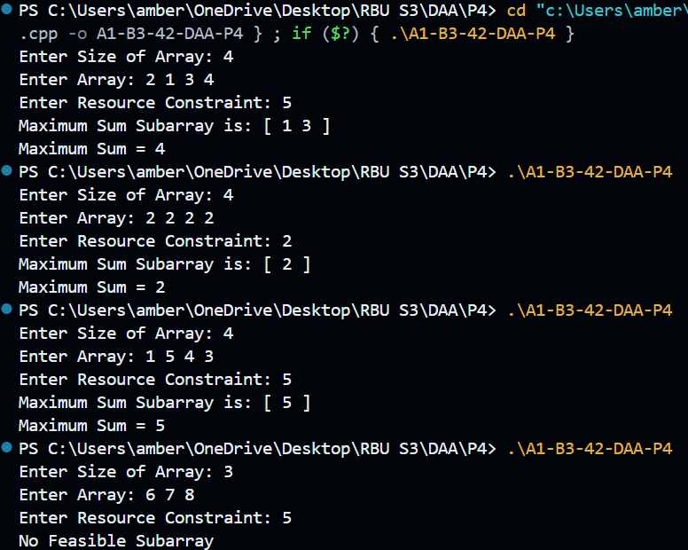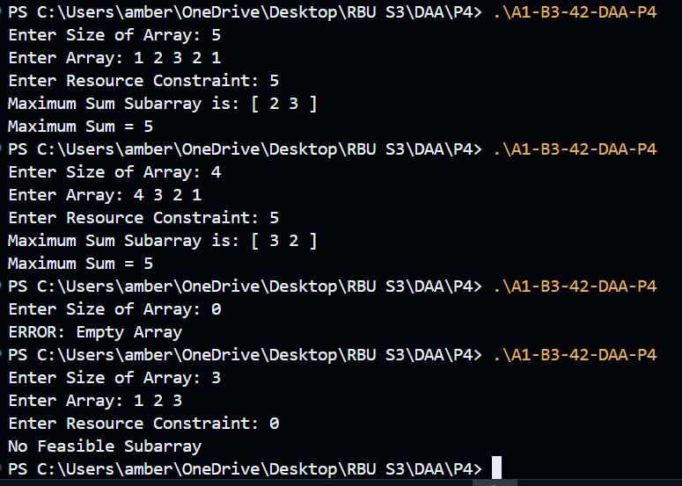
LeetCode:
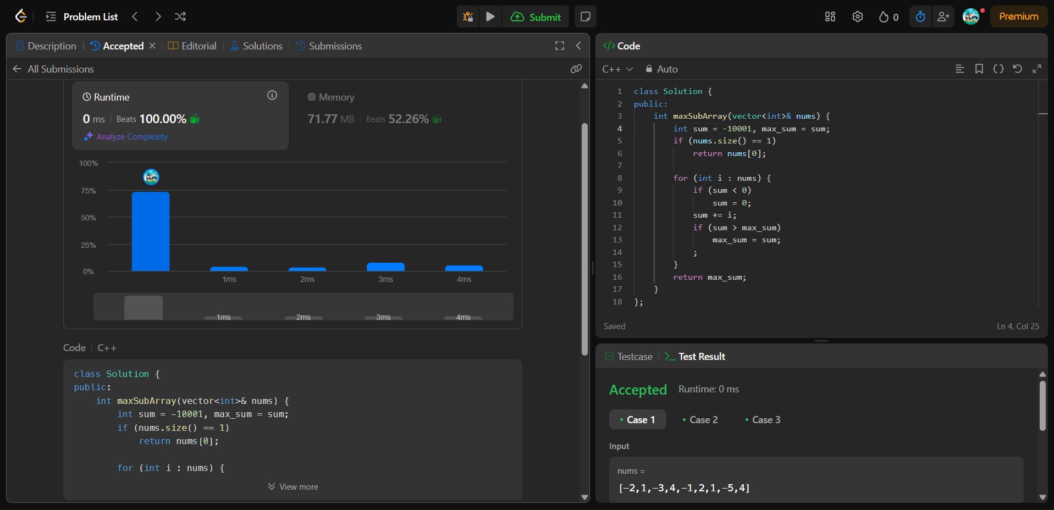

Code:
#include <bits/stdc++.h>
using namespace std;
typedef long long ll;

class Solution
{
public:
int maxSubArray(vector<int> &nums)
{
int sum = -10001, max_sum = sum;
if (nums.size() == 1)
return nums[0];

for (int i : nums)
{
if (sum < 0)
sum = 0;
sum += i;
if (sum > max_sum)
max_sum = sum;
;
}
return max_sum;
}
};

