A1-B3-42
Amber Shukla
DAA LAB

PRACTICAL NO. 2

Aim: Construction of Minimum Spanning Tree.

PART-A

CODE:

#include <bits/stdc++.h>
using namespace std;
#define ll long long

int main(void)
{
int size;

cout << "Enter Number of Frekles on Back: ";
cin >> size;

vector<vector<int>> Graph(size, vector<int>(size, -1));

for (int i = 0; i < size; i++)
{
for (int j = 0; j < size; j++)
{
if (i == j)
continue;
else if (Graph[j][i] != -1)
Graph[i][j] = Graph[j][i];
else
{
cout << "Enter Distance of Frekle " << i << " to Frekle " << j << ": ";
cin >> Graph[i][j];
}
}
}

cout << "\n\nThe adjacency matrix of the graph is:\n"
<< endl;
;

for (int i = 0; i < size; i++)
{
for (int j = 0; j < size; j++)
{
if (Graph[i][j] == -1)
Graph[i][j] = 0;

cout << Graph[i][j] << " ";
}
cout << endl;
}
cout << "\n\n";

vector<int> near(size, 0);
vector<pair<int, int>> MCST(size - 1);

int min = INT_MAX;
int u = 0, v = 0;
for (int i = 0; i < size; i++)
{
for (int j = i; j < size; j++)
{
int weight = std::min(Graph[i][j], Graph[j][i]);
if (weight && weight < min)
{
min = weight;
u = i;
v = j;
}
}
}

cout << "First Selected Edge: " << u << " - " << v << endl;

MCST[0] = {v, u};

for (int i = 0; i < size; i++)
{
if (i != u && i != v) {
int weight_u = Graph[i][u] > 0 ? Graph[i][u] : INT_MAX;
int weight_v = Graph[i][v] > 0 ? Graph[i][v] : INT_MAX;
near[i] = (weight_u < weight_v) ? u : v;
}
}

near[u] = near[v] = -1;

cout << "Near Array after first edge selection: " << endl;
for (int l = 0; l < near.size(); l++) {
cout << near[l] << " ";
}
cout << "\n\n";

for (int i = 1; i < size - 1; i++)
{
min = INT_MAX;
int k;

for (int j = 0; j < size; j++)
{
if (near[j] != -1)
{
int weight = std::min(Graph[j][near[j]], Graph[near[j]][j]);
if (weight && weight < min)
{
min = weight;
k = j;
}
}
}

cout << "\nSelected Edge " << i << ": " << near[k] << " - " << endl;

MCST[i] = {near[k], k};
near[k] = -1;

for (int j = 0; j < size; j++)
{
if (near[j] != -1)
{
int curr_weight = Graph[j][near[j]] > 0 ? Graph[j][near[j]] : INT_MAX;
int new_weight = Graph[j][k] > 0 ? Graph[j][k] : INT_MAX;
if (new_weight < curr_weight)
{
near[j] = k;
}
}
}

cout << "Near Array after iteration " << i << ": " << endl;

for (int l = 0; l < near.size(); l++)
{
cout << near[l] << " ";
}
cout << "\n\n";
}

int totalWeight = 0;

cout << "Edge \tWeight\n";
for (int i = 0; i < size - 1; i++)
{
cout << MCST[i].first << " - " << MCST[i].second << "\t"
<< Graph[MCST[i].first][MCST[i].second] << "\n";
totalWeight += Graph[MCST[i].first][MCST[i].second];
}
cout << "Total Weight of Minimum Spanning Tree: " << totalWeight << "\n";
}

OUTPUT:

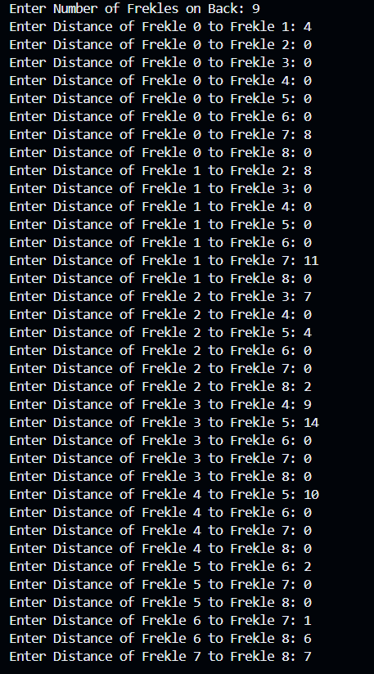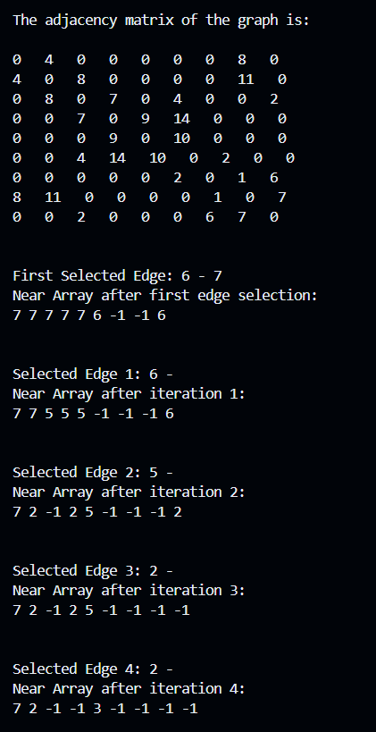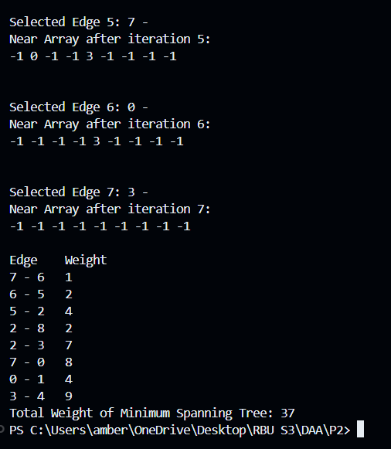

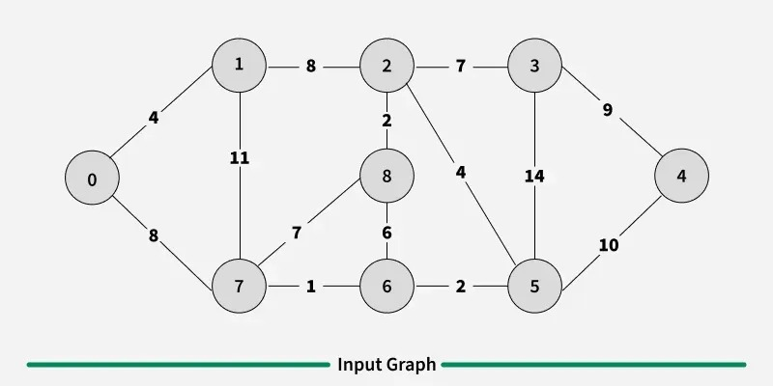

PART-B:
Problem Statement:
A. Consider the following for deciding connections in same state in India:
- Find the latitude and longitude of cities in same state. Consider 4 to 6 cities.
- Calculate the cost of connecting each pair of offices by computing the distance between different pair of different cities (as considered in part A) and construct a fully connected graph.
- Compute a minimum spanning tree using either Prims or Kruskals Method to find the cost of connecting offices in different cities.

CODE:

#include <algorithm>
#include <iostream>
#include <cmath>
#include <vector>
#include <string>
using namespace std;

const double unreachable = 999999.00;

double euclidean_dist(double x1, double y1, double x2, double y2);

int find(vector<int>& parent, int u) {
if (parent[u] != u) {
parent[u] = find(parent, parent[u]);
}
return parent[u];
}

void unionSets(vector<int>& parent, vector<int>& rank, int u, int v) {
int rootU = find(parent, u);
int rootV = find(parent, v);

if (rootU != rootV) {
if (rank[rootU] > rank[rootV]) {
parent[rootV] = rootU;
} else if (rank[rootU] < rank[rootV]) {
parent[rootU] = rootV;
} else {
parent[rootV] = rootU;
rank[rootU]++;
}
}
}

int main(void) {
int cities;
cout << "Enter number of cities (<= 6): ";
cin >> cities;

vector<string> city_names(cities);
vector<vector<double>> geoloc(cities, vector<double>(2));

for (int i = 0; i < cities; i++) {
cout << "Enter Name Of City " << i + 1 << ": ";
cin >> city_names[i];
cout << "Enter Geolocation x of City " << i + 1 << ": ";
cin >> geoloc[i][0];
cout << "Enter Geolocation y of City " << i + 1 << ": ";
cin >> geoloc[i][1];
}

vector<vector<double>> distances(cities, vector<double>(cities));

for (int i = 0; i < cities; i++) {
for (int j = 0; j < cities; j++) {
if (i == j) {
distances[i][j] = unreachable;
} else {
distances[i][j] = euclidean_dist(geoloc[i][0], geoloc[i][1], geoloc[j][0], geoloc[j][1]);
}
}
}

vector<pair<double, pair<int, int>>> sorted_routes;

for (int i = 0; i < cities; i++) {
for (int j = i + 1; j < cities; j++) {
if (distances[i][j] != unreachable) {
sorted_routes.push_back({distances[i][j], {i, j}});
}
}
}

sort(sorted_routes.begin(), sorted_routes.end());

vector<int> parent(cities);
vector<int> rank(cities, 0);
for (int i = 0; i < cities; i++) {
parent[i] = i;
}

double total_cost = 0.0;
vector<pair<string, string>> mst_edges;

for (const auto& route : sorted_routes) {
int u = route.second.first;
int v = route.second.second;
double dist = route.first;

if (find(parent, u) != find(parent, v)) {
unionSets(parent, rank, u, v);
total_cost += dist;
mst_edges.push_back({city_names[u], city_names[v]});
}
}

cout << "\nMST Edges:\n";
for (const auto& edge : mst_edges) {
cout << edge.first << " - " << edge.second << endl;
}
cout << "Total cost of MST: " << total_cost << endl;

return 0;
}

double euclidean_dist(double x1, double y1, double x2, double y2) {
return sqrt(pow(y2 - y1, 2) + pow(x2 - x1, 2));
}

OUTPUT:

