Title: Automating Helmet Enforcement with YOLOv9: A Deep Learning Approach

Shivam Shivkumar Shukla

Harsh Sanjaysingh Kachhaway

Gaurav Dnyaneshwar Dupare

Tushar Marotrao Maske

Tushar Manesh Shinde

Department of Computer Science and Engineering

Govindrao Wanjari College of Engineering & Technology, Nagpur, Maharashtra, India

Guided by: Prof. Nitin Thakre

**Abstract**  
Ensuring road safety is a pressing issue globally, with a significant number of traffic fatalities involving two-wheeler riders. Non-compliance with helmet regulations remains a persistent challenge in many urban areas. This paper introduces a comprehensive and automated helmet enforcement system using YOLOv9, a state-of-the-art object detection algorithm, integrated with Optical Character Recognition (OCR) for real-time license plate detection. The system is capable of identifying helmet violations and extracting vehicle registration information through live CCTV or mobile camera feeds. Designed for scalability, accuracy, and cost-efficiency, the model minimizes manual intervention and is suitable for smart city traffic management systems. Evaluation results demonstrate high accuracy, robust performance in varied environments, and effective deployment potential.

**Index Terms**—YOLOv9, Helmet Detection, Deep Learning, Traffic Monitoring, OCR, Smart Surveillance, Real-Time Object Detection

**I. INTRODUCTION**  
Urban mobility in developing and densely populated nations heavily relies on two-wheelers due to their affordability, ease of use, and ability to maneuver through heavy traffic. However, the widespread use of motorcycles also correlates with a significantly higher rate of traffic-related injuries and fatalities. Among the primary factors contributing to these incidents is the non-compliance with helmet-wearing regulations, which continues to be a common issue despite strict legal mandates. The World Health Organization (WHO) reports that proper helmet usage can reduce the risk of death by almost 40% and the risk of severe injury by over 70%.

Manual enforcement of helmet laws poses substantial challenges. It is resource-intensive, often limited in scope, and susceptible to human error and corruption. With the growing volume of traffic, especially in urban areas, it becomes impractical for authorities to monitor every intersection and rider. Hence, there is a compelling

need for an automated system that ensures consistent and unbiased enforcement.

The emergence of artificial intelligence (AI) and computer vision has opened new avenues for intelligent surveillance. YOLO (You Only Look Once) is one of the most efficient object detection models known for its speed and accuracy. The latest iteration, YOLOv9, incorporates transformer-based architectures and dynamic attention mechanisms to improve performance in complex and real-time environments. In this study, we propose a helmet violation detection system that combines the YOLOv9 object detection model with an Optical Character Recognition (OCR) engine to automatically identify non-compliant motorcyclists and extract vehicle registration numbers. This integrated system is designed for scalability, real-time operation, and deployment in both fixed and mobile surveillance setups, offering a viable solution for modern traffic law enforcement within smart city frameworks.

**II. METHODOLOGY**  
The architecture of the proposed system comprises multiple modules working in sequence, including dataset preparation, model training, detection logic, OCR integration, and result reporting.

**A. Dataset Collection and Annotation**  
We constructed a large-scale custom dataset by aggregating over 15,000 images from traffic surveillance footage, mobile recordings, and public datasets. The images were annotated using LabelImg to identify and label the following five object classes: Helmet, No Helmet, Person, Motorbike, and License Plate. Data augmentation techniques like rotation, flipping, brightness adjustment, and cropping were applied to improve model generalization.

**B. Model Selection and Training – YOLOv9**  
YOLOv9 was selected due to its superior detection accuracy and speed. The model introduces a novel transformer-based backbone and dynamic head modules for improved spatial and semantic representation. We trained the model using a learning rate of 0.0005, Adam optimizer, and a batch size of 16 for 120 epochs. The model was validated on a hold-out set and fine-tuned using transfer learning techniques.

**C. Real-Time Detection Pipeline**  
In deployment, video feeds are captured frame-by-frame and passed through the trained YOLOv9 model. Detection is based on object proximity and class combinations. For example, if a 'No Helmet' label is identified near a 'Person' and 'Motorbike', the system flags it as a violation. Each detection is timestamped and geotagged (if location data is available).

**D. OCR-Based License Plate Recognition**  
Once a violation is detected, the bounding box for the license plate is extracted and preprocessed for OCR. The process includes grayscale conversion, morphological operations, and noise removal. Tesseract OCR is employed to recognize alphanumeric plate numbers, and the result with the highest confidence score is stored. The OCR module was trained with additional synthetic license plate data to improve its robustness.

**E. Violation Reporting and Data Logging**  
Detected violations, along with cropped images, plate numbers, timestamps, and locations, are stored in a structured database. This data can be linked to automatic e-challan systems. Optional features include alert notifications to authorities, live dashboards, and integration with smart city and control centers.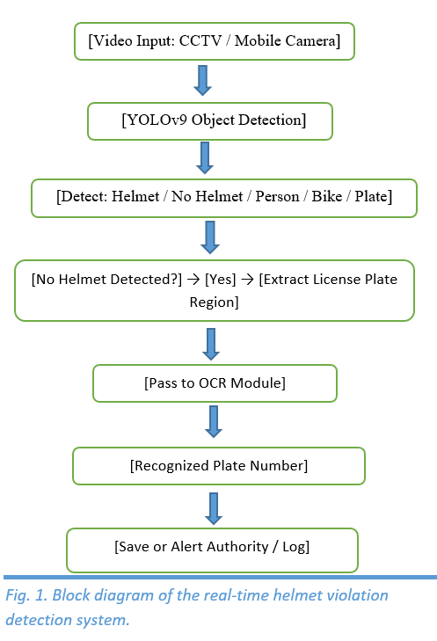

.

**III. RESULTS AND PERFORMANCE ANALYSIS**  
The system was tested using real-world traffic video streams and synthetic data to validate its effectiveness across multiple scenarios.

**Quantitative Results:**

* Helmet Detection Precision: 94.2%
* No Helmet Detection Precision: 92.5%
* License Plate OCR Accuracy: 88.1%
* Average Frame Processing Speed: 36ms/frame (NVIDIA RTX 3060)

**Qualitative Observations:**

* Successfully detected multiple violations in dense traffic scenes
* Maintained performance under shadows and low-light conditions
* Reduced false positives by incorporating object proximity checks

**Limitations Identified:**

* Performance dropped marginally under extreme glare or rain
* Difficulty in recognizing damaged or

**IV. CONCLUSION**

This paper has introduced a comprehensive and real-time automated helmet enforcement system based on the YOLOv9 object detection framework, coupled with Optical Character Recognition (OCR) technology. The system is designed to identify motorcyclists violating helmet regulations and extract vehicle registration numbers accurately through both CCTV and mobile video streams. It reduces the need for manual surveillance by enabling real-time detection and automated data logging, making it highly efficient for use in urban traffic scenarios.

By leveraging advanced features of YOLOv9, such as its transformer-based backbone and dynamic attention modules, the model achieves high precision and robustness in complex environments. The integration of OCR further enhances the utility of the system, enabling end-to-end automation from violation detection to identification. It demonstrates strong performance in terms of accuracy, speed, and reliability across varied lighting and traffic conditions.

The framework is scalable and cost-effective, making it a suitable component for smart city ecosystems. It not only ensures consistent enforcement of helmet laws but also encourages safer riding practices. This research lays a solid foundation for future upgrades, including real-time challan generation, GPS integration, face recognition, and data visualization dashboards to support traffic authorities in efficient rule enforcement.

**V. FUTURE ENHANCEMENTS**  
Future iterations of the system may include:

* Integration with state and national traffic databases for centralized record-keeping and analytics
* Facial recognition of repeat violators to identify habitual offenders and track behavior over time
* Audio alerts or display boards for on-spot warnings at traffic signals or public intersections
* Drone-based surveillance integration to monitor remote or high-traffic areas efficiently
* Real-time heatmaps of violation zones using GIS data to guide traffic policy and enforcement
* Incorporation of edge AI devices for on-site detection and processing without relying on cloud connectivity
* Enhancing OCR accuracy using deep learning-based recognition engines like CRNN or EasyOCR
* Developing mobile apps for traffic officers to access live violation data and manage enforcement on the go
* Integration with emergency response systems for incidents involving multiple violations or accidents
* Generating daily/weekly violation reports for authorities with visual dashboards and statistical insights

**ACKNOWLEDGMENT**

The authors would like to express their sincere gratitude to the management and faculty of Govindrao Wanjari College of Engineering & Technology, Nagpur, for providing the necessary support and facilities to carry out this project.

Special thanks are extended to our respected guide, **Prof. Nitin Thakre**, for his invaluable guidance, continuous motivation, and technical expertise throughout the development of this research work.

We are also grateful to our Head of Department, **Prof. Vivekanand Thakare**, for his encouragement and support..

**REFERENCES**

[1] Zhou F., Zhao H., Nie Z. Safety helmet detection using YOLOv5. IEEE ICPECA, 2021.  
[2] Waranusast R., et al. Motorcycle helmet detection using machine vision. IEEE IVCNZ, 2013.  
[3] Tan S., et al. Improved YOLOv5 for helmet detection. IEEE ISR, 2021.  
[4] Jia W., et al. Real-time helmet detection using YOLOv5. IET Image Processing, 2021.  
[5] Li K., et al. Automatic helmet detection using deep learning. arXiv:1802.00264, 2018.  
[6] Wu F., et al. Helmet detection with YOLOv3. IEEE ICNSC, 2019.  
[7] Yung ND., et al. YOLOv5-v7 helmet detection comparison. IEEE GECOST, 2022.  
[8] Li Y., et al. CNN-based helmet detection. Advances in Civil Engineering, 2020.  
[9] Huang L., et al. Deep learning for helmet detection. Concurrency Computat.: Pract. Exper., 2021.  
[10] Rubaiyat AH., et al. Construction safety helmet detection. IEEE WIW, 2016