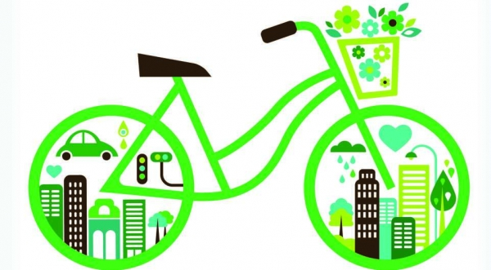

CREATING AWARENESS OF GREEN JOBS TO CONTRIBUTE TO ENVIRONMENTAL SUSTAINABILITY.

Sustainable Transportation

Twite Shukrani Monga

Contents

Task definition 0

Introduction 1

Task definition 2

Appendices 0

Discussion, Analysis and Findings, 1

1. How to Obtain a Green Job 1

2. How to Implement Green Jobs or Transition Existing Jobs 1

3. Challenges and Implications Associated with a Green Job 2

4. Overcoming Challenges and Implications in Pursuing a Green Job 2

5. Impact of Green Jobs on the Environment: 2

6. Solutions on How Green Jobs Will Improve the Environment: 2

7. How does sustainable transport support the concept of green jobs? 3

8. What is sustainable transport? 3

9.What are the challenges associated with transportation and how can we make our current forms of transportation more sustainable? 3

10.What future does sustainable transportation give to us? 3

Appendix B 4

4

4

Conclusion 5

Appendix C 6

Figure 1 0

Figure 2 1

Figure 3 1

Figure 4 6

Figure 5 7

# Task definition

To complete the task, I will start by conducting in-depth research on various sustainable energy sources, focusing on solar, wind, hydro, and geothermal power. The report will include an overview of each energy type, detailing their environmental impact and technological advancements. I will explore case studies and real-world applications to provide concrete examples of successful sustainable energy implementations. Additionally, the report will delve into economic considerations, examining the cost-effectiveness and potential financial benefits of adopting sustainable energy solutions. Policy frameworks and global initiatives supporting the transition to sustainable energy will be outlined to provide a broader context. Finally, the document will emphasize the critical role of sustainable transportation in addressing climate change and contributing to a cleaner, more resilient energy landscape.

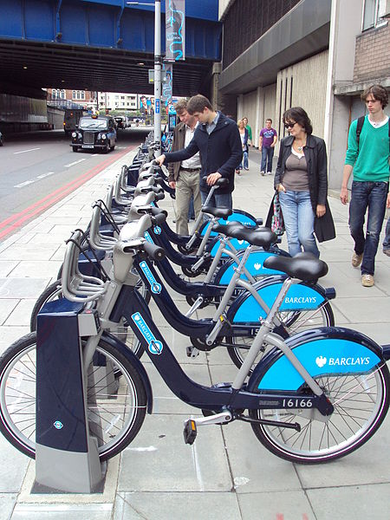Objective: This task aims to provide a comprehensive guide on obtaining, implementing, and adapting to green jobs, highlighting the associated challenges, implications, and the environmental impact. Additionally I will be using Microsoft Excel to propose solutions for overcoming challenges and fostering positive change for the environment through green job initiative

Figure 1

The task is to explore and analyse the impact of green jobs on promoting sustainable energy across diverse sectors, all this will be documented using Microsoft word. This involves researching how employment opportunities in renewable energy, energy efficiency, and environmental conservation contribute to fostering sustainability. The analysis should encompass various sectors, including but not limited to manufacturing, technology, construction, and agriculture, with a focus on how these green jobs play a crucial role in reducing carbon footprints, promoting clean energy sources, and creating a more environmentally friendly workforce. The goal is also to conduct research using the opinions of people using Microsoft Access. The target audience of this investigation is people who aim on transforming the transportation industry, the Principal of Queens High School and SGB.

# Introduction

Sustainable transportation is a fundamental aspect of building resilient and prosperous societies in the 21st century. It encompasses a holistic approach to mobility that considers environmental, social, and economic factors. At its essence, sustainable transportation seeks to minimize the negative impacts of transportation activities while maximizing benefits for individuals and communities alike.

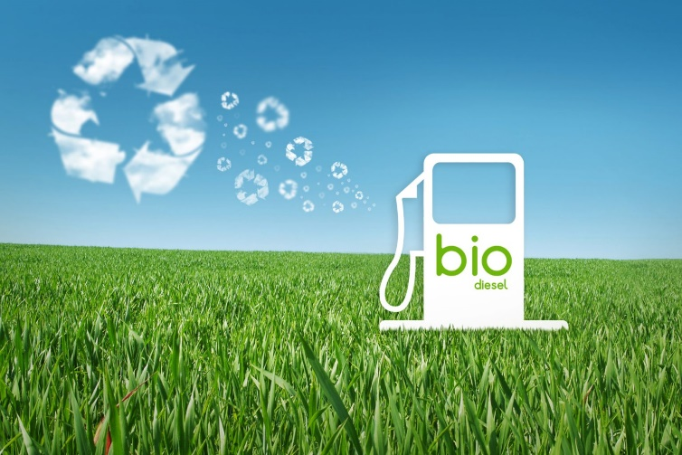One of the primary goals of sustainable transportation is to mitigate the environmental degradation caused by conventional transportation systems. By reducing greenhouse gas emissions, minimizing air and noise pollution, and conserving natural resources, sustainable transportation plays a vital role in combating climate change and preserving the planet for future generations. Embracing alternative fuels, such as electricity, hydrogen, and biofuels, and investing in energy-efficient technologies are pivotal steps in this transition.

Figure 2

Moreover, sustainable transportation has the potential to transform urban landscapes by alleviating traffic congestion and improving the quality of life for residents. Efficient public transit systems, cycling infrastructure, and pedestrian-friendly urban design not only reduce reliance on private vehicles but also promote active lifestyles and foster vibrant, inclusive communities. Accessible and affordable transportation options empower individuals to access education, employment, healthcare, and recreational opportunities, irrespective of their socioeconomic status or physical ability.

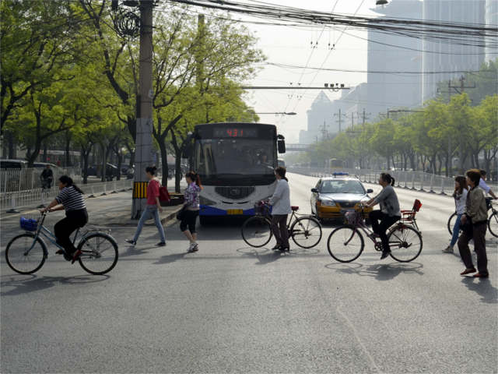Additionally, sustainable transportation initiatives can spur economic growth and innovation by creating new markets for clean technologies and green jobs. From the development of electric vehicles to the expansion of renewable energy infrastructure, the transition to sustainable transportation presents ample opportunities for entrepreneurship and investment. Furthermore, by reducing dependence on imported fossil fuels, countries can enhance energy security and resilience in the face of geopolitical uncertainties.

Figure 3

In essence, sustainable transportation is more than just a means of getting from point A to point B—it is a catalyst for positive change across multiple domains. By embracing innovation, collaboration, and a commitment to sustainability, societies can reap the manifold benefits of sustainable transportation, ranging from environmental stewardship to social inclusion and economic prosperity. As we navigate the challenges of the 21st century, sustainable transportation offers a pathway towards a brighter, more equitable future for all.

# Focus questions

How does sustainable transportation benefit the country and how can different methods of sustainability be implemented to better the country’s transportation industry?

# Appendices

Figure 2

Questions and Sources Table

# Discussion, Analysis and Findings,

1. How to obtain a green job?
2. How to implement green jobs or change jobs to green jobs
3. The challenges and implications associated with a green job
4. How the challenges and implications of pursuing a green job can be overcome
5. The impact (positive and negative) that a green job will have on the environment
6. Provide solutions on how green jobs will improve the environment?
7. How does sustainable transport support the concept of green jobs?
8. What is sustainable transport?
9. What are the challenges associated with transportation and how can we make our current forms of transportation more sustainable?
10. What future does sustainable transportation give to us?

## 1. How to Obtain a Green Job

Research and identify industries with a focus on sustainability and environmental responsibility.

Acquire relevant education, certifications, or training in green technologies and practices.

Network with professionals in the green sector and attend relevant events to enhance job prospects.

Update and tailor your resume to highlight skills and experiences relevant to green job opportunities.

Utilize online job platforms specializing in environmentally friendly and sustainable employment.

## 2. How to Implement Green Jobs or Transition Existing Jobs

Evaluate existing job roles for opportunities to integrate green practices.

Collaborate with management to introduce eco-friendly policies and initiatives.

Advocate for and implement sustainable practices within the workplace.

Encourage continuous learning and training for employees to adapt to green technologies.

## 3. Challenges and Implications Associated with a Green Job

- Identify potential challenges such as initial costs, resistance to change, and limited awareness.

Figure 6

 - Explore implications like job displacement in certain industries due to the shift towards sustainability.

- Research possible hurdles in adapting to new technologies and practices.

## 4. Overcoming Challenges and Implications in Pursuing a Green Job

- Develop comprehensive training programs to address skill gaps in the workforce.

- Implement financial incentives for businesses transitioning to green practices.

- Foster public awareness campaigns to educate communities about the benefits of green jobs.

- Collaborate with government agencies and non-profit organizations to create supportive policies.

## 5. Impact of Green Jobs on the Environment:

- Assess positive impacts, such as reduced carbon emissions, conservation of natural resources, and biodiversity preservation.

- Recognize potential negative impacts, such as the environmental footprint of certain technologies and industries.

## 6. Solutions on How Green Jobs Will Improve the Environment:

- Encourage the development and use of renewable energy sources.

- Invest in sustainable agriculture and forestry practices.

- Promote waste reduction and recycling initiatives.

- Support the development of green technologies and innovations.

By addressing each of these aspects, this task will provide a holistic understanding of the process of obtaining and transitioning to green jobs, along with insights into the challenges, implications, and environmental impact associated with such endeavour.

## 7. How does sustainable transport support the concept of green jobs?

Sustainable transport supports the concept of green jobs by creating employment opportunities in sectors that focus on environmentally friendly modes of transportation and infrastructure development. This includes jobs in industries such as public transportation, electric vehicle manufacturing, bicycle infrastructure construction, renewable energy production for transportation, and urban planning for sustainable mobility solutions. These jobs contribute to reducing greenhouse gas emissions, mitigating climate change, and promoting cleaner air and healthier communities.

## 8. What is sustainable transport?

Sustainable transport refers to modes of transportation and infrastructure systems that minimize environmental impact, conserve natural resources, and promote social equity. It encompasses various strategies and technologies aimed at reducing carbon emissions, improving energy efficiency, and minimizing pollution from transportation activities. Sustainable transport includes options such as walking, cycling, public transit, electric vehicles, carpooling, and eco-friendly fuels.

## 9.What are the challenges associated with transportation and how can we make our current forms of transportation more sustainable?

Challenges associated with transportation include congestion, air pollution, greenhouse gas emissions, dependence on fossil fuels, and inefficient infrastructure. To make current forms of transportation more sustainable, several measures can be implemented:

* Investing in public transportation and promoting its use through subsidies and incentives.
* Encouraging the adoption of electric vehicles (EVs) by providing incentives, expanding charging infrastructure, and investing in battery technology.
* 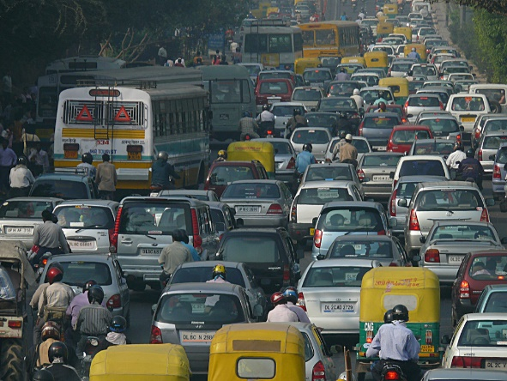Implementing urban planning strategies that prioritize walking, cycling, and transit-oriented development to reduce the need for private car usage.

Figure 7

* Promoting carpooling, ridesharing, and other shared mobility services to reduce the number of vehicles on the road.
* Investing in alternative fuels such as biofuels, hydrogen, and renewable energy sources for transportation.
* Implementing policies and regulations that promote fuel efficiency standards, emission reductions, and sustainable transportation practices.

## 10.What future does sustainable transportation give to us?

Sustainable transportation offers a future characterized by reduced carbon emissions, cleaner air, improved public health, enhanced energy security, and increased resilience to climate change. It can lead to more efficient and equitable transportation systems that better serve the needs of communities while minimizing environmental degradation. Additionally, sustainable transportation can stimulate economic growth and job creation in green industries, fostering innovation and technological advancement in the transportation sector. Overall, embracing sustainable transportation is essential for creating a more liveable and sustainable future for generations to come.

|  |  |  |  |  |  |  |  |  |
| --- | --- | --- | --- | --- | --- | --- | --- | --- |
| No. | Question | Question Level (1,2,3,4) | Category | Type of  Source | Bibliographical information | | Quality of Information found | |
| 1. | Would be best to obtain a green job? | 4 | Solution | **website** | **Authors** | Paul Freundlich | **Authority** | Paul Freundlich is a 20-year entertainment industry veteran who is the founder and president of Paul Freundlich Associates (pfa) |
| **Name of website** | Green America | **Currency** | 5 March 2021 |
| **Date created** | Founded in 1982, | **Accuracy** | <https://friendsoftheearth.uk/climate/how-get-green-job> |
| **Date accessed** | 05/03/2024 | **Objectivity** | NO presence of prejudice, bias |
| **URL** | <https://www.greenamerica.org/green-living/getting-green-job> | **Coverage** | The website provides information on how to obtain different green jobs |
| Acquire relevant education, certifications, or training in green technologies and practices as it benefits one more to have a green job, therefore yes. | | | | | | | | |
| No. | Question | Question Level (1,2,3,4) | Category | Type of  Source | Bibliographical information | | Quality of Information found | |
| 2 | How can you implement green jobs or change jobs to green jobs? | 2 | Solution | **website** | **Authors** | C40 Cities Climate Leadership Group, C40 Knowledge Hub | **Authority** |  |
| **Name of website** | C40 Knowledge Hub | **Currency** | 2013 |
| **Date created** | November 2022 | **Accuracy** | <https://www.generation.org/https/wwwgenerationorg/news/the-importance-of-green-jobs-why-they-matter-and-how-to-get-started/> |
| **Date accessed** | 05/03/2024 | **Objectivity** | NO presence of prejudice, bias |
| **URL** | <https://www.c40knowledgehub.org/s/article/How-to-measure-current-and-potential-green-jobs-in-your-city?language=en_US> | **Coverage** | The webpage provides further information on how you can implement a green jo |
| Evaluate existing job roles for opportunities to integrate green practices. | | | | | | | | |

|  |  |  |  |  |  |  |  |  |
| --- | --- | --- | --- | --- | --- | --- | --- | --- |
| No. | Question | Question Level (1,2,3,4) | Category | Type of  Source | Bibliographical information | | Quality of Information found | |
| 3 | What are the challenges and implications associated with a green job? | 1 | Challenges | **website** | **Authors** | League of Nations | **Authority** | The League of Nations was the first worldwide intergovernmental organisation whose principal mission was to maintain world peace. |
| **Name of website** | International Labour Organization | **Currency** | June 2017 |
| **Date created** | June 2015 | **Accuracy** | <https://www.oecd.org/environment/Employment-Implications-of-Green-Growth-OECD-Report-G7-Environment-Ministers.pdf> |
| **Date accessed** | 05/03/2024 | **Objectivity** | NO presence of prejudice, bias |
| **URL** | [WCMS_160269](../wcms_160269.pdf) | **Coverage** | This question covers the different positive or negative impacts associated with green jobs. |
| - Identify potential challenges such as initial costs, resistance to change, and limited awareness. | | | | | | | | |
| No. | Question | Question Level (1,2,3,4) | Category | Type of  Source | Bibliographical information | | Quality of Information found | |
| 4 | How can the challenges and implications of pursuing a green job can be overcome? | 2 | Solution | **Magazine** | **Authors** | Richard A. Clarke, Robert N. Stavins, J. Ladd Greeno, Joan L. Bavaria, Frances Cairncross, Daniel C. Esty, Bruce Smart, Johan Piet, Richard P. Wells, Rob Gray, Kurt Fischer, and Johan Schot | **Authority** | Richard A. Posner retired as a judge of the United States Court of Appeals for the Seventh Circuit in 2017. |
| **Name of website** | Harvard Business (**Magazine)** | **Currency** | From the Magazine (July–August 1994) |
| **Date created** | From the Magazine (July–August 1994) | **Accuracy** | <https://www.mdpi.com/2071-1050/14/8/4794> |
| **Date accessed** | 05/03/2024 | **Objectivity** | NO presence of prejudice, bias |
| **URL** | <https://hbr.org/1994/07/the-challenge-of-going-green> | **Coverage** | The above question explains the challenges and implications of pursuing a green job. |
| - Collaborate with government agencies and non-profit organizations to create supportive policies. | | | | | | | | |

|  |  |  |  |  |  |  |  |  |
| --- | --- | --- | --- | --- | --- | --- | --- | --- |
| No. | Question | Question Level (1,2,3,4) | Category | Type of  Source | Bibliographical information | | Quality of Information found | |
| 5 | The impact (positive and negative) that a green job will have on the environment? | 1 | Impact pact | **website** | **Authors** | League of Nations | **Authority** |  |
| **Name of website page** | International Labour Organization | **Currency** |  |
| **Date created** | March 2015 | **Accuracy** |  |
| **Date accessed** | 05/03/2024 | **Objectivity** | NO presence of prejudice, bias |
| **URL** | WCMS_160269 | **Coverage** |  |
| SUMMARY  - Assess positive impacts, such as reduced carbon emissions, conservation of natural resources, and biodiversity preservation. | | | | | | | | |
| No. | Question | Question Level (1,2,3,4) | Category | Type of  Source | Bibliographical information | | Quality of Information found | |
| 6 | Provide solutions on how green jobs will improve the environment? | 2 | Solution | **website** | **Authors** | Ninja Lacey and Siri Lijfering | **Authority** |  |
| **Name of website** | Blogs | **Currency** | 31 October 2022 |
| **Date created** | 31 October 2022 | **Accuracy** | <https://www.enelgreenpower.com/careers/green-jobs-future-sustainable-jobs> |
| **Date accessed** | 05/03/2024 | **Objectivity** | NO presence of prejudice, bias |
| **URL** | <https://www.decentjobsforyouth.org/resource-details/Blogs/1117> | **Coverage** | This question covers the different positive or negative impacts associated with green jobs. |
| SUMMARY  - Encourage the development and use of renewable energy sources. | | | | | | | | |

|  |  |  |  |  |  |  |  |  |
| --- | --- | --- | --- | --- | --- | --- | --- | --- |
| No. | Question | Question Level (1,2,3,4) | Category | Type of  Source | Bibliographical information | | Quality of Information found | |
| 7 | How does sustainable transport support the concept of green jobs? | 2 | challenge | **website** | **Authors** |  | **Authority** |  |
| **Name of website page** |  | **Currency** |  |
| **Date created** |  | **Accuracy** |  |
| **Date accessed** | 05/03/2024 | **Objectivity** | NO presence of prejudice, bias |
| **URL** |  | **Coverage** | This question covers the different positive or negative impacts associated with green jobs. |
| SUMMARY  Sustainable transport supports the concept of green jobs by creating employment opportunities | | | | | | | | |
| No. | Question | Question Level (1,2,3,4) | Category | Type of  Source | Bibliographical information | | Quality of Information found | |
| 8 | What is sustainable transport? |  | Question | **website** | **Authors** |  | **Authority** |  |
| **Name of website** |  | **Currency** |  |
| **Date created** |  | **Accuracy** |  |
| **Date accessed** | 05/03/2024 | **Objectivity** | NO presence of prejudice, bias |
| **URL** |  | **Coverage** | This question covers the different positive or negative impacts associated with green jobs. |
| SUMMARY  Sustainable transport refers to modes of transportation and infrastructure systems that minimize environmental impact, conserve natural resources, and promote social equity. | | | | | | | | |

|  |  |  |  |  |  |  |  |  |
| --- | --- | --- | --- | --- | --- | --- | --- | --- |
| No. | Question | Question Level (1,2,3,4) | Category | Type of  Source | Bibliographical information | | Quality of Information found | |
| 9 | What are the challenges associated with transportation and how can we make our current forms of transportation more sustainable? | 1 | Challenges | **website** | **Authors** |  | **Authority** |  |
| **Name of website/web page** |  | **Currency** |  |
| **Date created/updated** |  | **Accuracy** |  |
| **Date accessed** | 05/03/2024 | **Objectivity** | NO presence of prejudice, bias |
| **URL** |  | **Coverage** | 10% of topic |
| SUMMARY  Challenges associated with transportation include congestion, air pollution, greenhouse gas emissions, dependence on fossil fuels, and inefficient infrastructure | | | | | | | | |
| No. | Question | Question Level (1,2,3,4) | Category | Type of  Source | Bibliographical information | | Quality of Information found | |
| 10 | What future does sustainable transportation give to us? | 1 | Solution | **website** | **Authors** |  | **Authority** |  |
| **Name of website/web page** |  | **Currency** |  |
| **Date created** |  | **Accuracy** |  |
| **Date accessed** | 05/03/2024 | **Objectivity** | NO presence of prejudice, bias, skewing of information, etc. |
| **URL** |  | **Coverage** | 10% of topic |
| SUMMARY  Sustainable transportation offers a future characterized by reduced carbon emissions, cleaner air, improved public health, enhanced energy security, and increased resilience to climate change | | | | | | | | |

# Appendix B

# 

Figure 4

# 

Figure 5

# Conclusion

|  |
| --- |
| The use of sustainable transport is imperative for addressing various environmental, social, and economic challenges facing our world today. Through modes such as walking, cycling, public transit, and electric vehicles, sustainable transport offers numerous benefits. It reduces greenhouse gas emissions, mitigates air pollution, promotes physical activity, enhances public health, fosters equitable access to transportation, and contributes to economic development by creating jobs and reducing dependency on fossil fuels. Embracing sustainable transport not only helps combat climate change but also creates more liveable and resilient communities for present and future generations. Therefore, prioritizing and investing in sustainable transport solutions is essential for achieving a more sustainable and inclusive society. |

# Appendix C

|  |  |  |  |  |
| --- | --- | --- | --- | --- |
| **Learner name** | Twite | | **ID Number** | n/a |
| **Grade** | 12 | | **Year** | 2024 |
| **Subject** | Computer Applications Technology | | | |
| **Practical Assessment Task (PAT)** | | | **Teacher** | Mrs Marshman |
| Did you receive any help/information from anyone to complete this project?  ~~No~~ Yes (provide details below) | | | | |
| Help/Information received from (person): | | Nature of the help/information (provide evidence): | | |
|  | |  | | |
| I hereby declare that the contents of this assessment task are my own original work (except where there is clear acknowledgement and appropriate reference to the work of others) and that I have not plagiarised, copied from someone else or used work previously submitted for assessment by anyone.    ST.Monga  _________________________ __18_ / _03__ / 2024  SIGNATURE OF LEARNER DATE | | | | |