Task 1: Framing the Business Scenario.

Goal: Learn how to anticipate the questions your business leaders will need answers to.

Background Information: An online retail store has hired you as a consultant to review their data and provide insights that would be valuable to the CEO and CMO of the business. The business has been performing well and the management wants to analyse what the major contributing factors are to the revenue so they can strategically plan for next year.

The leadership is interested in viewing the metrics from both an operations and marketing perspective. Management also intends to expand the business and is interested in seeking guidance into areas that are performing well so they can keep a clear focus on what’s working. They would also like to view different metrics based on the demographic information that is available in the data.

A meeting with the CEO and CMO has been scheduled for next month and you need to draft the relevant analytics and insights that would help evaluate the current business performance and suggest metrics that would enable them to make the decision on expansion.

Remember, thinking from the perspective of business leaders allows you to analyse the data more effectively and present better insights.

Access the links in the resources below to better understand how business leaders think and approach business performance.

Task: To prepare for your meeting, you need to draft questions that you think will be important and relevant to the CEO and CMO. This preparation will be your guide as you develop your presentation.

For this task, you are only required to draft the questions. Make sure to think both quantitatively and qualitatively.

You’ve been provided a dataset in the resources below to use as the basis for your exploration. Review this data, taking note of what information has been provided, what insights you can garner, and what is relevant to both the CEO and CMO respectively.

Create a set of four questions that you anticipate each business leader will ask and want to know the answers to. Make sure you differentiate your questions, as both the CEO and CMO view business decisions through different lenses.

Submit your eight questions in total (4 for the CEO and 4 for the CMO) in the text submission box below.

Resources:

How to think from the perspective of a CEO

https://www.datapine.com/blog/ceo-dashboard-report-examples-and-templates/

Task 2: Choosing the Right Visuals

Goal: Learn which visuals are the most effective in a given scenario

Background Information: You have been asked by the CEO and CMO to provide visuals on the metrics that they wish to analyse for the online retail store. You will gather the requirements and provide them with the type of visual that would be best suited to the scenario. The senior management wants to understand how their business is performing and what areas are the key strengths of the company. They are also focused on identifying opportunities that would lead to growth and generate more revenue in the future.

You will be provided multiple visualisation requests by the CEO and you would need to provide the visual which would explain the data and insights in the simplest possible manner. The visual should adequately convey the information that you are trying to present. This exercise is critical to the senior management as any incorrect representation can lead to a wrong message being conveyed, or a wrong decision taken by the management. Therefore, you would need to make sure that the correct visuals are used to represent each set of data.

Task: In this task, you will be required to read the questions carefully and understand that businessrequirement. Once you have an idea of what is required from the perspective of the CEO and CMO, you will need to come up with the perfect visual which will illustrate what the senior managers are looking for in each scenario. Remember, data can be presented in multiple types of charts, but you are required to select the visual that would best display the information which is being presented.

You will be provided resources on how to select visuals based on the different scenarios, these are available in the resources section. These resources will help you get an idea on which visual to select for the given business scenario and will also guide you on how to choose the right chart or graph for your data. Each question will contain a unique scenario and you will be expected to answer the questions based on that scenario.

Resources:

Grammar of Graphics to understand the dimensions of visuals.

<https://towardsdatascience.com/a-comprehensive-guide-to-the-grammar-of-graphics-for-effective-visualization-of-multi-dimensional-1f92b4ed4149>

https://www.analyticsvidhya.com/blog/2021/09/how-to-choose-the-right-chart-for-data-visualization/

Choosing right charts based upon need such as Comparison, Distribution, Relationship, and Composition.

<https://infogram.com/page/choose-the-right-chart-data-visualization>

More:

<https://towardsdatascience.com/ultimate-guide-to-choosing-the-right-visual-2a77aa8eec08>

<https://chartio.com/learn/charts/how-to-choose-data-visualization/>

<https://www.tableau.com/learn/whitepapers/which-chart-or-graph-is-right-for-you>

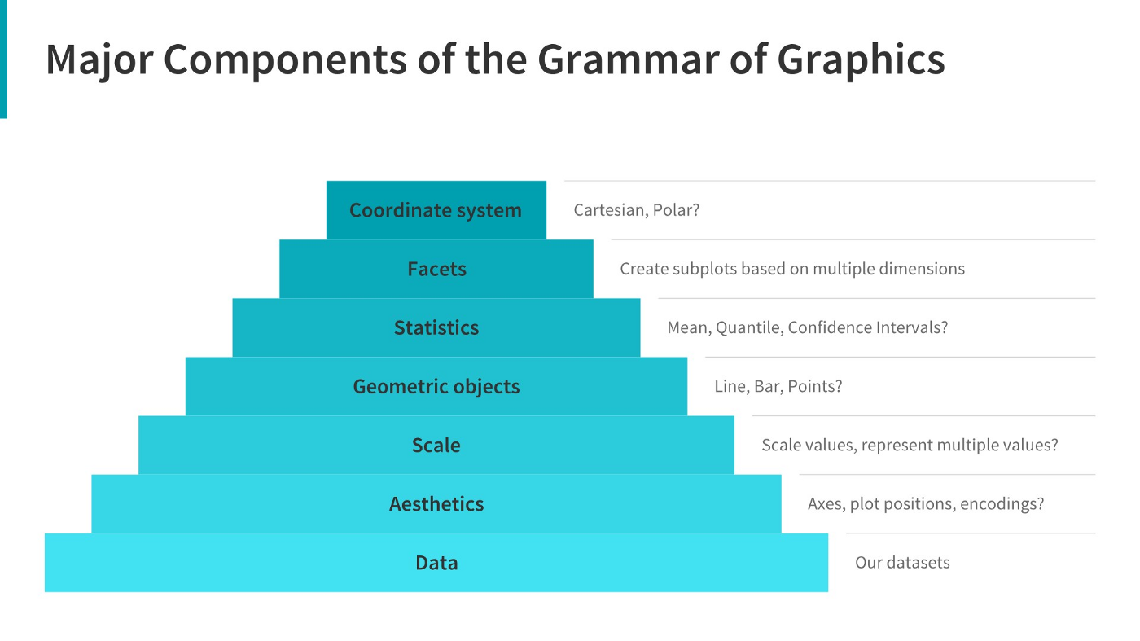

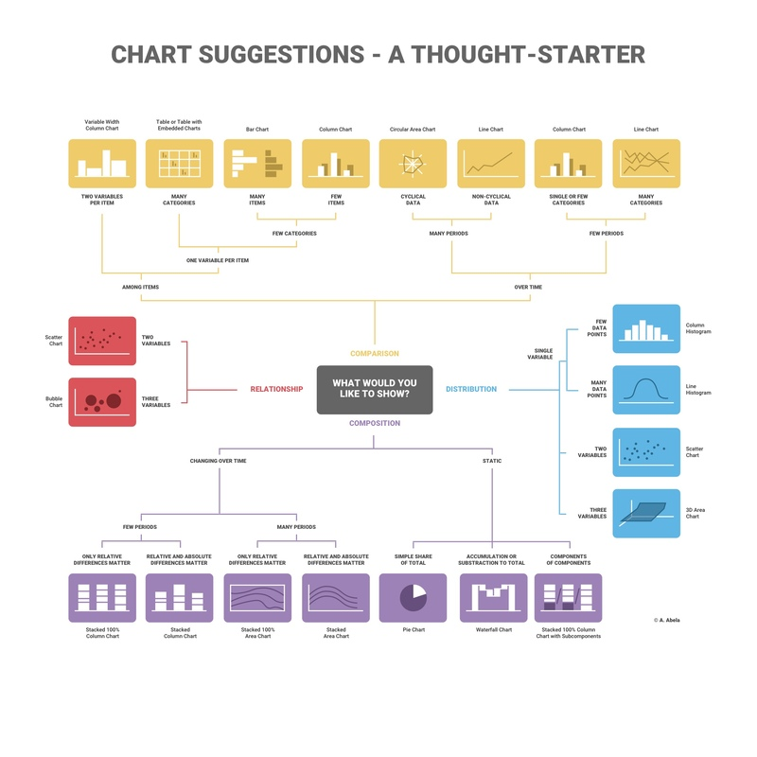

Task 3

Creating Effective visuals

Goal: Apply your understanding and create visuals absed on business scenerios

Background Information: The CEO and CMO have recently met to finalise the requirements and would like you to provide them with some analysis and visuals that would help answer their questions. Both, the executives are interested in viewing and understanding how they can use the data to make more meaningful decisions. You would need to provide insights which they can use to create the expansion strategy. The executives want to analyse the trends and the breakdown by different categories so that they have clarity on how the revenue is being generated and what are the main factors affecting the online store.

You will be provided with the requirements of the executives and how they want to view the data. After the requirement gathering phase, you would need to make sure that the data you are using is of good quality and does not contain any bad data that would have an adverse impact on your analysis. Once the data is cleaned, the next step would be to create the visuals on either Tableau or Power BI. No matter which tool you choose for the visuals, the result should be the same. These results will help the executives with effective decision making and assist in their expansion strategy.

Task:

In this task, you will create the visuals around four of the questions that the CEO and CMO have requested. You can use either Tableau or Power BI to create the visuals and we’ve provided the data in the resources below.   
**Both Power BI and Tableau have free trials that can be accessed in order to complete this task. You can find a resource below that directs you how to download these free trials.**  
  
**Data cleanup**  
Before you can begin the analysis, make sure that the data is cleaned properly. You have noticed that the data contains some returns to the store which are provided in negative quantities and there are unit prices which were input in error. You will need to perform the following steps to clean this data.

* Create a check that the quantity should not be below 1 unit
* Create a check that the Unit price should not be below $0

Please note that in order to apply the checks that have been mentioned above, you would need to use conditional formulas where the logic would state that if the conditions are met then the tool should exclude the data from analysis. You can also use data transformation methods to get rid of the bad data. Both these methods are provided in the resources section. Once this is done, the data will be good to be used for further analysis. Please note that this data should be cleaned up before attempting any question.  
  
Create each visual on a separate tab with the name of the tab displaying the question number. Once the visuals are created, save the files and upload them below.   
For Tableau users, you would need to upload in .twbx format whereas Power BI files need to be saved in .pbix format.   
Instructions on how to save in these formats are provided in the resources section.

Should you get stuck, please reference the Visuals Hints document in the resources.

**Estimated time for task completion: 1-1.5 hours depending on your learning style.**

**Question 1**  
The CEO of the retail store is interested to view the time series of the revenue data for the year 2011 only. He would like to view granular data by looking into revenue for each month. The CEO is interested in viewing the seasonal trends and wants to dig deeper into why these trends occur. This analysis will be helpful for the CEO to forecast for the next year.

**Question 2**  
The CMO is interested in viewing the top 10 countries which are generating the highest revenue. Additionally, the CMO is also interested in viewing the quantity sold along with the revenue generated. The CMO does not want to have the United Kingdom in this visual.

**Question 3**  
The CMO of the online retail store wants to view the information on the top 10 customers by revenue. He is interested in a visual that shows the greatest revenue generating customer at the start and gradually declines to the lower revenue generating customers. The CMO wants to target the higher revenue generating customers and ensure that they remain satisfied with their products.

**Question 4**  
The CEO is looking to gain insights on the demand for their products. He wants to look at all countries and see which regions have the greatest demand for their products. Once the CEO gets an idea of the regions that have high demand, he will initiate an expansion strategy which will allow the company to target these areas and generate more business from these regions. He wants to view the entire data on a single view without the need to scroll or hover over the data points to identify the demand. There is no need to show data for the United Kingdom as the CEO is more interested in viewing the countries that have expansion opportunities.

No LINKS – Just PDF