«Министерство образования и науки Российской Федерации Федеральное государственное бюджетное образовательное учреждение высшего образования «Алтайский государственный технический университет им. И.И. Ползунова»

Факультет информационных технологий

Кафедра прикладной математики

Отчёт защищён с оценкой__________________

Преподаватель Ананьев П.И.

«_____»__________________2022 г.

Отчёт

По лабораторной работе №4

«Создание модели данных с помощью CASE-средства, поддерживающего ER-моделирование»

Студент группы ПИ-92 Шульпов В.М.

Преподаватель доцент Ананьев П.И.

Барнаул 2022

**Вариант 34**

Кадры студентов. Паспортные данные, группа, адрес родителей, изучаемый язык, размер стипендии, наличие места в общежитии (или потребность в нем).

Концептуальная модель

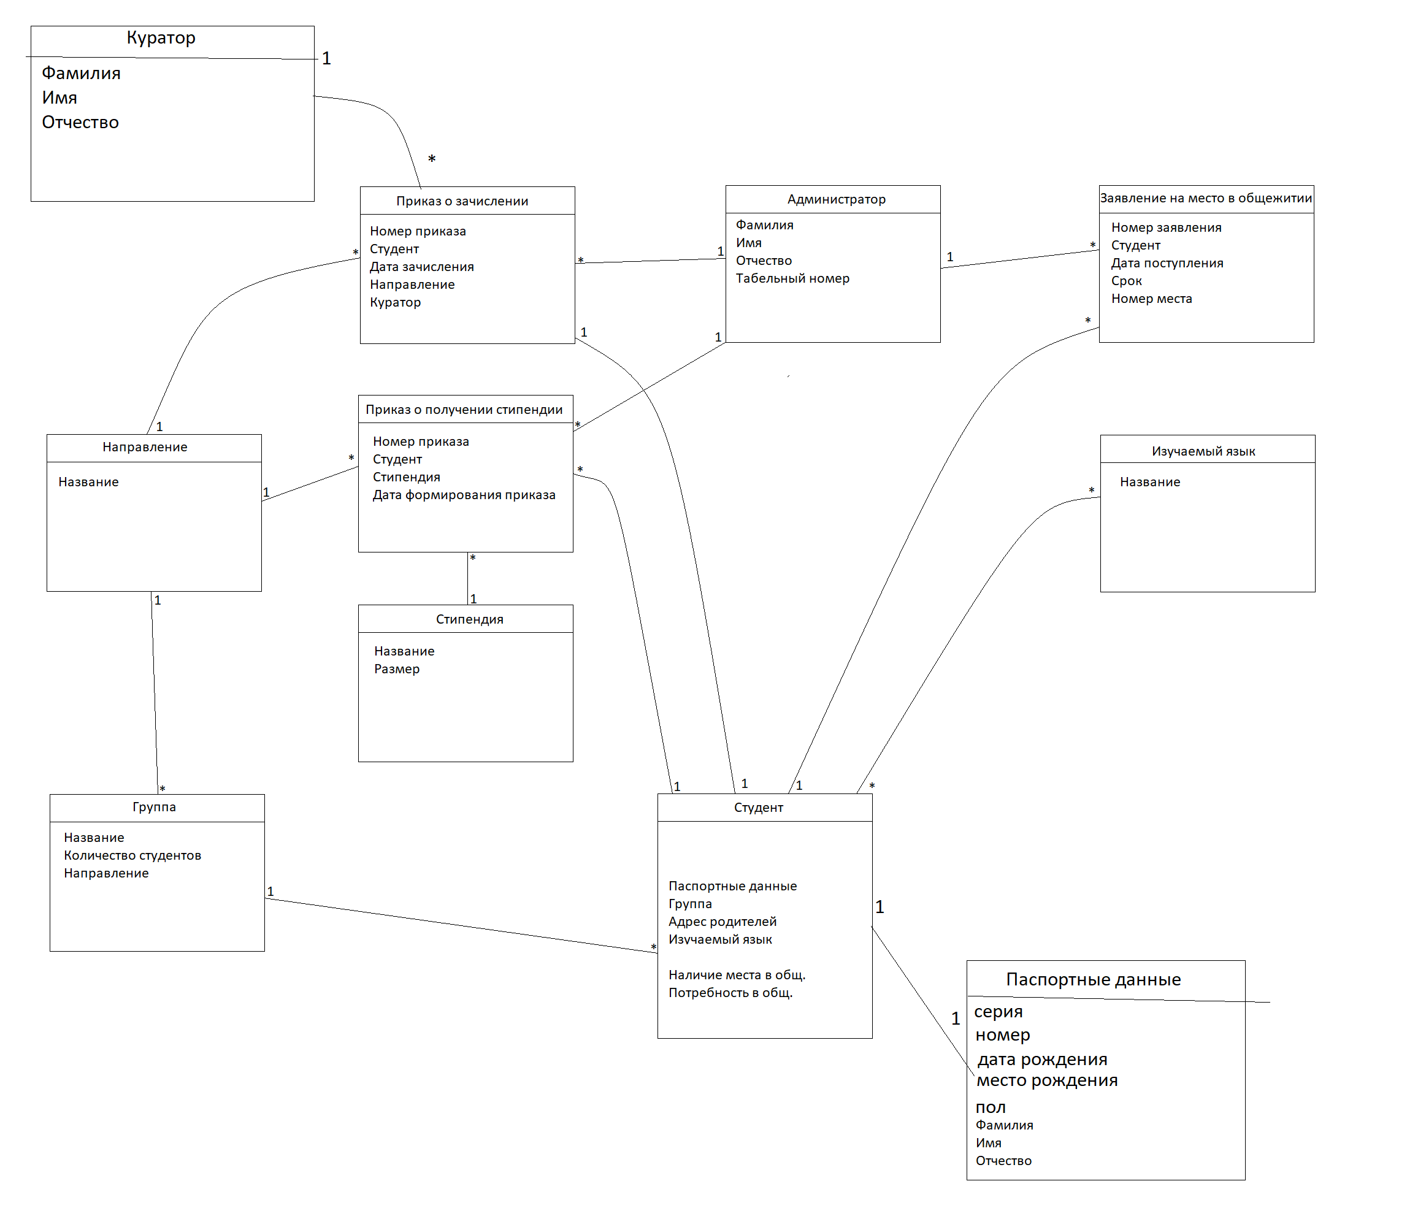

Реляционная модель

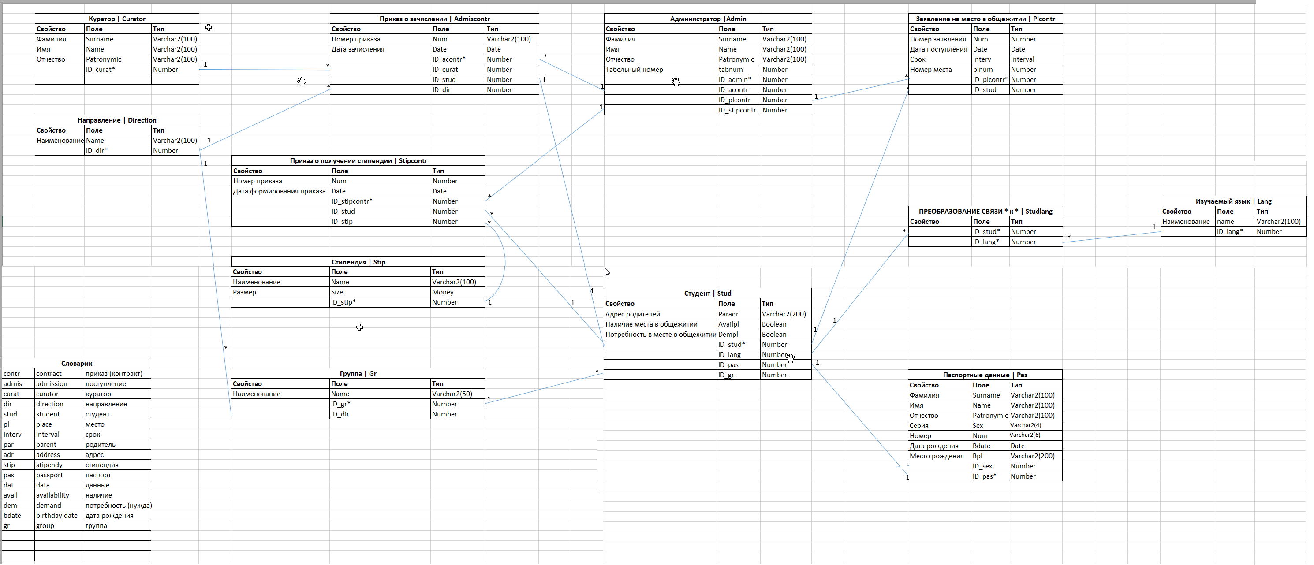

Логическая модель в технологии IDEF1X (captions)

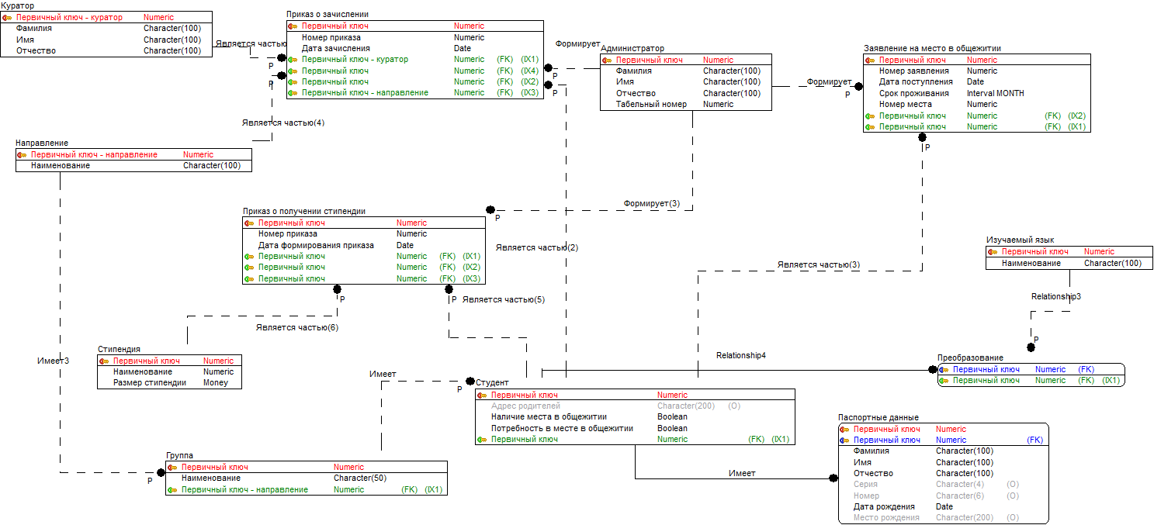

Физическая модель в технологии IDEF1X

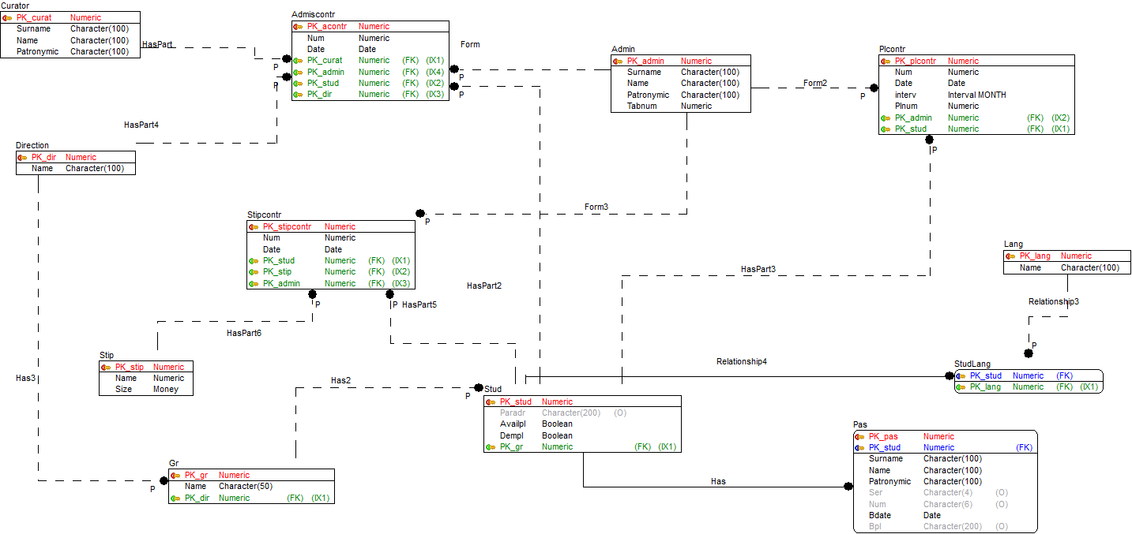

**Ссылочная целостность не нарушается** благодаря методам обработки restrict и cascade

cascade мы используем для идентифицирующей связи, а restrict – для не идентифицирующей связи.

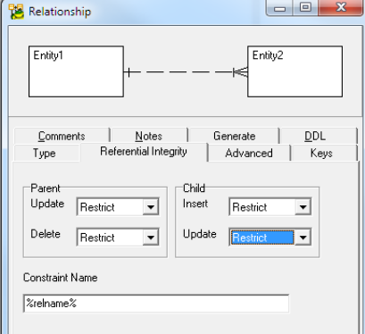

**Сгенерированный DLL скрипт**

/*

Created: 09.04.2022

Modified: 13.04.2022

Model: PostgreSQL 12

Database: PostgreSQL 12

*/

-- Create tables section -------------------------------------------------

-- Table Curator

CREATE TABLE "Curator"

(

"Surname" Character(100) NOT NULL,

"Name" Character(100) NOT NULL,

"Patronymic" Character(100) NOT NULL,

"PK_curat" Numeric NOT NULL

)

WITH (

autovacuum_enabled=true)

;

ALTER TABLE "Curator" ADD CONSTRAINT "PK_Curator" PRIMARY KEY ("PK_curat")

;

-- Table Direction

CREATE TABLE "Direction"

(

"Name" Character(100) NOT NULL,

"PK_dir" Numeric NOT NULL

)

WITH (

autovacuum_enabled=true)

;

ALTER TABLE "Direction" ADD CONSTRAINT "PK_Direction" PRIMARY KEY ("PK_dir")

;

-- Table Admiscontr

CREATE TABLE "Admiscontr"

(

"Num" Numeric NOT NULL,

"Date" Date NOT NULL,

"PK_acontr" Numeric NOT NULL,

"PK_curat" Numeric NOT NULL,

"PK_admin" Numeric NOT NULL,

"PK_stud" Numeric NOT NULL,

"PK_dir" Numeric NOT NULL

)

WITH (

autovacuum_enabled=true)

;

CREATE INDEX "IX_Relationship2" ON "Admiscontr" ("PK_curat")

;

CREATE INDEX "IX_Relationship5" ON "Admiscontr" ("PK_stud")

;

CREATE INDEX "IX_Relationship13" ON "Admiscontr" ("PK_dir")

;

CREATE INDEX "IX_Form" ON "Admiscontr" ("PK_admin")

;

ALTER TABLE "Admiscontr" ADD CONSTRAINT "PK_Admiscontr" PRIMARY KEY ("PK_acontr")

;

-- Table Admin

CREATE TABLE "Admin"

(

"Surname" Character(100) NOT NULL,

"Name" Character(100) NOT NULL,

"Patronymic" Character(100) NOT NULL,

"Tabnum" Numeric NOT NULL,

"PK_admin" Numeric NOT NULL

)

WITH (

autovacuum_enabled=true)

;

ALTER TABLE "Admin" ADD CONSTRAINT "PK_Admin" PRIMARY KEY ("PK_admin")

;

-- Table Plcontr

CREATE TABLE "Plcontr"

(

"Num" Numeric NOT NULL,

"Date" Date NOT NULL,

"interv" Interval MONTH NOT NULL,

"Plnum" Numeric NOT NULL,

"PK_plcontr" Numeric NOT NULL,

"PK_admin" Numeric NOT NULL,

"PK_stud" Numeric NOT NULL

)

WITH (

autovacuum_enabled=true)

;

CREATE INDEX "IX_Relationship6" ON "Plcontr" ("PK_stud")

;

CREATE INDEX "IX_Form2" ON "Plcontr" ("PK_admin")

;

ALTER TABLE "Plcontr" ADD CONSTRAINT "PK_Plcontr" PRIMARY KEY ("PK_plcontr")

;

-- Table Studlang

CREATE TABLE "Studlang"

(

)

WITH (

autovacuum_enabled=true)

;

-- Table Lang

CREATE TABLE "Lang"

(

"Name" Character(100) NOT NULL,

"PK_lang" Numeric NOT NULL

)

WITH (

autovacuum_enabled=true)

;

ALTER TABLE "Lang" ADD CONSTRAINT "PK_Lang" PRIMARY KEY ("PK_lang")

;

-- Table Pas

CREATE TABLE "Pas"

(

"Surname" Character(100) NOT NULL,

"Name" Character(100) NOT NULL,

"Patronymic" Character(100) NOT NULL,

"Ser" Character(4),

"Num" Character(6),

"Bdate" Date NOT NULL,

"Bpl" Character(200),

"PK_pas" Numeric NOT NULL,

"PK_stud" Numeric NOT NULL

)

WITH (

autovacuum_enabled=true)

;

ALTER TABLE "Pas" ADD CONSTRAINT "PK_Pas" PRIMARY KEY ("PK_pas","PK_stud")

;

-- Table Stud

CREATE TABLE "Stud"

(

"Paradr" Character(200),

"Availpl" Boolean DEFAULT False NOT NULL,

"Dempl" Boolean DEFAULT False NOT NULL,

"PK_stud" Numeric NOT NULL,

"PK_gr" Numeric NOT NULL

)

WITH (

autovacuum_enabled=true)

;

CREATE INDEX "IX_Relationship12" ON "Stud" ("PK_gr")

;

ALTER TABLE "Stud" ADD CONSTRAINT "PK_Stud" PRIMARY KEY ("PK_stud")

;

-- Table Stipcontr

CREATE TABLE "Stipcontr"

(

"Num" Numeric NOT NULL,

"Date" Date NOT NULL,

"PK_stipcontr" Numeric NOT NULL,

"PK_stud" Numeric NOT NULL,

"PK_stip" Numeric NOT NULL,

"PK_admin" Numeric NOT NULL

)

WITH (

autovacuum_enabled=true)

;

CREATE INDEX "IX_Relationship15" ON "Stipcontr" ("PK_stud")

;

CREATE INDEX "IX_Relationship16" ON "Stipcontr" ("PK_stip")

;

CREATE INDEX "IX_Form3" ON "Stipcontr" ("PK_admin")

;

ALTER TABLE "Stipcontr" ADD CONSTRAINT "PK_Stipcontr" PRIMARY KEY ("PK_stipcontr")

;

-- Table Stip

CREATE TABLE "Stip"

(

"Name" Numeric NOT NULL,

"Size" Money NOT NULL,

"PK_stip" Numeric NOT NULL

)

WITH (

autovacuum_enabled=true)

;

ALTER TABLE "Stip" ADD CONSTRAINT "PK_Stip" PRIMARY KEY ("PK_stip")

;

-- Table Gr

CREATE TABLE "Gr"

(

"Name" Character(50) NOT NULL,

"PK_gr" Numeric NOT NULL,

"PK_dir" Numeric NOT NULL

)

WITH (

autovacuum_enabled=true)

;

CREATE INDEX "IX_Has3" ON "Gr" ("PK_dir")

;

ALTER TABLE "Gr" ADD CONSTRAINT "PK_Gr" PRIMARY KEY ("PK_gr")

;

-- Table StudLang

CREATE TABLE "StudLang"

(

"PK_lang" Numeric NOT NULL,

"PK_stud" Numeric NOT NULL

)

WITH (

autovacuum_enabled=true)

;

CREATE INDEX "IX_Relationship3" ON "StudLang" ("PK_lang")

;

ALTER TABLE "StudLang" ADD CONSTRAINT "PK_StudLang" PRIMARY KEY ("PK_stud")

;

-- Create foreign keys (relationships) section -------------------------------------------------

ALTER TABLE "Admiscontr"

ADD CONSTRAINT "HasPart"

FOREIGN KEY ("PK_curat")

REFERENCES "Curator" ("PK_curat")

ON DELETE RESTRICT

ON UPDATE RESTRICT

;

ALTER TABLE "Admiscontr"

ADD CONSTRAINT "Form"

FOREIGN KEY ("PK_admin")

REFERENCES "Admin" ("PK_admin")

ON DELETE RESTRICT

ON UPDATE RESTRICT

;

ALTER TABLE "Plcontr"

ADD CONSTRAINT "Form2"

FOREIGN KEY ("PK_admin")

REFERENCES "Admin" ("PK_admin")

ON DELETE RESTRICT

ON UPDATE RESTRICT

;

ALTER TABLE "Admiscontr"

ADD CONSTRAINT "HasPart2"

FOREIGN KEY ("PK_stud")

REFERENCES "Stud" ("PK_stud")

ON DELETE RESTRICT

ON UPDATE RESTRICT

;

ALTER TABLE "Plcontr"

ADD CONSTRAINT "HasPart3"

FOREIGN KEY ("PK_stud")

REFERENCES "Stud" ("PK_stud")

ON DELETE RESTRICT

ON UPDATE RESTRICT

;

ALTER TABLE "Pas"

ADD CONSTRAINT "Has"

FOREIGN KEY ("PK_stud")

REFERENCES "Stud" ("PK_stud")

ON DELETE CASCADE

ON UPDATE CASCADE

;

ALTER TABLE "Stud"

ADD CONSTRAINT "Has2"

FOREIGN KEY ("PK_gr")

REFERENCES "Gr" ("PK_gr")

ON DELETE RESTRICT

ON UPDATE RESTRICT

;

ALTER TABLE "Admiscontr"

ADD CONSTRAINT "HasPart4"

FOREIGN KEY ("PK_dir")

REFERENCES "Direction" ("PK_dir")

ON DELETE RESTRICT

ON UPDATE RESTRICT

;

ALTER TABLE "Gr"

ADD CONSTRAINT "Has3"

FOREIGN KEY ("PK_dir")

REFERENCES "Direction" ("PK_dir")

ON DELETE RESTRICT

ON UPDATE RESTRICT

;

ALTER TABLE "Stipcontr"

ADD CONSTRAINT "HasPart5"

FOREIGN KEY ("PK_stud")

REFERENCES "Stud" ("PK_stud")

ON DELETE RESTRICT

ON UPDATE RESTRICT

;

ALTER TABLE "Stipcontr"

ADD CONSTRAINT "HasPart6"

FOREIGN KEY ("PK_stip")

REFERENCES "Stip" ("PK_stip")

ON DELETE RESTRICT

ON UPDATE RESTRICT

;

ALTER TABLE "Stipcontr"

ADD CONSTRAINT "Form3"

FOREIGN KEY ("PK_admin")

REFERENCES "Admin" ("PK_admin")

ON DELETE RESTRICT

ON UPDATE RESTRICT

;

ALTER TABLE "StudLang"

ADD CONSTRAINT "Relationship3"

FOREIGN KEY ("PK_lang")

REFERENCES "Lang" ("PK_lang")

ON DELETE RESTRICT

ON UPDATE RESTRICT

;

ALTER TABLE "StudLang"

ADD CONSTRAINT "Relationship4"

FOREIGN KEY ("PK_stud")

REFERENCES "Stud" ("PK_stud")

ON DELETE CASCADE

ON UPDATE CASCADE

;